PONDICHERRY ENGINEERING COLLEGE
DEPARTMENT OF COMPUTER SCIENCE AND ENGINEERING

SEMINAR REPORT ON
BRAIN COMPUTER INTERFACE - BRAINGATE TECHNOLOGY
Submitted by
Arthi.B (283175017)
Sandhya.S (283175171)
Veenas Katta (283175262)

Submitted to
Dr. R. Manoharan, Asst. Professor,
Seminar Coordinator.

Introduction
Since coming of new technologies, computers are becoming more intelligent than they were in the past. Man and machine interface has been one of the growing fields of research and development in the recent years. Most of the effort has been dedicated to the design of user friendly or ergonomic systems by means of innovative interfaces such as voice recognition, virtual reality. A brain computer interface, sometimes called direct neural interface or brain machine interface is a direct communication pathway between human or animal brain and an external device. Brain computer interface is a staple of science fiction writing. Over the past 15 years, productive brain computer interface research program have arisen. Present day brain computer interfaces determine the intent of the user from a variety of different electrophysiological signals. These signals include slow cortical potentials, P300 potentials or beta rhythms recorded from the scalp. They are translated in real time into commands that operate a computer display or any other device. In one way brain computer interface, computer either accepts commands from brain or sends signals to it. In two way brain computer interface, brains and external devices exchange information in both directions.
With assistive technologies computers adapt and change to user’s needs, from uniquely designed hardware peripherals to innovative softwares. Some scientists claim that it will not take long before computers become more intelligent than humans and humans can take advantage of these machines. A repercussion of this would be a world where humans and machines are getting melt with each other. An example of this is the BRAINGATE system which is a clinical trial ‘to turn thoughts into action’.
Many different disorders can disrupt the neuro muscular channels through which the brain communicates with and controls its external environment. Amyotrophic lateral sclerosis (ALS), brainstem stoke, brain or spinal cord injury and numerous other diseases impair the neural pathways that control the muscles or impair the muscles themselves. Those most severely affected may lose all voluntary muscles control, unable to communicate in any way. In the absence of methods for repairing the damage done by these disorders, a variety of methods for monitoring brain activity might serve as a BCI. BrainGate is a brain inplant system developed by biotech computer cyberkinetics in 2003 in conjunction with the department of neuro science at Brown University. The BrainGate system is a boon to the paralyzed. It is a mind-to-movement system that allows a quadriplegic man to control a computer using his thoughts. It is based on cyberkinetics platform technology to sense, transmit, analyse and apply the language of neurons.

BCI Technology
A brain-computer interface (BCI), sometimes called a direct neural interface or a brain-machine interface, is a direct communication pathway between a human or animal brain (brain cell culture) and an external device. In one-way BCIs, computers either accept commands from the brain or send signals to it (for example, to restore vision) but not both. Two-way BCIs would allow brains and external devices to exchange information in both directions but have yet to be successfully implanted in animals or humans. In this definition, the word brain means the brain or nervous system of an organic life form rather than the mind. Computer means any processing or computational device, from simple circuits to silicon chips (including hypothetical future technologies such as quantum computing).
Research on BCIs began in the 1970s, but it wasn't until the mid-1990s that the first working experimental implants in humans appeared. Following years of animal experimentation, early working implants in humans now exist, designed to restore damaged hearing, sight and movement. The common thread throughout the research is the remarkable cortical plasticity of the brain, which often adapts to BCIs, treating prostheses controlled by implants as natural limbs. With recent advances in technology and knowledge, pioneering researchers could now conceivably attempt to produce BCIs that augment human functions rather than simply restoring them, previously only the realm of science fiction.
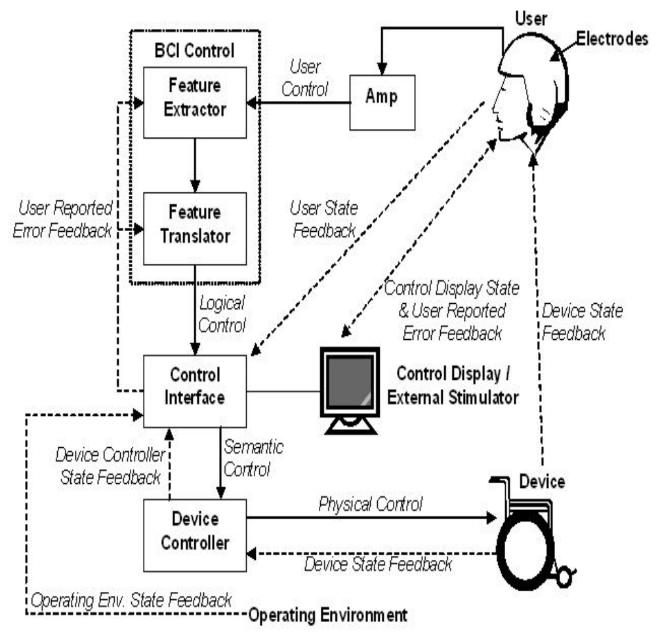

Fig1.Schematic Architecture of BCI

Brain Computer interface is of three types based on its features and are
1. Invasive BCI
2. Partially Invasive BCI
3. Non Invasive BCI

BrainGate Background
The BrainGate technology platform was designed to take advantage of the fact that many patients with motor impairment have an intact brain that can produce movement commands. This allows BrainGate system to create output signal directly from the brain, bypassing the route through the nerves to the muscles that cannot be used in paralyzed people.
BrainGate is a culmination of ten years of research by Dr. John Donoghue who is the chairman of the neuroscience department at Brown University and chief scientific officer for cyberkinetics. Dr. Gerhard Freighs helped him by experimenting on monkeys to control the cursor by thoughts alone. These researches cofounded cyberkinetcs, Inc.in. The company bears all the expenses required for the study. According to the Cyberkinetics website three patients have been implanted with the BrainGate system. The company has confirmed that one patient (Matthew Nagle) has a spinal cord injury while another has advanced ALS.
The implant, BrainGate, allowed Matthew Nagle, a 25 year old Massachusetts man who has been paralyzed from the neck down since 2001, because of a severe spinal cord injury, to control a cursor on a screen and to open and close the hand on a prosthetic limb just by thinking about the actions.
After few minutes spent calibrating the inplant, Mr. Matthew Nagle could read emails and plays the computer game Pong. He was able to draw circular shapes using a paint program and could also change channel and turn up the volume on a television, even while talking to people around him. After several months he could also operate simple robotic devices such as prosthetic hand, which he used to grasp and move objects. With practice the user can refine movements using signals from only a sample of cells.
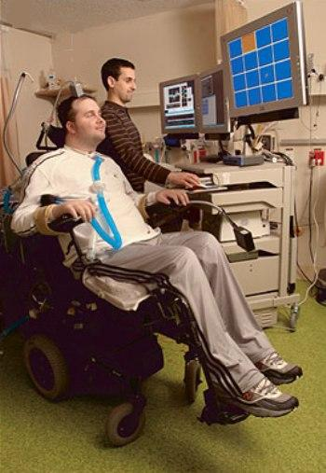

Fig 2.Clinical Trial
BrainGate is currently recruiting patients with a range of neuromuscular and neuro degenerative conditions for pilot clinical trials being conducted under an Investigational Device Exemption (IDE) in the United States. Cyberkinetics hopes to refine the BrainGate in the next two years to develop a wireless devise that is completely implantable and doesn’t have a plug, making it safer and less visible. And once the basics of brain mapping are worked out, there is potential for a wide variety of further applications.
The system is designed to restore functionality for a limited, immobile group of severely motor-impair individuals. It is expected that people using this system will employ a personal computer as a gateway to a range of self directed activities. These activities extend beyond typical computer functions.
Cyberkinetics is further developing the BrainGate system to provide limb movement to people with severe motor disabilities. The goal of this program would be to allow these individuals to one day use their arms and hands again. In addition Cyberkinetics is also developing products to allow for robotic control such as a thought controlled wheel chair.

How does the brain control motor function?
The brain is "hardwired" with connections, which are made by billions of neurons that make electricity whenever they are stimulated. The electrical patterns are called brain waves. Neurons act like the wires and gates in a computer, gathering and transmitting electrochemical signals over distances as far as several feet. The brain encodes information not by relying on single neurons, but by spreading it across large populations of neurons, and by rapidly adapting to new circumstances.
Motor neurons carry signals from the central nervous system to the muscles, skin and glands of the body, while sensory neurons carry signals from those outer parts of the body to the central nervous system. Receptors sense things like chemicals, light, and sound and encode this information into electrochemical signals transmitted by the sensory neurons. And interneurons tie everything together by connecting the various neurons within the brain and spinal cord. The part of the brain that controls motor skills is located at the ear of the frontal lobe.
How does this communication happen? Muscles in the body's limbs contain embedded sensors called muscle spindles that measure the length and speed of the muscles as they stretch and contract as you move. Other sensors in the skin respond to stretching and pressure. Even if paralysis or disease damages the part of the brain that processes movement, the brain still makes neural signals. They're just not being sent to the arms, hands and legs.
A technique called neuro feedback uses connecting sensors on the scalp to translate brain waves into information a person can learn from. The sensors register different frequencies of the signals produced in the brain. These changes in brain wave patterns indicate whether someone is concentrating or suppressing his impulses, or whether he is relaxed or tense.

Principle
The principle of operation of the BrainGate Neural Interface System is that with intact brain function, neural signals are generated even though they are not sent to the arms, hands and legs. These signals are interpreted by the systems and a cursor is shown to the user on a computer screen that provides an alternate "BrainGate pathway". The user can use that cursor to control the computer, just as a mouse is used.
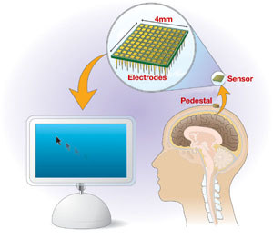

Fig 3. Principle of BrainGate
The technology driving this breakthrough in the Brain-Machine-Interface field has a myriad of potential applications, including the development of human augmentation for military and commercial purposes.

Working
The BrainGate Neural Interface device consists of a tiny chip containing 100 microscopic electrodes that is surgically implanted in the brain's motor cortex. The whole apparatus is the size of a baby aspirin. The chip can read signals from the motor cortex, send that information to a computer via connected wires, and translate it to control the movement of a computer cursor or a robotic arm. According to Dr. John Donaghue of Cyberkinetics, there is practically no training required to use BrainGate because the signals read by a chip implanted, for example, in the area of the motor cortex for arm movement, are the same signals that would be sent to the real arm. A user with an implanted chip can immediately begin to move a cursor with thought alone. However, because movement carries a variety of information such as velocity, direction, and acceleration, there are many neurons involved in controlling that movement. BrainGate is only reading signals from an extremely small sample of those cells and, therefore, only receiving a fraction of the instructions. Without all of the information, the initial control of a robotic hand may not be as smooth as the natural movement of a real hand. But with practice, the user can refine those movements using signals from only that sample of cells.
the BrainGate pilot device consists of a Sensor of the size of a contact lens, a cable and pedestal, which connects the chip to the computer, a cart which consists the signal processing unit .
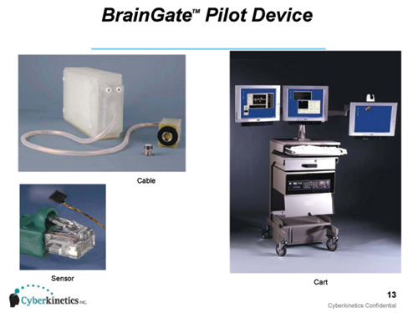

Fig 4. BrainGate Pilot Device
The BrainGate Neural Interface Device is a proprietary brain-computer interface that consists of an internal neural signal sensor and external processors that convert neural signals into an output signal under the users own control. The sensor consists of a tiny chip smaller than a baby aspirin, with one hundred electrode sensors each thinner than a hair that detect brain cell electrical activity. The sensor chip may be planted in the area of the brain responsible for body movements.
The chip is implanted on the surface of the brain in the motor cortex area that controls movement. In the pilot version of the device, a cable connects the sensor to an external signal processor in a cart that contains computers. The computers translate brain activity and create the communication output using custom decoding software. Importantly, the entire BrainGate system was specifically designed for clinical use in humans and thus, its manufacture, assembly and testing are intended to meet human safety requirements. Five quadriplegics patients in all are enrolled in the pilot study, which was approved by the U.S. Food and Drug Administration (FDA).

Motor Cortex

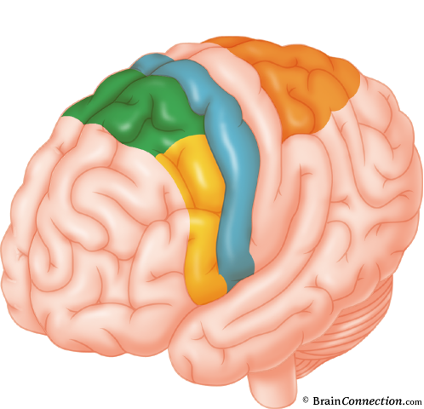

Fig 5. Primary Motor Cortex of Brain
Existing technology stimulates muscle groups that can make an arm move. The problem Surgeon or and his team faced was in creating an input or control signal. With the right control signal they found they could stimulate the right muscle groups to make arm movement.

Sense
Cyberkinetics' unique technology is able to simultaneously sense the electrical activity of many individual neurons. Our sensor consists of a silicon array about the size of a baby aspirin that contains one hundred electrodes, each thinner than a human hair. The array is implanted on the surface of the brain. In the BrainGate Neural Interface System, the array is implanted in the area of the brain responsible for limb movement. In other applications the array may be implanted in areas of the brain responsible for other body processes.

Transmit and Analyze
The human brain is a super computer with the ability to instantaneously process vast amounts of information. Cyberkinetics' technology allows for an extensive amount of electrical activity data to be transmitted from neurons in the brain to computers for analysis. In the current BrainGate System, a bundle consisting of one hundred gold wires connects the array to a pedestal which extends through the scalp. The pedestal is connected by an external cable to a set of computers in which the data can be stored for off-line analysis or analyzed in real-time. Signal processing software algorithms analyze the electrical activity of neurons and translate it into control signals for use in various computer-based applications.

Apply
Cyberkinetics' ability to generate control signals and develop computer application interfaces provides us with a platform to develop multiple clinical products. For example, using the BrainGate Neural Interface System, a person may be able to use his thoughts to control cursor motion and or replicate keystrokes on a computer screen. In another example, a doctor may study patterns of brain electrical activity in patients with epilepsy before, during and after seizures.

Implanting The Chip
There will be two surgeries, one to implant the BrainGate and one to remove it. Before surgery, there will be several precautionary measures in order to prevent infection; patients will have daily baths with antimicrobial soap and take antibiotics. In addition, MRI scans will be done to find the best place on the brain for the sensor. Under sterile conditions and general anesthesia, Doctor will drill a small hole into the skull and implant the sensor using the same methods as in the monkey studies. Patients will receive post-surgical care including a CT scan, some blood tests, and wound care in the hospital for 1 to 5 days after surgery. After surgery, one of the study doctors will see the patients at least once a week for six weeks, then monthly and as needed. A nurse will also check the patients regularly and will always carry a 24-hour pager. The skin around the pedestal will need to be carefully monitored during the study. Detailed instructions will be provided so that the patient’s daily care provider can help with skin care.
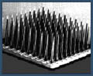

Fig 6. Neuro Chip
The sensor of the size of a contact lens is implanted in brain’s percental gyrus which control hand and arm movements. A tiny wire connects the chip to a small pedestal secured in the scull. A cable connects the pedestal to a computer. The brain's 100bn neurons fire between 20 and 200 times a second .The sensor implanted in the brain senses these electrical signals and passes to the pedestal through the wire. The pedestal passes this signals to the computer through the cable. The computer translates the signals into a communication output, allowing a person to move a cursor on a computer screen merely by thinking about it.
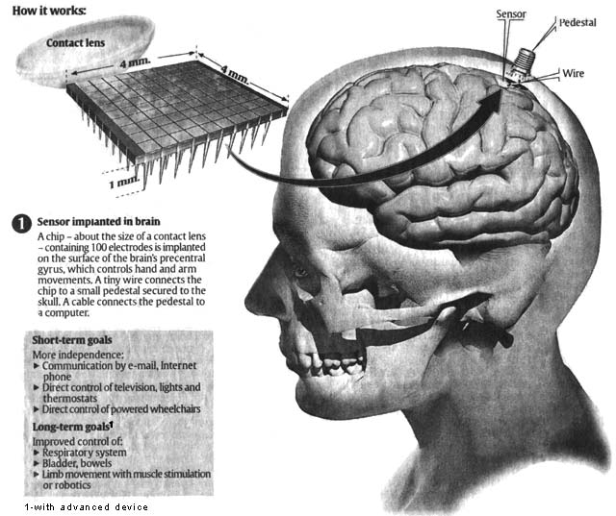

Fig 7. How the BrainGate works
Operation of the BCI system is not simply listening the EEG of user in a way that let’s tap this EEG in and listen what happens. The user usually generates some sort of mental activity pattern that is later detected and classified.

Preprocessing
The raw EEG signal requires some preprocessing before the feature extraction. This preprocessing includes removing unnecessary frequency bands, averaging the current brain activity level, transforming the measured scalp potentials to cortex potentials and demonizing. Frequency bands of the EEG :
Band | Frequency [Hz] | Amplitude [_V] | Location
Alpha (_) | 8-12 | 10 -150 | Occipital/Parietal regions
µ-rhythm | 9-11 | varies | Precentral/Postcentral regions
Beta (_) | 14 -30 | 25 | typically frontal regions
Theta (_) | 4-7 | varies | varies
Delta (_) | <3 | varies | varies

Detection
The detection of the input from the user and them translating it into an action could be considered as key part of any BCI system. This detection means to try to find out these mental tasks from the EEG signal. It can be done in time-domain, e.g. by comparing amplitudes of the EEG and in frequency-domain. This involves usually digital signal processing for sampling and band pass filtering the signal, then calculating these time or frequency domain features and then classifying them. These classification algorithms include simple comparison of amplitudes linear and non-linear equations and artificial neural networks. By constant feedback from user to the system and vice versa, both partners gradually learn more from each other and improve the overall performance.

Control
The final part consists of applying the will of the user to the used application. The user chooses an action by controlling his brain activity, which is then detected and classified to corresponding action. Feedback is provided to user by audio-visual means e.g. when typing with virtual keyboard, letter appears to the message box etc.

Training
The training is the part where the user adapts to the BCI system. This training begins with very simple exercises where the user is familiarized with mental activity which is used to relay the information to the computer. Motivation, frustration, fatigue, etc. apply also here and their effect should be taken into consideration when planning the training procedures.

Bio feedback
The definition of the biofeedback is biological information which is returned to the source that created it, so that source can understand it and have control over it. This biofeedback in BCI systems is usually provided by visually, e.g. the user sees cursor moving up or down or letter being selected from the alphabet.
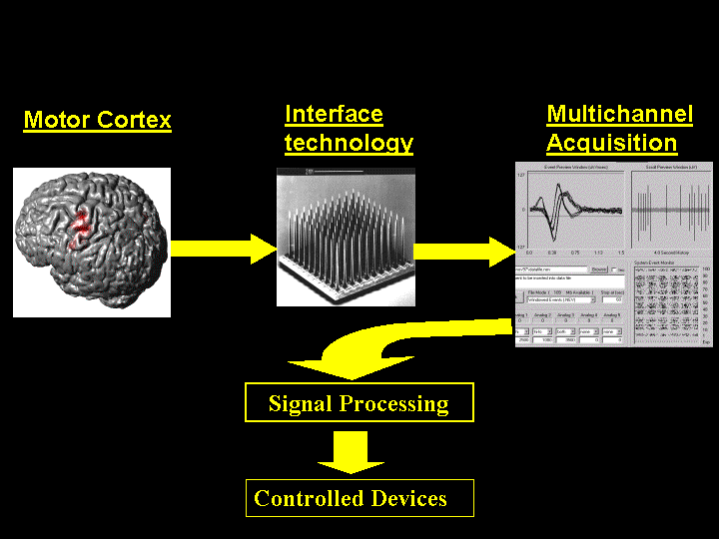

Fig 8. Various stages in working
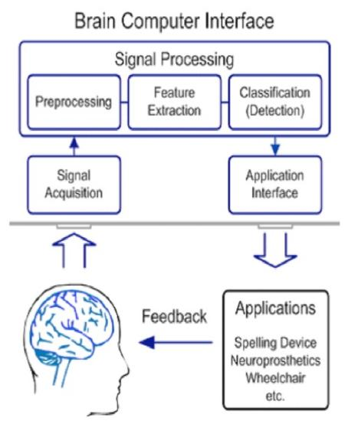

Fig 9. Brain Computer Interface-phases

Software behind BrainGate
In order to transmit and analyze signals, we require specialized software support for the BrainGate system. Since the BrainGate technology acts as a surrogate for the medical treatments which helps the differently-abled people to carry out their routine actions, just like any other people, we require an advanced software support for this. Softwares are necessary for transmission of the signals from the chip implanted on the brain to the machine and for decoding these signals and to converting it to corresponding action by the machine. The computers translate brain activity and create the communication output using custom decoding software. System uses adaptive algorithms and pattern-matching techniques to facilitate communication between the brain and machine.

The algorithms are written in languages like
- C,
- JAVA and
- MATLAB
WORKING OF THE SOFTWARE
The software is a BCI based on trials. A trial is a time interval where the user generates brainwaves to perform an action. The BCI tries to process this signal and to associate it to a given class. The association is done by feeding a neural net with the preprocessed EEG data. The neural net's output is then further processed and this final output corresponds to the given class. The neural net should be trained in order to learn the association.
The software allows you to
- Do simple Biofeedback. You can display raw EEG channels, narrow band frequency amplitudes and classes.
- Simulate trials.
- Record trials for a number of choices of different classes.
- Train the interface.
The software has three operating modes: SIMULATION, RECORDING and TRAINING. You can switch between operating modes by pressing F1, F2 or F3 respectively (the software doesn't change its mode instantly, because a trial shouldn't be interrupted in the middle).
The operation is quite simple. The user records several trials for the different classes (RECORDING mode). Each class is associated to a different mental task. After recording a reasonable amount of trials (more than 50 trials for each class), the user can train the system to learn a way to discriminate between the different classes (TRAINING mode). This process can be repeated in order to improve the quality of the recognition. The system can be tested under the SIMULATION mode. The detailed explanations of the different modes are as follows
SIMULATION AND RECORDING
These two modes perform single trials. The SIMULATION mode is used to test the BCI. RECORDING is the same as SIMULATION, with the difference that the EEG data is recorded and used as training examples. A trial has the following structure:
- Preparation: The BCI doesn't display anything but the EEG data and the features. The user can relax during this time
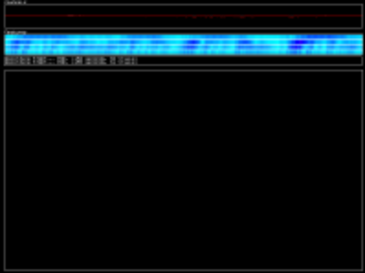
Fig 10. Screenshot of Preparation phase
- Prerecording: The BCI displays the target class by indicating a white target line. The user should start to perform the mental task associated to the target class, but the data isn't recorded yet.
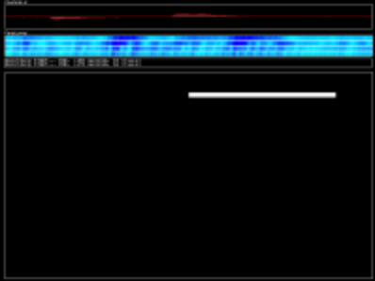
Fig 11. Screenshot of Prerecording phase
- Recording: The BCI displays the bars indicating which classes are recognized in each time instant. The EEG data is recorded (except in SIMULATION mode).
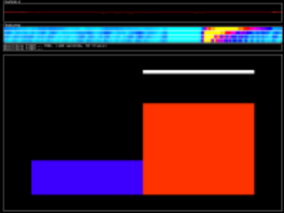
Fig 12. Screenshot of recording phase

TRAINING
Pressing the F3 key, the system starts to train the neural net with the available data. The training set used for this purpose is the set of the last Trial Buffer recorded trials' features. Training time depends upon the complexity of the training data and the amount of recorded data.
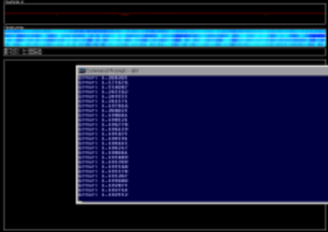
Fig 13. Screenshot of Training operation

BrainGate Research in Animals
Experiment on Rats:
Rats implanted with BCIs in Theodore Berger's experiments. Several laboratories have managed to record signals from monkey and rat cerebral cortexes in order to operate BCIs to carry out movement. Monkeys have navigated computer cursors on screen and commanded robotic arms to perform simple tasks simply by thinking about the task and without any motor output. Other research on rats has decoded visual signals.
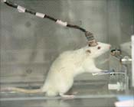

Fig 14. Rat Under Experiment
In 1999, researchers led by Garrett Stanley at Harvard University decoded neuronal firings to reproduce images seen by rats. The team used an array of electrodes embedded in the thalamus (which integrates all of the brain’s sensory input) of sharp-eyed rats. Researchers targeted 177 brain cells in the thalamus lateral geniculate nucleus area, which decodes signals from the retina. The rats were shown eight short movies, and their neuron firings were recorded. Using mathematical filters, the researchers decoded the signals to generate movies of what the rats saw and were able to reconstruct recognizable scenes and moving objects.

Experiment on Monkey:
Later experiments by Nicolelis using rhesus monkeys, succeeded in closing the feedback loop and reproduced monkey reaching and grasping movements in a robot arm. With their deeply cleft and furrowed brains, rhesus monkeys are considered to be better models for human neurophysiology than owl monkeys. The monkeys were trained to reach and grasp objects on a computer screen by manipulating a joystick while corresponding movements by a robot arm were hidden. The monkeys were later shown the robot directly and learned to control it by viewing its movements. The BCI used velocity predictions to control reaching movements and simultaneously predicted hand gripping force.
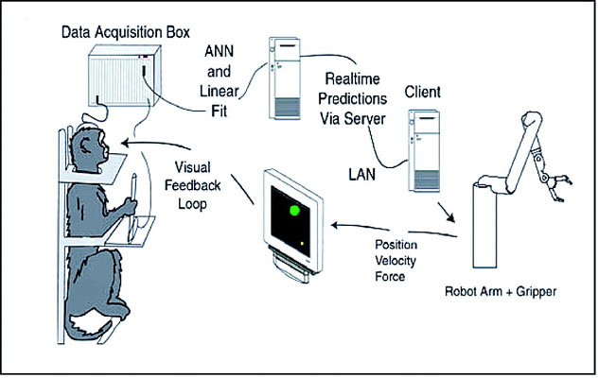

Fig 15. Experiment on Monkey
Other labs that develop BCIs and algorithms that decode neuron signals include John Donoghue from Brown University, Andrew Schwartz from the University of Pittsburgh and Richard Andersen from Caltech. These researchers were able to produce working BCIs even though they recorded signals from far fewer neurons than Nicolelis (15–30 neurons versus 50–200 neurons). Donoghue's group reported training rhesus monkeys to use a BCI to track visual targets on a computer screen with or without assistance of a joystick (closed-loop BCI). Schwartz's group created a BCI for three-dimensional tracking in virtual reality and also reproduced BCI control in a robotic arm.

Other Applications
In addition to the current patient portfolio, BrainGate is focused on the interpretation of neural recordings through software and neural network innovation. For example, a potential use of this would be study of neurological patterns in a patient with epilepsy.

MULTI DEVICE PATIENT AMBULATION SYSTEM
Various embodiments of an ambulation and movement assist system are helpful for those whose legs are paralyzed or their muscles involved in movement are affected. . For example, an ambulation system for a patient may comprise an exoskeleton device attached to the patient, an FES device at least partially implanted in the patient, and a biological interface apparatus. The biological interface apparatus comprises a sensor having a plurality of electrodes for detecting multi cellular signals, a processing unit configured to receive the multi cellular signals from the sensor, process the multi cellular signals to produce a processed signal, and transmit the processed signal to a controlled device. At least one of the exoskeleton device and the FES device is the controlled device of the biological interface apparatus. This helps the patient in achieving movement using these.

Biological interface system with surrogate controlled device
Various embodiments of a biological interface system and related methods are disclosed. The system may include a sensor comprising a plurality of electrodes for detecting multi cellular signals emanating from one or more living cells of a patient, and a processing unit configured to receive the multi cellular signals from the sensor and process the multi cellular signals to produce a processed signal. The processing unit may be configured to transmit the processed signal to a controlled device. The system further includes a first controlled device configured to send the processed signal, and a second controlled device configured to receive the processed signal. The first controlled device may provide feedback to the patient to improve control of the second controlled device.
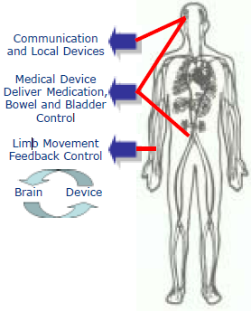

Fig 16. Potential Applications

Biological interface system with patient training apparatus
Various embodiments of a biological interface system and related methods are disclosed. The system may include a sensor having a plurality of electrodes for detecting multi cellular signals emanating from one or more living cells of a patient, and a processing unit configured to receive the multi cellular signals from the sensor and process the multi cellular signals to produce a processed signal. The processing unit may be configured to transmit the processed signal to a controlled device that is configured to receive the processed signal. The system may also include a patient training apparatus configured to receive a patient training signal that causes the patient training apparatus to controllably move one or more joints of the patient. The system may be configured to perform an integrated patient training routine to produce the patient training signal, to store a set of multi cellular signal data detected during a movement of the one or more joints, and to correlate the set of multi cellular signal data to a second set of data related to the movement of the one or more joints.

LIMB AND DIGIT MOVEMENT SYSTEM
The system comprises a biological interface apparatus and a joint movement device such as an exoskeleton device or FES device. The biological interface apparatus includes a sensor that detects the multi cellular signals and a processing unit for producing a control signal based on the multi cellular signals. Data from the joint movement device is transmitted to the processing unit for determining a value of a configuration parameter of the system. Also disclosed is a joint movement device including a flexible structure for applying force to one or more patient joints, and controlled cables that produce the forces required.
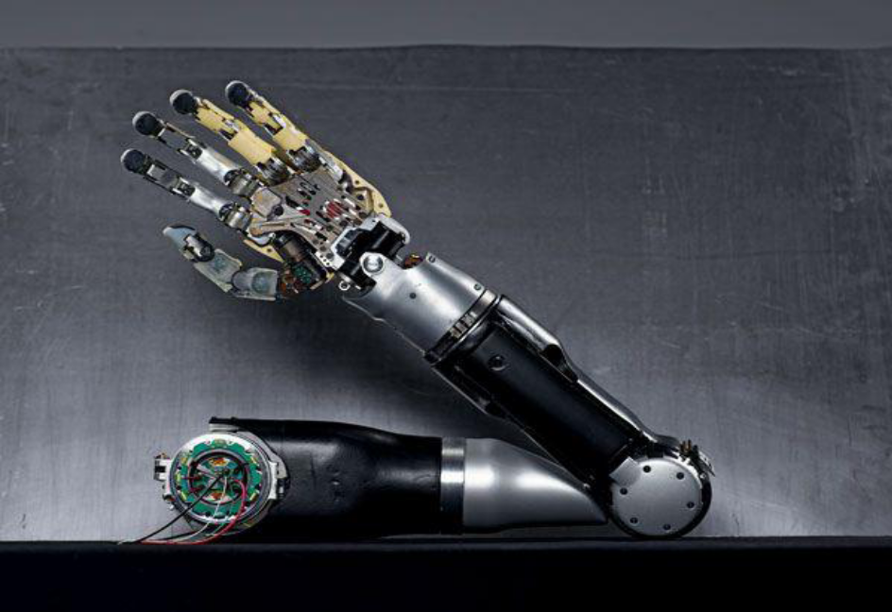
Fig 17. Controlling Robotic Arm

DARPA

The Brown University group was partially funded by the Defence Advanced Research Projects Agency (DARPA), the central research and development organisation for the US Department of Defence (DoD). DARPA has been interested in Brain-Machine-Interfaces (BMI) for a number of years for military applications like wiring fighter pilots directly to their planes to allow autonomous flight from the safety of the ground. Future developments are also envisaged in which humans could 'download' memory implants for skill enhancement, allowing actions to be performed that have not been learned directly.

THE MENTAL TYPEWRITER

Scientists demonstrated a brain-computer interface that translates brain signals into computer control signals. This application demonstrates how a paralyzed patient could communicate by using a mental typewriter alone without touching the keyboard. In the case of serious accident or illness, a patient’s limbs can be paralyzed, severely restricting communication with the outside world. The interface is already showing how it can help these patients to write texts and thus communicate with their environment. The person operating the mental typewriter uses the cursor to select a letters field. The next step reduces the choice, and after a few more steps we arrive at the individual letters, which can be used to write words. This process enables simple sentences to be constructed within minutes. A first prototype of the mental typewriter is currently available. In a series of experiments, different spelling methods are tested in terms of their usability and are adapted. It will be some years, though, before the mental typewriter can be used in everyday applications. Further research is needed, in particular to refine the EEG sensors.

Commercial BrainGate
Although the BrainGate technology system has been proven possible for real time implementation, it has not been released yet commercially. The commercial usage of this product would take another 3-5 years for its practical commercial release and use.

Advantages
- The BrainGate Neural Interface System is being designed to one day allow the user to interface with a computer and or other devices at a level of speed, accuracy and precision that is comparable to, or even faster than, what is possible with the hands of a non-disabled person.
- The BrainGate System may offer substantial improvement over existing assistive technologies. Currently available assistive devices have significant limitations for both the person in need and the caregiver. For example, even simple switches must be adjusted frequently, a process that can be time consuming.
- In addition, these devices are often obtrusive and may prevent the user from being able to simultaneously use the device and at the same time establish eye contact or carry on conversations with others.
- Potential advantages of the BrainGate System over other muscle driven or brain-based computer interface approaches include: its potential to interface with a computer without weeks or months of training; its potential to be used in an interactive environment, where the user's ability to operate the device is not affected by their speech, eye movements or ambient noise; and the ability to provide significantly more usefulness and utility than other approaches by connecting directly to the part of the brain that controls hand movement and gestures.

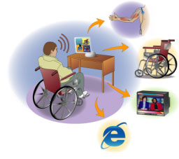
WITH A BRAINGATE YOU CAN:
- turn on or off the lights on your room
- Check and read E-mails
- Play games in computer
- Use your PC
- Watch and control your Television
- Control a robotic arm
Fig 18. Uses of BrainGate

Disadvantages
The disadvantage of the BrainGate System is that at this time, while still being perfected,
- The switches must be frequently adjusted which is a time consuming process. As the device is perfected this will not be an issue.
- There is also a worry that devices such as this will “normalize” society.
- The BrainGate Neural Interface System has not been approved by the FDA, but has been approved for IDE status, which means that it has been approved for pre-market clinical trials.
- Difficulty in adaptation and learning.
- Limitation in information transform rate. The latest technology is 20 bits/min.

Future Developments
In the future BrainGate system could be used by those individuals whose injuries are less severe. Next generation products may be able to provide an individual with the ability to control devices that allow breathing, bladder and bowel movements. New advances include second generation patient interface software that will enable users to perform a wide variety of daily activities without the assistance of the technician. Future development milestone of the BrainGate system also include a wireless interface between the implanted server and the computer.

Conclusion
The idea of connecting a computer to a brain is not new. As early as the 1950s it was possible to implant single or multiple electrodes into the cortex of humans and animals for recording or stimulation. The result was sometimes spectacular "control" of an animal’s motor behavior or attempted influence of neurological disorders. With the worldwide introduction of computers, and ongoing miniaturization, several research groups have started to look into the potential applicability of such BMIs, BCIs, or neural prostheses for use in patients. These devices, by extracting signals directly from the brain, might help to restore abilities to patients who have lost sensory or motor function because of disease or injury. In essence, the computer is used as a surrogate for the damaged region (e.g. the spinal cord in quadriplegic patients) and, in the case of a neuromotor prosthesis, acts to interpret brain signals and drive the appropriate effecter (e.g., muscles or a robotic arm). We shouldn’t speak about humans and machines anymore but rather of cognitive systems, where humans and machines are a part of the intelligence. We could say that the BrainGate can’t work without a human brain and the human brain (for someone who is paralysed) can’t function without the BrainGate system. In this way the human and the machine are interacting with each other and create together an intelligent system. By this system a person can work with a computer just by thoughts.

References
- www.howstuffworks.com
- “Cyberkinetics - Neurotechnology Systems, Inc.: BrainGate™ Neural Interface System” Cyberkinetics Neurotechnology Systems, Inc. 2005 www.cyberkineticsinc.com/content/medicalproducts/BrainGate.jsp
- “Brain computer Interfaces: where Human and Machine meet”, Published by IEEE Computer Society, IEEE 2007.
- “Real-world Applications for Brain-Computer Interface Technology”, Melody M.Moore, IEEE Transactions on Neural Systems and Rehabilitation Engineering, June 2003.
- http://www.en.wikipedia.com/braincomputerinterface
- www.scribd.com
- www.youtube.com
- "Brain Computer Interface Technology." Emotiv, 2009. 03 Mar. 2010. <http://www.emotiv.com/index.php>.
- “Brain Computer Interface”,Wikipedia,03 Mar 2010.
<http://en.wikipedia.org/wiki/Brain%E2%80%93computer_interface>.
- “BrainGate”,Wikipedia, 02 Feb 2010.
<http://en.wikipedia.org/wiki/BrainGate>.

