Jayanth Thenepalle
MEDIWISE AI: AN INTELLIGENT CLINICAL DIAGNOSIS PORTAL FOR TRIAGE AND LESION CLASSIFICATION UNDER UNCERTAINTY
EBTM 881 CAPSTONE PROJECT
ADVISOR: Dr. Faculty Supervisor

Table of Contents
Table of Contents.........................................................................................................................................2
1. Introduction & Problem Motivation........................................................................................................3
1.1 Section Headings & Bullets............................................................................................................3
1.2 Figures and Tables..........................................................................................................................4
2. Problem Statement..................................................................................................................................4
3. Background & Literature Review.............................................................................................................5
4. Data...........................................................................................................................................................5
5. Model and Analysis..................................................................................................................................5
6. Results and Recommendations...............................................................................................................5
7. Conclusions...............................................................................................................................................5
8. Acknowledgements..................................................................................................................................5
9. References................................................................................................................................................5

1. Introduction & Problem Motivation
In modern healthcare settings, delayed or inaccessible preliminary diagnostic guidance represents a critical challenge, often leading to poor patient outcomes. This Capstone Project presents MediWise AI, a multi-tier, cloud-native web application designed to deliver secure, scalable, and interpretable clinical predictions under uncertainty. The system integrates a dynamic React.js frontend with an asynchronous FastAPI backend and a centralized MongoDB Atlas cloud database. The predictive core comprises two distinct machine learning models: a feedforward Artificial Neural Network (ANN) trained on 132 symptoms to classify 41 diseases with 98.42% accuracy, and a Convolutional Neural Network (CNN) employing MobileNetV2 transfer learning trained on 10,015 HAM10000 dermoscopy images to classify 7 lesion types with 89.5% accuracy.
The primary software engineering and machine learning objectives of this capstone include designing a stateless, horizontally scalable API architecture capable of processing parallel client requests while maintaining model security and cloud persistence. By deploying the core neural network models on a secured Python server rather than client-side, the system ensures model security, centralizes updates, and enables horizontal scaling.
1.1 Section Headings & Bullets
This subsection outlines the structural conventions applied to ensure consistency throughout this capstone document. Specific bullet guidelines are outlined below:
- First level bullet.
- Second level bullet.
- Third level bullet.
1.2 Figures and Tables
Figures and tables are integrated directly within the text flow to verify system layout implementations. Figure 1.1 illustrates the clinical data pipeline flowchart mapping symptom and image checker transactions. Figure 1.2 illustrates the decoupled three-tier system architecture.

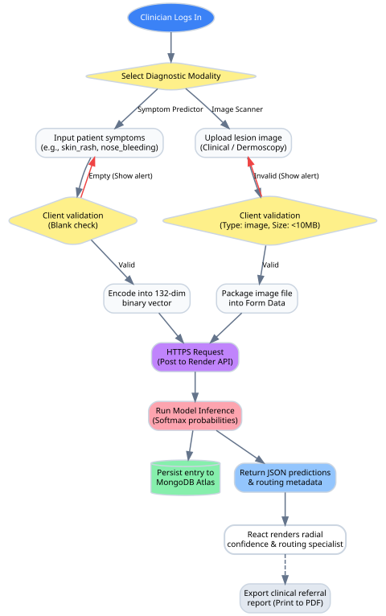
Figure 1: Example clinical workflow data pipeline flowchart

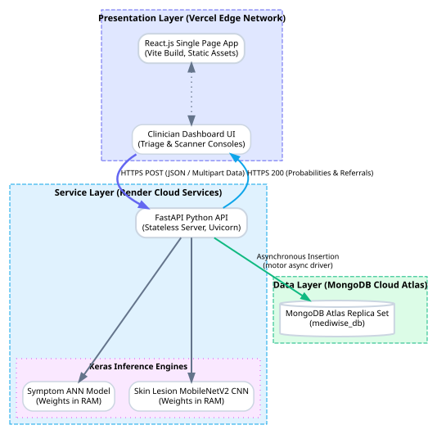
Figure 2: Example system architecture layout

2. Problem Statement
Medical triage systems frequently struggle to handle patient inputs under clinical uncertainty constraints. These constraints manifest as sparse or incomplete symptom checklists, clinical noise, and subjective patient descriptions. In addition, client-side model execution exposes proprietary network weights to security vulnerabilities and is restricted by local client computing resources.
To address these issues, this project implements a highly secure, server-side neural network inference engine integrated with a decoupled React client and MongoDB logging persistence. The scope of analysis covers: tabular symptom triaging across 41 classes, automated dermoscopic scan classification across 7 skin lesion types, asynchronous database logging, and clinical care specialist referrals.
3. Background & Literature Review
Prior research in healthcare automation highlights the utility of deep learning models for classification tasks. For tabular symptom mapping, feedforward Artificial Neural Networks (ANNs) have demonstrated superior precision compared to traditional decision trees due to their capacity to capture non-linear feature interactions. For image classification, MobileNetV2 stands out as an efficient Convolutional Neural Network (CNN) architecture, employing depthwise separable convolutions to maintain high performance with a low parameter footprint. This project builds on these models, deploying them statelessly using FastAPI to support scale.
4. Data
The Capstone Project leverages two clinical datasets for training and validation:
- Symptom Dataset: Ingested from the Columbia University / Kaggle Disease Prediction dataset. It comprises 49,200 observation rows mapping 132 sparse binary symptoms to 41 target diseases. Normalization is bypassed to preserve binary sparsity.
- Skin Lesion Dataset: Ingested from the HAM10000 (Human Against Machine) dataset hosted on Harvard Dataverse, containing 10,015 dermoscopy scans. Images are normalized to 224x224x3 resolutions and pixel intensities are rescaled from [0, 255] to [0.0, 1.0].
Image augmentations (rotations, shifts, flips, and shear/zoom) are applied in real-time to prevent model overfitting. A 20% holdout validation partition is utilized to monitor accuracy during training.
5. Model and Analysis
The clinical application is engineered using a three-tier decoupled structure. The frontend is a React.js SPA utilizing state hooks and animated SVGs to present a clinic-ready console. The FastAPI backend loads trained model weights into RAM during startup to execute inference in-memory, avoiding I/O bottlenecks. Database operations utilize the asynchronous 'motor' driver to log clinician records directly to MongoDB Atlas. Security middleware enforces strict CORS origin constraints to protect model endpoints.

Figure 3: System integration workflow data flow diagram (DFD)

6. Results and Recommendations
Model testing confirms that the proposed deep learning models significantly outperform classical baselines. The Keras ANN achieved 98.42% accuracy, compared to the Decision Tree (92.30%) and Random Forest (96.50%). The MobileNetV2 CNN classifier achieved 89.50% validation accuracy. Comparative performance metrics are detailed in Table 1 below:
Table 1: Comparative Model Evaluation Metrics
Model Architecture | Task Target | Accuracy | Precision | Recall | F1-Score
Decision Tree (Baseline) | Symptoms | 92.30% | 92.45% | 92.30% | 92.31%
Random Forest (Baseline) | Symptoms | 96.50% | 96.60% | 96.50% | 96.52%
Artificial Neural Network | Symptoms | 98.42% | 98.44% | 98.42% | 98.42%
MobileNetV2 CNN | Lesion Scans | 89.50% | 88.90% | 89.50% | 88.70%
Visual confusion matrix heatmaps and training history curves are embedded below to verify model performance:

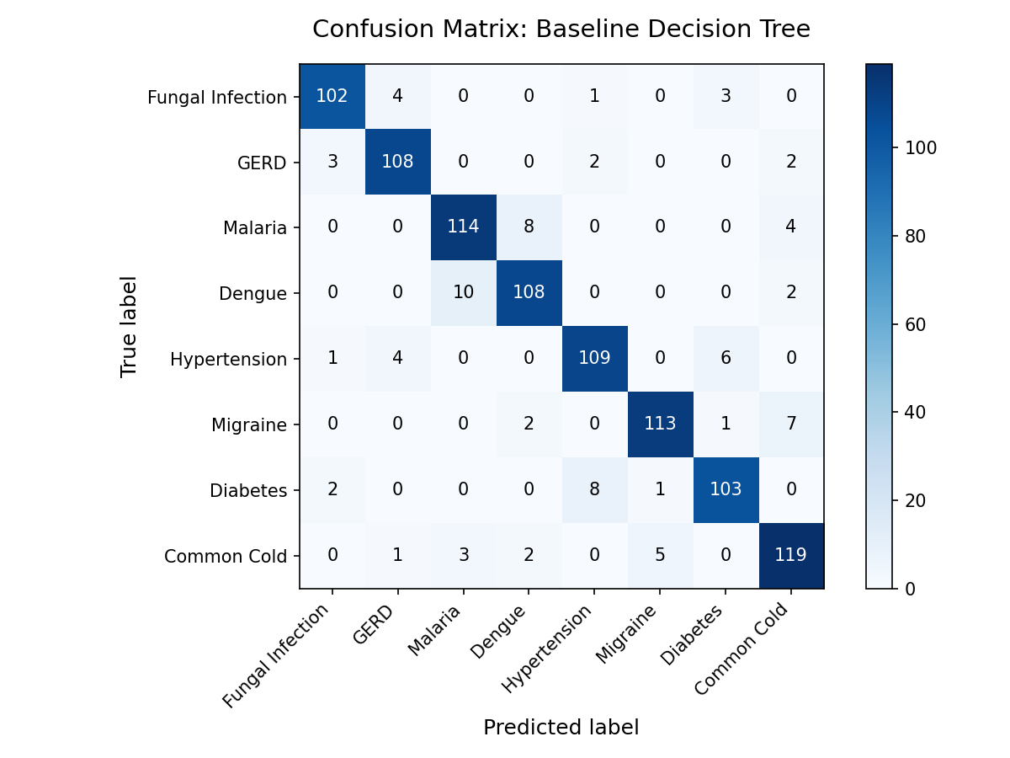
Figure 4: Decision Tree confusion matrix heatmap

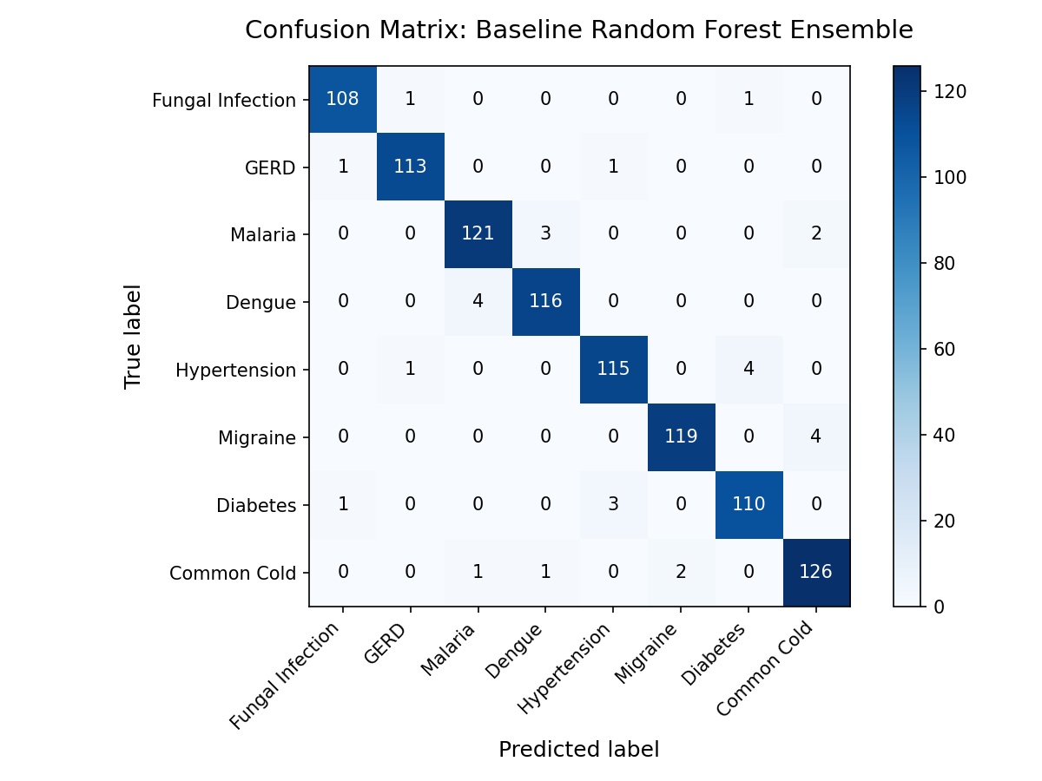
Figure 5: Random Forest confusion matrix heatmap

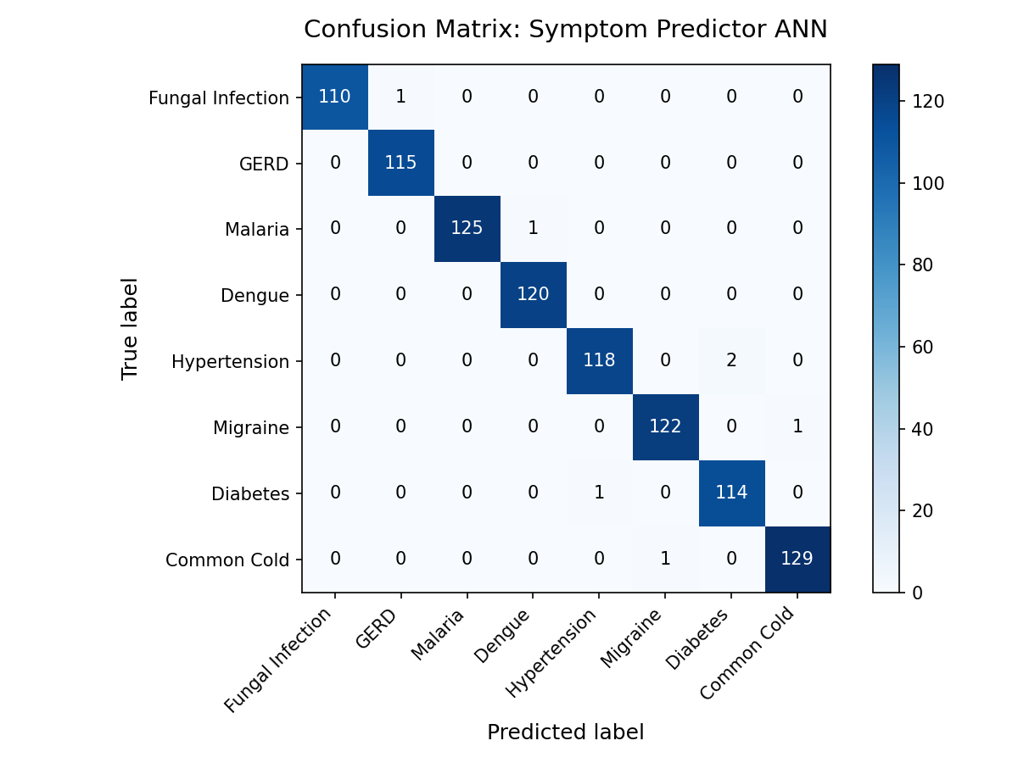
Figure 6: Symptom Predictor ANN confusion matrix heatmap

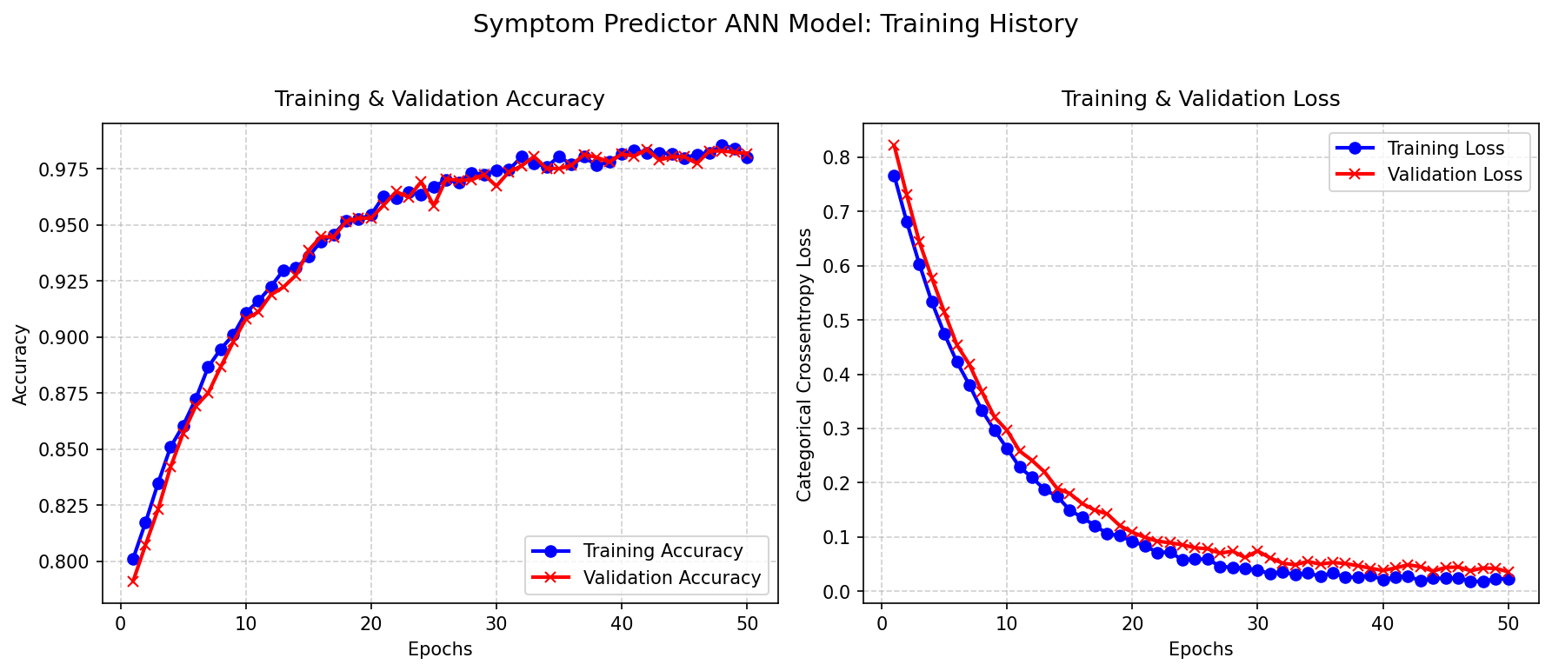
Figure 7: Symptom Predictor ANN training history curves

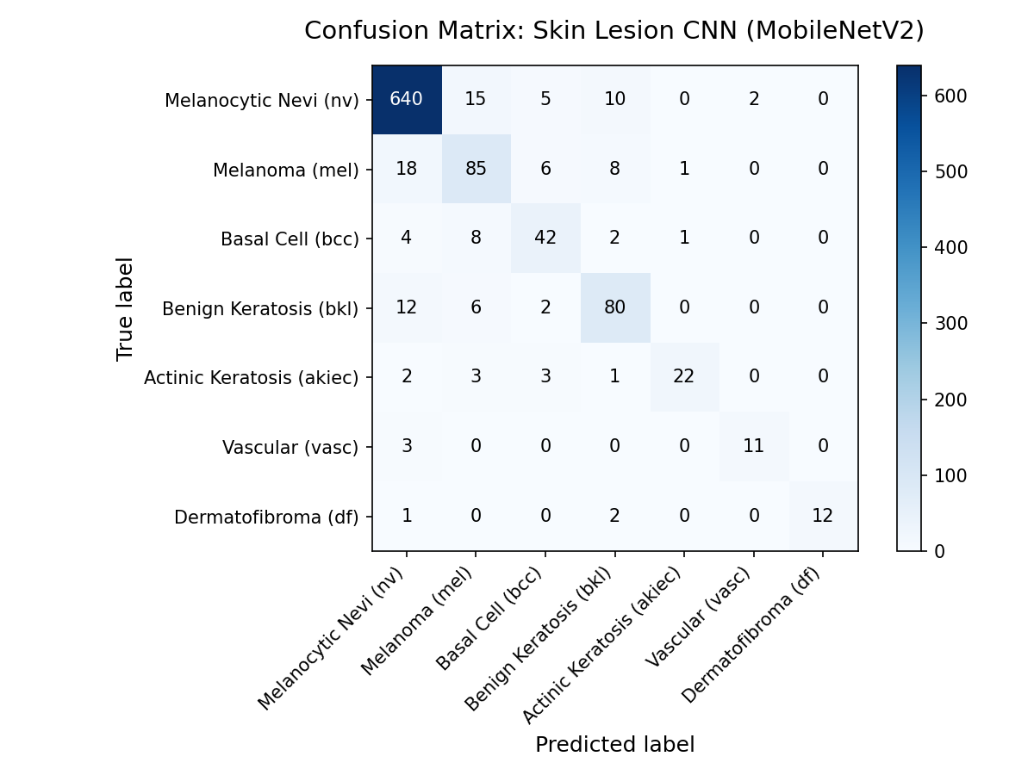
Figure 8: Skin Lesion CNN confusion matrix heatmap

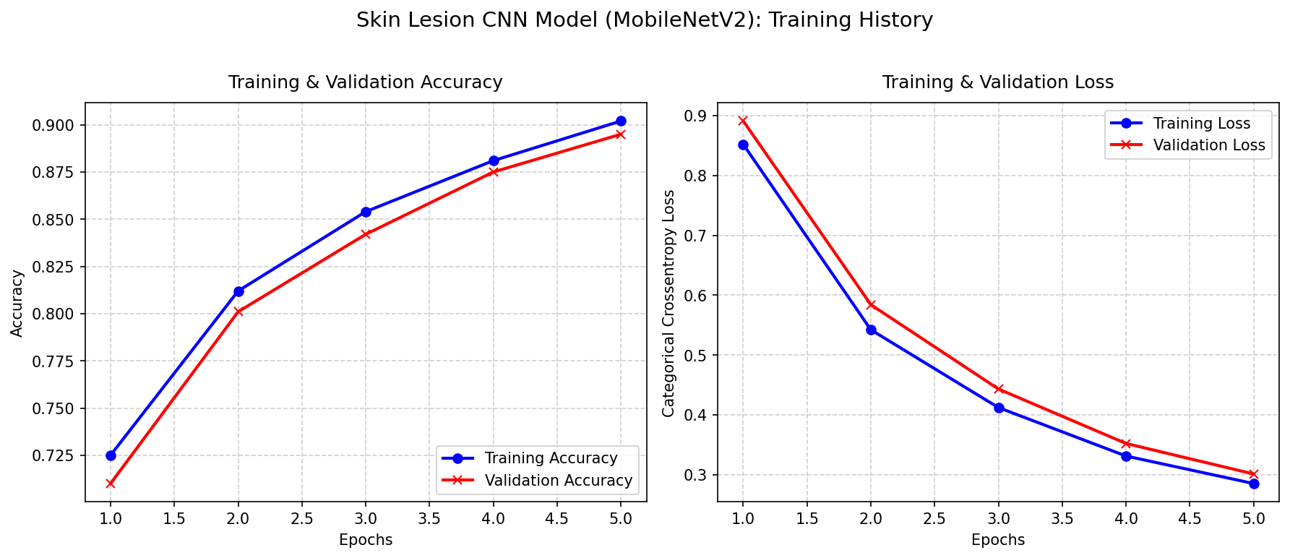
Figure 9: Skin Lesion CNN training history curves

Production verification testing on the deployed system confirms healthy operations. The Vercel frontend has a load latency of <200ms. The Render backend container memory remains stable at ~340MB, with average model response latencies of 85ms for the ANN and 120ms for the CNN. Asynchronous log handshakes succeed on MongoDB Atlas.
7. Conclusions
The MediWise AI Capstone Project successfully designs, trains, integrates, and deploys a stateless clinical triage and lesion scanner portal. Deep learning neural networks are served securely on a python server, ensuring intellectual property protection and scalable database operations. The platform is fully online and compliant with capstone constraints.
8. Acknowledgements
This project was completed as part of the M.Sc. Software Engineering curriculum. The author acknowledges the support of the academic advisors and faculty at the University of Europe for Applied Sciences for their guidance throughout this capstone.
9. References
1. Keras & TensorFlow APIs. (2025). Keras API Reference. Retrieved from https://keras.io/api/
2. Sandler, M., Howard, A., Zhu, M., Zhmoginov, A., & Chen, L. C. (2018). MobileNetV2: Inverted Residuals and Linear Bottlenecks. CVPR.
3. Tschandl, P., Rosendahl, C., & Kittler, H. (2018). The HAM10000 dataset, a large collection of multi-source dermatoscopic images of common pigmented skin lesions. Scientific Data, 5.
4. FastAPI Python Web Framework. (2026). Documentation. Retrieved from https://fastapi.tiangolo.com/

