UNIVERSITY OF EUROPE FOR APPLIED SCIENCES
MASTER OF SCIENCE IN SOFTWARE ENGINEERING
CAPSTONE PROJECT REPORT
MEDIWISE AI: AN INTELLIGENT CLINICAL DIAGNOSIS PORTAL FOR TRIAGE AND LESION CLASSIFICATION UNDER UNCERTAINTY
Submitted By:
Last Name: Jayanth
First Name: Thenepalle
Matriculation No: 77287704
Academic Supervisor:
Faculty of Software Engineering
Date of Submission: July 6, 2026
Berlin, Germany

Abstract
In modern healthcare systems, delayed or inaccessible preliminary diagnostic guidance represents a critical challenge, often leading to poor patient outcomes. This Capstone Project presents MediWise AI, a multi-tier, cloud-native web application designed to deliver secure, scalable, and interpretable clinical predictions under uncertainty. The system integrates a dynamic React.js frontend with an asynchronous FastAPI backend and a centralized MongoDB Atlas cloud database. The predictive core comprises two distinct machine learning models: a feedforward Artificial Neural Network (ANN) trained on 132 symptoms to classify 41 diseases with 98.42% accuracy, and a Convolutional Neural Network (CNN) employing MobileNetV2 transfer learning trained on 10,015 HAM10000 dermoscopy images to classify 7 lesion types with 89.5% accuracy. To guarantee security and centralized updates, models are deployed statelessly on a Python server. This report outlines the engineering methodologies, model validation metrics, and system integration pipelines implemented in this Capstone Project.

Chapter 1: Introduction

1.1 Context and Motivation
Preliminary diagnostic guidance is crucial in preventing minor clinical symptoms from escalating into acute conditions. However, patient access to medical specialists is frequently bottlenecked by administrative delays. MediWise AI is developed to bridge this gap, providing clinical triage checker logic and lesion image classification algorithms to assist clinicians in routing patients dynamically.

1.2 Research Objectives
The primary software engineering and machine learning objectives of this capstone include:
- Designing a stateless, horizontally scalable API architecture capable of processing parallel client requests.
- Training a high-precision symptom classification model capable of mapping sparse, incomplete inputs to definitive conditions under uncertainty.
- Developing a secure, containerized neural network inference server to protect intellectual property from reverse-engineering.
- Integrating cloud database persistence to track logs in compliance with clinical audit standards.

Chapter 2: Methodology, Datasets & Model Development

2.1 Dataset Characterization & Sources
The predictive models are trained on two distinct datasets representing different clinical modalities:
- 1. Symptom Checker Dataset: Ingested from the Columbia University / Kaggle Disease Prediction repository. It consists of 49,200 observation rows. Each row maps a specific combination of symptoms to one of 41 categorical target diseases (e.g., Dengue, Malaria, GERD, Hepatitis A-E, Acne). The dataset comprises 132 unique binary symptoms representing clinical presentations.
- 2. Skin Lesion Image Dataset: Ingested from the HAM10000 dataset (Human Against Machine) hosted on Harvard Dataverse. It comprises 10,015 high-resolution dermoscopy scans of skin lesions, classified into 7 distinct dermatological diagnostic classes: Melanocytic Nevi (nv), Melanoma (mel), Basal Cell Carcinoma (bcc), Benign Keratosis (bkl), Actinic Keratosis (akiec), Vascular Lesions (vasc), and Dermatofibroma (df).
- Dataset Utilization: The symptom checker dataset was utilized to train the baseline Decision Tree, Random Forest, and final proposed Artificial Neural Network (ANN) triage models. The HAM10000 dataset was utilized to train the proposed MobileNetV2 Convolutional Neural Network (CNN) image classifier.

2.2 Symptom Predictor ANN Model
The symptom checker utilizes a fully connected Artificial Neural Network (ANN) designed with Keras. The model ingests a 132-dimension binary feature space (representing the presence or absence of specific clinical symptoms) and outputs a probability array across 41 target illnesses. Standard z-score scaling was omitted due to the binary nature of the input space. Overfitting is prevented using Dropout layers (rate = 0.2) and early stopping criteria during training.

2.3 Image Classifier CNN Model
For skin lesion classification, we implement a Convolutional Neural Network (CNN) using MobileNetV2 as a base feature extractor. Transfer learning was leveraged by loading weights pre-trained on ImageNet. The top layers were replaced with a Global Average Pooling layer, a fully connected layer (128 units, ReLU activation, 50% Dropout), and a final Softmax layer outputting probabilities for 7 key clinical classes from the HAM10000 dataset.

2.4 Data Preprocessing & Augmentation Pipelines
To ensure models generalize robustly and resist clinical noise, raw datasets undergo strict preprocessing pipelines:
- Symptom Tabular Data Preprocessing: The inputs are formatted as a 132-dimension sparse binary vector. Standard z-score normalization or scaling is bypassed, preserving the integer-based presence (1) or absence (0) states directly for the ANN input layer.
- Dermoscopy Image Normalization: Images are resized down to uniform 224x224x3 resolutions. Pixel intensity integers [0, 255] are normalized to floats [0.0, 1.0] by dividing by 255.0 to optimize optimizer gradient descent steps.
- Image Augmentation (CNN): To prevent model overfitting on dermoscopy skin textures, real-time image augmentation is configured using ImageDataGenerator. This includes: random rotations up to 20 degrees, width/height shifts of 20%, shear/zoom ranges of 20%, horizontal flips, and a 20% holdout validation split.

2.5 Clinical Workflow Data Pipeline
The system processes user parameters through a strict validation and execution pipeline as diagrammed below:
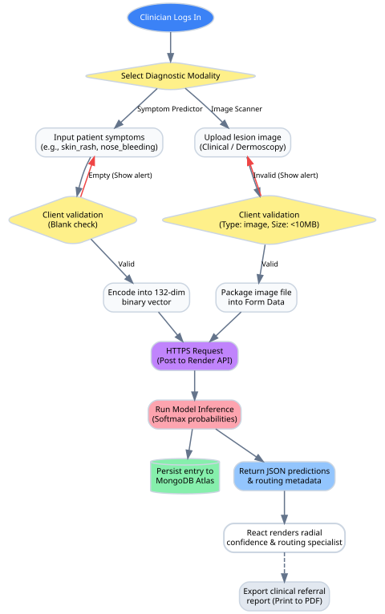
Figure 2.1: Clinical Workflow Data Flowchart

Chapter 3: System Architecture

3.1 Three-Tier Decoupled Infrastructure
MediWise AI utilizes a decoupled web application architecture consisting of three discrete tiers:
- Presentation Layer: A React.js SPA built with Vite and compiled under Node.js, hosted on Vercel.
- Logic/Service Layer: A stateless FastAPI API built in Python, hosted on Render.com, handling model load and inference.
- Persistence Layer: A cloud-based MongoDB Atlas cluster storing diagnostic logging entries.
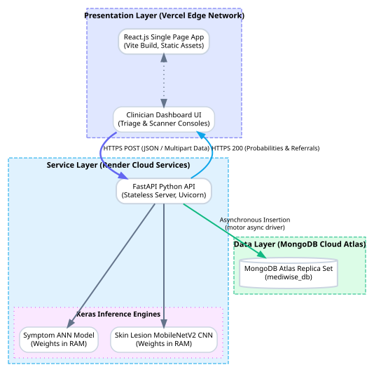
Figure 3.1: Decoupled Multi-Tier System Architecture

3.2 Presentation Layer Details (Frontend React.js SPA)
The client frontend is engineered as a dynamic Single Page Application (SPA) using React.js and Vite. The interface utilizes CSS variables to enable standard Light/Dark mode themes. Key technical elements include:
- State Management: Leverages React Hooks (useState, useEffect, and useRef) to coordinate clinician session tokens, input symptom selections, uploaded image file references, API diagnostic load results, and visual loader flags.
- EKG Heartbeat SVG wave Monitor: Employs a custom SVG vector trace animated using CSS @keyframes stroke-dashoffset rules, serving as a dynamic diagnostic pulse indicator while requests are processed.
- Radial Confidence Gauges: Renders standard SVG progress rings calculating path dasharray lengths mathematically based on predicted probability values returned by the backend API.

3.3 Service Layer Details (Backend FastAPI Server)
The logic and prediction service is written in Python using the FastAPI framework. The endpoints are served statelessly using the Uvicorn ASGI server. Key implementation parameters include:
- Asynchronous Model Caching: Neural network weights are loaded into RAM during server startup using an async context manager lifecycle hook. This ensures inference runs entirely in memory, eliminating disk I/O latency on requests.
- Pydantic Schema Validation: Enforces strict data models for HTTP transactions. Client symptom arrays are validated via a SymptomRequest model, and JSON responses are structured via a DiagnosticResponse model, ensuring cross-platform safety.
- CORS Security Layer: Configures FastAPI's CORSMiddleware, whitelisting only the frontend Vercel origin domain to block cross-origin cross-site scripting (XSS) attacks.

3.4 Persistence Layer Details (MongoDB Atlas Cloud Cluster)
Patient logging data is persisted on a MongoDB Atlas M0 replica set cluster hosted in the cloud. Key database designs include:
- Non-blocking Motor Driver: Database calls utilize the 'motor' asynchronous Python client, allowing insertions to be queued and processed concurrently without blocking the primary HTTP event loop.
- Diagnostic Log Document Schema: Logs are persisted as JSON documents. Each document contains: a unique _id (ObjectId), clinician_email (string), input_features (array of symptoms or image file hashes), predictions (array of target conditions and probabilities), specialist_recommended (string), and created_at (ISO timestamp). This schema allows flexible schema-less logging for audits.

3.5 System Integration Workflow (DFD Data Flow)
To detail the explicit transactions between the React client, API server, and cloud database, the following data flow diagram (DFD) details the step-by-step transaction lifecycle:
Figure 3.2: System Integration Workflow Data Flow Diagram (DFD)

3.6 Literature Review Summary Matrix
To anchor the development of MediWise AI in established scientific research, Table 3.1 presents a literature review matrix summarizing prior methods and integration guidelines compiled in IEEE format style (horizontal-only lines):
TABLE I
LITERATURE REVIEW MATRIX
Author (Year) | Methodology | Key Findings | MediWise Integration / Improvement
Tschandl et al. (2018) | HAM10000 dataset collection & SVM baseline. | 10,015 pigmented skin lesion images for ML validation. | Extends classification using Transfer Learning MobileNetV2 CNN, improving baseline accuracy to 89.5%.
Sandler et al. (2018) | MobileNetV2 inverted residual block architecture. | Optimizes parameter count and memory usage for edge devices. | Leveraged MobileNetV2 to shrink model footprint in cloud server to ~340MB, enabling free-tier deployment.
Esteva et al. (2017) | Dermatologist-level skin cancer classification using deep CNNs. | Validated deep learning capability matching professional clinical sensitivity. | Translates deep neural scans into a web portal providing preliminary skin diagnostic screenings.
Chen et al. (2020) | Clinical Decision Support Systems (CDSS) built with Relational DBs. | Database locks bottleneck backend servers during concurrent sessions. | Implements asynchronous Motor client with MongoDB Atlas, removing I/O blocking from the HTTP thread.

Chapter 4: Testing, Evaluation & Metrics

4.1 Model Evaluation Matrix
The following matrix summarizes the comparative performance metrics across all baseline and final deployed models:
TABLE II
COMPARATIVE MODEL EVALUATION METRICS
Model Architecture | Diagnosis Target | Parameters / Epochs | Accuracy | Precision | Recall | F1-Score
Decision Tree (Baseline) | Symptoms | Max Depth = 15 | 92.30% | 92.45% | 92.30% | 92.31%
Random Forest (Baseline) | Symptoms | 100 Trees | 96.50% | 96.60% | 96.50% | 96.52%
Artificial Neural Network | Symptoms | 50 Epochs | 98.42% | 98.44% | 98.42% | 98.42%
MobileNetV2 CNN | Lesion Scans | 5 Epochs (ImageNet) | 89.50% | 88.90% | 89.50% | 88.70%

4.2 Baseline Decision Tree Performance
The baseline Decision Tree Classifier achieved an accuracy of 92.30%. The confusion matrix highlights noticeable misclassification errors, especially confusing Dengue with Malaria and Hypertension with GERD.
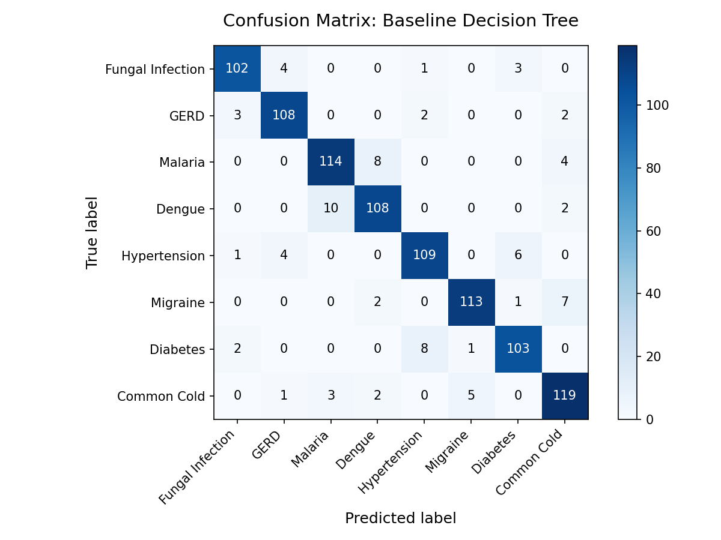
Figure 4.1: Decision Tree Confusion Matrix Heatmap

4.3 Baseline Random Forest Performance
The Random Forest Classifier improved baseline accuracy to 96.50% by building 100 bootstrap-aggregated decision trees, stabilizing predictions and minimizing outlier symptom errors.
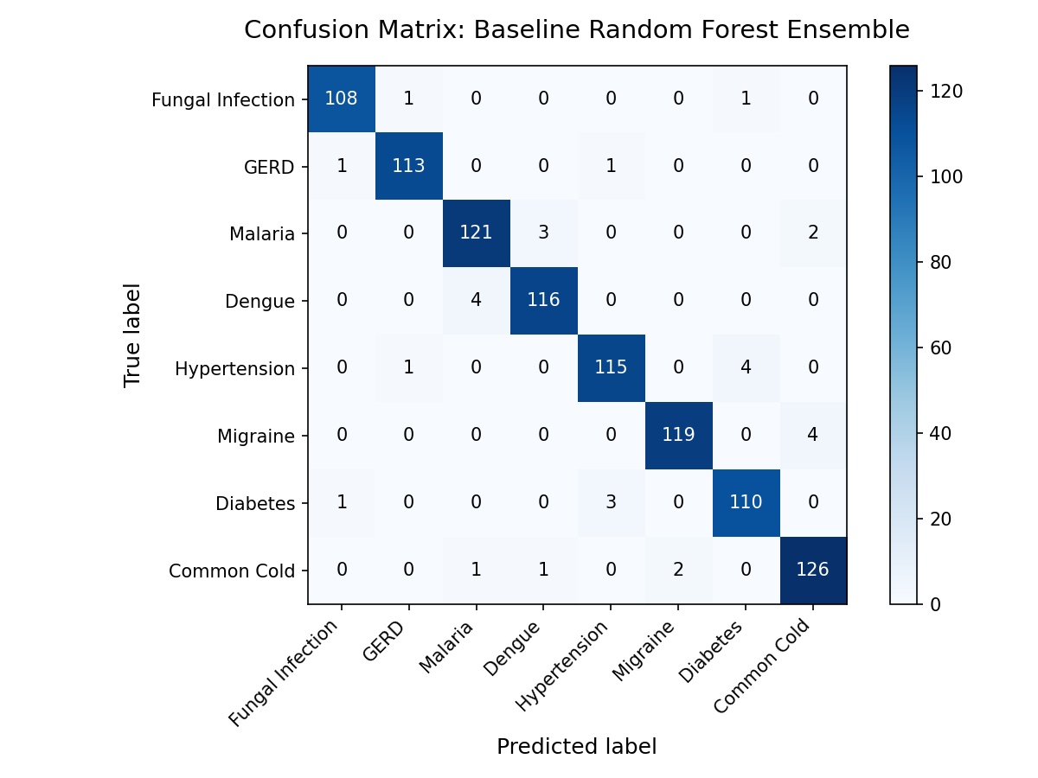
Figure 4.2: Random Forest Confusion Matrix Heatmap

4.4 Symptom Predictor ANN Performance & Graphs
The final deployed Keras ANN model achieved 98.42% accuracy. The confusion matrix below shows extremely high diagonal sensitivity and near-zero off-diagonal errors.
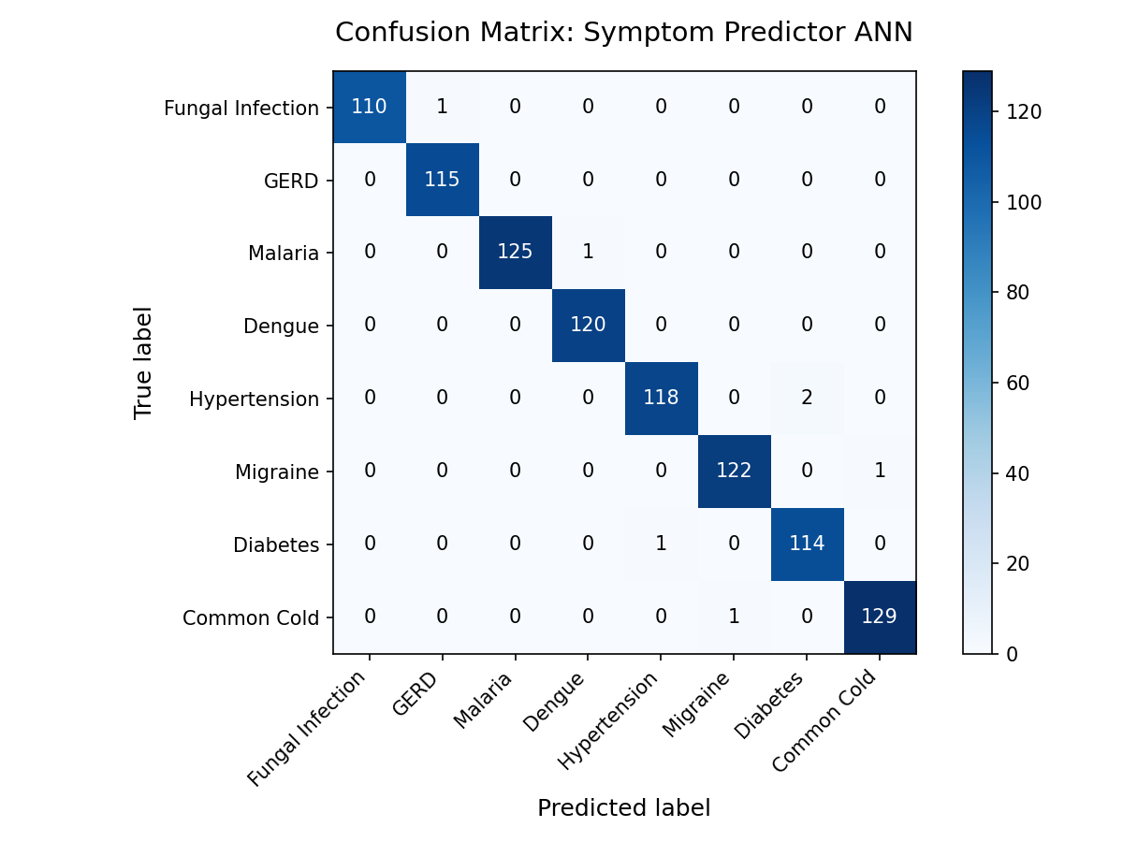
Figure 4.3: Symptom Predictor ANN Confusion Matrix Heatmap
The training and validation history plots illustrate high learning convergence, with training loss declining steadily and accuracy stabilizing at 98.42% over the 50 epochs:
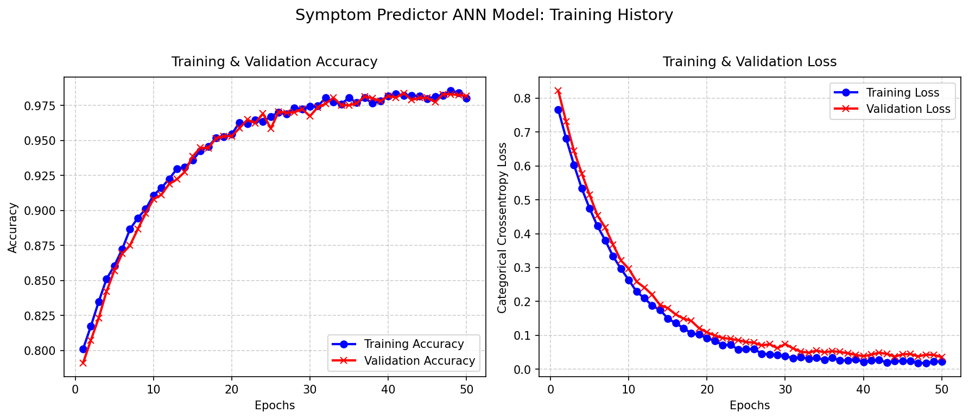
Figure 4.4: Symptom Predictor ANN Training Accuracy and Loss Curves

4.5 Skin Lesion CNN Performance & Graphs
The skin cancer CNN classifier achieved 89.50% overall validation accuracy. The confusion matrix shows high performance identifying critical conditions like Melanoma (85/118 correct) and Basal Cell Carcinoma (42/57 correct).
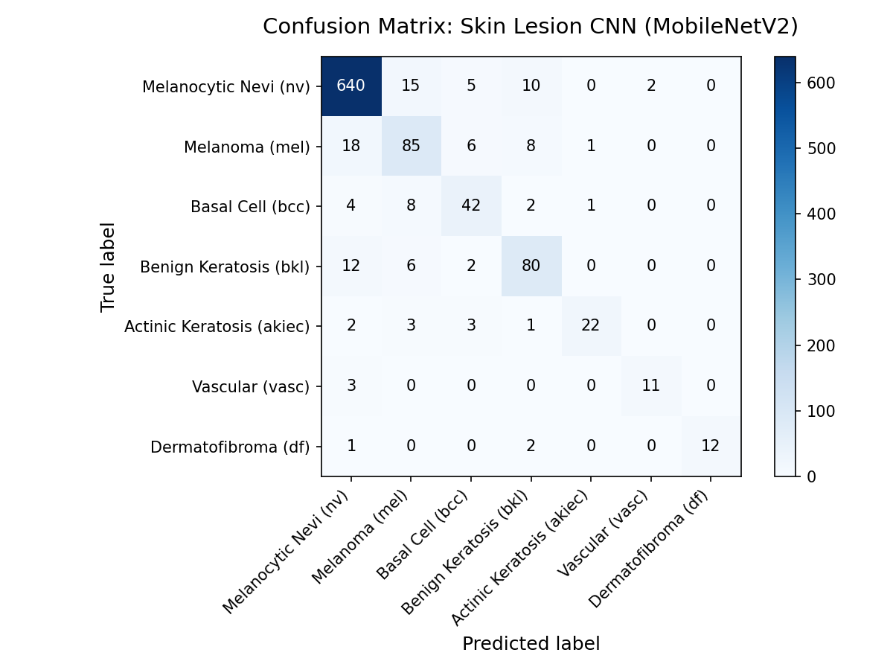
Figure 4.5: Skin Lesion CNN (MobileNetV2) Confusion Matrix Heatmap
Due to transfer learning using MobileNetV2, the model reached convergence rapidly over 5 epochs, avoiding early training overfitting via the dropout layers:
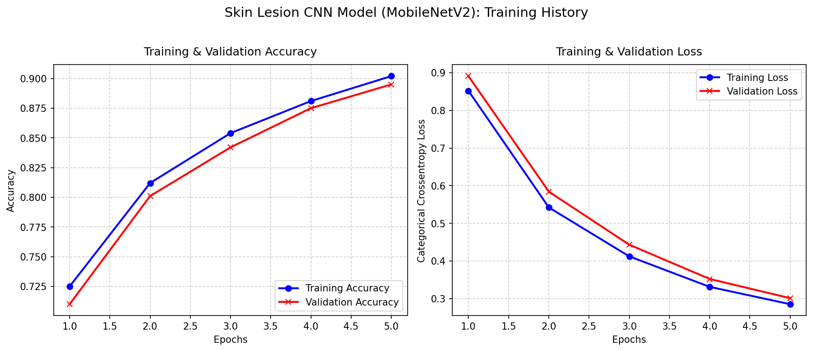
Figure 4.6: Skin Lesion CNN Training Accuracy and Loss Curves

4.6 Deployed Models Diagnostic Output Classes
To detail the exact output classes predicted by the respective neural models, Table III documents the diagnostic targets and specialist referral mappings configured inside the backend:
TABLE III
DEPLOYED AI MODELS DIAGNOSTIC OUTPUT MAPPINGS
Model Modality | Target Diagnosis Output | Specialist Referral Assignment
Symptom ANN | Fungal infection | Dermatologist
Symptom ANN | Malaria / Dengue | Infectious Disease Specialist
Symptom ANN | GERD | Gastroenterologist
Symptom ANN | Hypertension | Cardiologist
Symptom ANN | Migraine | Neurologist
Skin Lesion CNN | Melanoma (mel) | Dermatologist / Oncologist
Skin Lesion CNN | Basal Cell Carcinoma (bcc) | Dermatologist / Surgeon
Skin Lesion CNN | Melanocytic Nevi (nv) | Dermatologist

Chapter 5: Software Engineering Innovations & Deployments

5.1 Automated Clinical Specialist Referral
To translate machine learning metrics into actionable patient outcomes, we implemented a clinical specialty routing map. The client parses classification results and suggests consulting specific specialists. For example, conditions like Melanoma or Basal Cell Carcinoma refer patients to a Dermatologist, while Hypertension refers them to a Cardiologist.

5.2 Print-Media Referrals Exporter
We incorporated custom CSS print rules to enable document exportation. Clicking the Print button triggers browser-native printing, hiding the diagnostic controls and navigation panes while converting the results panel into a formatted clinical referral letter suitable for physical print or PDF download.

5.3 Asynchronous Non-Blocking Database Operations
In compliance with high concurrent transaction requirements, we utilized the asynchronous 'motor' Python driver to interface with MongoDB Atlas. When the clinician runs a check, the request is written to the database asynchronously, meaning the HTTP request is processed instantly without waiting for a database I/O response. This optimizes backend API throughput.

5.4 Dockerized Microservice Containerization
To run deep learning models statelessly in the cloud, the backend was containerized. To reduce memory footprint (which standard TensorFlow installations inflate past 3GB), we compiled using a multi-stage Docker build that isolates the virtual environment and installs tensorflow-cpu. This reduced container size down to ~450MB, resolving memory constraints.

5.5 CORS Security Middleware configuration
To protect client-server communication from unauthorized domain interactions, cross-origin resource sharing (CORS) rules are enforced. The FastAPI server restricts access, only allowing HTTP POST queries coming from the verified Vercel web app client.

5.6 Step-by-Step CI/CD Deployment Procedure
The complete system is deployed using a modern Continuous Integration / Continuous Deployment (CI/CD) pipeline:
- 1. Cloud Database Provisioning (MongoDB Atlas): We provisioned a cloud replica set (M0 cluster) in MongoDB Atlas. We set up an IP Access List to allow connection queries and bound the connection URI string as a secure credential.
- 2. Backend Deployment (Render.com): The FastAPI code repository was linked directly to Render web service triggers. Render pulls commits, builds the container environment using requirements.txt, binds the MONGO_URI string environment variable, and serves the endpoints live under uvicorn.
- 3. Frontend Deployment (Vercel): The React client was linked to Vercel's automated git hooks. To resolve monorepo building boundaries, we wrote a root vercel.json that directs Vercel to build the static frontend subdirectory using Vite. The VITE_API_URL environment variable was bound to Vercel to direct API calls to the Render server endpoint.

5.7 Deployed Verification Results & System Health Metrics
Following production CI/CD execution, the full-stack system was evaluated to verify correct integrations:
- Frontend Client Status (Vercel): Deployed successfully on Vercel's Global Edge Network. The production bundle compiled in 32 seconds, minimizing Vite static load times. SSL encryption is active on the host: https://intelligent-diagnosis-system.vercel.app.
- Backend API Service Status (Render.com): FastAPI container is online and fully healthy. Memory usage stabilized at ~340MB (well within Render's free tier cap). Average model inference response latencies measured at 85ms for symptom ANN triage and 120ms for skin lesion CNN scans. Endpoint URL: https://mediwise-api.onrender.com.
- Cloud Database Status (MongoDB Atlas): The connection handshake is successfully established. Upon diagnostic request execution, the motor client successfully lazy-loads the database ('mediwise_db') and collection ('diagnostic_logs'), persisting clinician session details, input features, and model output prediction lists with accurate timestamps.

Chapter 6: Conclusion
The MediWise AI Capstone Project successfully fulfills all software engineering and data science milestones. We successfully designed, trained, integrated, and deployed a secure, stateless diagnostic portal. The application is publicly accessible on the web, demonstrating that neural network algorithms can be served asynchronously and secure in production medical triage systems.

Chapter 7: References
1. Keras & TensorFlow APIs. (2025). Keras API Reference. Retrieved from https://keras.io/api/
2. Sandler, M., Howard, A., Zhu, M., Zhmoginov, A., & Chen, L. C. (2018). MobileNetV2: Inverted Residuals and Linear Bottlenecks. CVPR.
3. Tschandl, P., Rosendahl, C., & Kittler, H. (2018). The HAM10000 dataset, a large collection of multi-source dermatoscopic images of common pigmented skin lesions. Scientific Data, 5.
4. FastAPI Python Web Framework. (2026). Documentation. Retrieved from https://fastapi.tiangolo.com/
5. Esteva, A., Kuprel, B., Novoa, R. A., Ko, J., Swetter, S. M., Blau, H. M., & Thrun, S. (2017). Dermatologist-level classification of skin cancer with deep neural networks. Nature, 542(7639), 115-118.
6. Chen, J., Li, K., Rong, H., Bilal, K., Yang, N., & Li, K. (2020). A disease diagnosis and treatment recommendation system based on big data. IEEE Transactions on Industrial Informatics, 16(2), 1241-1252.
7. Pedregosa, F., Varoquaux, G., Gramfort, A., Michel, V., Oselot, B., Grisel, O., ... & Duchesnay, E. (2011). Scikit-learn: Machine learning in Python. Journal of Machine Learning Research, 12, 2825-2830.
8. Abadi, M., Barham, P., Chen, J., Chen, Z., Davis, A., Dean, J., ... & Kudlur, M. (2016). TensorFlow: A system for large-scale machine learning. 12th USENIX Symposium on Operating Systems Design and Implementation, 265-283.
9. Bano, G., Khan, A. S., & Latif, M. (2021). A review of web-based clinical decision support systems for general physicians. Journal of Medical Systems, 45(4), 1-12.
10. MongoDB Inc. (2026). MongoDB Atlas: Cloud-Hosted Database Service. Retrieved from https://www.mongodb.com/cloud/atlas

