**ASSIGNMENT 6**

**AIM:**

Read the marks obtained by the students of second year in an online examination of a particular subject. Find out maximum and minimum marks obtained in that subject using heap data structure.

**OBJECTIVE:**

To study and learn the concepts of heap data structure.

**THEORY:**

Heap definition- It is a Complete (Binary) Tree with each node having HEAP PROPERTY. Elements are filled level by level from left- to-right. If A is a parent node of B, then the key (the value) of node A is ordered with respect tothe key of node B with the same ordering applying across the heap.

Types of heap: 1) Min heap

2) Max heap

* MAX HEAP definition:
  + Complete (Binary) tree with the property that the **value of each node** is at least as large as the value of its children (i.e. >= value of its children)
* MIN HEAP definition:
  + Complete (Binary) tree with the property that the **value of each node** is at most as large as the value of its children (i.e. <= value of its children)

**ALGORITHM:**

To maintain the max heap property i.e. MAXHEAPIFY

MAX-HEAPIFY(A, i, n)

1. l ← LEFT(i)
2. r ← RIGHT(i)
3. **if** l ≤ n and A[l] > A[i]
4. **then** largest ←l
5. **else** largest ←i
6. **if** r ≤ n and A[r] > A[largest]
7. **then** largest ←r
8. **if** largest ≠ i
9. **then** exchange A[i] ↔ A[largest]
10. MAX-HEAPIFY(A, largest, n)

**PROGRAM:**

#include<iostream>

using namespace std;

class heap

{

public:

void printarray(int a[], int n);

void heapsort(int a[], int n);

void minimum(int a[],int n);

void maximum(int a[],int n);

};

void heapify(int a[],int n,int i);

void heap:: heapsort(int a[], int n)

{

for(int i=(n/2)-1; i>=0;i--)

{

heapify(a,n,i);

}

for(int i=(n-1);i>=0;i--)

{

int temp= a[0];

a[0]= a[i];

a[i]= temp;

heapify (a,i,0);

}

}

void heapify(int a[],int n, int i)

{

int largest=i;

int l= (2*i)+1;

int r=(2*i)+2;

if(l<n && a[l]>a[largest])

largest=l;

if(r<n && a[r]>a[largest])

largest=r;

if(largest!=i)

{

int t= a[i];

a[i]=a[largest];

a[largest]=t;

heapify(a,n,largest);

}

}

void heap:: printarray(int a[],int n)

{

for(int i=0;i<n;i++)

{

cout<<a[i]<<"";

cout<<"\n";

}

}

void heap::maximum(int a[],int n)

{

cout<<"MAXIMUM MARKS:"<<a[n-1]<<endl;

}

void heap::minimum(int a[],int n)

{

cout<<"MINIMUM MARKS:"<<a[0]<<endl;

}

int main()

{

heap h;

int a[100],n;

cout<<"Enter number of students"<<endl;

cin>>n;

cout<<"enter the marks"<<endl;

for(int i=0;i<n;i++)

{

cin>>a[i];

}

cout<<"HEAP SORT"<<endl;

h.heapsort(a,n);

cout<<"DISPLAY THE HEAP"<<endl;

h.printarray(a,n);

char ch;

int choice;

cout<<"DO YOU WANT TO SEE MAXIMUM OR MINIMUM MARKS(y/n)"<<endl;

cin>>ch;

while(ch=='y')

{

cout<<"MENU"<<endl;

cout<<"1.MAXIMUM MARKS"<<endl;

cout<<"2.MINIMUM MARKS"<<endl;

cout<<"ENTER YOUR CHOICE"<<endl;

cin>>choice;

switch(choice)

{

case 1:

h.maximum(a,n);

break;

case 2:

h.minimum(a,n);

break;

default:

cout<<"SORRY!WRONG CHOICE"<<endl;

break;

}

cout<<"DO YOU WANT TO CONTINUE"<<endl;

cin>>ch;

}

return 0;

}

**OUTPUT:**

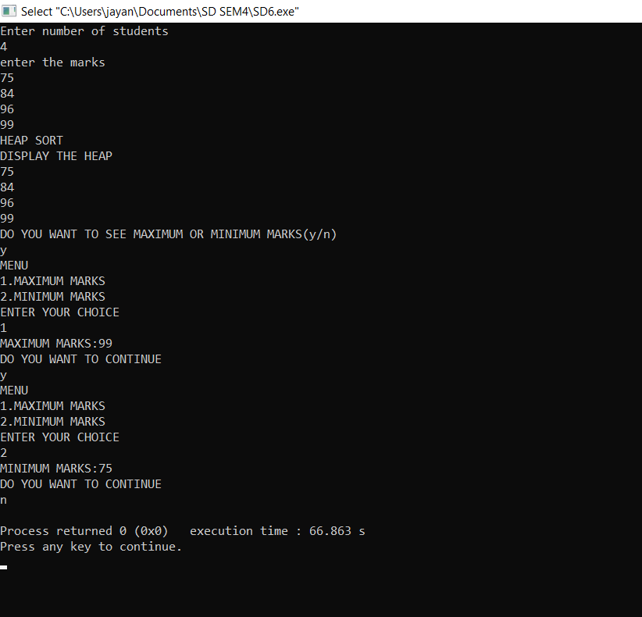

**CONCLUSION:**

We successfully implemented heap data structure.