**ASSIGNMENT 7**

**AIM:**

Insert the keys into a hash table of length m using open addressing using double hashing with h(k)=(1+kmod(m-1)).

**OBJECTIVE:**

To study and learn the concepts of double hashing.

**THEORY:**

**Double hashing** is a collision resolving technique in **Open Addressed** Hash tables. Double hashing uses the idea of applying a second hash function to key when a collision occurs.

Double hashing can be done using:  
**(hash1(key) + i * hash2(key)) % TABLE_SIZE**  
Here hash1() and hash2() are hash functions and TABLE_SIZE  
is size of hash table.  
(We repeat by increasing i when collision occurs)

First hash function is typically hash1(key) = key % TABLE_SIZE

A popular second hash function is:

**hash2(key) = PRIME – (key % PRIME)** where PRIME is a prime smaller than the TABLE_SIZE.

A good second Hash function is:

* It must never evaluate to zero
* Must make sure that all cells can be probed

**ALGORITHM:**

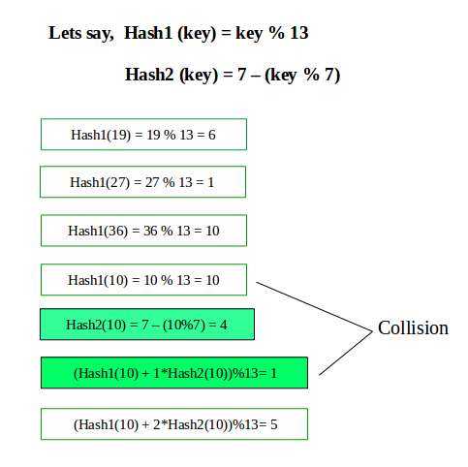

**PROGRAM:**

#include <iostream>

using namespace std;

class dr

{

int n=10;

int arr[100][3];

int c;

public:

dr()

{

cout<<"Table of size "<<n<<" created\n";

for(int i=0;i<n;i++)

{

arr[i][0]=0;

arr[i][1]=-1;

arr[i][2]=-1;

}

c=0;

}

void add(int,int);

int find_key(int);

void display();

void update_val(int,int);

};

void dr::add(int key,int value)

{

int new_hash_addr1,new_hash_addr2,main_hash_addr=-1,j=0;

if(this->find_key(key)!=-1)

{

cout<<"Key already exists\n";

return;

}

if(c==(n-1))

{

cout<<"Table full, request denied\n";

}

new_hash_addr1=(key)%n;

new_hash_addr1=1+(key%(n-1));

if(arr[new_hash_addr1][1]==-1)

{

arr[new_hash_addr1][0]=key;

arr[new_hash_addr1][1]=value;

}

else if(arr[new_hash_addr2][1]==-1)

{

arr[new_hash_addr2][0]=key;

arr[new_hash_addr2][1]=value;

}

else

{

while(arr[new_hash_addr2][2]!=-1)

{

main_hash_addr=new_hash_addr2;

new_hash_addr2=arr[main_hash_addr][2];

}

main_hash_addr=new_hash_addr2;

for(int i=0;i<n;i++)

{

new_hash_addr2=(main_hash_addr+i)%n;

if(arr[new_hash_addr2][1]==-1)

{

arr[new_hash_addr2][0]=key;

arr[new_hash_addr2][1]=value;

arr[main_hash_addr][2]=new_hash_addr2;

c++;

break;

}

}

}

}

void dr::display()

{

cout<<"Key\t\tValue\t\tChain\n";

for(int i=0;i<n;i++)

{

cout<<arr[i][0]<<"\t\t"<<arr[i][1]<<"\t\t"<<arr[i][2]<<endl;

}

}

int dr::find_key(int key)

{

int search_addr=key%n,f=0;

while(arr[search_addr][0]!=key && arr[search_addr][2]!=-1)

{

search_addr=arr[search_addr][2];

}

if(arr[search_addr][0]==key)

{

return arr[search_addr][1];

}

else if(arr[search_addr][2]==-1)

{

return -1;

}

}

int main()

{

char r;

do

{

char op;

dr table;

int c;

do

{

cout<<"--------------------Menu--------------------\n";

cout<<"1] Insert value\n2] Display\n";

cout<<"____________________________________________\n";

cout<<"Enter your choice: ";

cin>>c;

switch(c)

{

case 1: {

int key,val;

cout<<"Enter key: ";

cin>>key;

cout<<"Enter value: ";

cin>>val;

table.add(key,val);

}

break;

case 2: table.display();

break;

default:cout<<"Invalid\n";

}

cout<<"\nDo you wish to go again? ";

cin>>op;

}while(op=='y' || op=='Y');

cout << "Test pass?(y/n): " << endl;

cin>>r;

}while(r=='n' || r=='N');

cout<<"******************\n";

cout<<"* Thank You! *\n";

cout<<"******************\n";

return 0;

}

**OUTPUT:**

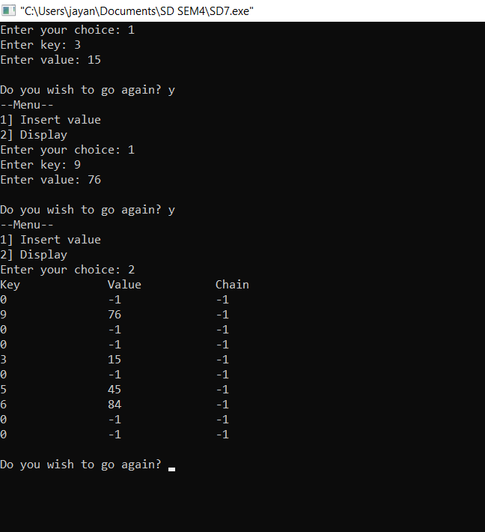

**CONCLUSION:**

We successfully implemented open addressing using double hashing.