KEY POINTS FOR FEATURE DESCRIPTORS
ASSIGNMENT 04 – 1216098
The Laplacian of Gaussian starts by applying the Gaussian filtering first to remove the noise and then applies the Laplacian i.e., the sum of the second derivatives in the x and y direction.
To detect the blob cores accurately, σ sigma value in LOG filter must be changed to match the size of blob in the sunflower picture.
Also, the kernel size should be large enough to accommodate size of Gaussian
And adjustment of padding must be done properly to avoid boundary detection problem.
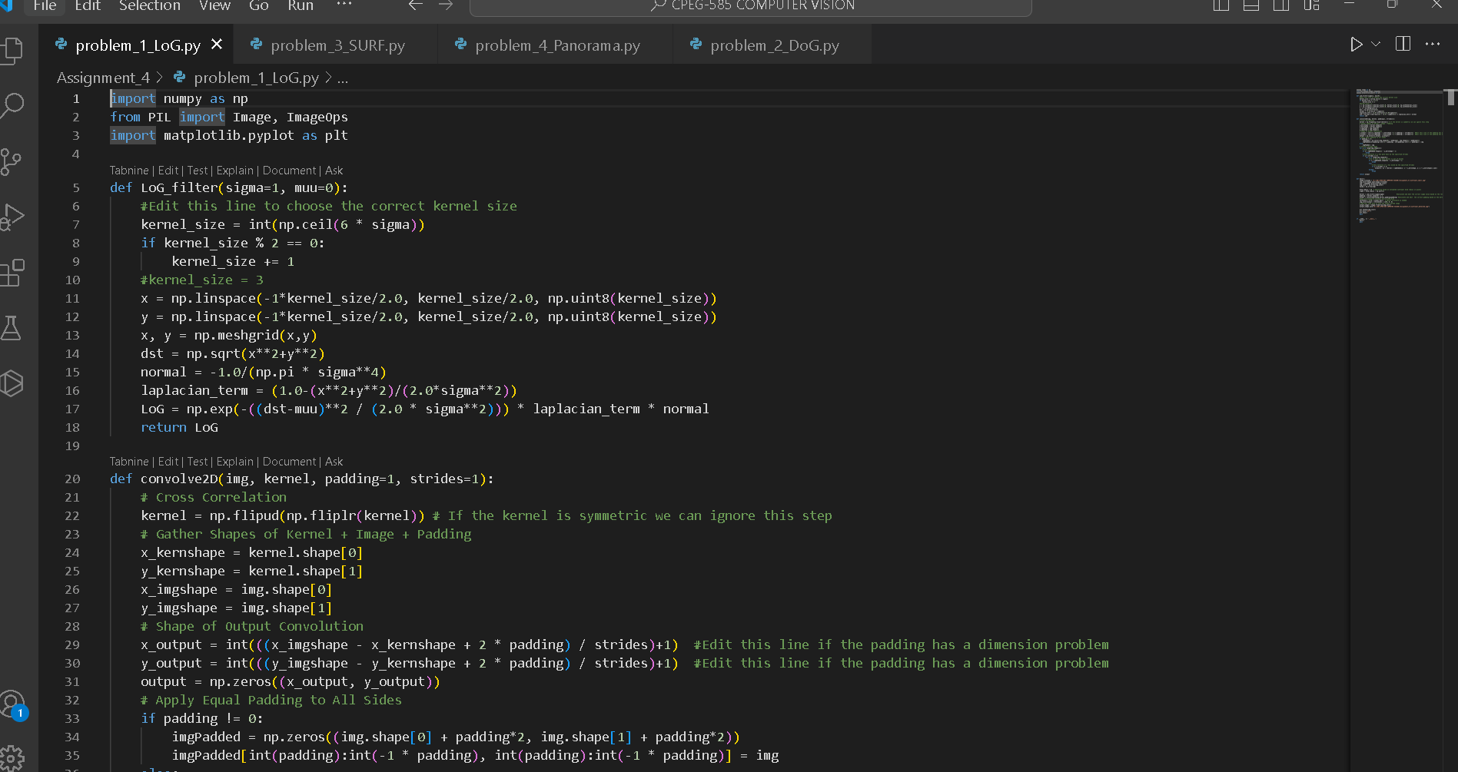

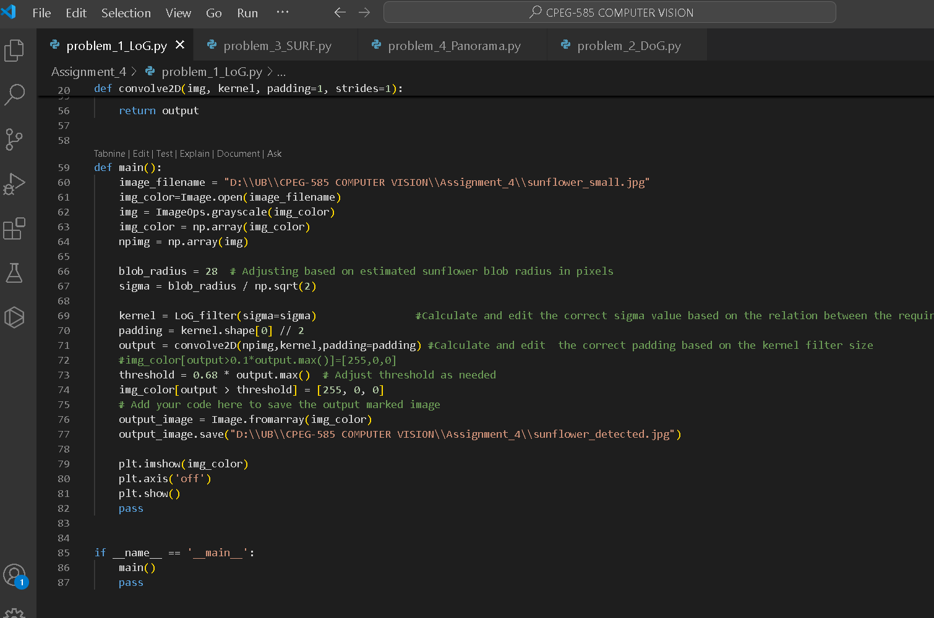

Here I have adjusted the threshold value to 0.68 to identify the blobs correctly. The sunflower core radius is 28/sqrt(2)

2)
The Difference of Gaussian (DoG) filter approximates the Laplacian of Gaussian (LoG) but is computationally faster.

And comparing the LOG and DOG is like
- DOG is slightly less accurate as subtracting two Guassians
- DOG is faster than LOG cause of two Guassians
- For speed and efficiency, DoG outperforms LoG and is suitable for detecting sunflowers’ blob cores.
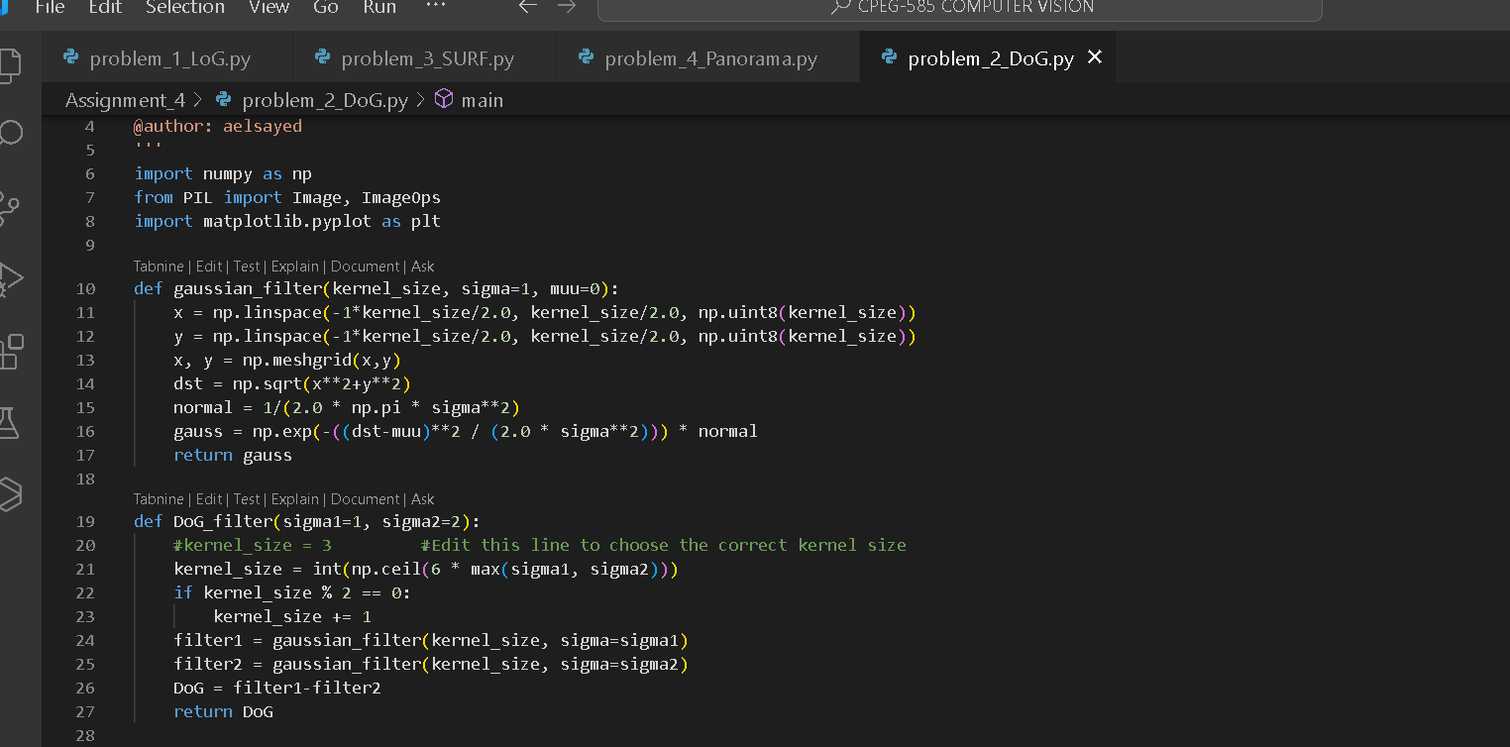

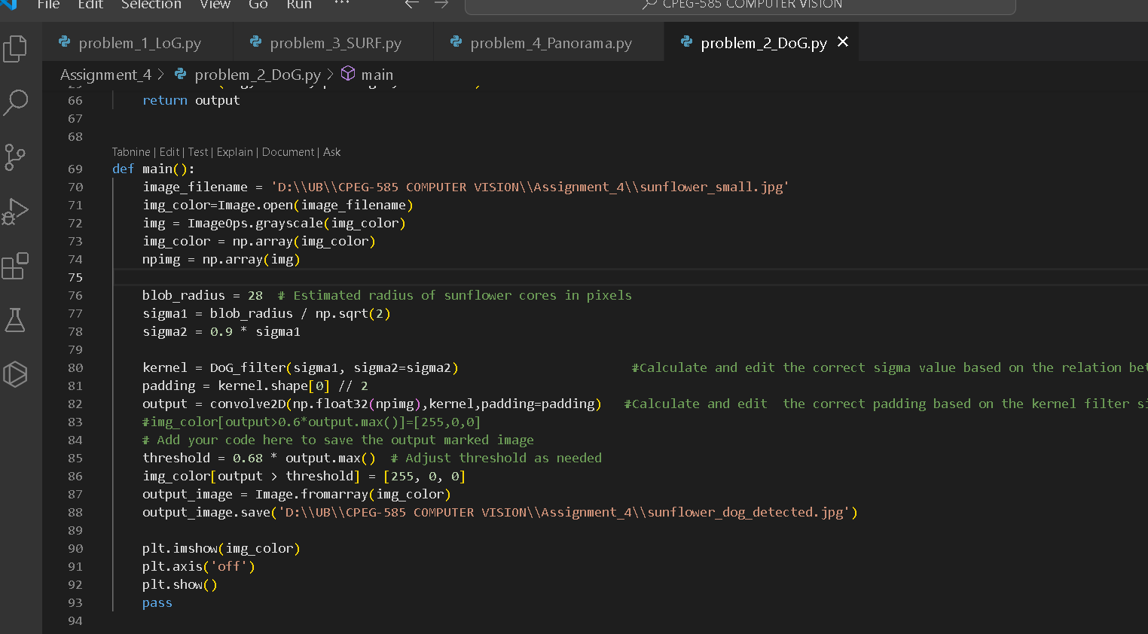

And similarly I have played with sigma and threshold valued to identify blobs.

3)
Out of all SIFT is high in accuracy, fast in speed, higher scalability and ease of use.
Adjusting contrast threshold for SIFT to focus specifically on sunflower core blobs and exclude leaves.
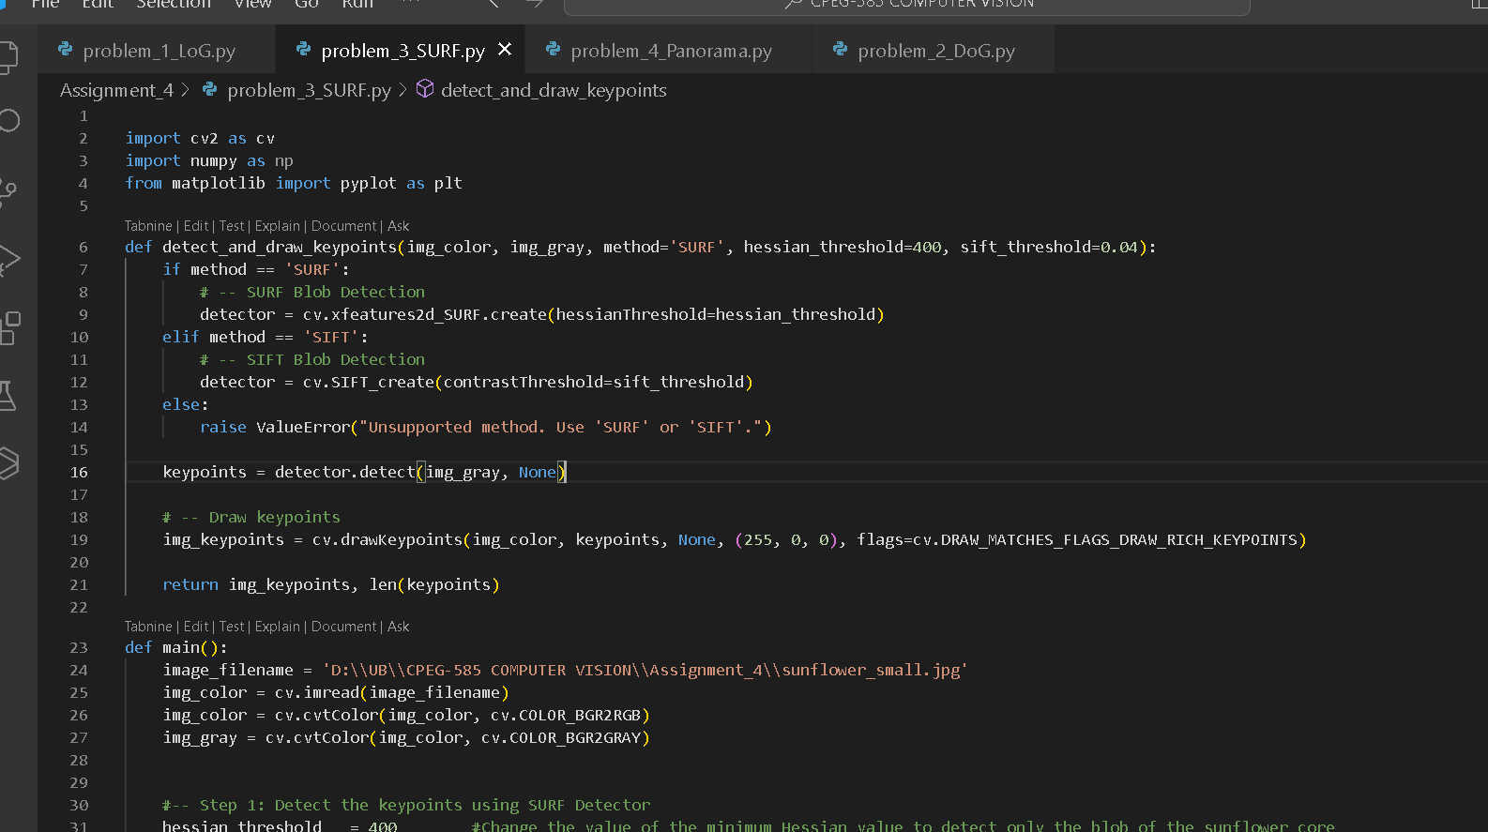

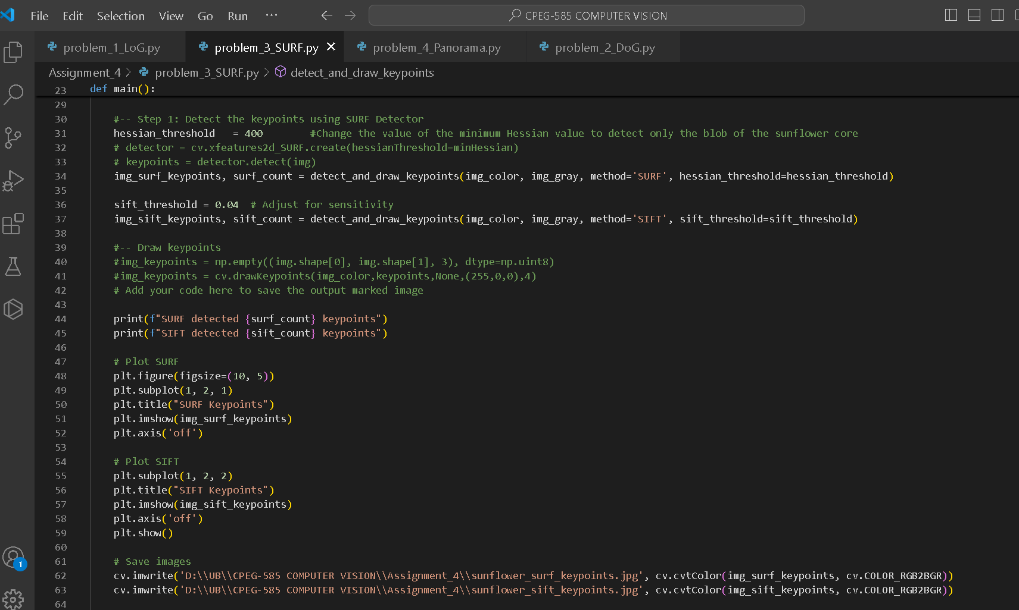

4)
