Confidence-Aware Peer-Relative Degradation Trajectory Analysis for Early End-of-Life Risk Prediction in Lithium-Ion Batteries

Keywords: Lithium-ion battery; battery degradation; peer-relative analysis; end-of-life risk prediction; peer matching; Peer-Match Reliability Index (PMRI); machine learning; probability calibration; early warning.

FIELD OF THE INVENTION
The present invention relates generally to the field of battery health monitoring, battery degradation analysis, and machine-learning-based risk assessment. More particularly, the invention relates to a computer-implemented system and method for early end-of-life risk screening of lithium-ion battery cells using peer-relative degradation analysis and reliability-aware predictive modelling.
The invention specifically concerns the extraction of battery operating-condition features and degradation-trajectory features from cycle-indexed battery measurements, the identification of comparable reference battery cells through weighted similarity-based peer matching, and the calculation of a Peer-Match Reliability Index (PMRI) to quantify the reliability of the selected peer group.
The invention further relates to the generation of a horizon-specific end-of-life risk estimate by combining individual battery features, peer-relative degradation characteristics, and reliability-related information. The system may be used in battery monitoring, battery performance evaluation, predictive maintenance, battery fleet analysis, and other applications requiring early identification of lithium-ion battery cells exhibiting an elevated risk of reaching an end-of-life condition.
BACKGROUND OF THE PRESENT INVENTION
Lithium-ion batteries are widely used in electric vehicles, portable electronic devices, energy storage systems, and other applications requiring rechargeable energy storage. During repeated charging and discharging cycles, the capacity and other operating characteristics of a lithium-ion battery cell may change as a result of degradation. The rate and pattern of degradation may vary between individual cells depending on their initial characteristics, charging conditions, operating temperature, internal resistance, and usage history.
Early identification of battery degradation is important for assessing battery condition and identifying cells that may reach an end-of-life condition within a specified future period. However, degradation during the initial cycles may be relatively small, and the observed measurements of a battery cell may not, by themselves, provide sufficient information to determine whether its degradation behaviour differs significantly from that of comparable cells.
Conventional approaches to battery degradation assessment may rely on individual-cell measurements, historical capacity trends, manually defined thresholds, or predictive models trained using previously collected battery data. Although such approaches can provide useful information, an assessment based only on an individual cell's measurements may not adequately account for differences between cells operating under different conditions. Furthermore, a prediction generated by a machine-learning model may not indicate whether suitable reference cells are available to support a reliable comparison with the cell under evaluation.
Peer-based comparison provides a means of evaluating a battery cell relative to other cells having similar operating and initial-condition characteristics. Nevertheless, the usefulness of such a comparison depends on the similarity and availability of the selected reference cells, the consistency of their degradation trajectories, and the completeness of the available measurements. Where the selected reference cells are dissimilar or exhibit substantial variation, peer-relative degradation features may provide a less dependable basis for assessing the target cell.
Accordingly, there is a need for a battery degradation analysis system that combines individual-cell measurements and degradation-trajectory features with similarity-based reference-cell selection, peer-relative degradation analysis, and an explicit assessment of peer-match reliability. Such a system may further provide a horizon-specific end-of-life risk estimate and indicate when the available peer comparison is insufficient or requires additional review.
The present invention addresses this technical problem through a computer-implemented approach that extracts features from battery measurements available up to a defined observation cutoff, selects comparable reference cells using weighted feature-distance calculations, derives peer-relative degradation characteristics, and calculates a Peer-Match Reliability Index (PMRI). The resulting reliability information is considered alongside predictive-model outputs to support early end-of-life risk screening of lithium-ion battery cells.

OBJECTIVES OF THE INVENTION
The principal objective of the present invention is to provide a computer-implemented system and method for early end-of-life risk screening of lithium-ion battery cells by combining individual-cell degradation analysis with peer-relative comparison and peer-match reliability assessment.
The further objectives of the invention are as follows:
- To extract relevant battery-condition, operating-condition, and degradation-trajectory features from cycle-indexed battery measurements available up to a predefined observation cutoff.
- To identify comparable reference battery cells using a similarity-based peer-matching mechanism that employs standardized features and weighted distance calculations.
- To derive peer-relative degradation features by comparing the capacity, degradation slope, capacity fade, internal resistance, and related characteristics of a target battery cell with those of selected reference cells.
- To develop a Peer-Match Reliability Index (PMRI) that combines peer similarity, degradation-trajectory agreement, peer availability, and feature completeness into a composite measure of peer-match reliability.
- To incorporate peer-relative degradation information and reliability-related features into machine-learning models for estimating the risk of a battery cell reaching an end-of-life condition within a specified future cycle horizon.
- To identify situations in which the selected reference cells provide an insufficient or inconsistent basis for comparison and to generate appropriate reliability warnings for such situations.
- To provide a comparative modelling framework that evaluates the contribution of individual-cell features, degradation-trajectory features, peer-relative features, and PMRI-related features to end-of-life risk screening.
- To reduce information leakage during model development and evaluation by restricting feature extraction to the selected observation cutoff, separating battery cells across data partitions, and limiting reference-cell selection to the designated training reference pool.
- To provide interpretable outputs, including predicted risk scores, peer-relative degradation information, reliability indicators, and graphical representations of the target cell and its selected reference cells.
- To support the application of the proposed system in battery health monitoring, predictive maintenance, battery fleet assessment, and engineering evaluation of lithium-ion battery cells.

SUMMARY OF THE INVENTION
The present invention provides a computer-implemented system and method for early end-of-life risk screening of lithium-ion battery cells using peer-relative degradation analysis and a reliability-aware machine-learning framework. The system combines individual battery measurements, degradation-trajectory characteristics, similarity-based reference-cell selection, and a Peer-Match Reliability Index (PMRI) to generate a horizon-specific end-of-life risk estimate.
In accordance with the invention, cycle-indexed measurements associated with a target battery cell are processed up to a predefined observation cutoff. The system extracts features representing the initial operating conditions, battery condition at the observation cutoff, individual degradation trajectory, and differences between discharge-capacity curves. The extracted features provide a representation of the battery cell's observed condition and degradation behaviour without using measurements from cycles beyond the selected observation cutoff.
A peer-matching module identifies reference battery cells having characteristics similar to those of the target cell. The matching process standardizes selected operating-condition and battery-condition features using statistics derived from a designated training reference pool. A weighted Euclidean distance is calculated between the target cell and eligible reference cells, and the nearest reference cells are selected subject to a predefined minimum peer-count requirement. The target cell is excluded from its own reference set.
Following peer selection, a peer-relative analysis module compares the target cell with the selected reference cells. The module derives characteristics including deviations in discharge capacity, capacity degradation slope, capacity fade, and internal resistance, together with measures of peer-group dispersion and relative capacity position. These features enable the observed behaviour of the target cell to be assessed in relation to a group of comparable cells.
The invention further provides a Peer-Match Reliability Index (PMRI) for assessing the quality of the selected peer comparison. In the described implementation, PMRI combines four components, namely peer similarity, degradation-trajectory agreement, peer availability, and feature completeness. The components are combined using configurable weights to obtain a composite score bounded between zero and one. Reliability warnings may be generated when the peer group is insufficient, peer distances are high, peer degradation trajectories exhibit excessive variation, or the composite reliability score falls below a predefined threshold.
A predictive module uses selected battery features to estimate whether the target cell will reach an end-of-life condition within a specified future cycle horizon. In the implemented configuration, the prediction target indicates whether the cell reaches the defined end-of-life criterion within the next 500 cycles after the observation cutoff. The end-of-life criterion is defined in the project implementation as discharge capacity reaching 80% of nominal capacity.
The predictive framework supports comparison of different feature configurations, including initial and current-condition features, individual degradation-trajectory features, peer-relative features, and reliability-related features. The system may apply probability calibration and decision thresholds derived from training data to produce risk estimates and corresponding screening categories.
The system may further comprise a graphical interface for presenting predicted risk, matched reference cells, peer-relative degradation characteristics, PMRI values, reliability warnings, and graphical comparisons between the target cell's degradation trajectory and those of the selected reference cells. Such presentation allows a user to interpret the risk estimate together with information about the reliability of the peer comparison.
The disclosed invention therefore provides an integrated approach to battery end-of-life risk screening in which individual-cell degradation information is evaluated in the context of comparable reference cells, while the reliability of that comparison is explicitly assessed and reported. The described implementation is suitable for research and engineering evaluation, and its use in operational battery-management applications requires appropriate application-specific validation.

6. BRIEF DESCRIPTION OF THE DRAWINGS
The accompanying drawings illustrate the system architecture and operational procedure of the proposed Reliability-Aware Peer-Relative Degradation Analysis System and Method for Early End-of-Life Risk Screening in Lithium-Ion Battery Cells. The drawings are intended to aid understanding of the invention and should be read in conjunction with the detailed description.
FIG. 1 — System Architecture / Component Diagram
FIG. 1 illustrates the overall system architecture, including the battery data input, data preprocessing module, feature extraction module, peer-matching module, peer-relative degradation analysis module, Peer-Match Reliability Index (PMRI) module, end-of-life (EOL) risk prediction module, and output and visualization module. The figure also illustrates the training reference pool and target battery cell as separate data sources, the selection of comparable reference cells, and the flow of information between the analysis and prediction components. The risk prediction module uses the configured feature sets and a trained logistic regression model with probability calibration to estimate the probability of reaching the defined EOL threshold within the specified prediction horizon.
FIG. 2 — Operational Flow for Early End-of-Life Risk Screening
FIG. 2 illustrates the sequence of operations performed by the proposed method. The process begins with receiving cycle-indexed battery measurements and selecting an observation cutoff. The measurements are preprocessed, and early-life features are extracted using information available up to the selected cutoff. Selected features are standardized using statistics obtained from the training reference pool, after which peer matching is performed using weighted Euclidean distance.
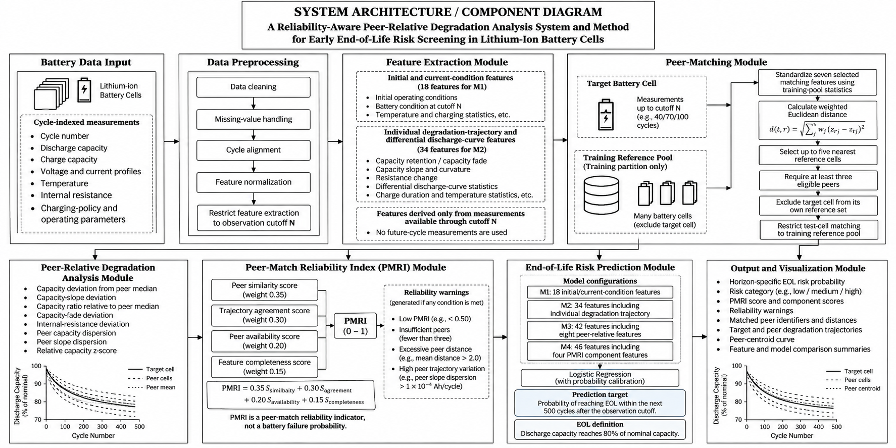
The figure further illustrates the decision concerning the availability of a sufficient number of eligible peers, calculation of peer-relative degradation features, computation of the PMRI, and generation of reliability warnings when applicable. The workflow then proceeds to horizon-specific EOL risk estimation using the selected trained model, followed by preparation and presentation of the risk estimate, peer-matching diagnostics, reliability information, and associated visualizations. The flow includes a path for insufficient peer availability so that this condition is identified as a limitation of the peer-relative analysis rather than automatically being treated as battery failure.
FIG.1
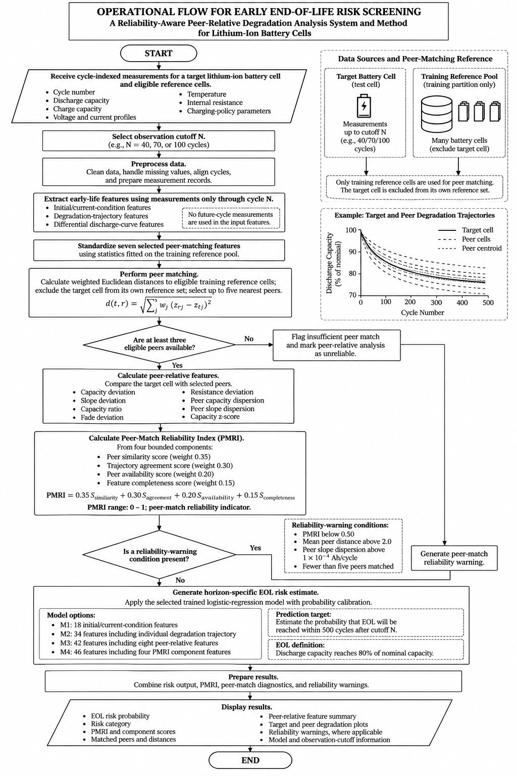
FIG .2

DETAILED DESCRIPTION OF THE INVENTION
The Peer-Relative Early Degradation Detection and End-of-Life Risk Prediction System operates through a plurality of interconnected components that receive battery cycling data, extract degradation-related characteristics, identify comparable battery cells, assess peer-relative degradation behaviour, estimate end-of-life risk, and present the resulting analysis through an interactive interface. Reference is made to FIG. 1 for the arrangement of system components and to FIG. 2 for the operational sequence.
1. Battery Data Acquisition Module:
The Battery Data Acquisition Module receives battery cycling records from the publicly available lithium-ion battery aging dataset used in the project. The dataset contains experimental measurements from lithium-iron-phosphate (LFP) and graphite battery cells subjected to charging and discharging cycles. The received records include discharge capacity, charge capacity, internal resistance, temperature measurements, charging time, and charging-protocol parameters. Each record is associated with a battery-cell identifier and the corresponding cycle information.
The module prepares the data for subsequent analysis by identifying the available observations for each cell and determining whether the cell has sufficient information for the configured prediction task. The use of cell identifiers enables the system to distinguish individual batteries and to maintain cell-level separation between training and evaluation data.
2. Data Preprocessing and Observation Cutoff Module:
The Data Preprocessing and Observation Cutoff Module prepares the received records for analysis at predefined observation cutoffs of 40, 70, and 100 cycles. At each cutoff, the system uses the measurements available up to that point to construct the corresponding feature representation.
The module supports the preparation of standardized numerical features using statistics obtained from the permitted training data. This arrangement is intended to prevent information from held-out test cells from influencing the fitted preprocessing parameters. Cells for which the relevant outcome cannot be reliably established are handled as censored or excluded records, as applicable, rather than being automatically assigned an unsupported outcome label.
3. Battery Feature Engineering Module:
The Battery Feature Engineering Module transforms the processed battery records into numerical characteristics for degradation analysis and end-of-life risk classification. The module generates features representing initial battery condition, operating protocol, measurements at the observation cutoff, early degradation trajectory, and differential-voltage-curve statistics.
The initial-condition and snapshot features describe the observed condition of the cell, including capacity, coulombic efficiency, internal resistance, temperature, and charging behaviour. The trajectory features describe changes in battery capacity, capacity fade, degradation slope, curvature, resistance, temperature, and charging time over the available observation interval.
The implementation organizes these features into four model configurations, designated M1, M2, M3, and M4, containing 18, 34, 42, and 46 features, respectively. These configurations enable the system to evaluate the contribution of individual battery measurements, degradation trajectory information, peer-relative characteristics, and peer-reliability information to the prediction task.
4. Peer Matching and Similarity Assessment Module:
The Peer Matching and Similarity Assessment Module identifies reference battery cells having characteristics comparable to those of a target cell. The module compares selected initial-condition and operating features, including charging-protocol parameters, initial discharge capacity, initial internal resistance, initial temperature, and internal resistance at the observation cutoff.
The selected features are standardized using training-derived parameters and compared through a weighted Euclidean distance calculation. The implemented default weighting assigns greater importance to selected charging-protocol characteristics and distributes the remaining weight across the other matching features.
The module ranks eligible reference cells according to their calculated distance and selects up to five nearest peers. A minimum of three valid peers is required for a peer comparison. The target cell is excluded from its own reference group, and the evaluation procedure uses the training-cell reference pool when matching held-out test cells.
Where sufficient eligible peers or matching measurements are unavailable, the system identifies the matching limitation rather than treating an incomplete comparison as fully reliable.
5. Peer-Relative Degradation Analysis Module:
The Peer-Relative Degradation Analysis Module compares the target cell's observed degradation characteristics with the corresponding characteristics of its selected peers. The module calculates eight peer-relative features, comprising capacity deviation from the peer median, degradation-slope deviation, relative capacity ratio, capacity-fade deviation, internal-resistance deviation, peer-capacity dispersion, peer-slope dispersion, and a standardized capacity deviation.
These features represent the difference between the target cell's observed condition and the behaviour of comparable reference cells. For example, a target cell whose capacity or degradation slope differs substantially from its peer group may exhibit a degradation pattern that warrants further examination.
The module provides the peer-relative features to the subsequent classification pipeline. Such deviations are treated as comparative indicators rather than definitive proof of a battery defect or impending failure.
6. Peer-Match Reliability Assessment Module:
The Peer-Match Reliability Assessment Module implements a Peer-Match Reliability Index (PMRI) to represent the reliability of the available peer comparison. The index combines four components: peer similarity, agreement among peer degradation trajectories, availability of valid peers, and completeness of the matching features.
In the implemented configuration, the respective component weights are 0.35, 0.30, 0.20, and 0.15. The component scores are bounded between zero and one, and the resulting PMRI is likewise bounded between zero and one.
The module also evaluates warning conditions associated with insufficient peer availability, excessive mean peer distance, excessive dispersion among peer degradation slopes, and PMRI below the configured threshold. The default warning conditions include fewer than five matched peers, mean peer distance greater than 2.0, peer-slope dispersion greater than (10^{-4}) Ah per cycle, and PMRI below 0.50.
The PMRI is used as a heuristic indicator of peer-comparison suitability. It is not interpreted as a calibrated probability of battery failure. The reliability information is made available alongside the classification result so that users can distinguish a prediction supported by a suitable peer comparison from one affected by limited or inconsistent reference data.

7. End-of-Life Risk Prediction Module:
The End-of-Life Risk Prediction Module receives the engineered battery features and applies a trained machine-learning classifier to estimate whether the target cell will reach its defined end-of-life within a specified future cycle horizon.
For the principal benchmark task, end-of-life is defined as the first cycle at which discharge capacity reaches 80% of nominal capacity. The primary classification target indicates whether the cell is expected to reach this threshold within 500 cycles after the selected observation cutoff. The implementation also prepares additional target definitions for alternative prediction horizons and early-failure analysis.
The principal classification pipeline uses standardized logistic regression with L2 regularization and balanced class weighting. The project also implements a Random Forest classifier as an additional benchmark. The M1 configuration uses initial-condition and snapshot features; M2 adds individual degradation trajectory and differential-voltage-curve features; M3 further adds peer-relative features; and M4 additionally incorporates peer-reliability features.
The implementation includes probability calibration using Platt scaling based on out-of-fold training predictions. The resulting risk estimate and classification are generated according to the configured model and decision threshold. The system therefore performs future EOL-risk classification; a continuous remaining-useful-life estimate is not represented as a validated output of the described classification pipeline.
8. Model Validation and Performance Assessment Module:
The Model Validation and Performance Assessment Module evaluates the implemented prediction configurations using separate training, primary-test, and secondary-test cell partitions. The evaluation process includes checks intended to identify cell-level data leakage, inappropriate use of held-out data during preprocessing, and improper use of test outcomes during probability calibration.
The module supports evaluation using measures including AUROC, area under the precision-recall curve, Brier score, expected calibration error, sensitivity, specificity, false-positive rate, and F1-score, where applicable to the evaluated experiment. It also supports comparison of the model configurations across observation cutoffs and test cohorts.
The project evaluates whether the addition of peer-relative and peer-reliability features improves prediction performance over individual-condition and trajectory-based models. Such improvement is dependent on the evaluation cohort and operating conditions; accordingly, the system does not presume that the most feature-rich model will necessarily produce the best result in every setting.
9. Interactive Dashboard and Result Presentation Module:
The Interactive Dashboard and Result Presentation Module provides a user interface for viewing battery-risk predictions and the supporting degradation analysis. The implementation uses a Python-based HTTP server together with browser-based interface components.
The dashboard presents model predictions, risk classifications, comparisons across observation cutoffs, peer trajectories, peer-centroid overlays, PMRI values, and reliability warnings. It also provides access to model-comparison results and relevant evaluation visualizations.
By presenting the prediction together with peer-relative information and the associated reliability indicators, the module allows a user to examine the basis and limitations of the estimated risk rather than relying exclusively on a standalone classification label.
10. Illustrative Example of Operation:
By way of a non-limiting example, a battery cell undergoing repeated charging and discharging cycles is selected for early-life degradation assessment at an observation cutoff of 70 cycles. The system receives the available measurements for the target cell up to that cutoff and prepares the corresponding capacity, resistance, temperature, charging, and trajectory features.
The Peer Matching and Similarity Assessment Module compares the target cell with eligible reference cells from the permitted training pool and selects up to five nearest peers, provided that the minimum peer requirements are satisfied. The Peer-Relative Degradation Analysis Module then compares the target cell's capacity, degradation slope, fade, and resistance characteristics with those of the selected peers.
The Peer-Match Reliability Assessment Module calculates PMRI and determines whether any configured reliability warnings apply. The resulting feature representation is passed to the selected classification model, which estimates the likelihood that the target cell will reach the defined end-of-life threshold within the configured 500-cycle horizon following the observation cutoff.
The dashboard presents the estimated risk, classification, peer-relative trajectory information, and reliability indicators. If the peer group is insufficient or the comparison is affected by the configured warning conditions, that limitation is presented alongside the prediction. The example illustrates the system's operation and does not imply any particular numerical risk estimate or guaranteed prediction accuracy.
11. Security, Data Integrity and Fail-Safe Considerations:
The system uses cell-level data partitions and training-derived preprocessing parameters to reduce the risk of information leakage between model development and evaluation. The target cell is excluded from its own peer group, and held-out test cells are compared against the permitted training reference pool.
The system also accounts for incomplete observations, censored outcomes, missing matching features, and insufficient peer availability within the relevant processing stages. Where a valid peer comparison cannot be established, the corresponding peer-relative information is not treated as a fully reliable comparison.
The PMRI and associated warnings communicate limitations in the peer-matching process. Model evaluation and probability calibration are performed using the designated training procedures rather than being fitted directly to held-out test outcomes. These measures support the integrity of the experimental evaluation; they do not, by themselves, establish certification for safety-critical battery control or guarantee the correctness of every individual prediction.
12. Advantages of the Invention:
The invention provides a unified approach to early-life battery degradation analysis and end-of-life risk screening. Its potential advantages include: (i) analysis of degradation behaviour before the end-of-life event is observed; (ii) comparison of a target battery with similar reference cells rather than relying solely on absolute measurements; (iii) integration of individual trajectory and peer-relative features within a common classification framework; (iv) explicit assessment of peer-match reliability through PMRI and associated warnings; (v) evaluation of probability estimates and classification performance across separate battery-cell cohorts; and (vi) presentation of predictions and supporting peer comparisons through an interactive dashboard.
These advantages describe the functions and intended benefits of the implemented approach. The extent of any improvement in predictive performance depends on the dataset, prediction horizon, observation cutoff, and evaluation conditions.
13. Alternative Embodiments:
While the system has been described with reference to the implemented battery-aging dataset, peer-matching procedure, PMRI formulation, and classification pipeline, the underlying approach may be adapted to other battery datasets and lithium-ion cell chemistries, provided that the required measurements and reference data are available.
In alternative embodiments, the number of selected peers, matching-feature weights, observation cutoffs, prediction horizons, and reliability thresholds may be adjusted according to the characteristics of the battery population and the intended application. Additional battery-health measurements or trajectory descriptors may also be incorporated into the feature-engineering process.
Alternative classification or probability-calibration methods may be used, subject to suitable training and validation. The system may further be extended to process battery measurements from laboratory test equipment, battery-management systems, or fleet-monitoring platforms. Any continuous remaining-useful-life prediction, real-time operational control, or additional warning mechanism would require its own implementation and validation before being represented as an established system capability.
14. Industrial Applicability:
The invention is applicable to battery-aging research, lithium-ion cell characterization, battery-health monitoring, predictive maintenance research, and comparative assessment of battery degradation. It may be used by battery researchers, cell manufacturers, battery testing laboratories, and developers of battery-monitoring software to examine early-life degradation behaviour and estimate end-of-life risk using historical cycling measurements.
The system can be implemented using conventional computing hardware, data-processing software, and machine-learning libraries. Its applicability to deployed battery-management systems or safety-critical applications would depend on further validation using representative operating conditions, suitable real-world data, and the requirements of the intended deployment.

CLAIMS
We claim:
- A computer-implemented system for early end-of-life risk prediction and peer-relative degradation analysis of lithium-ion battery cells, the system comprising: a battery data acquisition module configured to receive cycle-level battery measurements including discharge capacity, charge capacity, internal resistance, temperature measurements, charging time and charging-protocol parameters; a data preprocessing and feature engineering module configured to prepare battery records at a predefined observation cutoff and derive battery-condition and degradation-trajectory features; a peer-matching module configured to identify reference battery cells having similar initial-condition and operating characteristics to a target battery cell; a peer-relative degradation analysis module configured to determine deviations between the target battery cell and the identified reference battery cells; a Peer-Match Reliability Index (PMRI) module configured to assess the reliability of the peer comparison; and a machine-learning classification module configured to estimate whether the target battery cell will reach a predefined end-of-life threshold within a specified future cycle horizon based on the derived features.
- The system as claimed in claim 1, wherein the said peer-matching module is configured to standardize selected matching features using parameters derived from training data, calculate a weighted Euclidean distance between the target battery cell and eligible reference battery cells, rank the reference battery cells according to the calculated distance, and select up to five nearest peers subject to a minimum peer-availability requirement, while excluding the target battery cell from its own reference group.
- The system as claimed in claim 1, wherein the said peer-relative degradation analysis module is configured to derive peer-relative features comprising target-cell capacity deviation from peer capacity, degradation-slope deviation, relative capacity ratio, capacity-fade deviation, internal-resistance deviation, peer-capacity dispersion, peer-slope dispersion, and standardized capacity deviation.
- The system as claimed in claim 1, wherein the said Peer-Match Reliability Index (PMRI) module is configured to calculate a composite reliability score from a plurality of component scores comprising peer similarity, peer trajectory agreement, peer availability and matching-feature completeness, and to generate a reliability warning when one or more predefined conditions relating to peer count, peer distance, peer-slope dispersion or the calculated reliability score are satisfied.
- The system as claimed in claim 1, wherein the said machine-learning classification module comprises a plurality of feature configurations, including a baseline configuration using battery initial-condition and observation-cutoff features, a trajectory configuration incorporating individual degradation features, a peer-relative configuration incorporating peer-relative degradation features, and a confidence-aware configuration incorporating peer-reliability features, thereby enabling comparative evaluation of the contribution of the respective feature groups to end-of-life risk prediction.
- The system as claimed in claim 1, wherein the said machine-learning classification module is configured to apply a standardized logistic regression classifier with regularization and class weighting to estimate the probability that the target battery cell will reach an end-of-life threshold within a predefined future cycle horizon, and to apply probability calibration using predictions generated from training data.
- The system as claimed in claim 1, wherein the said predefined end-of-life threshold corresponds to the first cycle at which discharge capacity reaches 80% of nominal capacity, and wherein the said classification module is configured to determine whether the target battery cell reaches the said threshold within 500 cycles following a selected observation cutoff.
- The system as claimed in claim 1, further comprising an interactive dashboard configured to present the predicted end-of-life risk, the corresponding classification, peer-relative degradation trajectories, peer-comparison information, PMRI values, reliability warnings and model evaluation visualisations.
- A computer-implemented method for early end-of-life risk screening of lithium-ion battery cells, the method comprising: receiving cycle-level battery measurements for a target battery cell and eligible reference battery cells; selecting a predefined observation cutoff; preparing battery-condition and degradation-trajectory features from measurements available up to the said cutoff; standardizing selected matching features using training-derived parameters; calculating similarity distances between the target battery cell and eligible reference battery cells; selecting a peer group according to the calculated distances and peer-availability requirements; deriving peer-relative degradation features; calculating a Peer-Match Reliability Index from peer similarity, trajectory agreement, peer availability and feature completeness; providing the resulting feature representation to a trained machine-learning classifier; estimating the probability that the target battery cell will reach a predefined end-of-life threshold within a specified future cycle horizon; and presenting the resulting risk estimate and peer-comparison reliability information through an interactive dashboard.
- The method as claimed in claim 9, wherein the training, preprocessing and probability-calibration procedures are performed using designated training data, and wherein held-out test battery cells are excluded from fitting the preprocessing and calibration parameters, thereby supporting cell-level evaluation of the end-of-life risk prediction system.

ABSTRACT
A computer-implemented system for peer-relative degradation analysis and early end-of-life risk prediction of lithium-ion battery cells is disclosed. The system receives cycle-level battery measurements and derives battery-condition, degradation-trajectory and operating-protocol features at predefined observation cutoffs. A peer-matching module identifies comparable reference battery cells using standardized matching features and weighted distance calculations. A peer-relative degradation analysis module derives features representing differences between the target cell and its selected peers, including capacity deviation, degradation-slope deviation, capacity-fade deviation, internal-resistance deviation and peer-trajectory dispersion. A Peer-Match Reliability Index (PMRI) module combines peer similarity, trajectory agreement, peer availability and feature completeness to assess the reliability of the comparison and generate corresponding warnings. A machine-learning classification module processes the resulting feature representation to estimate whether the target battery cell will reach a predefined end-of-life threshold within a specified future cycle horizon. In one implementation, end-of-life is defined by discharge capacity reaching 80% of nominal capacity, and the primary prediction target concerns the occurrence of end-of-life within 500 cycles following the observation cutoff. Multiple feature configurations enable comparative assessment of individual-condition, trajectory-based, peer-relative and peer-reliability information. An interactive dashboard presents risk estimates, classifications, peer-relative trajectories and reliability indicators to support early-life battery degradation screening and comparative analysis.

