Complete Specification:
System and Method for Confidence-Aware Peer-Relative Degradation Trajectory Analysis for Early End-of-Life Risk Prediction in Lithium-Ion Batteries
The following specification particularly describes the invention and the way it is to be performed.
Keywords: Lithium-Ion Battery, Peer-Relative Degradation Analysis, End-of-Life Risk Prediction, Peer Matching, Peer-Match Reliability Index (PMRI), Probability Calibration
FIELD OF THE INVENTION:
This invention relates to computer-implemented systems and methods for battery health monitoring and battery degradation analysis, and more particularly to a machine-learning-based system that extracts operating-condition and degradation-trajectory features from cycle-indexed measurements of a lithium-ion battery cell available up to a defined observation cutoff, identifies comparable reference cells through weighted similarity-based peer matching, derives peer-relative degradation features, calculates a Peer-Match Reliability Index (PMRI) quantifying the reliability of the selected peer group, and generates a horizon-specific end-of-life risk estimate for early risk screening of the said cell.
The invention lies broadly in the fields of battery health monitoring, battery degradation analysis and machine-learning-based risk assessment, and more particularly in the sub-field of reliability-aware, peer-relative end-of-life risk screening that integrates feature extraction, peer matching, reliability assessment, predictive modelling and result presentation within a single technical architecture. The system may be used in battery performance evaluation, predictive maintenance, battery fleet analysis, and other applications requiring early identification of lithium-ion battery cells exhibiting an elevated risk of reaching an end-of-life condition.
BACKGROUND OF THE PRESENT INVENTION:
Lithium-ion batteries are widely used in electric vehicles, portable electronic devices, energy storage systems and other applications requiring rechargeable energy storage. During repeated charging and discharging cycles, the capacity and other operating characteristics of a cell change as a result of degradation, and the rate and pattern of such degradation vary between individual cells depending on their initial characteristics, charging conditions, operating temperature, internal resistance and usage history. Early identification of cells that may reach an end-of-life condition within a specified future period is therefore important; however, degradation during the initial cycles is relatively small, and the measurements of a cell, taken by themselves, may not indicate whether its degradation behaviour differs significantly from that of comparable cells.
Conventional approaches to degradation assessment rely on individual-cell measurements, historical capacity trends, manually defined thresholds, or predictive models trained on previously collected battery data. An assessment based only on the measurements of an individual cell does not adequately account for differences between cells operating under different conditions. A prediction generated by a machine-learning model, moreover, does not indicate whether suitable reference cells are available to support a reliable comparison with the cell under evaluation. Peer-based comparison, in which a cell is evaluated relative to other cells having similar initial-condition and operating characteristics, offers a means of addressing the first limitation; but its usefulness depends on the similarity and availability of the selected reference cells, the consistency of their degradation trajectories and the completeness of the available measurements, and, where the selected cells are dissimilar or widely varying, peer-relative features provide a less dependable basis for assessing the target cell.
There is, accordingly, a need for a single, integrated system that combines individual-cell measurements and degradation-trajectory features with similarity-based reference-cell selection, peer-relative degradation analysis and an explicit assessment of peer-match reliability, and that provides a horizon-specific end-of-life risk estimate while indicating when the available peer comparison is insufficient or requires additional review. The present invention seeks to address this need.
OBJECTIVE OF THE INVENTION:
The objective of the System and Method for Confidence-Aware Peer-Relative Degradation Trajectory Analysis for Early End-of-Life Risk Prediction in Lithium-Ion Batteries is to provide a single, integrated, reliability-aware platform for early end-of-life risk screening of lithium-ion battery cells. The specific objectives of the invention are as follows:
- Early-Life Feature Extraction: To extract battery-condition, operating-condition and degradation-trajectory features from cycle-indexed battery measurements available up to a predefined observation cutoff, without using measurements from later cycles.
- Similarity-Based Peer Matching: To identify comparable reference battery cells by means of standardized features and weighted distance calculations, with the target cell excluded from its own reference set.
- Peer-Relative Degradation Analysis: To derive peer-relative degradation features by comparing the capacity, degradation slope, capacity fade, internal resistance and related characteristics of a target cell with those of its selected reference cells.
- Peer-Match Reliability Assessment: To provide a Peer-Match Reliability Index (PMRI) combining peer similarity, degradation-trajectory agreement, peer availability and feature completeness into a composite measure, and to generate reliability warnings where the peer comparison is insufficient or inconsistent.
- Horizon-Specific End-of-Life Risk Estimation: To estimate, by a machine-learning classifier using individual, trajectory, peer-relative and reliability-related features, the probability that a cell reaches an end-of-life condition within a specified future cycle horizon.
- Comparative Feature-Configuration Framework: To provide a plurality of feature configurations enabling evaluation of the contribution of individual-cell, degradation-trajectory, peer-relative and PMRI-related features to end-of-life risk screening.
- Reduced Information Leakage: To reduce information leakage during model development and evaluation by restricting feature extraction to the observation cutoff, separating battery cells across data partitions, and limiting reference-cell selection to a designated training reference pool.
- Interpretable Outputs and Broad Applicability: To provide interpretable outputs, including risk scores, peer-relative degradation information, reliability indicators and graphical comparisons, in support of battery health monitoring, predictive maintenance, battery fleet assessment and engineering evaluation.
SUMMARY OF THE INVENTION:
The System for Reliability-Aware Peer-Relative Degradation Analysis comprises a Battery Data Acquisition Module for receiving cycle-indexed battery measurements; a Data Preprocessing and Observation Cutoff Module; a Battery Feature Engineering Module; a Peer Matching and Similarity Assessment Module; a Peer-Relative Degradation Analysis Module; a Peer-Match Reliability Assessment Module implementing a Peer-Match Reliability Index (PMRI); an End-of-Life Risk Prediction Module; a Model Validation and Performance Assessment Module; and an Interactive Dashboard and Result Presentation Module.
Cycle-indexed measurements associated with a target battery cell are processed up to a predefined observation cutoff. The system extracts features representing the initial operating conditions, the battery condition at the observation cutoff, the individual degradation trajectory, and differences between discharge-capacity curves, without using measurements from cycles beyond the cutoff. Selected matching features are standardized using statistics derived from a designated training reference pool, a weighted Euclidean distance is calculated between the target cell and eligible reference cells, and the nearest reference cells are selected subject to a predefined minimum peer-count requirement, the target cell being excluded from its own reference set.
The target cell is then compared with the selected reference cells to derive peer-relative features, including deviations in discharge capacity, degradation slope, capacity fade and internal resistance, together with measures of peer-group dispersion and relative capacity position. The reliability of the selected peer comparison is assessed by the PMRI, which combines four component scores, namely peer similarity, degradation-trajectory agreement, peer availability and feature completeness, using configurable weights to obtain a composite score bounded between zero and one. Reliability warnings are generated when the peer group is insufficient, peer distances are high, peer degradation trajectories exhibit excessive variation, or the PMRI falls below a predefined threshold.
A machine-learning classifier, using one of a plurality of feature configurations, estimates whether the target cell will reach an end-of-life condition within a specified future cycle horizon. In one implementation, end-of-life is defined as the discharge capacity reaching 80% of nominal capacity, and the prediction target is whether this occurs within 500 cycles after the observation cutoff. Probability calibration and decision thresholds derived from training data are applied to produce a risk estimate and a screening category. The predicted risk, matched reference cells, peer-relative characteristics, PMRI values, reliability warnings and graphical comparisons of the target and reference degradation trajectories are presented through an interactive dashboard, so that the risk estimate may be interpreted together with the reliability of the peer comparison.
DESCRIPTION OF THE DRAWINGS:
The invention is illustrated, by way of example and not of limitation, in the accompanying drawings, in which:
FIG. 1 shows the System Architecture / Component Diagram of the invention, illustrating the battery data input, the data preprocessing module, the feature extraction module, the peer-matching module with the target battery cell and the training reference pool as separate data sources, the peer-relative degradation analysis module, the Peer-Match Reliability Index (PMRI) module, the end-of-life risk prediction module, and the output and visualization module, together with the flow of data between them.
FIG. 2 shows the Flow Diagram of the invention, illustrating the operational sequence followed by the system, from receipt of cycle-indexed measurements and selection of the observation cutoff, through preprocessing, feature extraction, standardization and weighted-distance peer matching, the decision on availability of a sufficient number of eligible peers, calculation of peer-relative features and the PMRI, generation of reliability warnings, and horizon-specific end-of-life risk estimation, to the preparation and display of results, including a path by which insufficient peer availability is identified as a limitation of the peer-relative analysis and not treated as battery failure.
Together, these two drawings are sufficient to enable a person skilled in the art to understand the architecture (FIG. 1) and the operational logic (FIG. 2) of the invention, as further explained in the detailed description below.
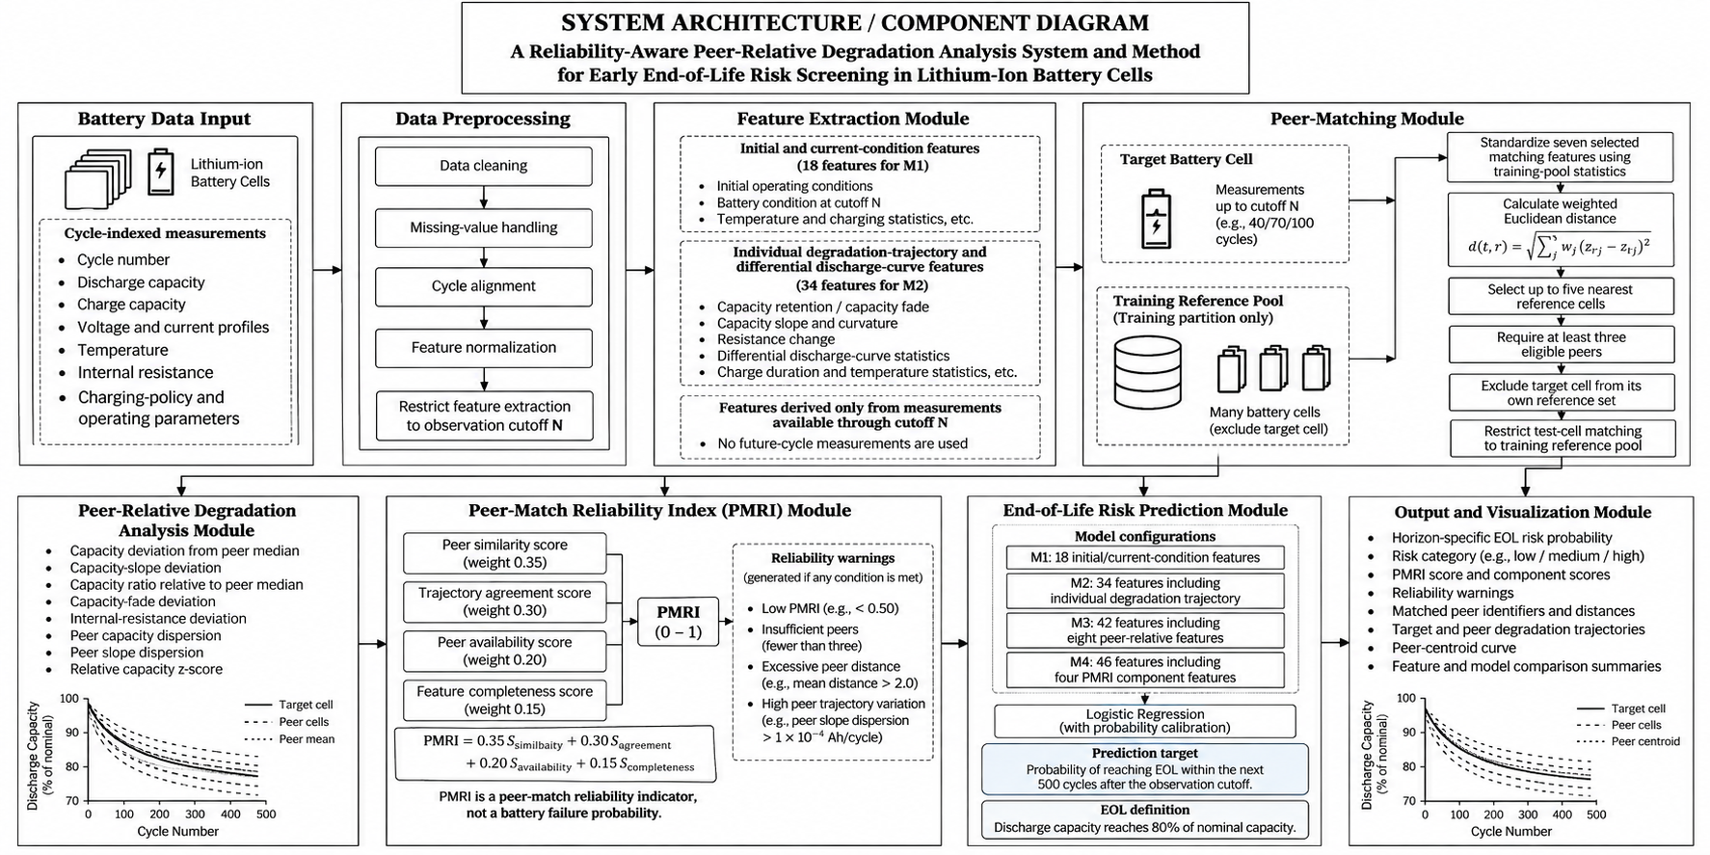
FIG. 1: System Architecture / Component Diagram
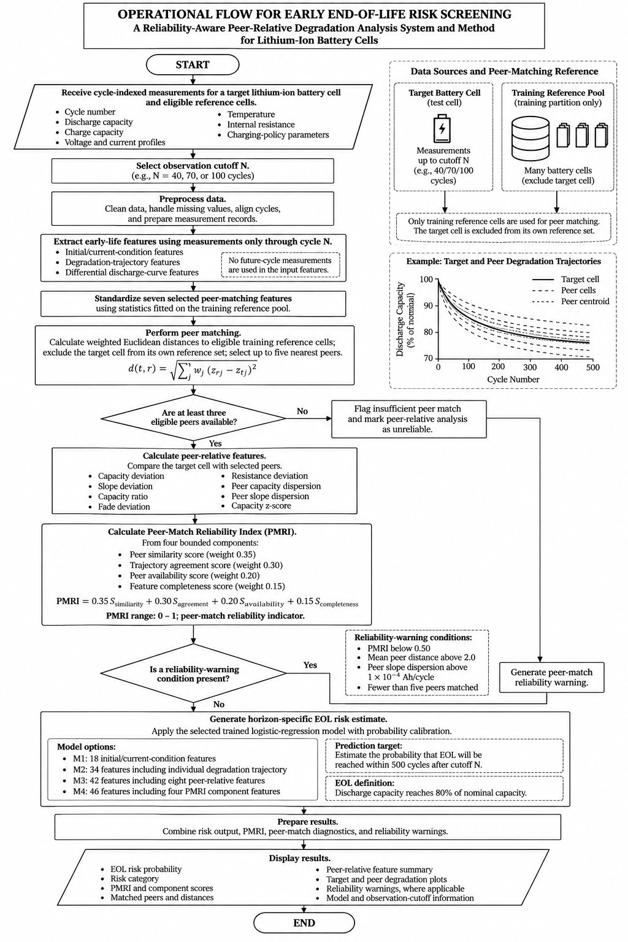
FIG. 2: Flow Diagram
DETAILED DESCRIPTION OF THE INVENTION:
The System for Reliability-Aware Peer-Relative Degradation Analysis operates through the following components, which work together to receive battery cycling data, extract degradation-related features, identify comparable cells, assess peer-relative behaviour and its reliability, estimate end-of-life risk and present the result in a unified manner. Reference is made to FIG. 1 for the arrangement of components and to FIG. 2 for the operational sequence.
1. Battery Data Acquisition Module:
The Battery Data Acquisition Module receives cycle-indexed battery measurements, including discharge capacity, charge capacity, internal resistance, temperature measurements, charging time, voltage and current profiles and charging-protocol parameters, each record being associated with a battery-cell identifier and cycle information. In one embodiment, the records are obtained from a publicly available lithium-ion battery aging dataset of lithium-iron-phosphate (LFP)/graphite cells subjected to repeated charging and discharging cycles. The module identifies the observations available for each cell and determines whether the cell has sufficient information for the configured prediction task, the cell identifiers enabling cell-level separation between training and evaluation data.
2. Data Preprocessing and Observation Cutoff Module:
This module cleans the received records, handles missing values and aligns cycles, and prepares them for analysis at predefined observation cutoffs, such as 40, 70 and 100 cycles, so that the feature representation at each cutoff is constructed only from measurements available up to that cutoff. Numerical features are standardized using statistics obtained from permitted training data only, so that held-out test cells do not influence the fitted preprocessing parameters. Cells for which the relevant outcome cannot be reliably established are handled as censored or excluded records, as applicable, and are not assigned an unsupported outcome label.
3. Battery Feature Engineering Module:
The Battery Feature Engineering Module transforms the processed records into numerical features representing initial battery condition, operating protocol, measurements at the observation cutoff, early degradation trajectory, and differential-discharge-curve statistics. The initial-condition and snapshot features describe the observed condition of the cell, including capacity, coulombic efficiency, internal resistance, temperature and charging behaviour; the trajectory features describe changes in capacity, capacity fade, degradation slope, curvature, resistance, temperature and charging time over the available observation interval.
The features are organised into four model configurations, designated M1, M2, M3 and M4, containing 18, 34, 42 and 46 features respectively, which enable evaluation of the contribution of individual-cell measurements, degradation-trajectory information, peer-relative characteristics and peer-reliability information to the prediction task.
4. Peer Matching and Similarity Assessment Module:
This module identifies reference cells having characteristics comparable to those of a target cell. Selected matching features, including charging-protocol parameters, initial discharge capacity, initial internal resistance, initial temperature and internal resistance at the observation cutoff, are standardized using training-derived parameters and compared through a weighted Euclidean distance, d(t, r) = √(Σj wj (zrj − ztj)²), where z denotes a standardized matching feature and w its weight. In one embodiment, seven matching features are used, with a greater weight assigned to selected charging-protocol characteristics and the remaining weight distributed across the other matching features.
The module ranks the eligible reference cells by calculated distance and selects up to five nearest peers, a minimum of three valid peers being required for a peer comparison. The target cell is excluded from its own reference group, and, when matching held-out test cells, only the training-cell reference pool is used. Where sufficient eligible peers or matching measurements are unavailable, the system identifies the matching limitation and does not treat the incomplete comparison as fully reliable.
5. Peer-Relative Degradation Analysis Module:
The Peer-Relative Degradation Analysis Module compares the observed degradation characteristics of the target cell with those of its selected peers and calculates eight peer-relative features, namely capacity deviation from the peer median, degradation-slope deviation, relative capacity ratio, capacity-fade deviation, internal-resistance deviation, peer-capacity dispersion, peer-slope dispersion and a standardized capacity deviation. A target cell whose capacity or degradation slope differs substantially from that of its peer group may exhibit a degradation pattern that warrants further examination. Such deviations are treated as comparative indicators, and not as proof of a defect or of impending failure, and are provided to the classification pipeline.
6. Peer-Match Reliability Assessment Module:
The Peer-Match Reliability Assessment Module implements the Peer-Match Reliability Index (PMRI), which combines four component scores, each bounded between zero and one, namely peer similarity (weight 0.35), agreement among peer degradation trajectories (weight 0.30), availability of valid peers (weight 0.20) and completeness of the matching features (weight 0.15), such that PMRI = 0.35·Ssimilarity + 0.30·Sagreement + 0.20·Savailability + 0.15·Scompleteness, and is itself bounded between zero and one.
The module further evaluates warning conditions which, in one embodiment, comprise fewer than five matched peers, a mean peer distance greater than 2.0, a peer-slope dispersion greater than 1×10-4 Ah per cycle, and a PMRI below 0.50. The PMRI is a heuristic indicator of the suitability of the peer comparison and is not a calibrated probability of battery failure. It is made available alongside the classification result so that a prediction supported by a suitable peer comparison may be distinguished from one affected by limited or inconsistent reference data.
7. End-of-Life Risk Prediction Module:
The End-of-Life Risk Prediction Module applies a trained machine-learning classifier to the engineered features to estimate whether the target cell will reach its defined end-of-life within a specified future cycle horizon. In one embodiment, end-of-life is the first cycle at which discharge capacity reaches 80% of nominal capacity, and the primary classification target is whether this occurs within 500 cycles after the selected observation cutoff; additional target definitions may be prepared for alternative horizons and early-failure analysis.
The principal classifier is a standardized logistic regression with L2 regularization and balanced class weighting, a Random Forest classifier being provided as an additional benchmark. Configuration M1 uses initial-condition and snapshot features; M2 adds individual degradation-trajectory and differential-discharge-curve features; M3 further adds the peer-relative features; and M4 additionally incorporates the PMRI component features. Probability calibration is performed by Platt scaling using out-of-fold training predictions, and the risk estimate and classification are generated according to the configured model and decision threshold. The module performs future end-of-life risk classification and does not output a continuous remaining-useful-life estimate.
8. Model Validation and Performance Assessment Module:
This module evaluates the prediction configurations using separate training, primary-test and secondary-test cell partitions, and includes checks for cell-level data leakage, inappropriate use of held-out data during preprocessing, and improper use of test outcomes during probability calibration. Performance is assessed using measures such as AUROC, area under the precision-recall curve, Brier score, expected calibration error, sensitivity, specificity, false-positive rate and F1-score, across observation cutoffs and test cohorts. The improvement obtained from adding peer-relative and peer-reliability features depends on the evaluation cohort and operating conditions, and the most feature-rich configuration is not presumed to be the best in every setting.
9. Interactive Dashboard and Result Presentation Module:
The Interactive Dashboard and Result Presentation Module, implemented in one embodiment using a Python-based HTTP server with browser-based interface components, presents the predicted end-of-life risk and risk category, comparisons across observation cutoffs, target and peer degradation trajectories, peer-centroid overlays, matched-peer identifiers and distances, PMRI values and component scores, reliability warnings, and model-comparison and evaluation visualizations. By presenting the prediction together with the peer-relative information and reliability indicators, the module allows a user to examine the basis and limitations of the estimated risk and not merely a standalone classification label.
10. Illustrative Example of Operation:
By way of a non-limiting working example, a battery cell undergoing repeated charging and discharging cycles is selected for early-life assessment at an observation cutoff of 70 cycles. The system receives the measurements of the target cell up to that cutoff and prepares the corresponding capacity, resistance, temperature, charging and trajectory features. The Peer Matching and Similarity Assessment Module compares the target cell with eligible reference cells of the permitted training pool and selects up to five nearest peers, provided that the minimum peer requirement is satisfied. The Peer-Relative Degradation Analysis Module then compares the capacity, degradation-slope, fade and resistance characteristics of the target cell with those of the selected peers, and the Peer-Match Reliability Assessment Module calculates the PMRI and determines whether any configured reliability warning applies.
The resulting feature representation is passed to the selected classification model, which estimates the likelihood that the target cell will reach the defined end-of-life threshold within the 500-cycle horizon following the observation cutoff. The dashboard presents the estimated risk, the classification, the peer-relative trajectory information and the reliability indicators, and, where the peer group is insufficient or a warning condition applies, that limitation is presented alongside the prediction. The example illustrates the operation of the system and does not imply any particular numerical risk estimate or guaranteed prediction accuracy.
11. Security, Data Integrity and Fail-Safe Considerations:
The system uses cell-level data partitions and training-derived preprocessing parameters to reduce the risk of information leakage between model development and evaluation; the target cell is excluded from its own peer group, and held-out test cells are compared only against the permitted training reference pool. Probability calibration and model evaluation are performed using the designated training procedures and are not fitted directly to held-out test outcomes. Incomplete observations, censored outcomes, missing matching features and insufficient peer availability are accounted for within the relevant processing stages, and where a valid peer comparison cannot be established, the corresponding peer-relative information is flagged as not fully reliable, and is not treated as battery failure, and a reliability warning is presented to the user. These measures support the integrity of the evaluation; they do not, by themselves, establish certification for safety-critical battery control or guarantee the correctness of every individual prediction.
12. Advantages of the Invention:
The invention offers several advantages over assessments based solely on individual-cell measurements, including: (i) analysis of degradation behaviour in early life, before the end-of-life event is observed; (ii) comparison of a target cell with similar reference cells, and not solely on absolute measurements; (iii) integration of individual-trajectory and peer-relative features within a common classification framework; (iv) explicit assessment of peer-match reliability through the PMRI and associated warnings; (v) evaluation of probability estimates and classification performance across separate cell cohorts; and (vi) presentation of predictions and supporting peer comparisons through an interactive dashboard. The extent of any improvement in predictive performance depends on the dataset, prediction horizon, observation cutoff and evaluation conditions.
13. Alternative Embodiments:
While the system has been described with reference to a particular battery-aging dataset, peer-matching procedure, PMRI formulation and classification pipeline, it will be appreciated by a person skilled in the art that the same principle may be extended, without departing from the scope of the invention, to (i) other battery datasets and lithium-ion cell chemistries, provided that the required measurements and reference data are available; (ii) adjustment of the number of selected peers, matching-feature weights, observation cutoffs, prediction horizons and reliability thresholds according to the battery population and intended application; (iii) incorporation of additional battery-health measurements or trajectory descriptors; (iv) use of alternative classification or probability-calibration methods, subject to suitable training and validation; and (v) processing of measurements from laboratory test equipment, battery-management systems or fleet-monitoring platforms. Any continuous remaining-useful-life prediction or real-time operational control would require its own implementation and validation.
14. Industrial Applicability:
The invention is industrially applicable in the fields of battery-aging research, lithium-ion cell characterization, battery-health monitoring, predictive maintenance and comparative assessment of battery degradation, and may be used by battery researchers, cell manufacturers, battery testing laboratories and developers of battery-monitoring software, and is capable of being implemented using conventional computing hardware, data-processing software and machine-learning libraries. Its application to deployed battery-management systems or safety-critical applications would depend on further validation under representative operating conditions.
CLAIMS:
We claim:
- A computer-implemented system for early end-of-life risk prediction and peer-relative degradation analysis of lithium-ion battery cells, the system comprising: a battery data acquisition module configured to receive cycle-level battery measurements including discharge capacity, charge capacity, internal resistance, temperature measurements, charging time and charging-protocol parameters; a data preprocessing and feature engineering module configured to prepare battery records at a predefined observation cutoff and derive battery-condition and degradation-trajectory features; a peer-matching module configured to identify reference battery cells having initial-condition and operating characteristics similar to those of a target battery cell; a peer-relative degradation analysis module configured to determine deviations between the target battery cell and the identified reference battery cells; a Peer-Match Reliability Index (PMRI) module configured to assess the reliability of the peer comparison; and a machine-learning classification module configured to estimate, based on the derived features, whether the target battery cell will reach a predefined end-of-life threshold within a specified future cycle horizon.
- The system as claimed in claim 1, wherein the said peer-matching module is configured to standardize selected matching features using parameters derived from training data, calculate a weighted Euclidean distance between the target battery cell and eligible reference battery cells, rank the reference battery cells by the calculated distance, and select up to five nearest peers subject to a minimum peer-availability requirement, while excluding the target battery cell from its own reference group; and wherein the said peer-relative degradation analysis module is configured to derive peer-relative features comprising capacity deviation from peer capacity, degradation-slope deviation, relative capacity ratio, capacity-fade deviation, internal-resistance deviation, peer-capacity dispersion, peer-slope dispersion and standardized capacity deviation.
- The system as claimed in claim 1, wherein the said PMRI module is configured to calculate a composite reliability score from a plurality of component scores comprising peer similarity, peer trajectory agreement, peer availability and matching-feature completeness, and to generate a reliability warning when one or more predefined conditions relating to peer count, peer distance, peer-slope dispersion or the calculated reliability score are satisfied; and wherein the said machine-learning classification module comprises a plurality of feature configurations, including a baseline configuration, a trajectory configuration, a peer-relative configuration and a confidence-aware configuration incorporating peer-reliability features, and is configured to apply a regularized, class-weighted logistic regression classifier with probability calibration using predictions generated from training data, the said predefined end-of-life threshold corresponding to the first cycle at which discharge capacity reaches 80% of nominal capacity within 500 cycles following the said observation cutoff.
- A computer-implemented method for early end-of-life risk screening of lithium-ion battery cells, the method comprising: receiving cycle-level battery measurements for a target battery cell and eligible reference battery cells; selecting a predefined observation cutoff; deriving battery-condition and degradation-trajectory features from measurements available up to the said cutoff; standardizing selected matching features using training-derived parameters; calculating similarity distances between the target battery cell and the eligible reference battery cells and selecting a peer group according to the calculated distances and peer-availability requirements; deriving peer-relative degradation features; calculating a Peer-Match Reliability Index from peer similarity, trajectory agreement, peer availability and feature completeness; providing the resulting feature representation to a trained machine-learning classifier to estimate the probability that the target battery cell will reach a predefined end-of-life threshold within a specified future cycle horizon; and presenting the risk estimate together with peer-comparison reliability information through an interactive dashboard, wherein preprocessing and probability-calibration parameters are fitted using designated training data and held-out test battery cells are excluded from such fitting.
ABSTRACT:
A system and method for confidence-aware, peer-relative degradation trajectory analysis and early end-of-life risk prediction of lithium-ion battery cells is disclosed. The system receives cycle-level battery measurements and derives battery-condition, degradation-trajectory and operating-protocol features at a predefined observation cutoff. A peer-matching module identifies comparable reference cells using standardized matching features and weighted distance calculations, and a peer-relative degradation analysis module derives features representing differences between a target cell and its selected peers, including capacity deviation, degradation-slope deviation, capacity-fade deviation, internal-resistance deviation and peer-trajectory dispersion. A Peer-Match Reliability Index (PMRI) module combines peer similarity, trajectory agreement, peer availability and feature completeness to assess the reliability of the comparison and to generate corresponding warnings. A machine-learning classification module processes the resulting feature representation to estimate whether the target cell will reach a predefined end-of-life threshold within a specified future cycle horizon; in one implementation, end-of-life is defined by discharge capacity reaching 80% of nominal capacity and the prediction target concerns the occurrence of end-of-life within 500 cycles following the observation cutoff. Multiple feature configurations enable comparative assessment of individual-condition, trajectory-based, peer-relative and peer-reliability information, and an interactive dashboard presents risk estimates, peer-relative trajectories and reliability indicators to support early-life battery degradation screening.

