IBM DATA ANALYTICS

PROJECT V

NAME : JAYANTHI M
REGISTER : 420421104030
ROLL NO : 14

WEBSITE TRAFFIC ANALYSIS

Problem statement :
Outline the project's objective, design thinking process, and development phases.
Describe the analysis objectives, data collection process, data visualization using IBM Cognos, and Python code integration.
Explain how the insights from the analysis can help website owners improve user experience.

SOLUTION STATEMENTS:

• Outline the project's objective, design thinking process, and development phases.

> Web traffic analytics refers to collecting data about who comes to your website and what they do when they get there.
>>That data is crucial to building effective sales and marketing strategies. While most people assume more traffic is always better, that's not always true.

Design thinking process:

> Design thinking is a human-centered approach that involves empathizing with users, defining their needs, ideating solutions, prototyping and testing them, and iterating to improve them. In this article, you will learn how to leverage data and analytics to inform and enhance your design thinking process at every stage.

The five stages of design thinking, according to the d.school, are:
- Empathize:
- * research your users' needs.
- Define:
- *state your users' needs and problems.
- Ideate:
- *challenge assumptions and create ideas.
- Prototype:
- *start to create solutions.
- Test:
- *try your solutions out.
- 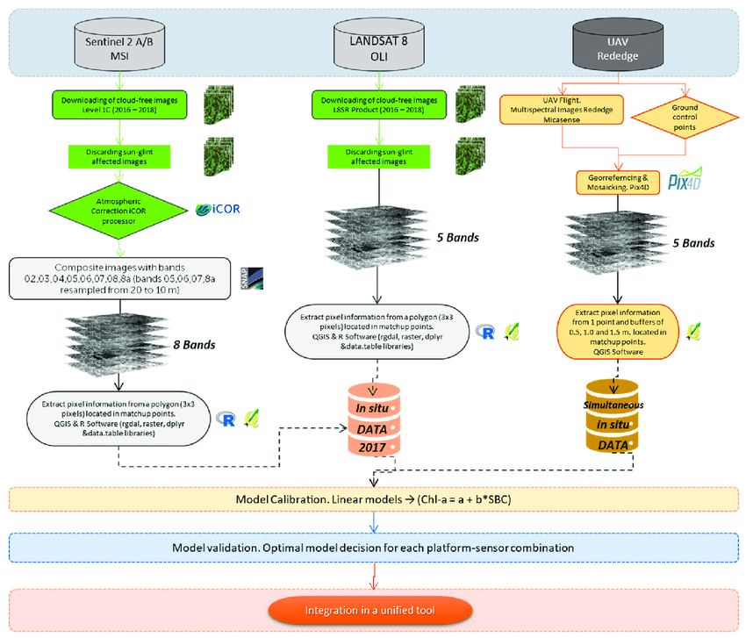
Development phases:
* Data analytics is the analysis of qualitative and quantitative data from your business and the competition to drive continual
improvement of your users’ online experience to enable you to
achieve your organisational goals.
* It allows you to measure, manage and analyse marketing performance to maximise efectiveness.
1. Data Collection:
* Web Analytics Tools: Use web analytics tools like Google
Analytics, Adobe Analytics, or Matomo (formerly Piwik) to
gather data about your website & visitors, their behavior, and
other relevant metrics.
2. Key Metrics:
Traffic Sources: Understand where your visitors are coming
from.
This can include organic search, direct traffic, referral traffic
from other websites, social media, and paid advertising.
3. Traffic Segmentation:
* Analyze traffic by segments such as new vs. returning
visitors, device type (desktop, mobile, tablet), geographic location,
and referral sources.
* Segmenting your

4. User Behavior:
* Track the user journey through your website, including the
path they take, the pages they visit, and the actions they perform.
* Heatmaps and session recordings can provide visual insights
into user behavior and interactions.
6. Goal Tracking:
*Set up goals and conversion funnels in your analytics tool to
measurethe success of specific actions or objectives.
*Analyze the steps users take to complete these goals and
optimizethe process.

PURPOSE TO DEVELOP THE-PROJECT:

Controlling web traffic:

Persons for visiting the site most importantly for the few farts of the
webpage will be helpful for us to maintain the secured website. Allowing the
access for website based on the based on the geographical network with the help
of the google maps will help the authorized person to find the exact traffic of the
website.

Increase website traffic:

Website-traffic is often increasing by space of a website in search engines
and buying advertisements, which involves-email in bulk, pop-up advertisements,
and also the page-annunciations. Website-traffic also can be built as per
purchasing the advertisements which will be provided offline basedadvertising. If
the website page will provide details with a page that appears-on any surf, then it
cannot be found by someone visiting its related pages in a great way.

Flux Traffic:

Website traffic which arrived-from a list which is not paid at gateways or
indexes is typically mentioned as a Flux traffic. Flux traffic is often produced by
containing the web site index , search engines, guides. To track the number of
visitors of each page in the-website.
Your analyzed data will also tell about how well your search engine
optimization on your site is working. Not only these two things, how content and
attract visitors.

Existing system:

The Existing System of web-traffic-analyzers don't have any tool to trace
any information about the website like how many people have visited that website
or from where it's open.

Overloaded traffic:
When there is a huge amount of website traffic it can slow down access. but
when the website-traffic is reduced it can become or can make provident for your
website. This is because the increase of requests for files on the website happens
The main aim of the project is business methodology-modernization. We also have
been giving gibberish trying to computerize different-forms of various web traffic.

• Describe the analysis objectives, data collection process, data visualization using IBM Cognos, and Python code integration.
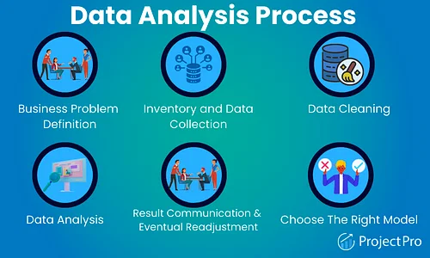

Necessary step to follow:
1.Import Libraries:
Start by importing the necessary libraries.
Program:
import pandas as pd
import numpy as np
import seaborn as sns
import matplotlib.pyplot as plt
from sklearn.metrics import accuracy_score
%matplotlib inline

2.Load the Dataset:

Load your into a Pandas DataFrame.You can typically find house price datasets in csv format,but you can adapt this code to other formats as needed.

Program:

df = pd.read_csv('daily-website-visitors.csv')

Let's Visualize daily website visiters data and get some insight on our dataset!
Python has lots of visualization tools from Pandas, Matplotlib and Seaborn Libraries. We'll use couples of them to visualize data. You'll find data visualization quite interesting and v interesting fact is without calculating/applying any algorthim we will be able to make intuition on Data.

Relationship between Day.Of.Week and Page.Loads using scatter plot:
plt.figure(figsize=(14,8))
ax = df[df.Day=='Sunday'].plot.scatter(x='Day.Of.Week', y='Page.Loads', label='Sunday')
df[df.Day=='Monday'].plot.scatter(x='Day.Of.Week', y='Page.Loads', color='red', label='Monday', ax=ax)
df[df.Day=='Tuesday'].plot.scatter(x='Day.Of.Week', y='Page.Loads', color='orange', label='Tuesday', ax=ax)
ax.set_xlabel("Day.Of.Week")
ax.set_ylabel("Page.Loads")
ax.set_title("Relationship between Day.Of.Week and Page.Loads")
plt.show()

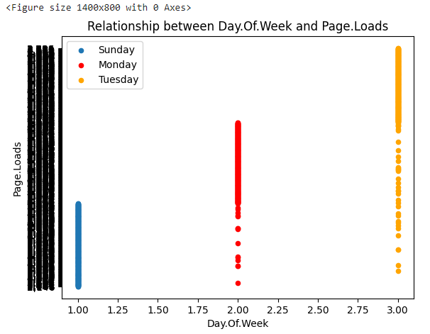

Histogram:
df.hist(edgecolor='black', linewidth=1)
plt.show()

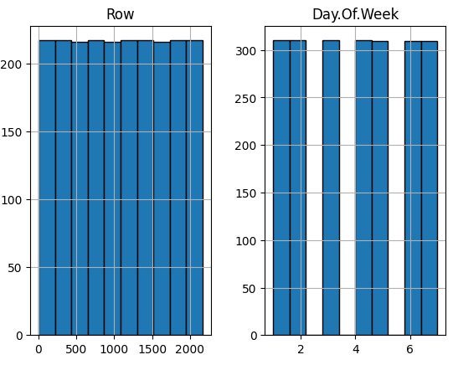

Take a look at density:
df.plot(kind = "density", figsize=(10,8))

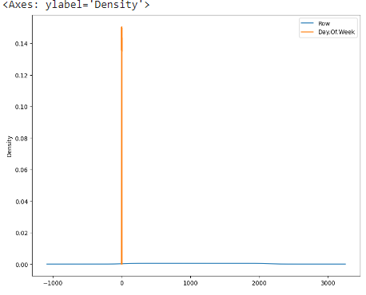

Seaborn:
Seaborn has many nice functions for plotting. You can create jointplot, hisplot, pairplot, boxplot, violinplot(it's damn cool), heatmap polt etc etc. I recommend seaborn personally cause it has many cool ploting techniques!
Program:
import seaborn as sns
df = pd.read_csv('daily-website-visitors.csv')
sns.jointplot(x='Day.Of.Week',y='Page.Loads', data = df)
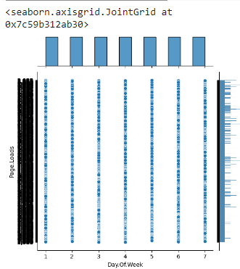
#Seaborn Scatterplot by Day on Day.Of.Week vs Page.Loads
g = sns.FacetGrid(df, hue='Day')
g = g.map(plt.scatter, 'Day.Of.Week','Page.Loads').add_legend()

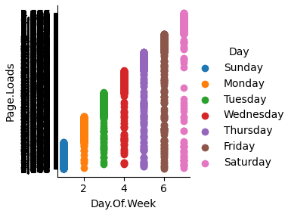
# seaborn scatterplot by Day on Unique.Visits vs First.Time.Visits

g = sns.FacetGrid(df, hue='Day')
g = g.map(plt.scatter, 'Unique.Visits', 'First.Time.Visits').add_legend()
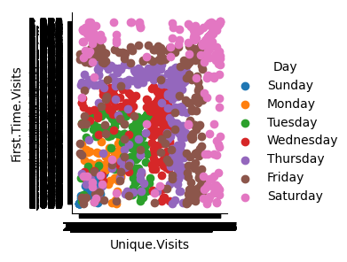
Box Plot:
Box Plot is the visual representation of the depicting groups of numerical data through their quartiles. Boxplot is also used for detect the outlier in data set. It captures the summary of the data efficiently with a simple box and whiskers and allows us to compare easily across groups.
Program:
df.boxplot(by = 'Day', figsize = (16,8))

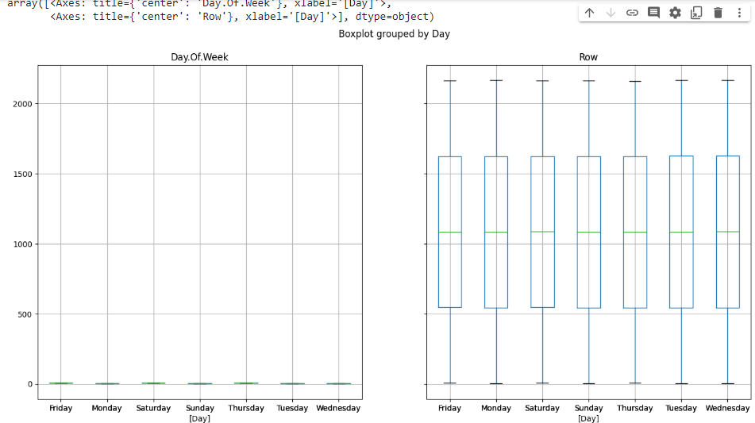
Voilin Plot:
A violin plot plays a similar role as a box-and-whisker plot. It shows the distribution of data points after grouping by one (or more) variables. Unlike a box plot, each violin is drawn using a kernel density estimate of the underlying distribution.
Program:
plt.figure(figsize=(14,10))
plt.subplot(2,2,1)
sns.violinplot(x='Day', y='Day.Of.Week', data=df, size=5)
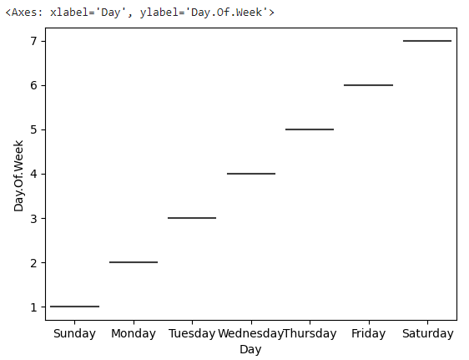
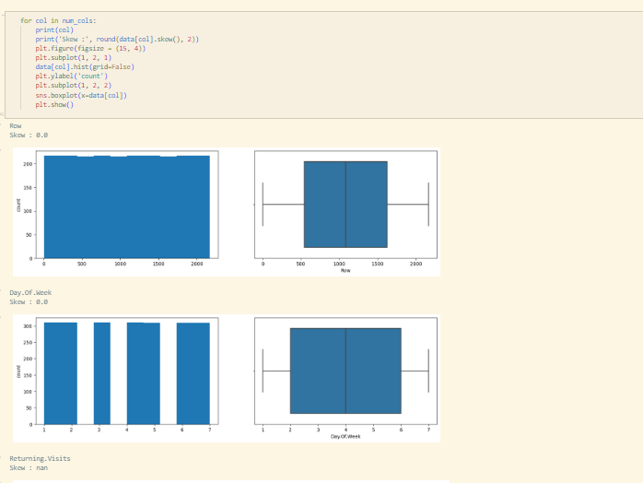

Types of Daily Visits Comparison :

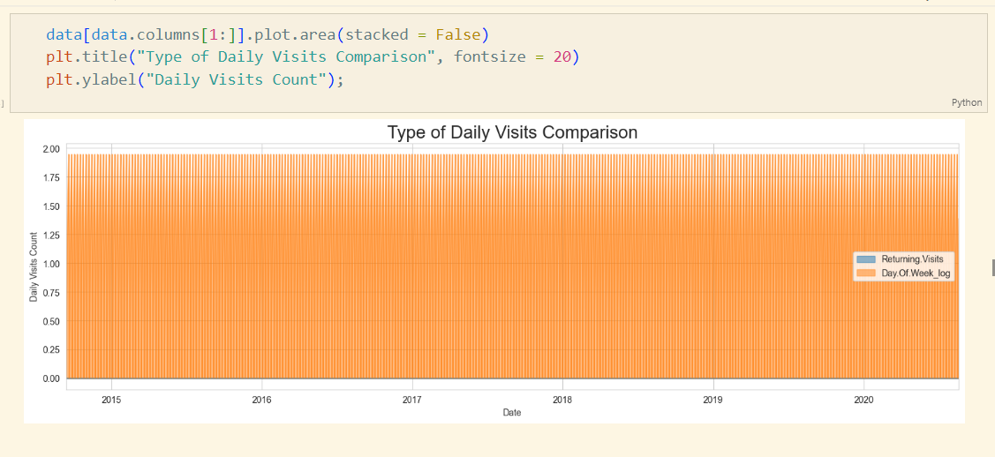

Web Traffic by Wednesday:

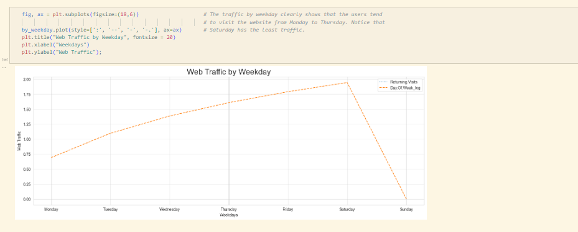

Web traffic by year

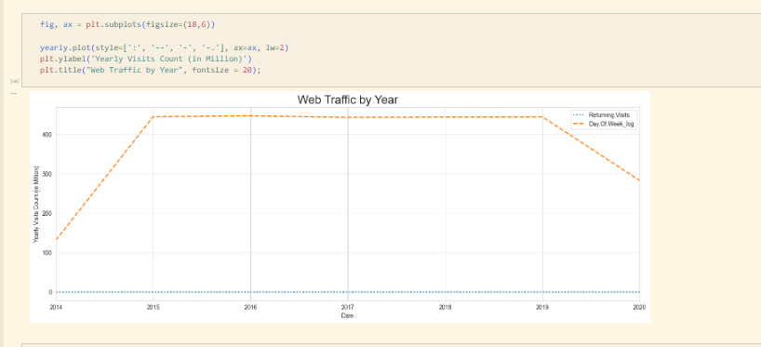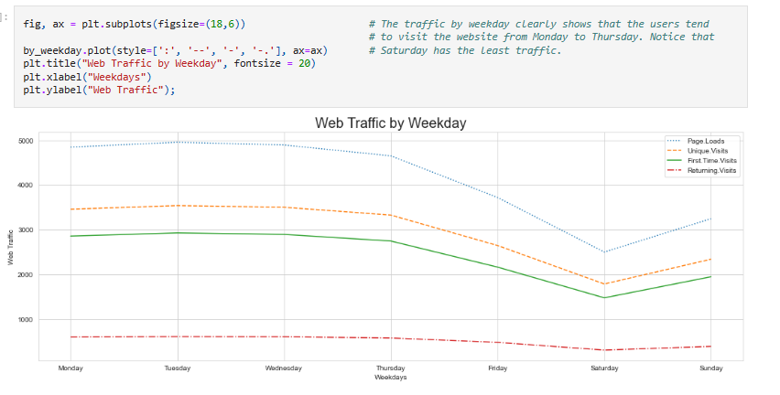
Web traffic by month
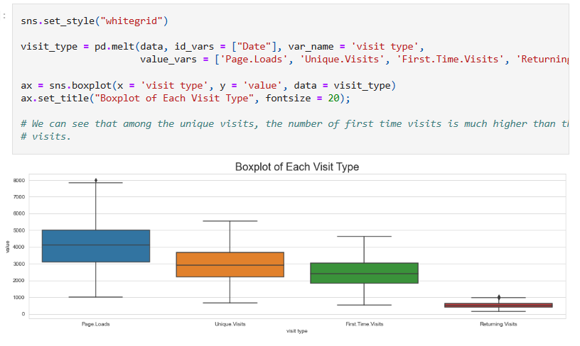
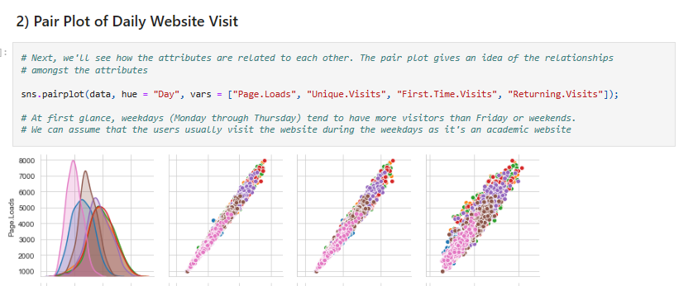
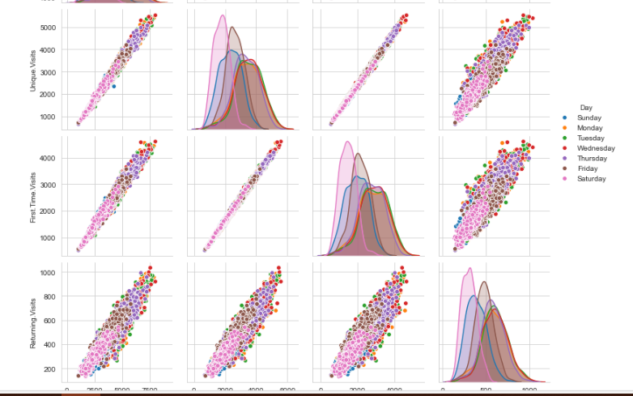

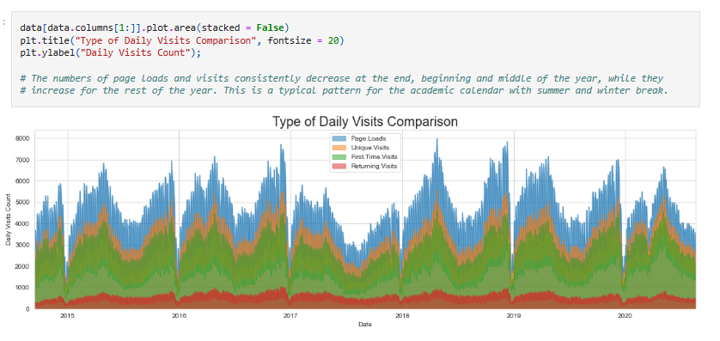
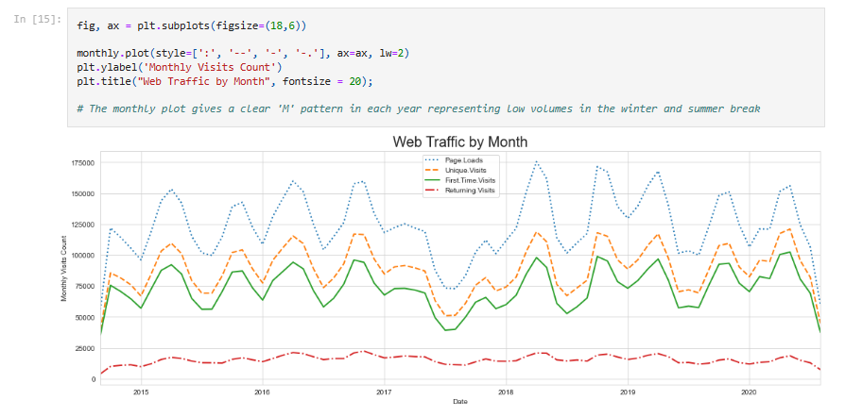
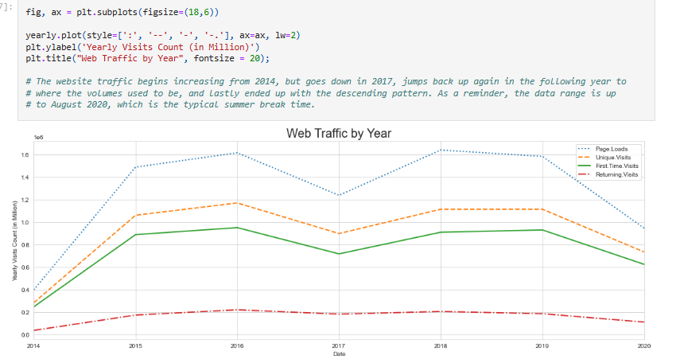
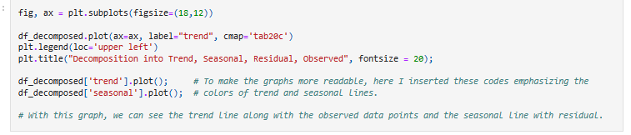
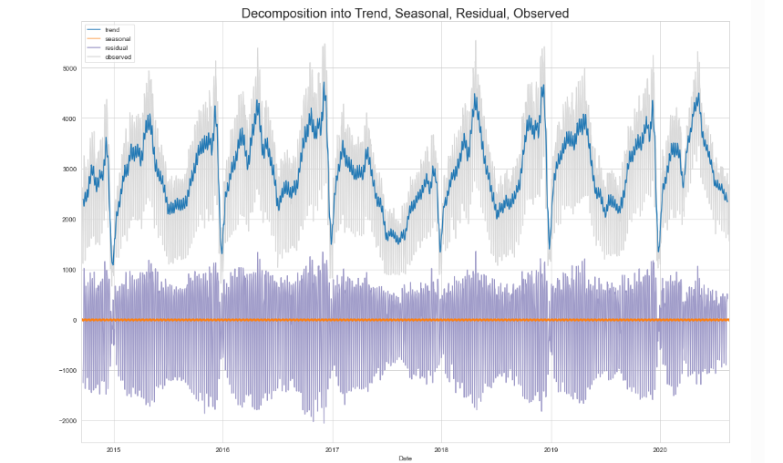

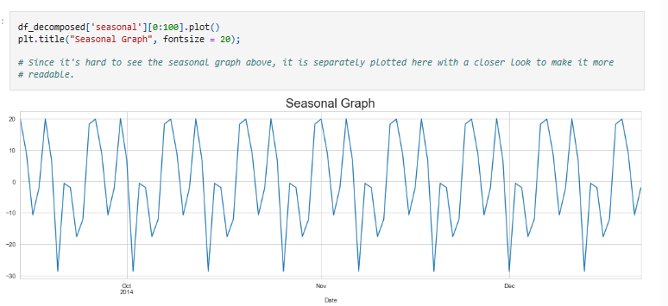

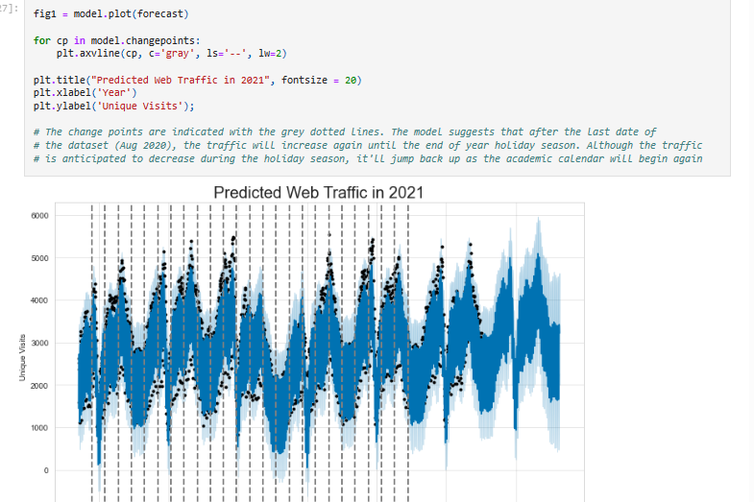
fig2 = model.plot_components(forecast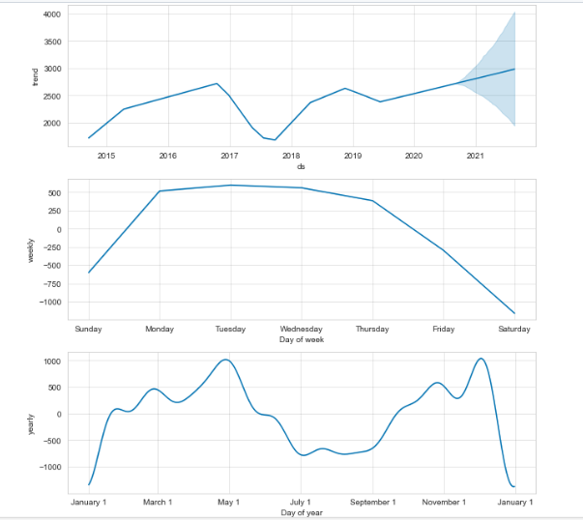

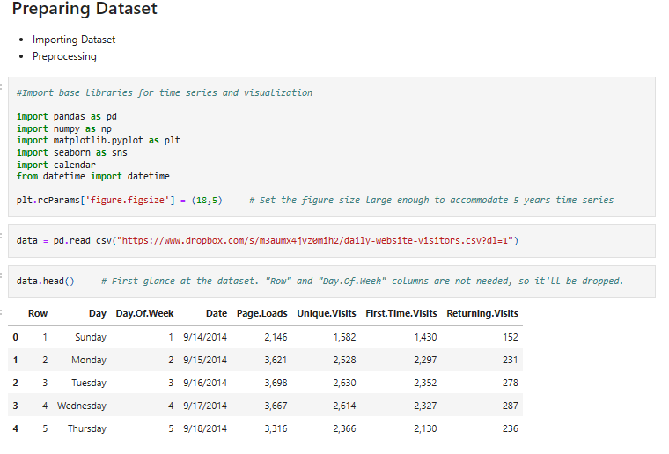
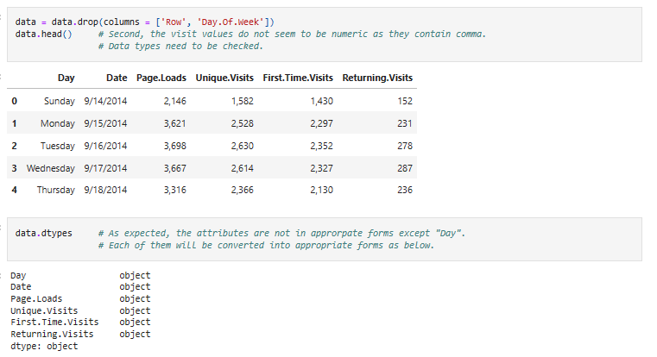
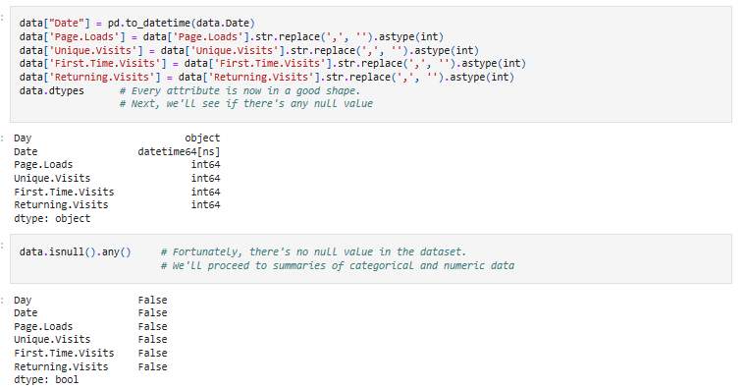
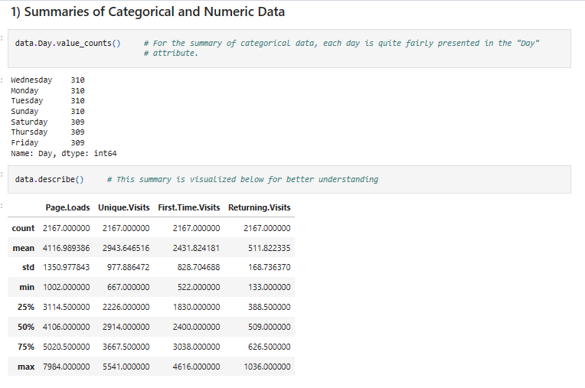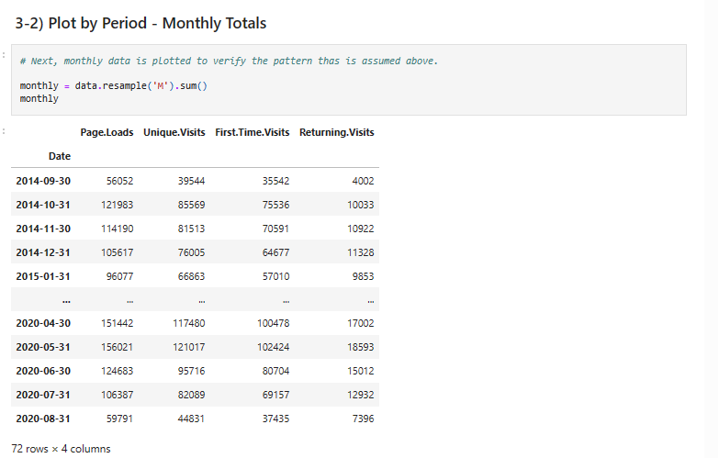
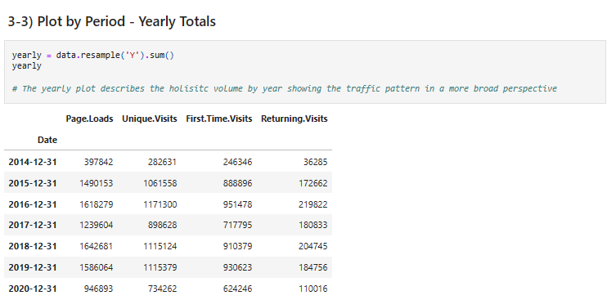
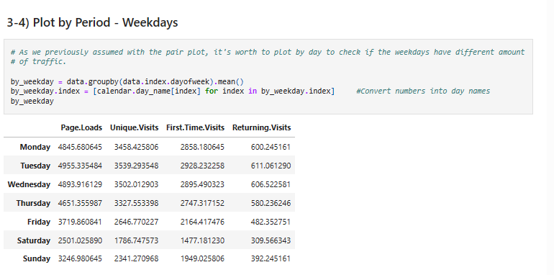
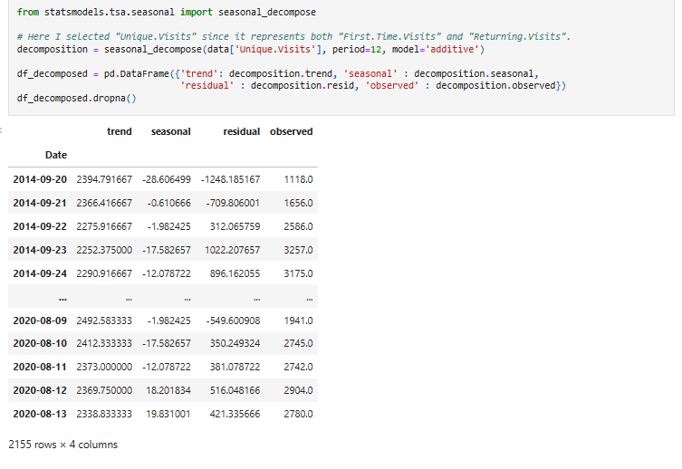

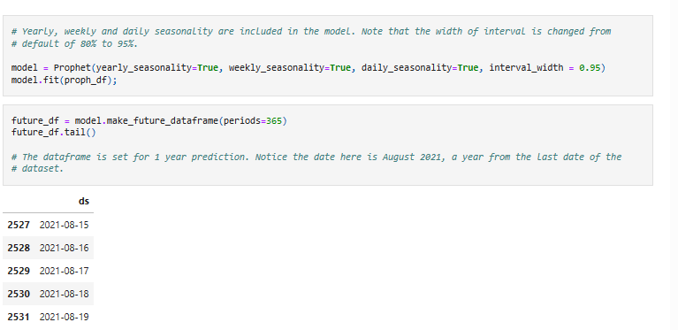
Use IBM Cognos to create interactive dashboards and reports that display insights such as popular pages, traffic sources, and user engagement metrics.
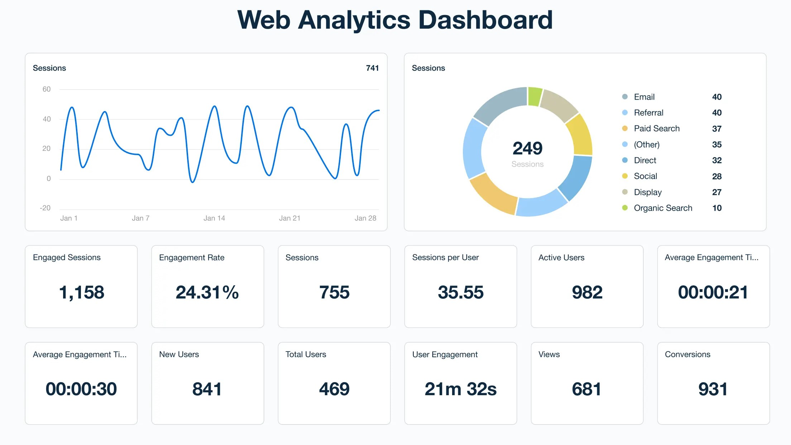
• Explain how the insights from the analysis can help website owners improve user experience.

Website traffic analysis provides valuable insights that drive actionable strategies.
By analyzing visitor behavior, businesses can optimize their website and improve user experience.
For instance, identifying popular landing pages helps focus content creation efforts on what resonates with the audience.

Insights can I get from web analytics:
For example,
web analytics will show you the most popular pages on your website, and the most popular paths to purchase. With website analytics, you can also accurately track the effectiveness of your online marketing campaigns to help inform future efforts.

the benefit of a website analysis
Website analytics are a useful tool in optimising your website performance by highlighting how users are interacting with your data. Not only does it allow you to understand how well your website is performing, but it provides insightful data about your visitors.

The insights from the analysis:

Analyze Your Keywords

Increase the number of potential customers who find your website.
Take a look at the keywords that people are using to find your website. Are they typing in your business name, or are they typing in words or phrases related to your offerings? When searching for a product or service, people don’t type business names into the search engine; they search for the product or service they are looking for, in their particular location or for their specific circumstances. This is why getting found for relevant searches is of the utmost importance, especially if your business name doesn’t include or indicate your offerings.
To increase the number of people who find your website, work on your search engine optimization. Try to get each page to rank for different keywords, all of which should be related to your business, products, and services.

Reduce Your Bounce Rate

Increase engagement on your website, to help with conversion and SEO.
The bounce rate of a website is the percent of your website visitors who exit without visiting a second page. A bounce rate around 50% is okay, but if it’s higher than that you’ll want to work on engaging your website visitors more. To reduce your bounce rate, make sure that your navigation bar is present on every page of your site, so that visitors can access different pages without having to use the back button or return to the homepage every time. Also, include links in your pages to other pages on your website, either by hyperlinking within the text or using call to action buttons.

Optimize Popular Pages

Optimize secondary pages on your website, where visitors are more likely to convert.
The homepage of a website typically has the highest traffic, but don’t forget about the next couple of popular pages. The quantity of traffic on these other pages may be lower, but the quality of that traffic may very well be higher. This is because visitors on your homepage are most likely getting acquainted with your business, while visitors to the other pages are interested and want to learn more.
To improve your website, identify your “runner-up” pages and insert calls to action on them, as visitors here may be more likely to convert.

Improve Lead Rate

Optimize your site for lead generation with tracking and contact forms.
How many website visitors do you get each week or month? How many of those visitors convert into leads or customers? To be able to find out if your website is generating leads, you’ll need to use tracked links for your landing pages, have a tracked phone number on your website, and also replace any publicly visible email addresses with contact forms. This will help your website to not only generate leads, but also to find out which activities are generating the most leads.
Your number of leads is not as important as the percentage of website visitors that convert into leads. The more traffic your website gets, the more leads you should be getting. If your lead rate is stagnant or declining despite growing traffic, you may want to check out this post: Three Free Ways to Generate More Leads from Your Website.

Analyze Long-Term Trends

Stay on your toes to ensure an upward overall trend.
Take a look at your number of website visitors over a long period of time (such as one year or more). Is the graph flat, trending down, or trending up? It goes without saying that you want your traffic to be trending upward. If it is flat, you probably need to brush up on your SEO or introduce some new strategies such as social media campaigns or online advertising. If your traffic is trending downward, your competitors may be marketing more aggressively effectively than you.
With an understanding of the metrics, your business website can be a powerful lead-generating tool. Take some time to get familiar with the data. You won’t be an expert right away, but the more time you spend with it the better you’ll be able to make sense of it, and the more efficiently you can improve your marketing strategies.

Increase Referral Traffic

Use your network and social media to increase your referral traffic.
Search engines aren’t the only means by which a potential customer can find your website. In addition to search, two other sources of website traffic are direct and referral. Direct visitors refer to people who typed your website address directly into their browser. They may have heard about you from someone else or through an advertisement and decided to learn more by investigating your website.
Referral visitors are those who arrived by clicking on a link to your website from another website—not to be confused with a search engine like Google—such as an influencer blog post or social media post). If your referral traffic is low, reach out to people in your network who could include a link in their content to your website. You might also want to reach out to local media outlets for any publicity opportunities. In addition, be sure to maintain an active presence on social media, posting regularly with links to helpful and informative blog posts and website pages.

Conclusion:
Website traffic data is highly valuable for investors to gain real-time insights into a company's performance and growth potential.
trafficanalytics refers to collecting data about who comes to your website and what they do when they get there. That data is crucial to building effective sales and marketing strategies. While most people assume more traffic is always better, that's not always true
*Web analytics is the collection, reporting, and analysis of website data. The focus is on identifying measures based on your organizational and user goals and using the website data to determine the success or failure of those goals and to drive strategy and improve the user's experience.

