DESIGN

PIN DIAGRAM OF ATMEGA328 MICROCONTROLLER:

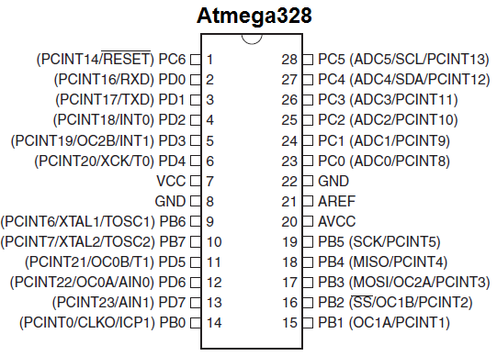

CIRCUIT DIAGRAM:

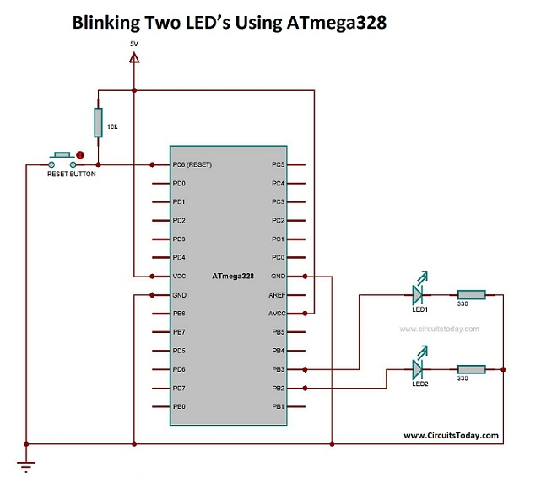

PIN DESCRIPTION OF ATMEGA328

* Functions associated with the pins must be known in order to use the device appropriately.
* ATmega-328 pins are divided into different ports which are given in detail below.
* **VCC**is a digital voltage supply.
* **AVCC**is a supply voltage pin for analog to digital converter.
* **GND**denotes Ground and it has a 0V.
  + **Port A**consists of the pins from **PA0**to**PA7.**These pins serve as an analog input to analog to digital converters. If analog to digital converter is not used, **port** **A**acts as an eight (8) bit bidirectional input/output port.
  + **Port B**consists of the pins from **PB0**to**PB7.**This port is an 8 bit bidirectional port having an internal pull-up resistor.
  + **Port C**consists of the pins from **PC0**to**PC7.**The output buffers of **port C**has symmetrical drive characteristics with source capability as well high sink.
  + **Port D**consists of the pins from **PD0**to**PD7.** It is also an 8 bit input/output port having an internal pull-up resistor.