Login System (Client & Support Team)
Login page 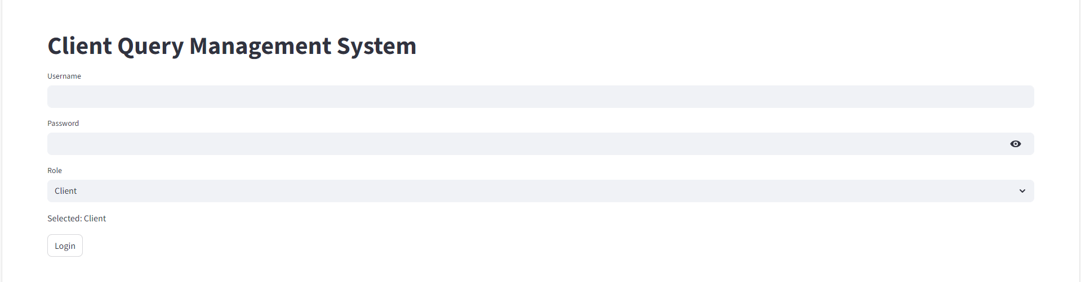
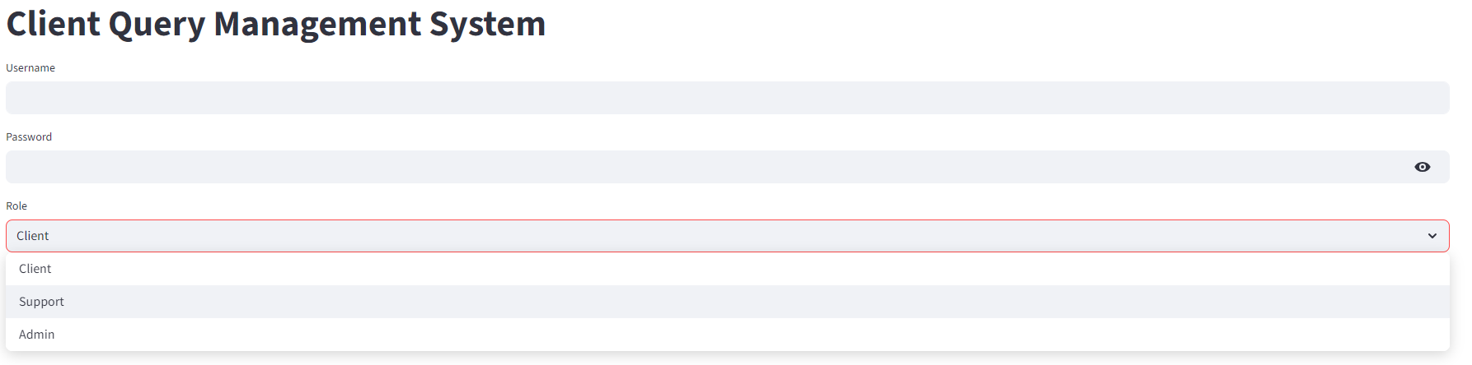

Hashed password 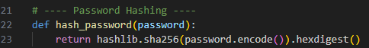
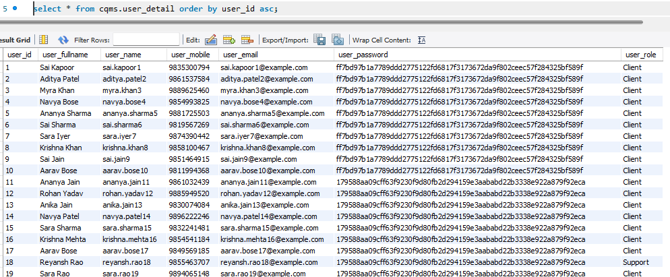

Login to client 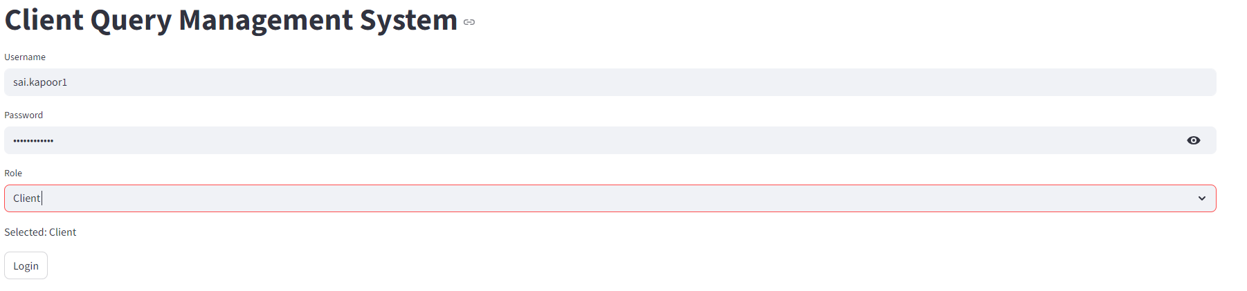
Successful login 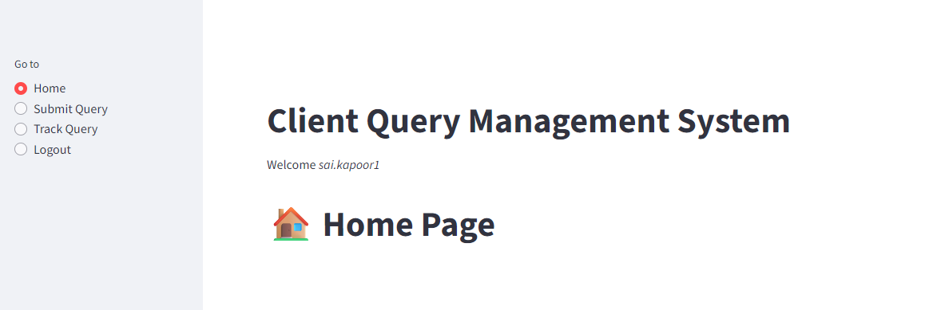
Logout 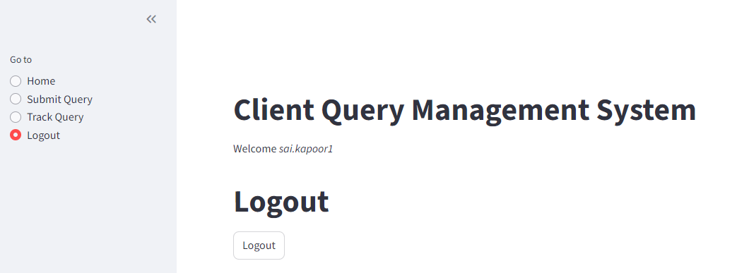
After logout automatically navigates to login page 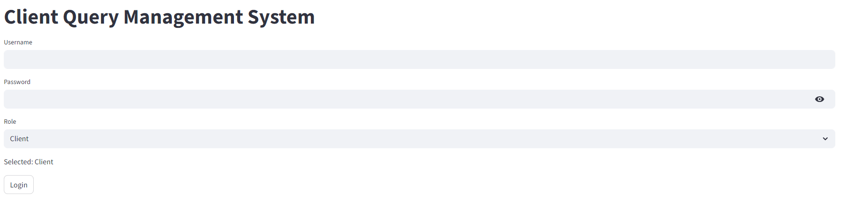
Unable to login after providing the wrong password 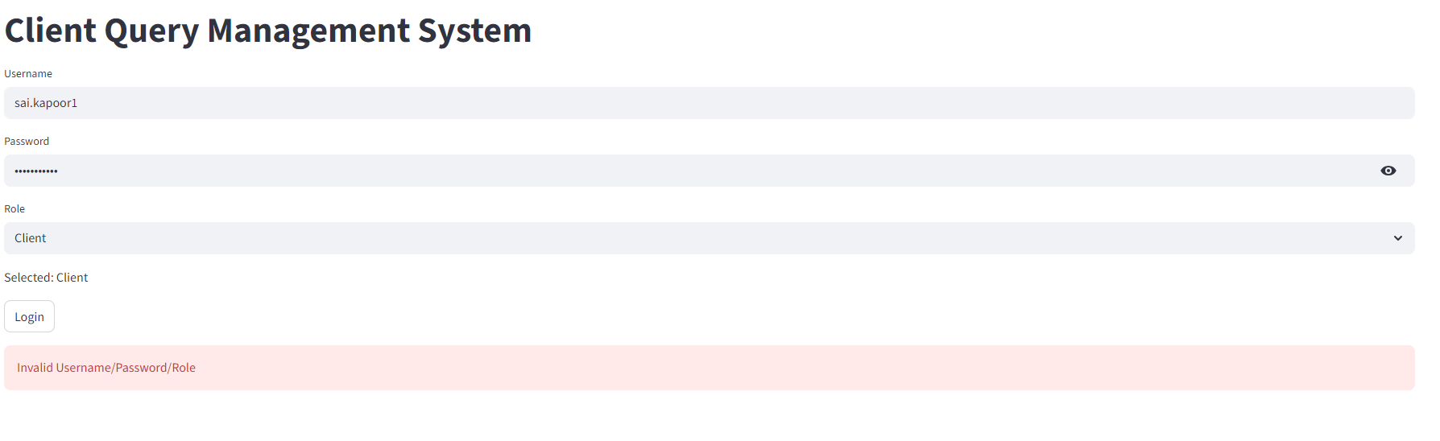

Support login 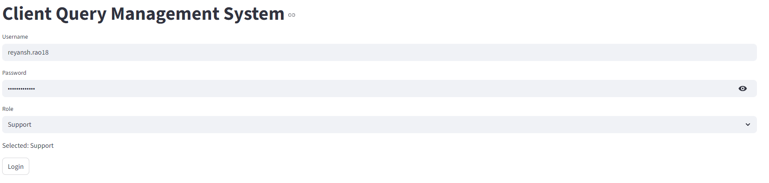
Successful login 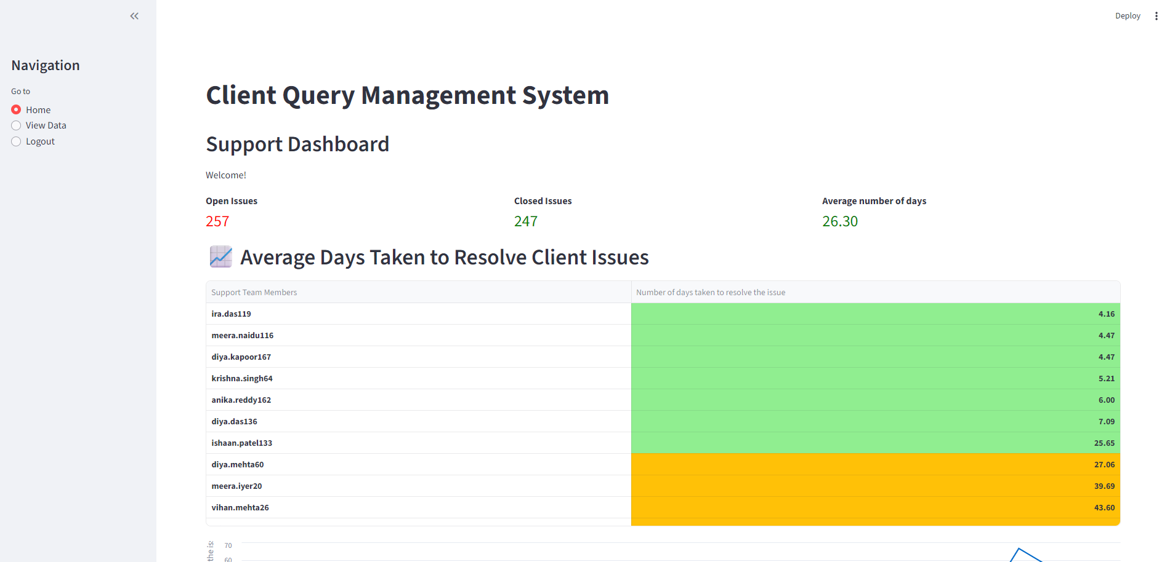

Client User flow
User inputs cred 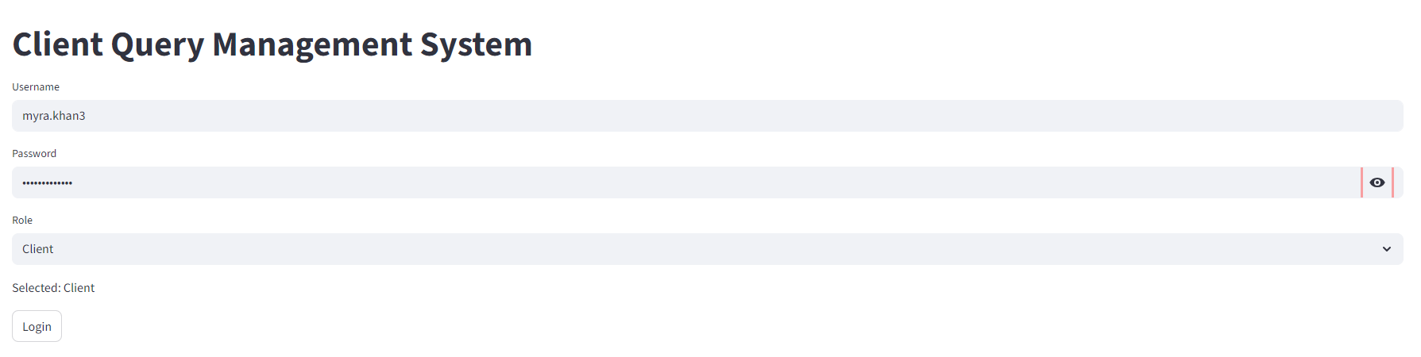
Home page 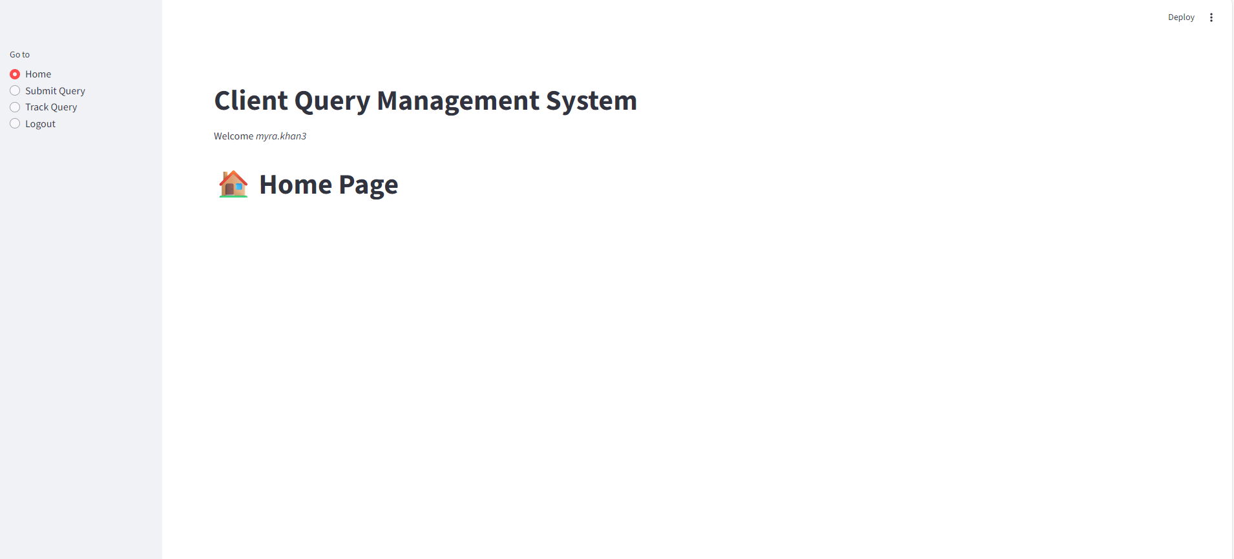

Additionally added the Track query. As there is no query raised by the user, so user gets the error ‘No data found!’ 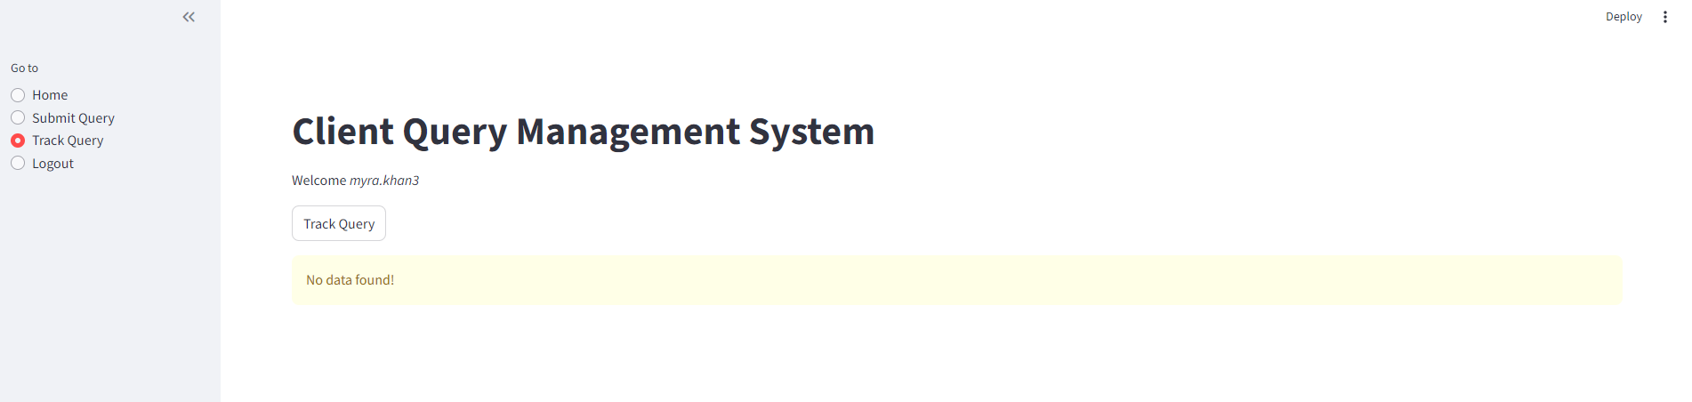
User raises the query 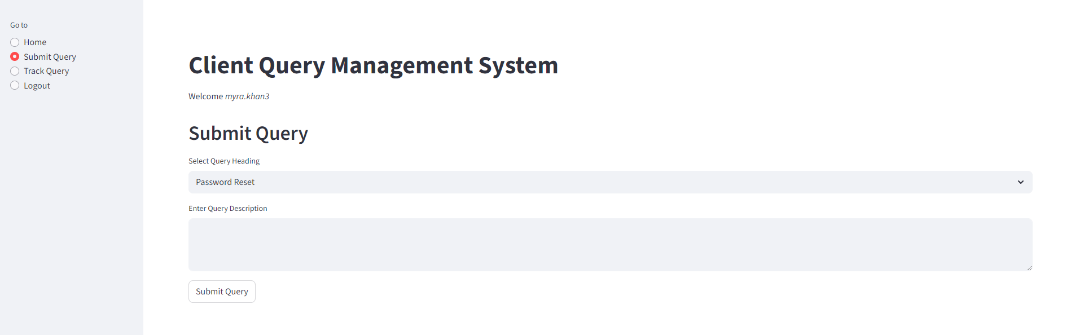
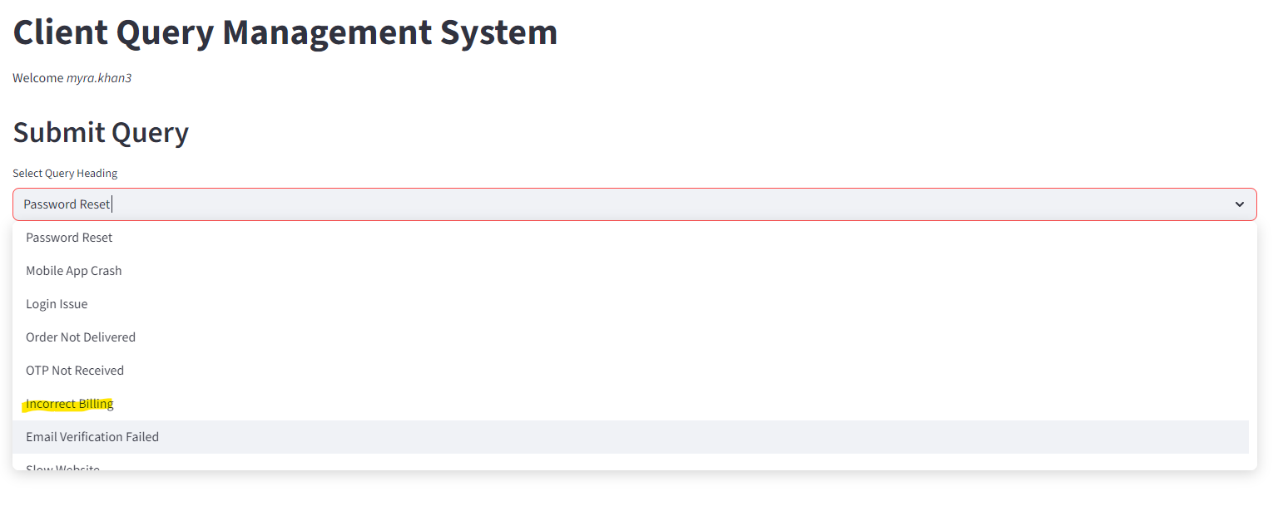
Inputs the data
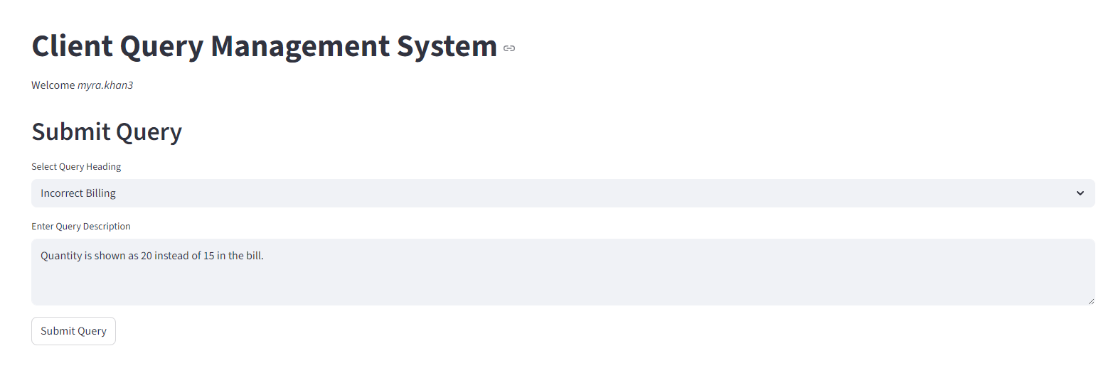
Submitted successfully 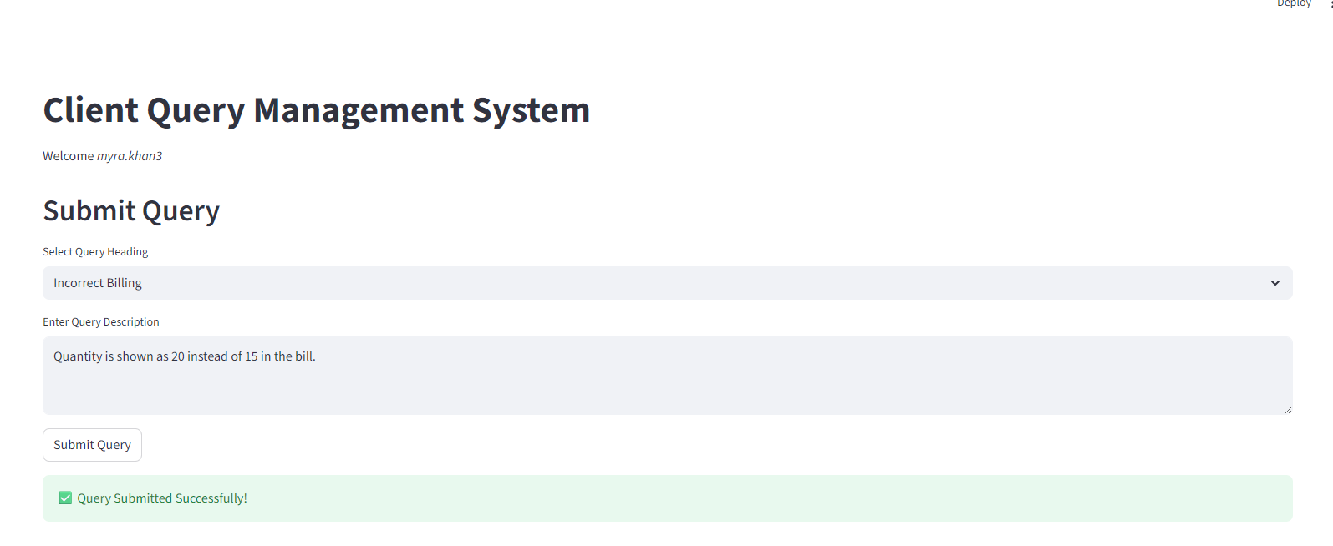
Same is available in Track query 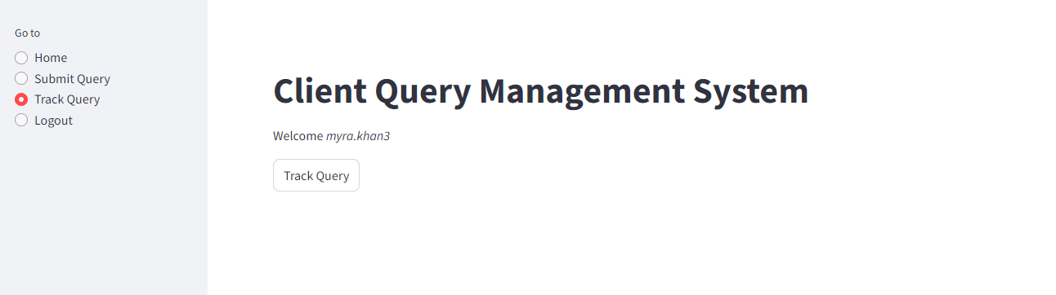
Open issues are displayed
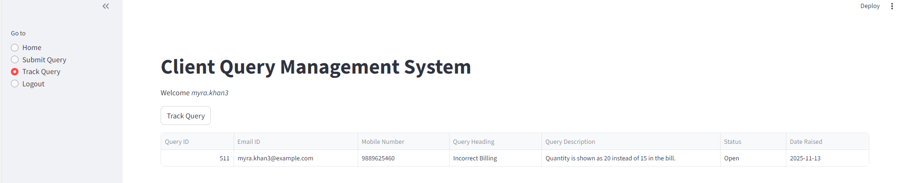
Logout
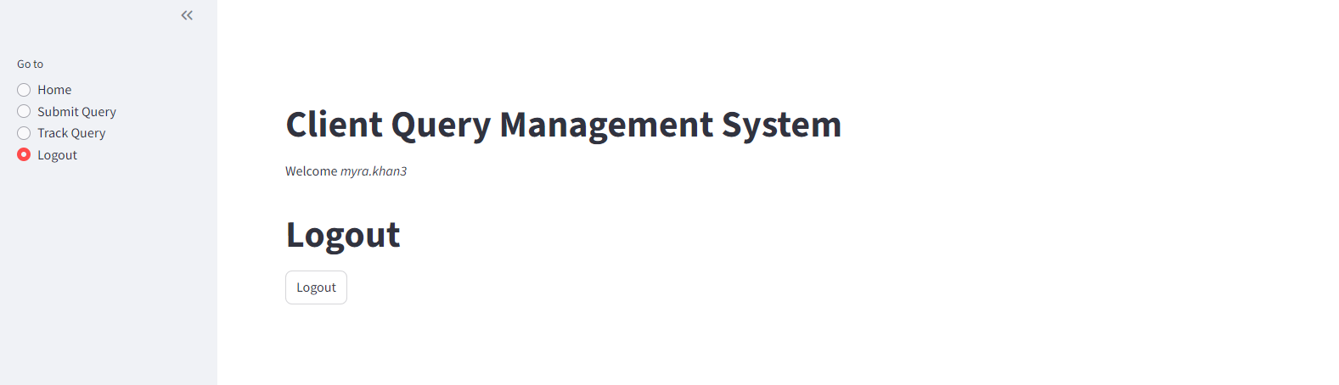

Support User flow
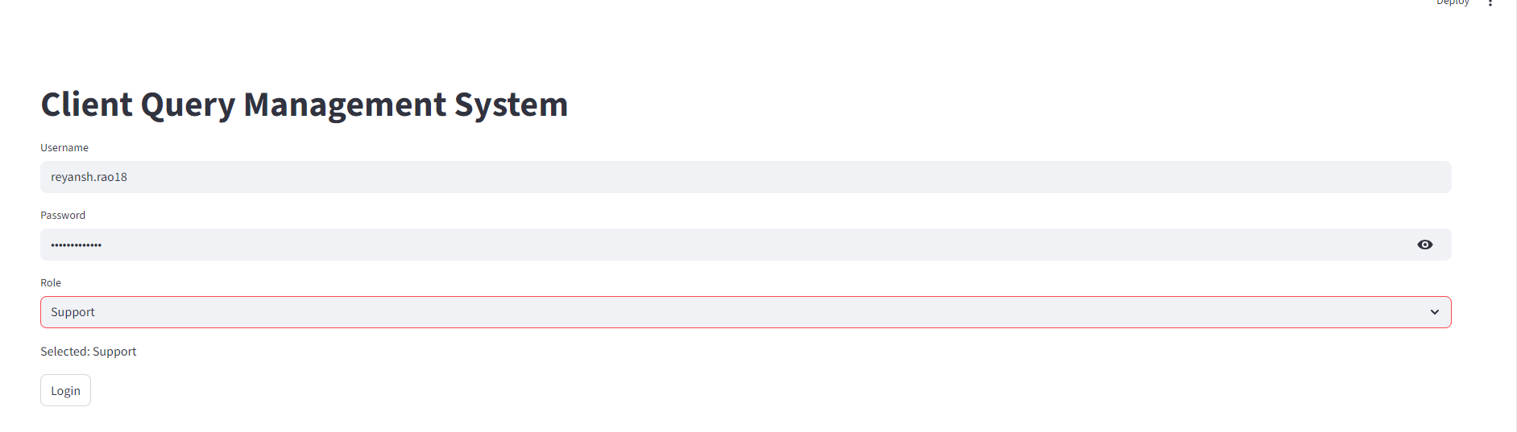
Home page. It shows some of the statistics relating to the query handling
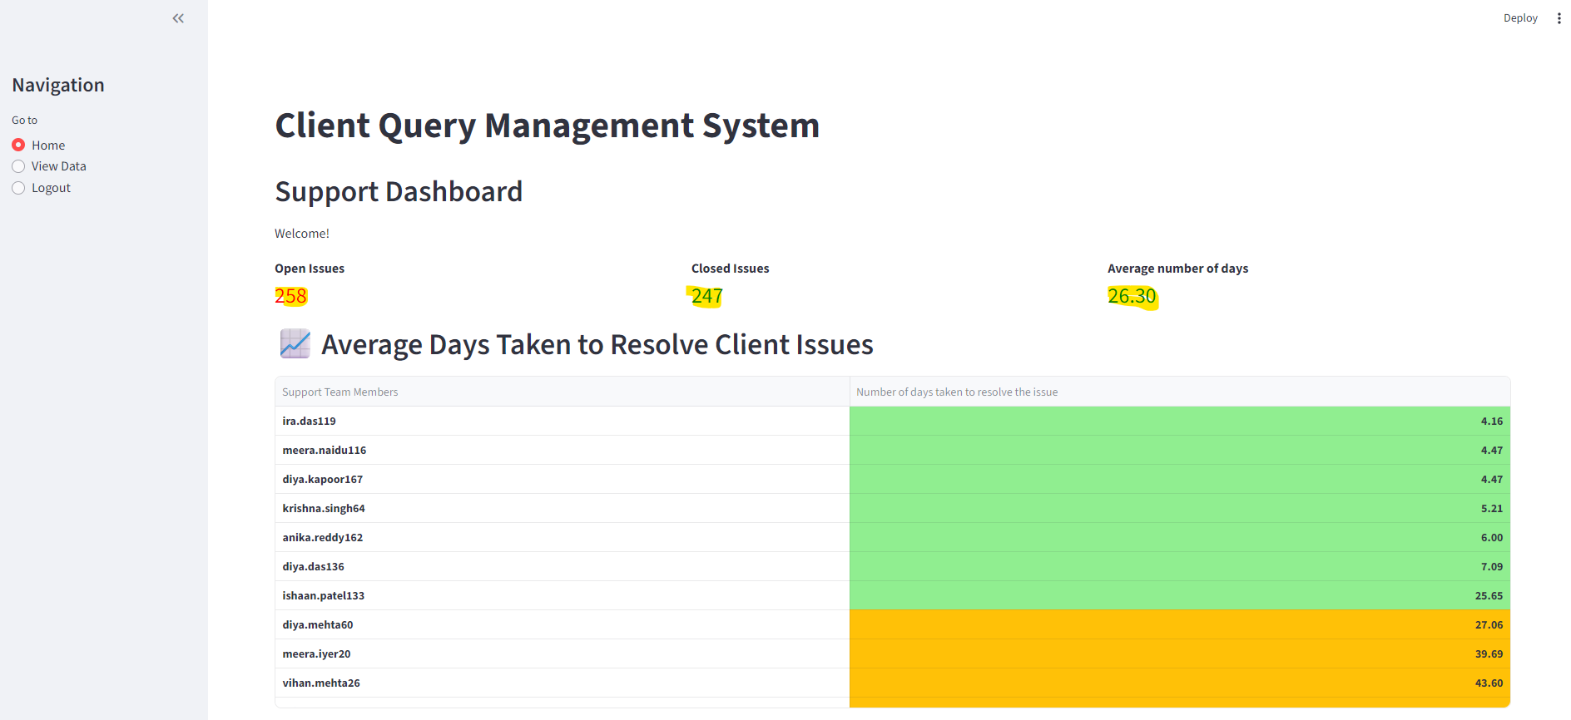
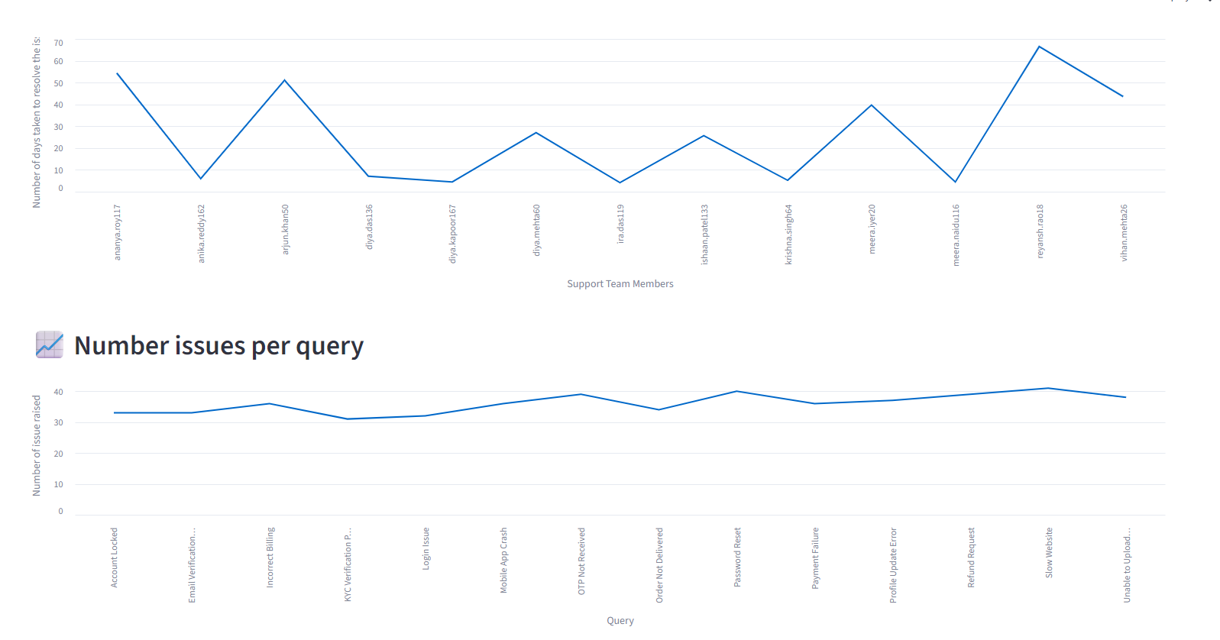

User can search for the open query 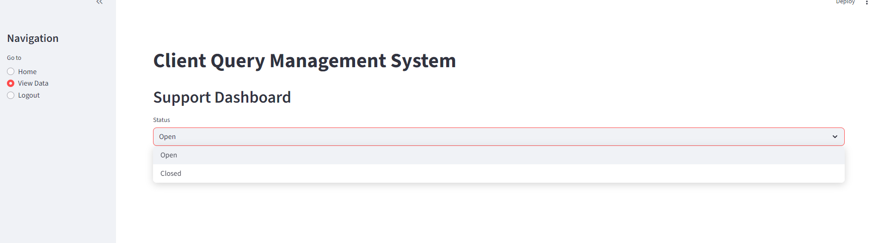

Closed query, no option to edit, only view 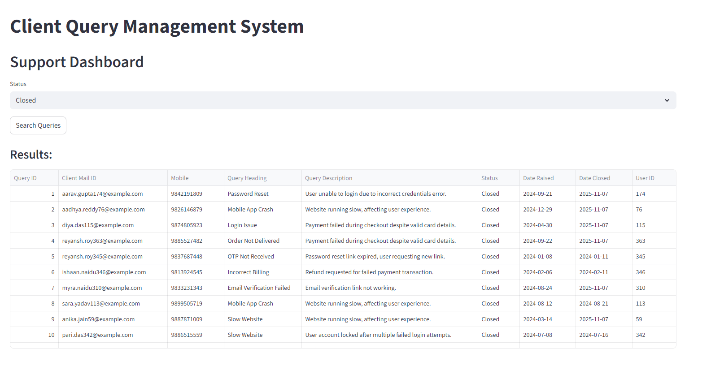
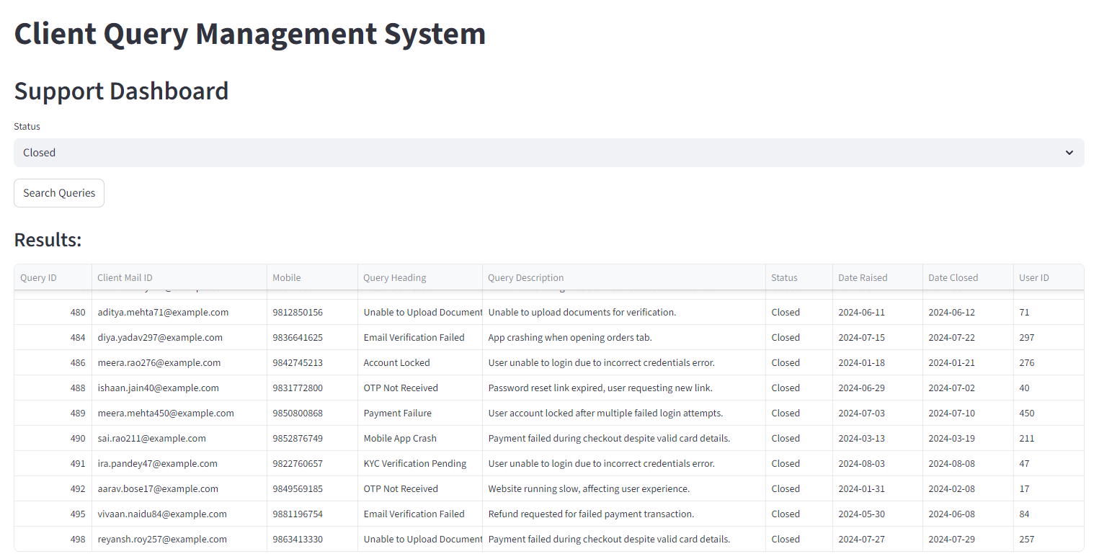

User searches the open query. Result is to view and after scross down edit option will come 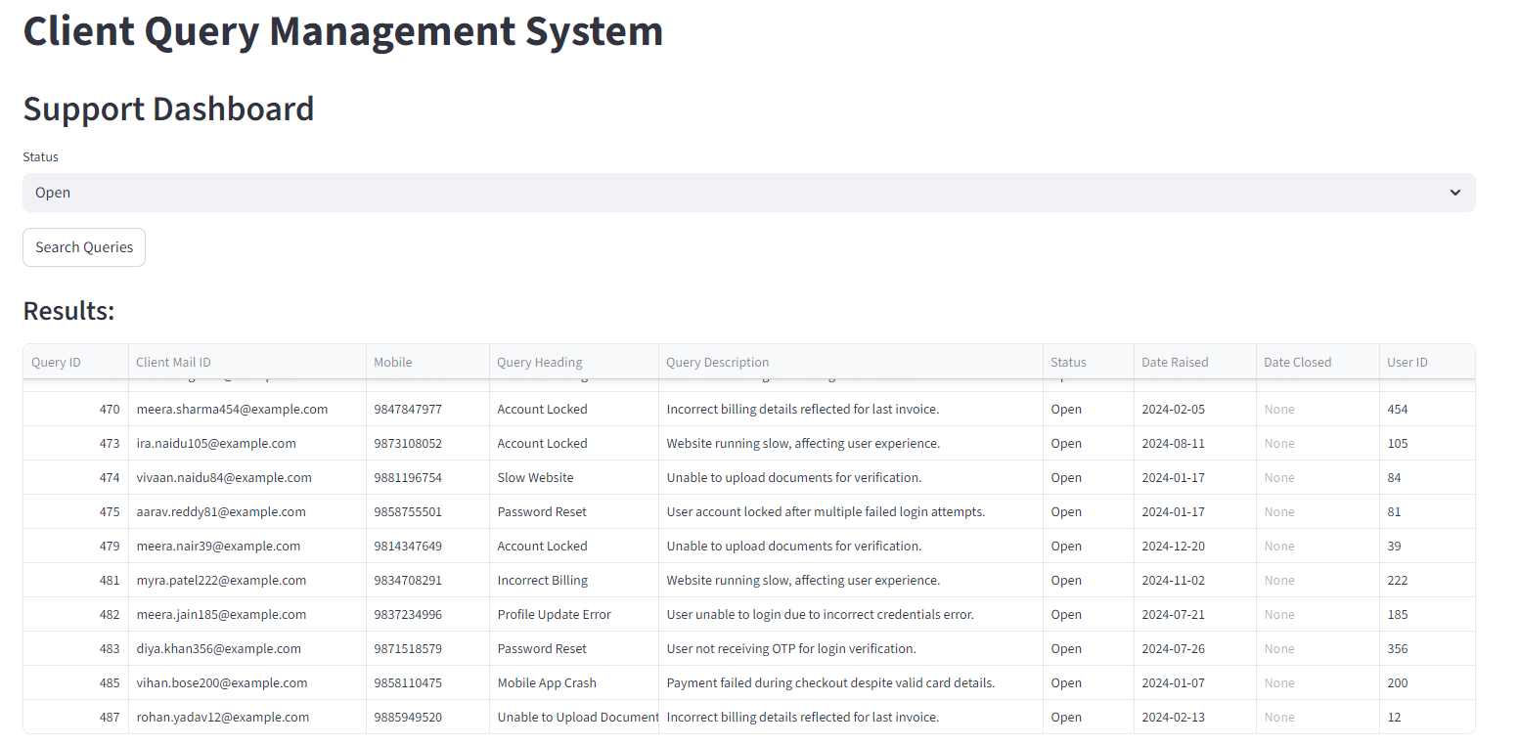
User can edit the record 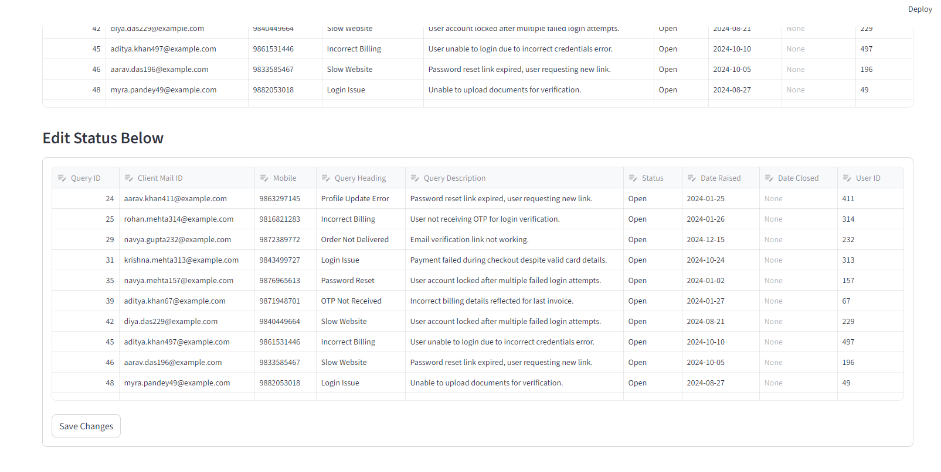
User updates the status and saves 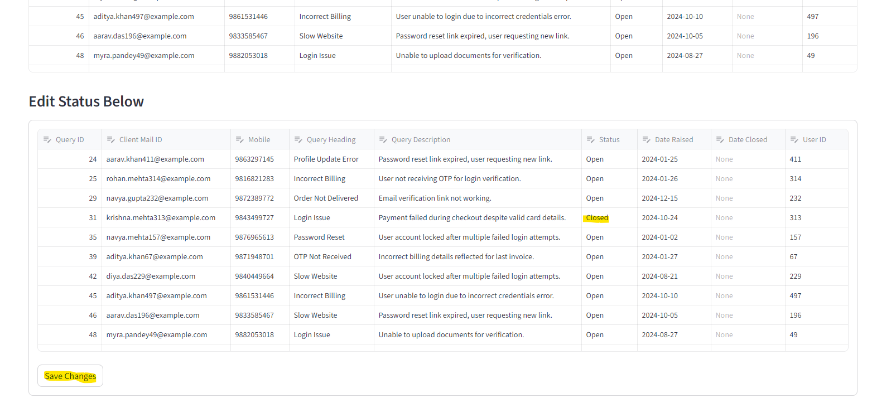
Record is updated 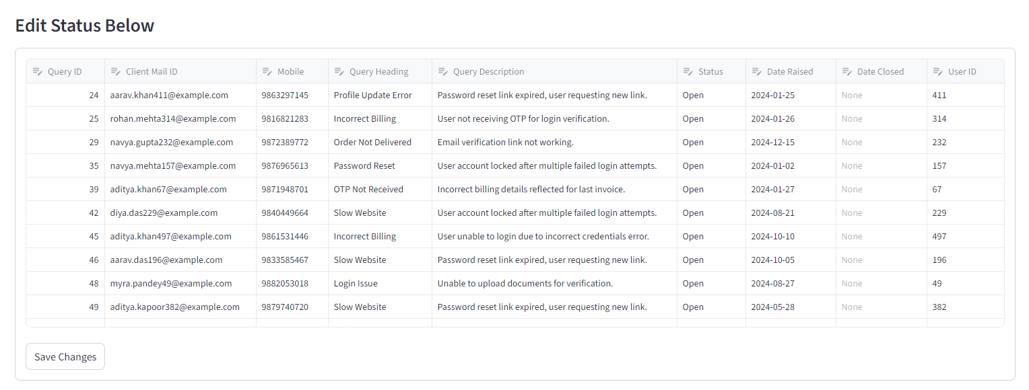
Available in closed section 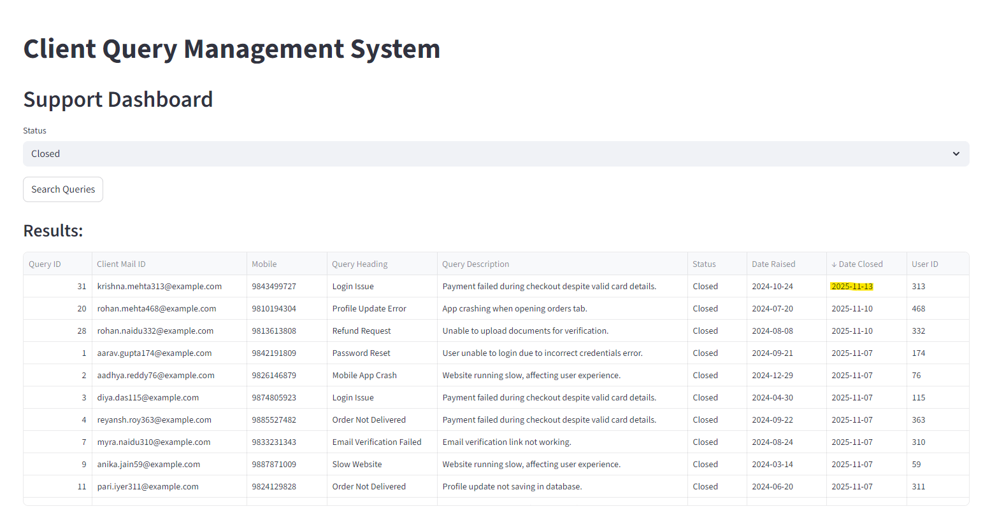
User Logout
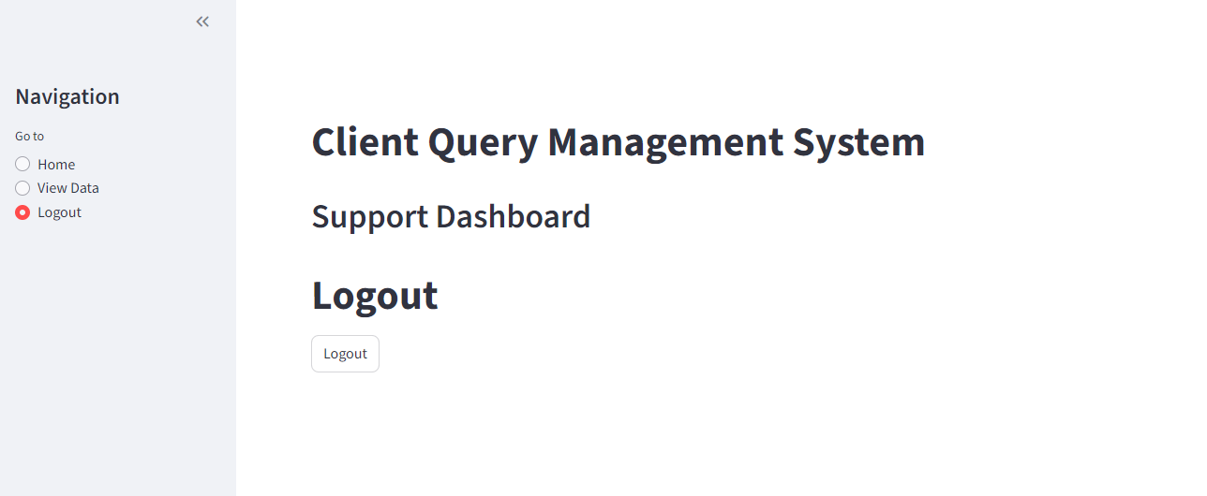

Admin flow (To create user) Additional part
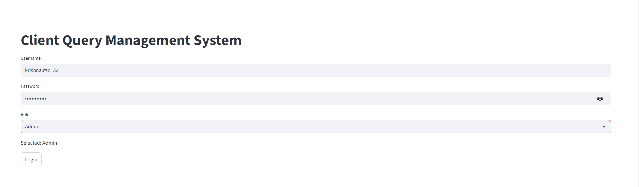
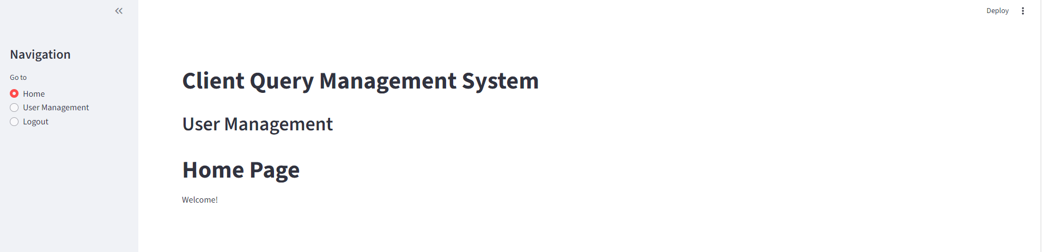
Creation of user 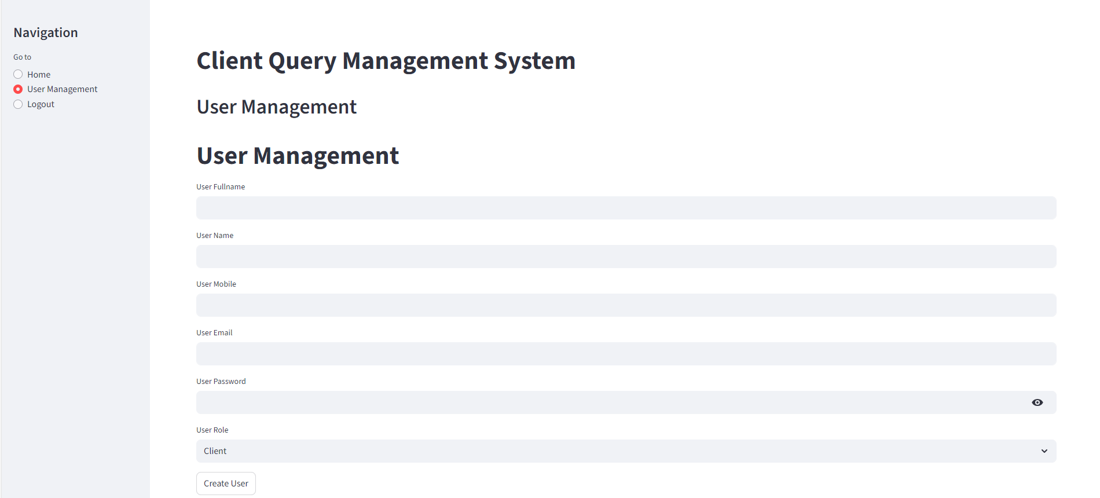
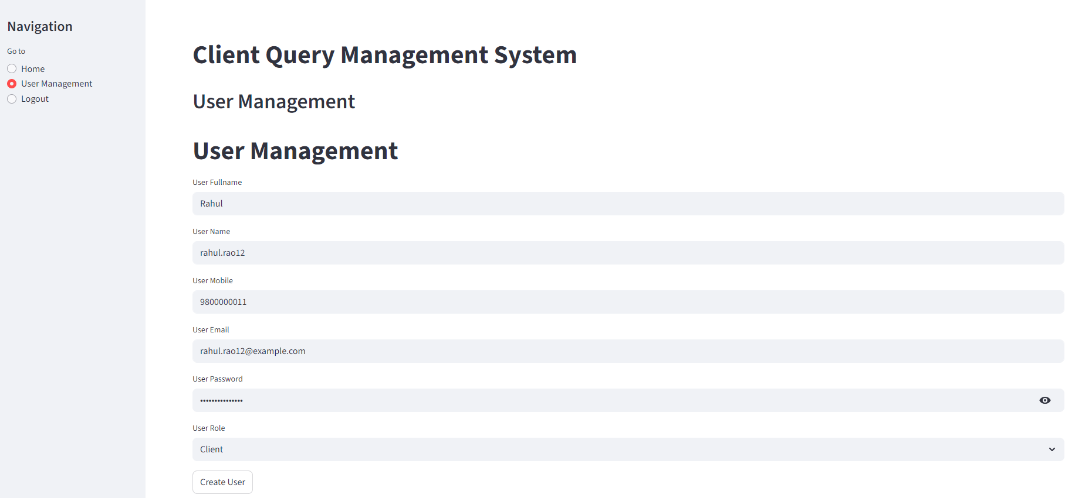
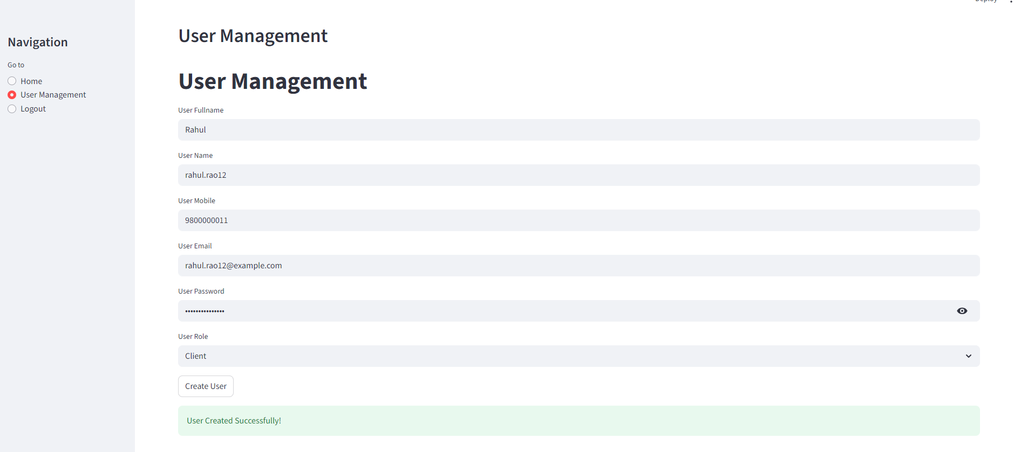
User is created in DB 