Comprehensive Report

EDA:
- Total number of data 148532.
- Duplicates are removed.
- There were cuisine with time stamp and those data are removed.
- Nan in rating is updated with mean.
- Cost had the string values and those are replaced with median.

Encoding:
- Label encoder done for the city.
- Cuisine is encoded with multi label classifier MultiLabelBinarizer.

Model:
K-NearestNeighbors model with cosine similarity is used as it is relating to the classification of data and then to suggest the restaurant based on the filters provided by users.
- KNN retrieves the most similar restaurants for a user query, while K-Means only groups restaurants into clusters without personalized similarity search.
- KNN works well for recommendation tasks, whereas K-Means is mainly used for data segmentation or grouping.
- KNN does not require a training phase, but K-Means requires iterative training to form clusters.
- KNN with cosine similarity captures fine-grained similarity between restaurants, while K-Means may lose detail by assigning restaurants only to a single cluster.

Demo
Landing page 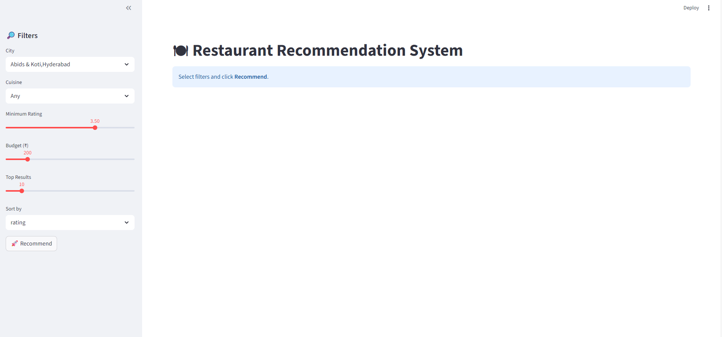

Suggestions based on the filter 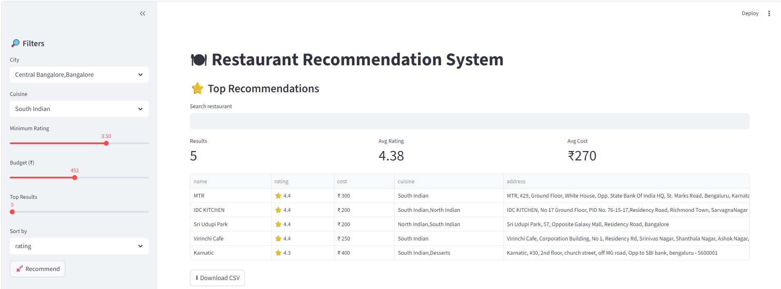
Budget is 281 so cost is less than 281 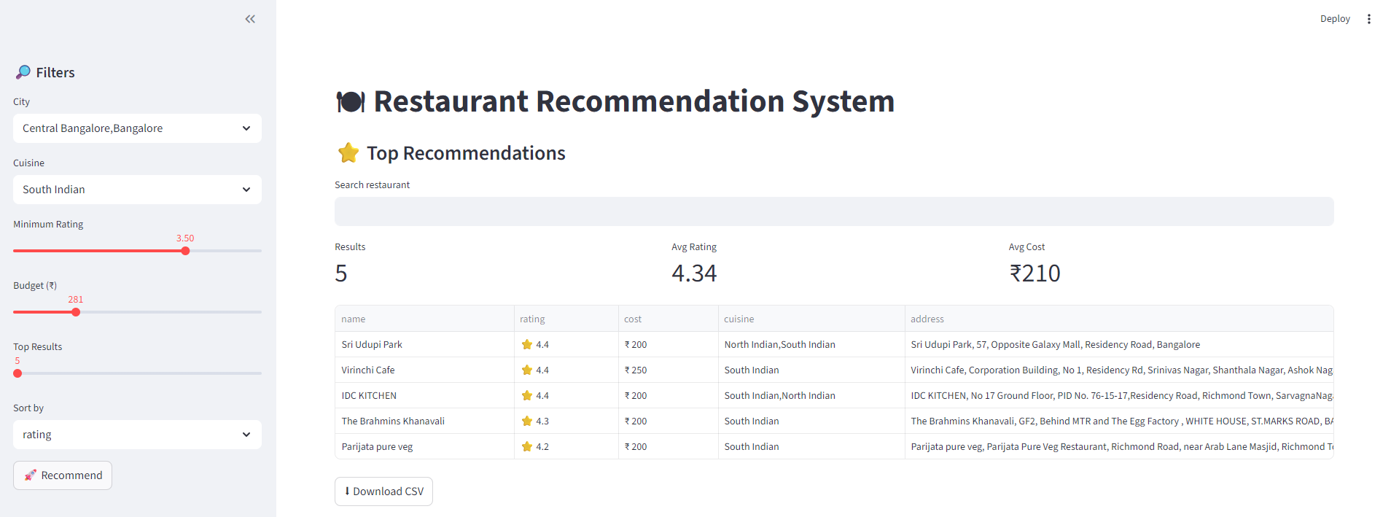
Rating is increased to 4.4 so number of records are reduced 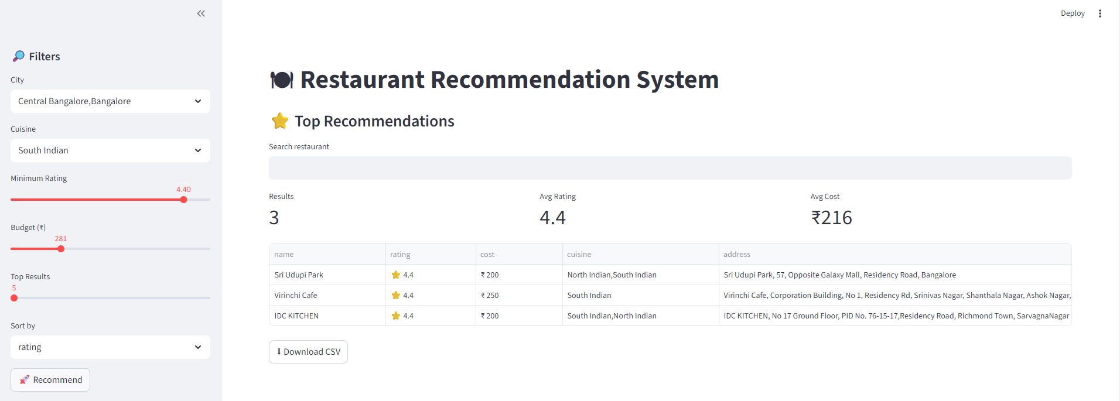
No restaurants matching for the criteria 