**Spring 2023: CS5710 – Machine Learning**

**In-Class Programming Assignment-2**

**Name : Jayanth Sri Sai Dulla**

**700#: 700734068**

**Video Link:** **https://drive.google.com/file/d/1c2Avd84z7lEkwUvnjj8FXbA68XHOk5X6/view?usp=sharing**

**Github Link:** **https://github.com/Jayanthsrisaidulla1998/MLAssignment2/upload**

1. **Use a python code to display the following star pattern using the for loop**

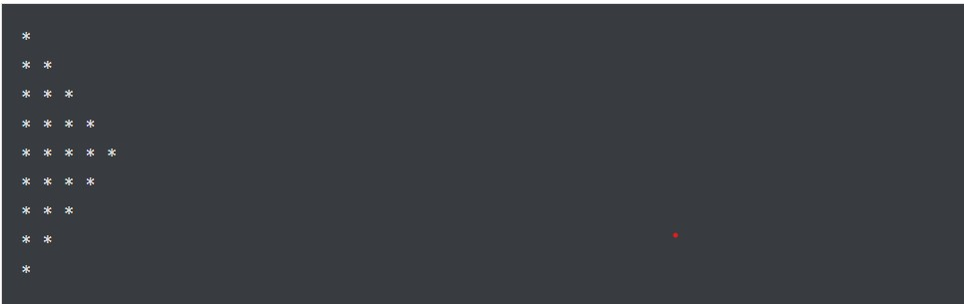

1. **Use looping to output the elements from a provided list present at odd indexes. my_list = [10, 20, 30, 40, 50, 60, 70, 80, 90, 100]**

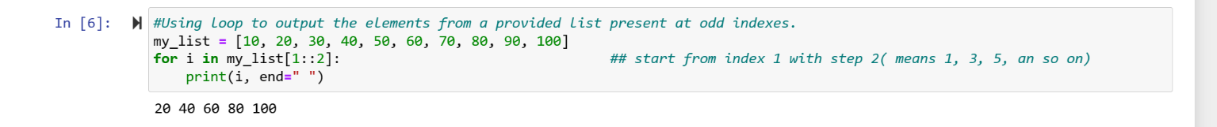

1. **Write a code that appends the type of elements from a given list. Input**

**x = [23, ‘Python’, 23.98]**

**Expected output**

**[23, 'Python', 23.98]**

**[<class 'int'>, <class 'str'>, <class 'float'>]**

1. **Write a function that takes a list and returns a new list with unique items of the first list.**

**Sample List: [1,2,3,3,3,3,4,5]**

**Unique List: [1, 2, 3, 4, 5]**

1. **Write a function that accepts a string and calculate the number of upper-case letters and lower-case letters.**

**Input String: 'The quick Brow Fox' Expected Output:**

**No. of Upper-case characters: 3**

**No. of Lower-case Characters: 12**

** Follow the rubric guidelines.

**Submission Guidelines:**

1. Once finished document your code and make sure all parts if the assignments are completed.
2. Push your code to your GitHub repo and update the ReadMe file, add your info.
3. Submit the assignment.
4. Present your work in class time to proof the execution and complete submission.

**After class submission:**

1. Once finished document your code and make sure all parts if the assignments are completed.
2. Push your code to your GitHub repo and update the ReadMe file, add your info.
3. Submit the assignment before the deadline.
4. Record a short video (1~3) minute, proof of execution and complete assignment.
5. Add video link to ReadMe file.