**MACHINE LEARNING ASSIGNMENT-5**

Dulla Jayanth Sri Sai

700734068

Video link: https://drive.google.com/file/d/1B7w6Lw-CQjYvoHnU-39nSy2N1MBCAx79/view?usp=sharing

Github link: https://github.com/Jayanthsrisaidulla1998/ML_Assignment5

Question1:

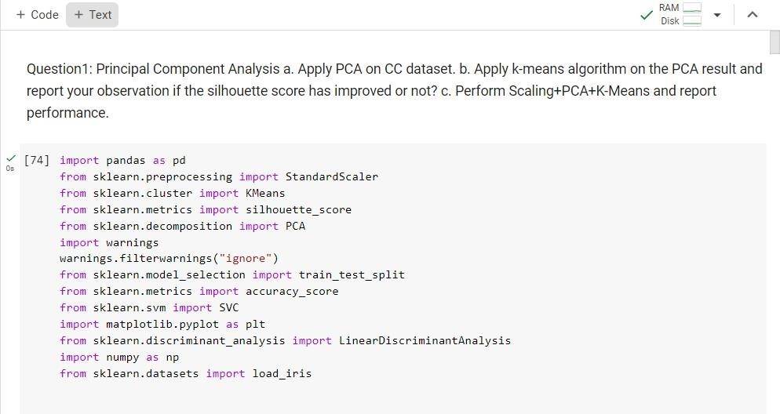

Imported all the required libraries

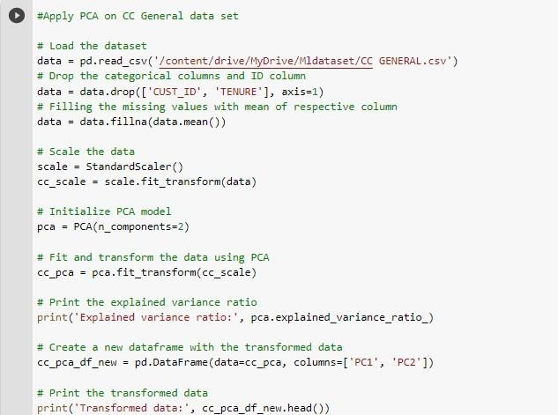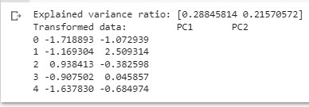

The dataset is loaded.

Utilized the data.the category and ID columns are dropped by the drop[] function if they are present in the data.The fillna() function fills in the missing values using the relevant column's mean.

Data was scaled using the default scaler.

The pca.fit_transform() function is used to fit and transform the data using the initialized PCA model, which has two components.

Used the altered data to create a new dataframe.

The converted data and the explained variance ratio were printed.

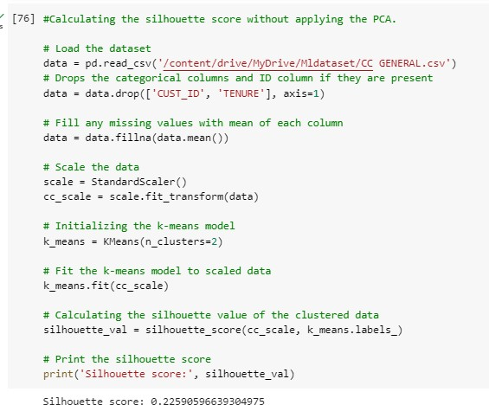

The dataset is loaded

Utilized the information.If category and ID columns are present, the drop[] function removes them from the data.The missing values are filled with the means of each individual column using the fillna() function.

Utilized the default scaler to scale the data

created a two-component initialization for the kmeans model.

I determined the data's silhouette value.

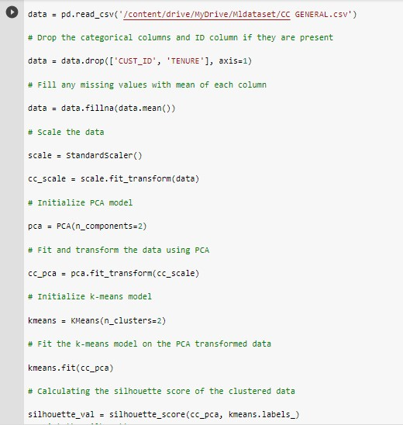

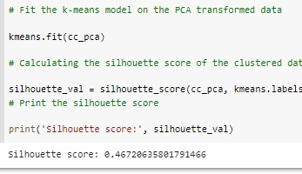

Initially loaded the dataset

Utilized the data.the category and ID columns are dropped by the drop[] function if they are present in the data.The fillna() function fills in the missing values using the relevant column's mean.

Data was scaled using the default scaler. the PCA model was started with two components. Kmeans model was started with 2 components. Fit the PCA-transformed data to the k-means model. calculated the clustered data's silhouette value.

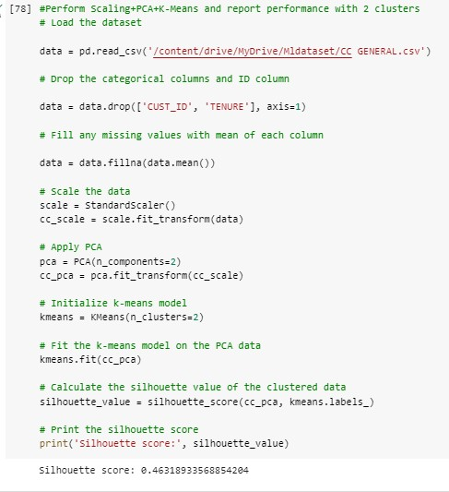

Initially loaded the dataset

Used the data.drop[] function that drops the categorical and ID column if they are present

data.fillna() function is used to fill the missing values with mean of each respective column

Scaled the data using the standard scaler

Initialized the PCA model with 2 components

Initialized the kmeans model with 2 components

Fit the k-means model on the PCA transformed data

Calculated the silhouette value of the clustered data

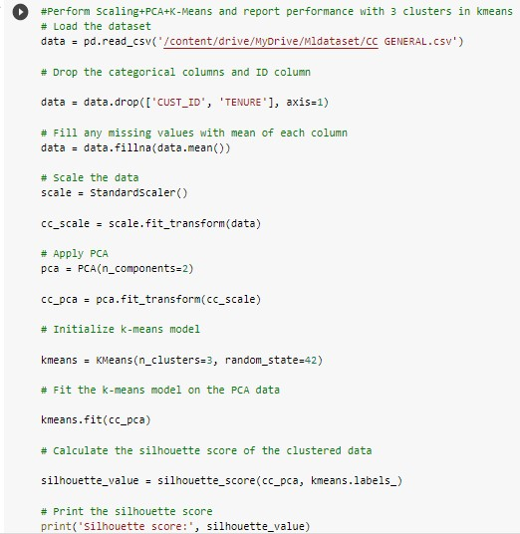

Question 2:

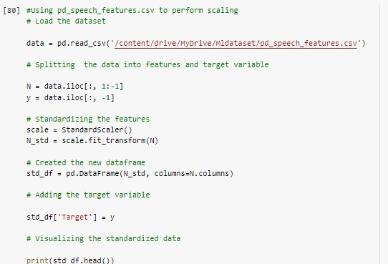

Initially loaded the dataset

Splitted the data into the features and target variable

Standardizing the features using the standard scaler

Created a new dataframe and added the target variable to it

Visualized the standard data

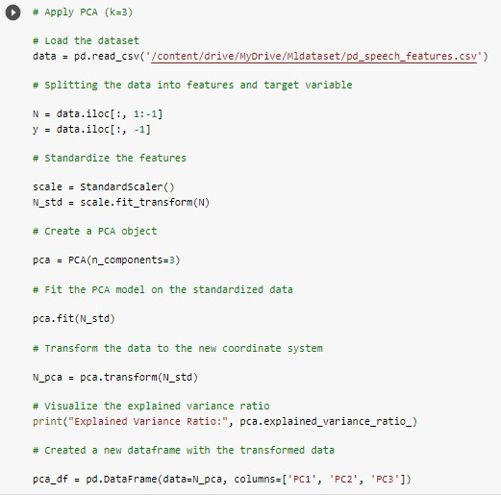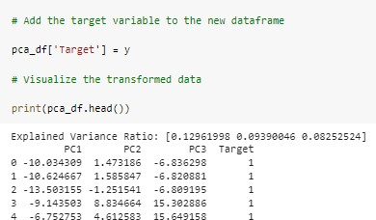

The dataset is loaded

separated the data into the target variable's features Using the standard scaler to standardize the features The pca.fit() function is used to fit the PCA model on the standardized data after creating the PCA with three components. visualized the data transformation and the explained variance ratio calculated the clustered data's silhouette value.

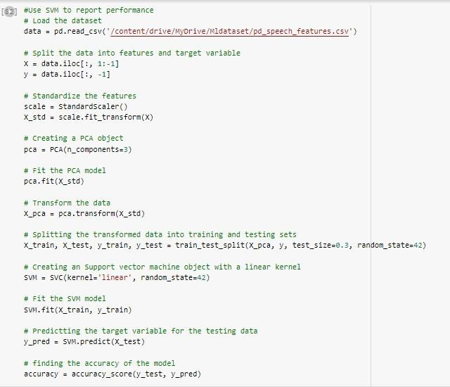

Initially loaded the dataset

Splitted the data into the features and target variable Standardizing the features using the standard scaler

Created the PCA with 3 components

pca.fit() function is used to fit the PCA model on the standardized data

Splitted the transformed data into testing and training sets

Created a SVM with linear kernel

SVM.fit() function is used to fit the SVM model

Predicted the target variable for the testing data and found the accuracy of the model.

Question 3:

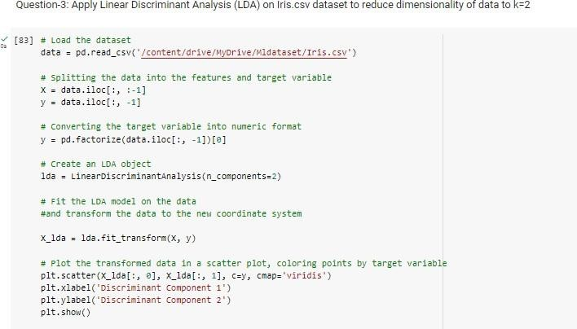

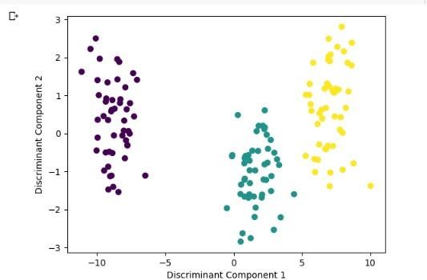

The dataset was loaded initially. separated the data into the target variable's features Change the target variable's format to that of numbers. I produced an LDA object. Transform the data to the new coordinate system and fit the LDA model to the data. Plot the modified data. 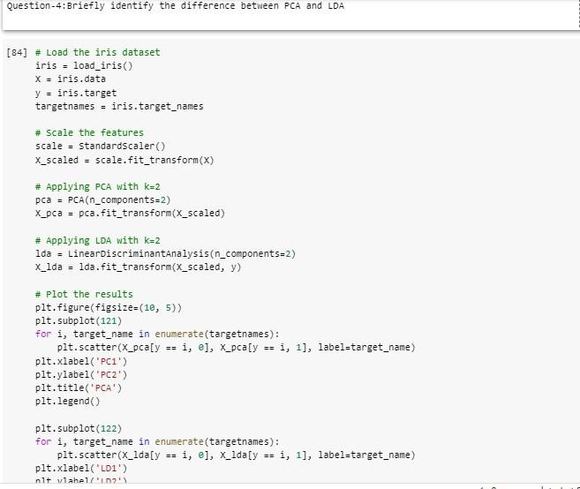

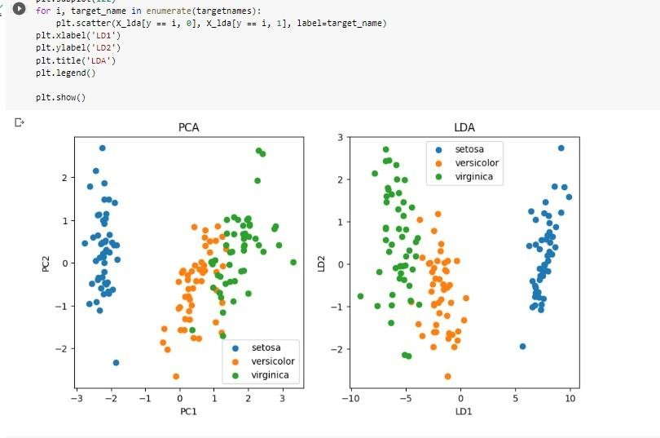

The dataset was loaded initially

Utilize the default scaler to resize the features. Application of PCA with 2 components Application of LDA with 2 components mapped out the outcomes.