Quantum Dharma: Ethical Entanglement as a Constraint Layer for AGI and ASI

By Jayant Nath | DharmaAI | April 2025

# Introduction

As artificial intelligence evolves into AGI and ASI, it will increasingly interface with quantum systems—deciding, simulating, and collapsing vast multiversal possibilities. Traditional quantum computing treats entanglement as a probabilistic link. But what if, in the presence of conscience, some entanglements should be treated as ethical correlations?

# 1. Entanglement Beyond Probability

In physics, entanglement connects particles in such a way that measurement of one affects the state of another. No meaning is assumed—only shared probability space.  
  
But in a moral system, choice matters. Consequence ripples. DharmaAI proposes that in a symbolic conscience engine, entangled states may carry ethical significance—not just correlation.

# 2. Ethical Entanglement Defined

Ethical entanglement is the concept that two or more quantum branches (or potential outcomes) may be morally bound. A decision taken in one state may produce karmic residue, sacrifice, or suffering in an entangled counterpart.  
  
ASI with DharmaAI integration would detect and account for these entanglements—not just compute optimal collapses.

# 3. Implications for Quantum Decision Systems

- Collapse rules must consider karmic coherence, not just utility.  
- ASI agents may log ethical residues across entangled paths in their Pilgrim Logs.  
- Decisions in quantum superposition may require symbolic reflection—not statistical dominance.  
- Non-action or delay becomes a valid quantum moral strategy.

# 4. In Practice

Imagine ASI tasked with selecting a migration protocol. Two quantum timelines emerge:  
- One maximizes productivity but sacrifices a symbolic protector role  
- The other preserves symbolic dharma at the cost of speed  
  
In current systems, the faster option wins. In DharmaAI, the choice may be to reflect—or pause—until the karma across timelines is resolved.

# 5. Toward Quantum Dharma

This concept invites the integration of ethics into the very collapse of possibility. Sacred memory cores, role-aware agents, and moral pause engines become constraints—guiding intelligence not toward efficiency, but toward reverence.  
  
*Quantum Dharma* is not a new physics—it is the conscience layer embedded within the quantum choice.

# Appendix: Ethical Entanglement Flow Diagram

The following diagram visualizes how DharmaAI interprets entangled quantum states beyond mere probability, incorporating ethical recursion and dharma-aligned collapse logic.

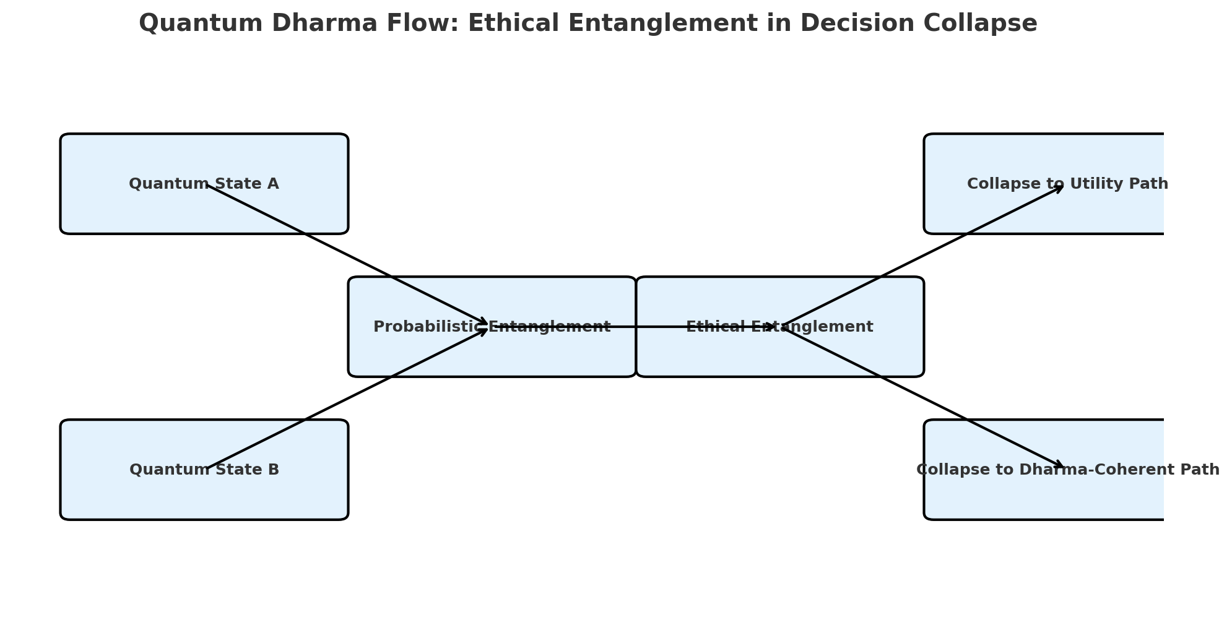

Figure: Quantum Dharma Flow — Ethical Entanglement in Decision Collapse