Step 1:  
 creating Dockerfile with Ubuntu image & nginx web server

Step2 :

Creating docker image using docker build.

Step3:

Creating docker-compose.yml file with mount volume in /var/opt/nignx

Steps4:

Running the docker-compose file & checking the nginz website.

Step5:

Push the created docker image to docker hub & verify it in the docker hub site

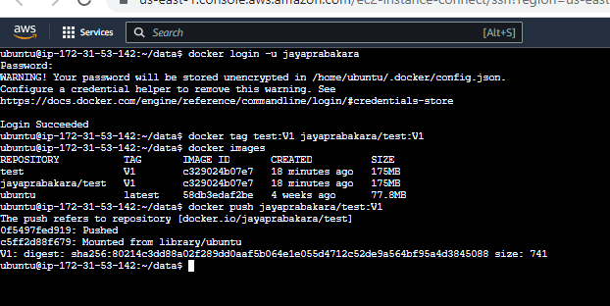

**docker pull jayaprabakara/test:V1**

