1. Install docker on EC2 :

Sudo apt install docker.io

Docker --version

1. explore the docker commands (docker images, containers)
2. docker pull :

1. docker images:

1. docker run :

1. docker ps



1. docker ps -a



1. docker stop :

1. docker start:

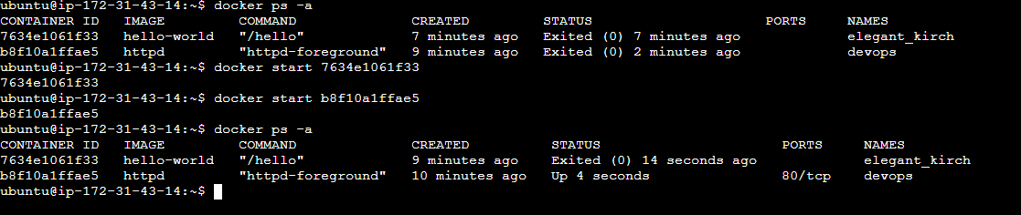

1. docker rm:

1. docker rmi :

