WhatNext Vision Motors
Shaping the Future of Mobility with Innovation and Excellence
Salesforce CRM Project Submission Report
Department of Computer Science and Engineering
Academic Year 2026–2027

User Story
WhatNext Vision Motors is implemented as a Salesforce CRM solution to streamline vehicle ordering, dealership operations and customer service. The system centralizes vehicle, dealer, customer, order, test-drive and service-request information. Automation supports dealer assignment, stock validation, test-drive reminders, order processing, reporting and dashboard monitoring.

1. INTRODUCTION

1.1 Project Overview
WhatNext Vision Motors uses Salesforce CRM to modernize vehicle ordering and dealership operations. The solution provides a centralized Lightning application for managing vehicles, dealers, customers, vehicle orders, test drives and service requests. Salesforce Flows automate dealer assignment and test-drive reminders, while Apex automation validates stock and updates vehicle inventory. Batch Apex and Scheduled Apex support processing of pending orders. Reports and dashboards provide operational visibility.

1.2 Purpose
The purpose of the project is to reduce manual effort in vehicle sales and service operations by centralizing business data and automating repetitive activities. The system is designed to validate vehicle stock before an order is accepted, assign a dealer based on customer/dealer location data, send scheduled test-drive reminders, process pending orders when stock is available, and provide management reports and dashboards.

2. IDEATION PHASE

2.1 Problem Statement
User | Trying to | Problem / Because | Impact
Operations Manager | Manage vehicle orders and stock | Information may be manual or distributed across processes | Delays, stock errors and follow-up effort
Customer | Place a vehicle order and receive updates | Availability and order progress may not be clear | Uncertainty and delayed communication

2.2 Empathy Map Canvas
User Persona: Operations Manager
- Think & Feel: Concerned about incorrect orders, stock errors and delayed processing.
- Hear: Customer and dealer queries about availability, orders and service.
- See: Vehicle, customer, order and service information that needs centralized management.
- Say & Do: Perform follow-ups and coordinate vehicle and dealer information.
- Pain: Manual effort, delays, stock-related errors and cancellations.
- Gain: Automation, centralized records, reports and dashboards.

2.3 Brainstorming & Idea Prioritization
- Manual registers
- Spreadsheet-based tracking
- Standalone vehicle portal
- Salesforce CRM
Salesforce CRM was selected as the implementation platform because it provides centralized data management, configurable automation, Lightning UI, Apex extensibility, reports and dashboards in one platform.

3. REQUIREMENT ANALYSIS PHASE

3.1 Customer Journey Map
Inquiry → Vehicle Selection → Order Placement → Stock Validation → Dealer Assignment → Order Confirmation → Test Drive → Service → Reporting

3.2 Solution Requirements
ID | Functional Requirement
FR-1 | Vehicle management
FR-2 | Dealer management
FR-3 | Customer and vehicle order management
FR-4 | Stock validation for vehicle orders
FR-5 | Dealer assignment based on customer/dealer location data
FR-6 | Test-drive scheduling and reminder automation
FR-7 | Reports and dashboard monitoring
FR-8 | Pending-order processing using Batch Apex
NFR | Description
Usability | Lightning UI and dedicated application navigation
Security | Salesforce platform access controls and user permissions
Reliability | Automation should process supported records consistently
Performance | Bulk-aware Apex and Batch Apex are used for scalable processing
Availability | Salesforce cloud platform provides access to the application
Scalability | Custom objects, flows and Apex can support additional vehicle/dealer data

3.3 Data Flow Diagram
Customer / Staff Input → Vehicle Order Creation → Apex Stock Validation → Flow-Based Dealer Assignment → Order Status Processing → Batch/Scheduled Processing → Reports & Dashboard
Supporting customer journey: Customer → Vehicle Selection → Order/Test Drive/Service Request → Salesforce Objects → Automation → Operational Reporting.

3.4 Technology Stack
Layer | Technology / Salesforce Component
UI | Salesforce Lightning Experience
Application | Salesforce Lightning App – WhatNext Vision Motors
Data | Salesforce Custom Objects
Automation | Record-Triggered Flows
Business Logic | Apex Trigger + Trigger Handler
Bulk Processing | Batch Apex
Scheduling | Scheduled Apex
Reporting | Salesforce Reports
Visualization | Salesforce Dashboard
Development | VS Code + Salesforce CLI

4. PROJECT DESIGN PHASE

4.1 Problem–Solution Fit
The project addresses fragmented vehicle sales and service activities through a centralized Salesforce CRM. Vehicle and customer information is stored in related custom objects. Automated stock validation prevents unsupported orders, dealer assignment reduces manual selection, scheduled test-drive reminders support customer communication, and reports/dashboard components provide visibility into operational data.

4.2 Proposed Solution
Parameter | Description
Problem | Manual or disconnected vehicle ordering and operational tracking
Platform | Salesforce CRM
Core Innovation | Automated business processes using Flow and Apex
Stock Control | Apex validates available stock and reduces stock after confirmation
Dealer Assignment | Flow assigns a dealer using customer address and dealer location data
Customer Engagement | Scheduled test-drive reminder email
Operational Processing | Batch Apex confirms pending orders when stock becomes available
Monitoring | Reports and dashboard for inventory, orders, test drives and service requests

4.3 Solution Architecture
- Vehicle Object – stores vehicle model, stock, price, dealer and status.
- Vehicle Dealer Object – stores dealer location, code, phone and email.
- Vehicle Customer Object – stores customer contact, address and preferred vehicle type.
- Vehicle Order Object – tracks customer, vehicle, order date, status and assigned dealer.
- Vehicle Test Drive Object – tracks scheduled test drives and status.
- Vehicle Service Request Object – tracks service issues, dates and status.
- Vehicle Order Dealer Assignment Flow – assigns dealer data to a pending order.
- Vehicle Test Drive Reminder Flow – schedules a reminder email one day before a scheduled test drive.
- VehicleOrderTrigger + VehicleOrderTriggerHandler – validates stock and updates inventory when an order becomes confirmed.
- VehicleOrderBatch – processes pending orders when stock is available.
- VehicleOrderScheduler – starts the batch process on the configured schedule.
- Reports and Dashboard – provide operational monitoring.

5. PROJECT PLANNING & SCHEDULING

5.1 Project Planning
The project follows an Agile-style sprint structure. Work was divided into setup, data modeling, automation, Apex development, reporting and dashboard activities.
Sprint | Epic | Main Activities | Points
Sprint 1 | Developer Setup | Salesforce Developer Edition and development environment setup | 3
Sprint 2 | Data Modeling | Create six custom objects, fields, lookups and tabs | 5
Sprint 3 | Automation | Dealer assignment flow and test-drive reminder flow | 5
Sprint 4 | Apex | Trigger handler, trigger, Batch Apex and Scheduled Apex | 8
Sprint 5 | Reports | Custom report types and operational reports | 5
Sprint 6 | Dashboard | Dashboard with inventory, orders, test drives and service requests | 5

6. PROJECT DEVELOPMENT

6.1 Salesforce Account and Development Environment
A Salesforce Developer Edition environment was configured for the project. The project was also connected to VS Code using Salesforce CLI for metadata retrieval and source-code management.
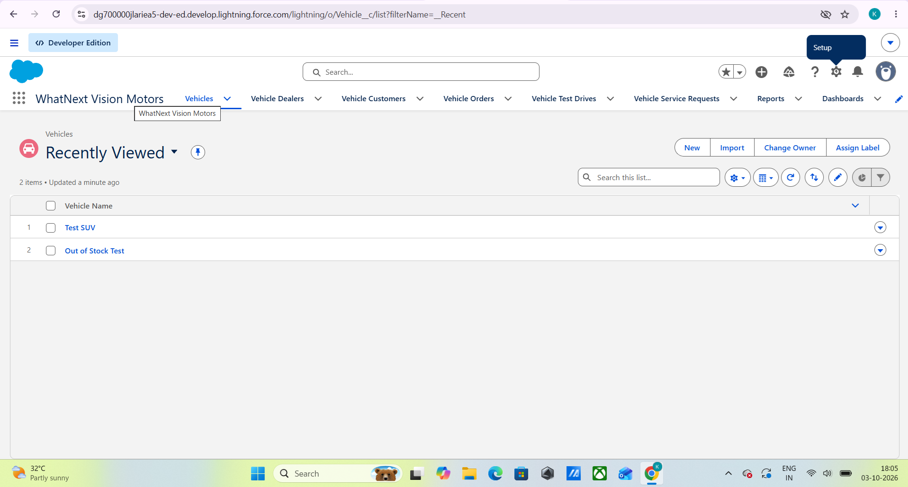

6.2 Data Modeling
Object | Purpose
Vehicle__c | Stores vehicle details, model, stock quantity, price, dealer and status
Vehicle_Dealer__c | Stores authorized dealer information and location
Vehicle_Customer__c | Stores customer contact and address information
Vehicle_Order__c | Tracks vehicle purchase orders and assigned dealer
Vehicle_Test_Drive__c | Tracks test-drive bookings
Vehicle_Service_Request__c | Tracks service requests

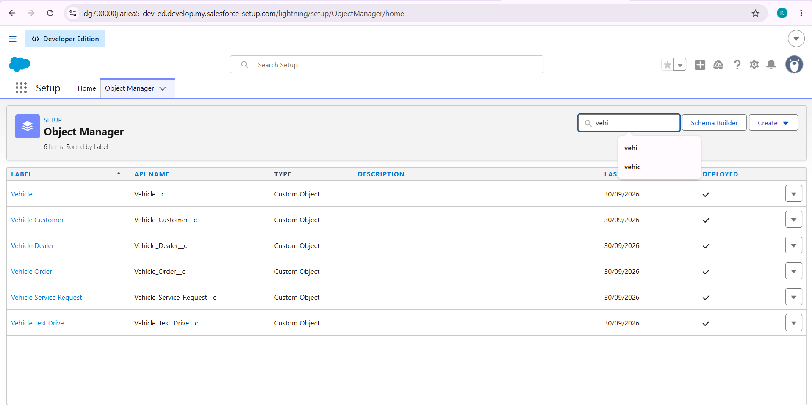

6.3 Lightning App
The Lightning App named “WhatNext Vision Motors” was created with navigation for Vehicles, Vehicle Dealers, Vehicle Customers, Vehicle Orders, Vehicle Test Drives, Vehicle Service Requests, Reports and Dashboards.

6.4 Automation – Dealer Assignment
A record-triggered Flow named “Vehicle Order Dealer Assignment” runs when a Vehicle Order is created with Pending status. It retrieves the related customer, finds a dealer whose Dealer Location matches the customer Address, and updates the Vehicle Dealer lookup on the order. The flow was activated and tested with project test data.
Implementation note: the project guide describes this as nearest-dealer assignment, while the implemented Flow uses an address/location equality match. It should therefore be documented as location-based dealer assignment unless a true distance calculation is added later.

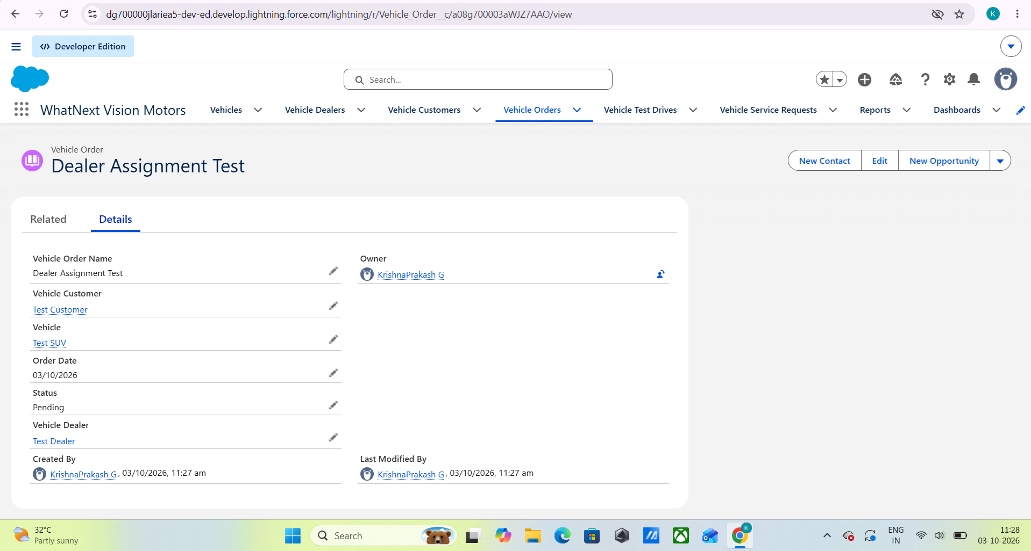

6.5 Automation – Test Drive Reminder
A record-triggered Flow named “Vehicle Test Drive Reminder” runs for scheduled test drives. A scheduled path is configured one day before the Test Drive Date. The Flow retrieves the related customer and sends an email with the subject “Reminder: Your Test Drive is Tomorrow!”. The flow was debugged without errors and activated.
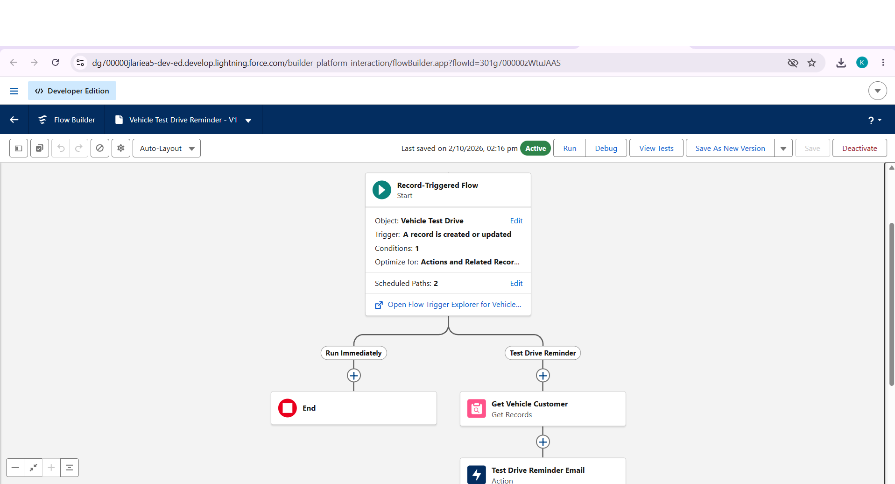

6.6 Apex Trigger and Trigger Handler
VehicleOrderTrigger runs before and after insert/update events on Vehicle Order. VehicleOrderTriggerHandler performs two main functions: it validates that the selected vehicle has available stock, and when an order changes to Confirmed it reduces stock by one. When stock reaches zero, the vehicle status is updated to Out of Stock.
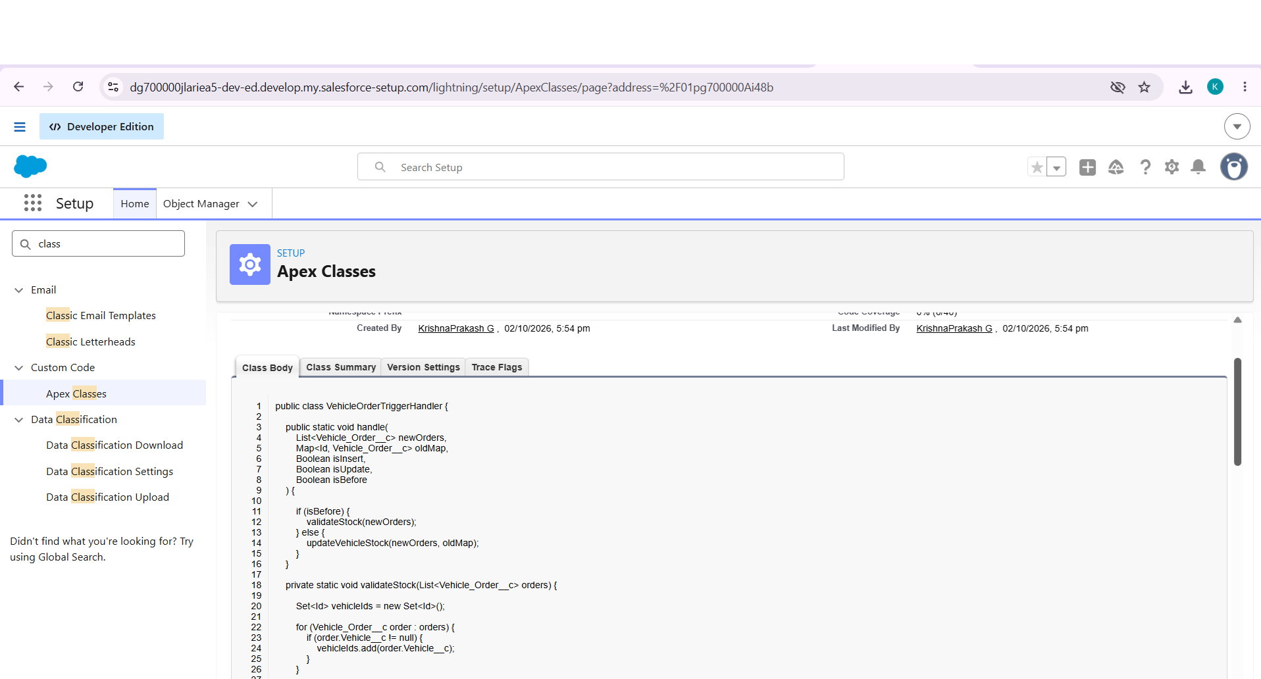
The stock validation uses addError() to prevent creation/update of an order when the selected vehicle has zero or negative stock.

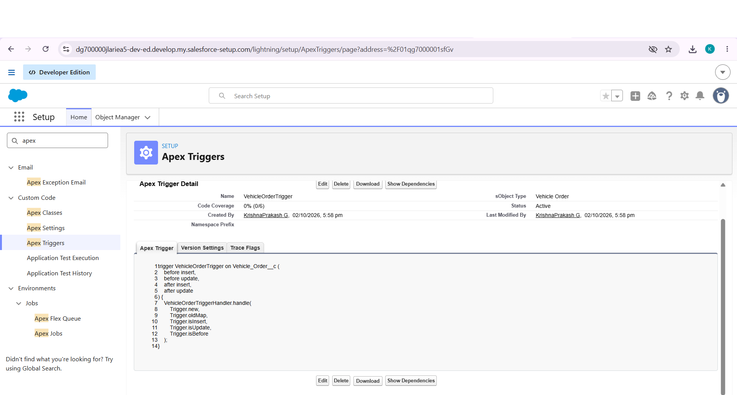

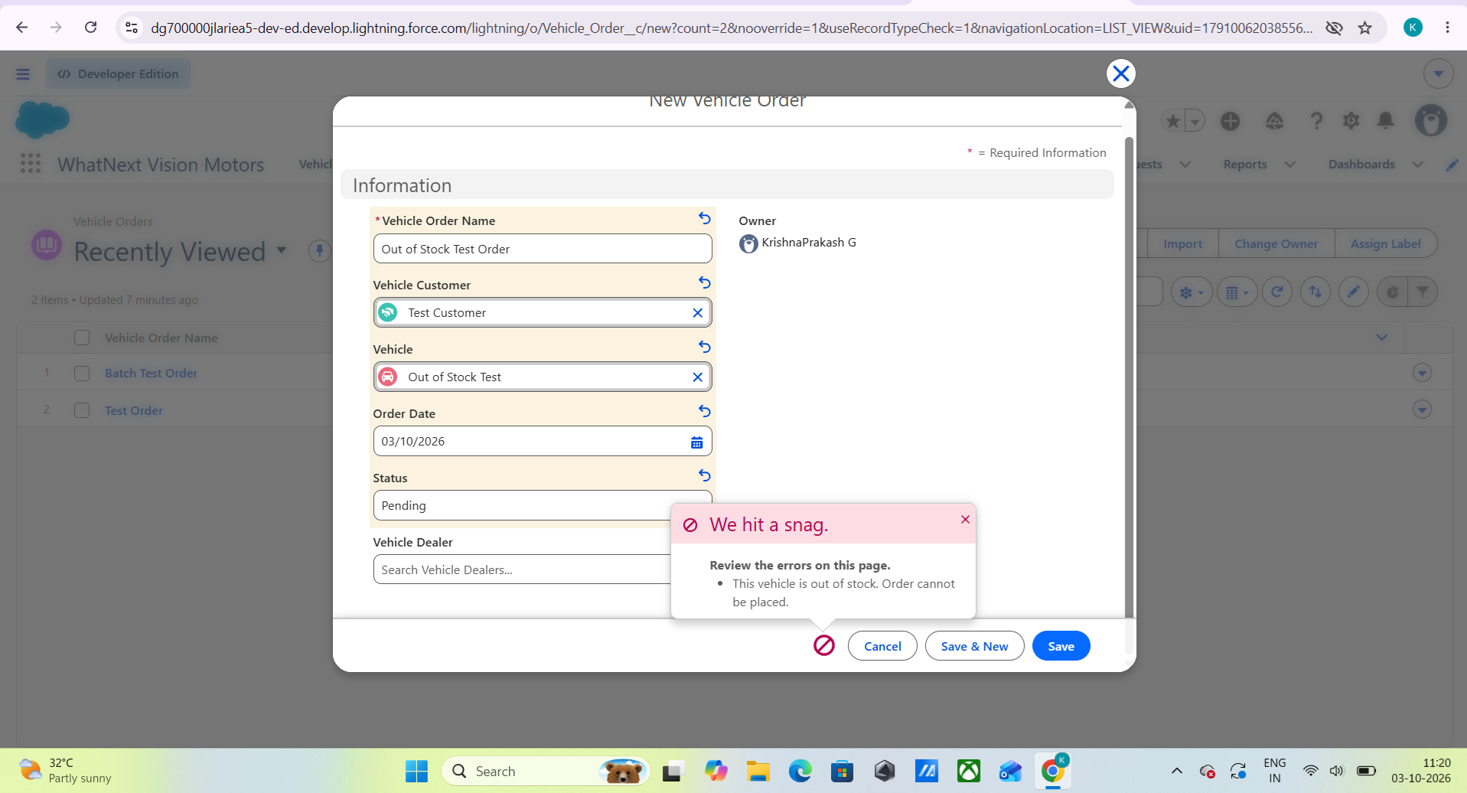

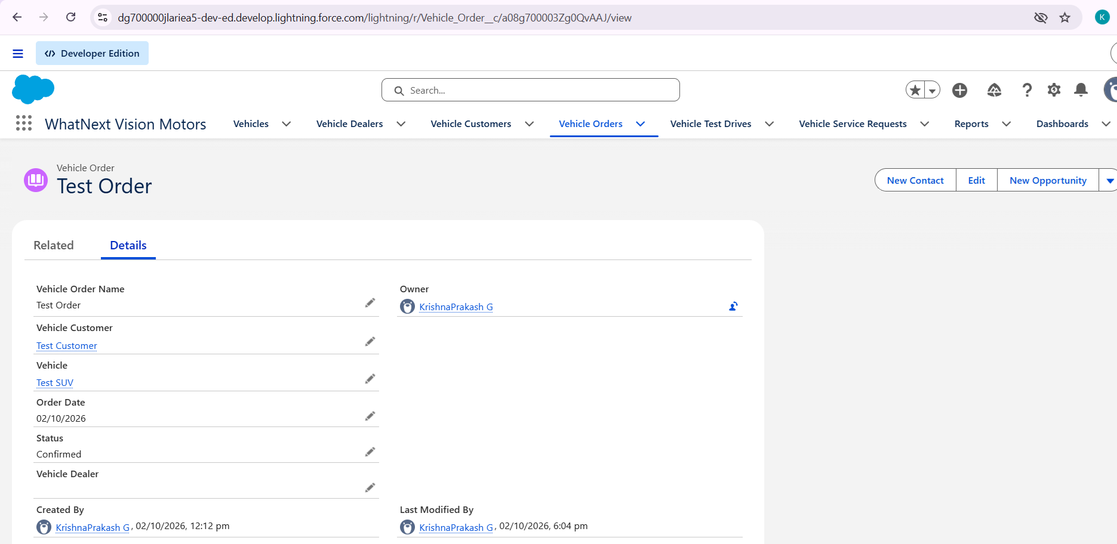

6.7 Batch Apex
VehicleOrderBatch queries Pending vehicle orders with a selected vehicle. When the related vehicle has stock greater than zero, the batch changes the order status to Confirmed. The batch was executed using a batch size of 50 and tested with a project test order.

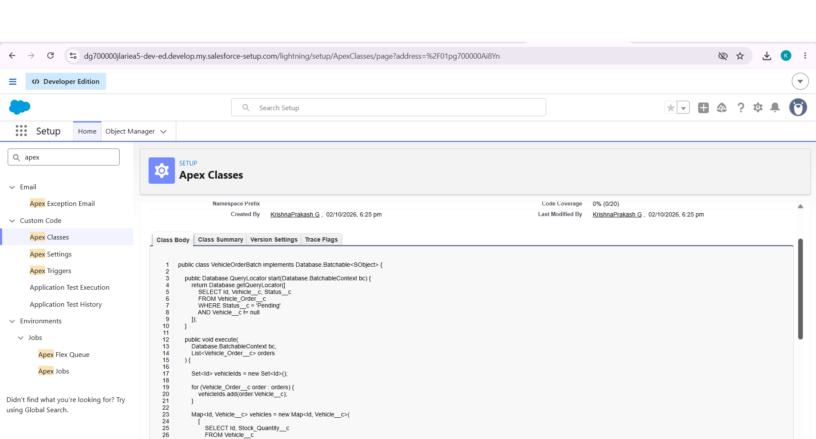

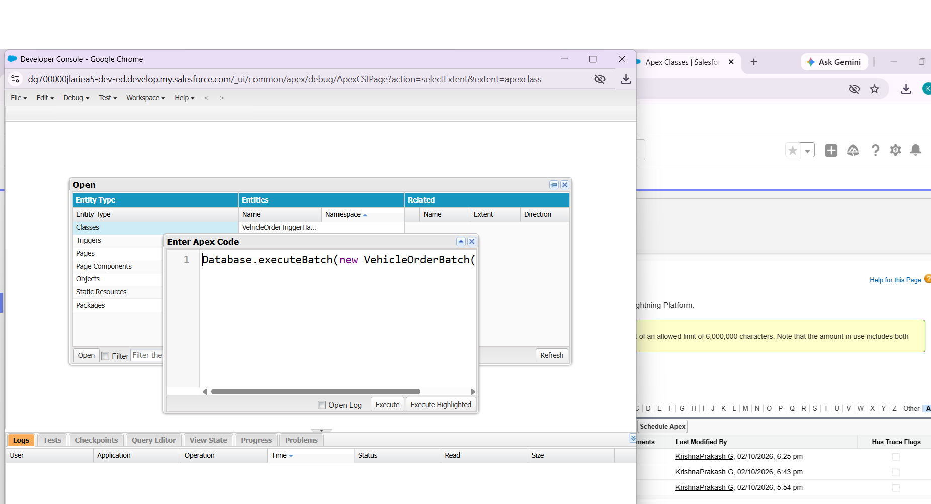

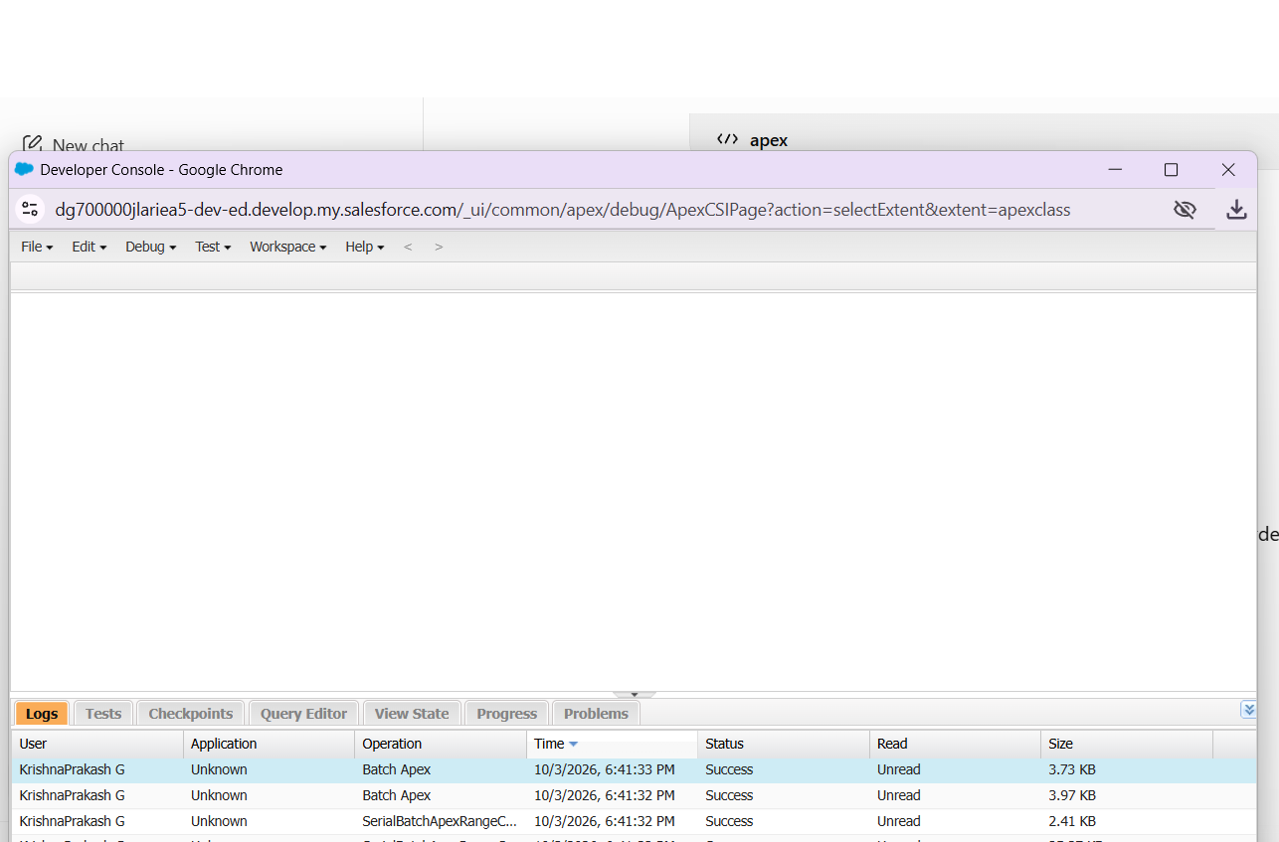

6.8 Scheduled Apex
VehicleOrderScheduler implements the Schedulable interface and starts VehicleOrderBatch with a batch size of 50. The scheduler was configured through Salesforce Scheduled Jobs using the available weekly scheduling option in the development org.

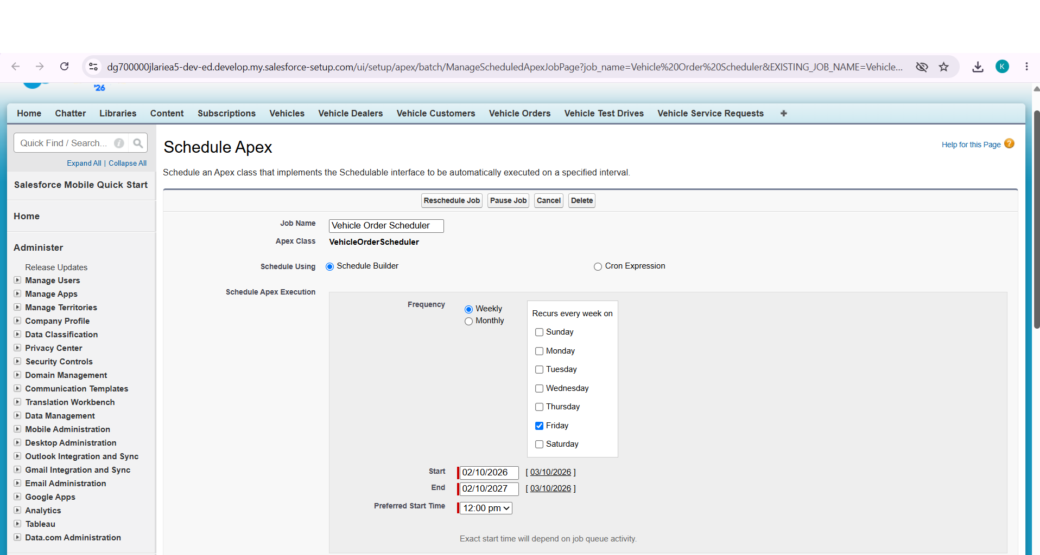

6.9 Reports
- Vehicle Inventory Report – vehicle model, stock quantity, price, dealer and status.
- Vehicle Orders Report – orders grouped by Status for summary monitoring.
- Vehicle Test Drives Report – customers, vehicles, test-drive dates and status.
- Vehicle Service Requests Report – service records, customers, vehicles, dates, issues and status.

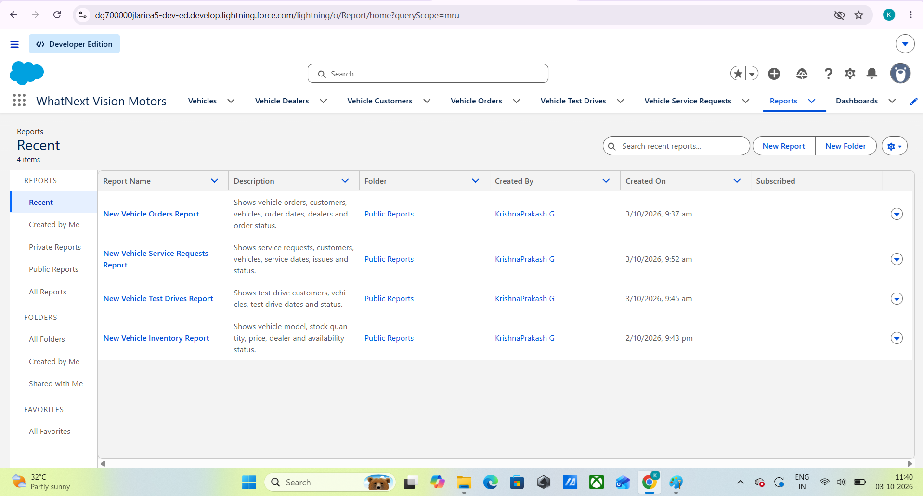

6.10 Dashboard
The “WhatNext Vision Motors Dashboard” was created to monitor four project areas: Vehicle Orders, Vehicle Service Requests, Vehicle Test Drives and Vehicle Inventory. The dashboard components use the corresponding Salesforce reports.

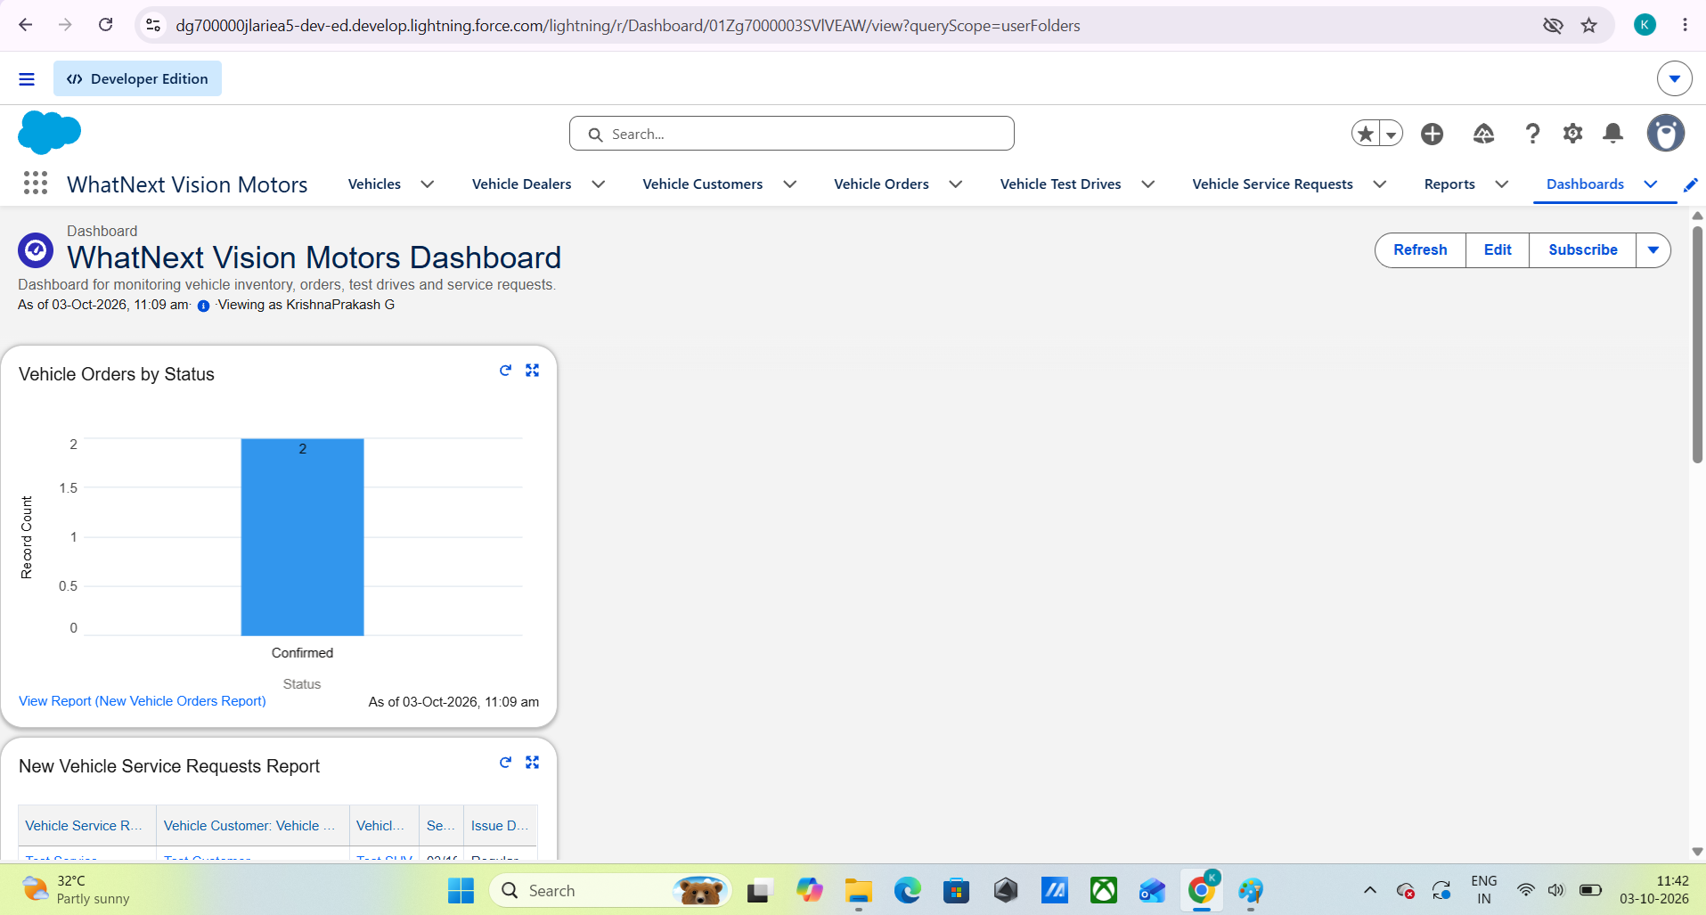

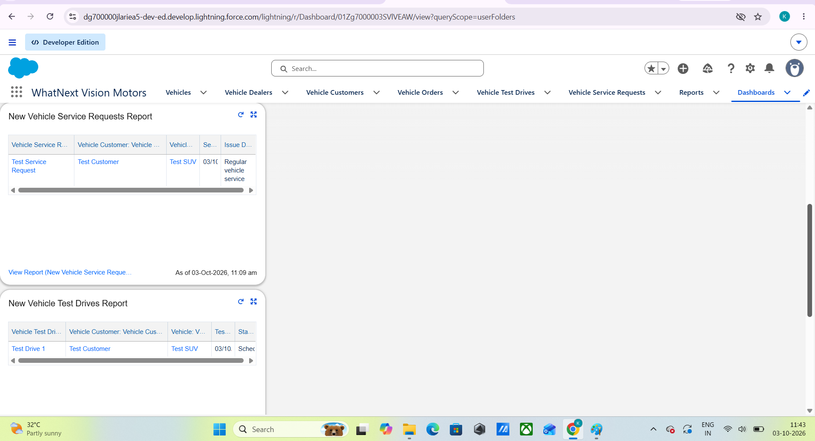

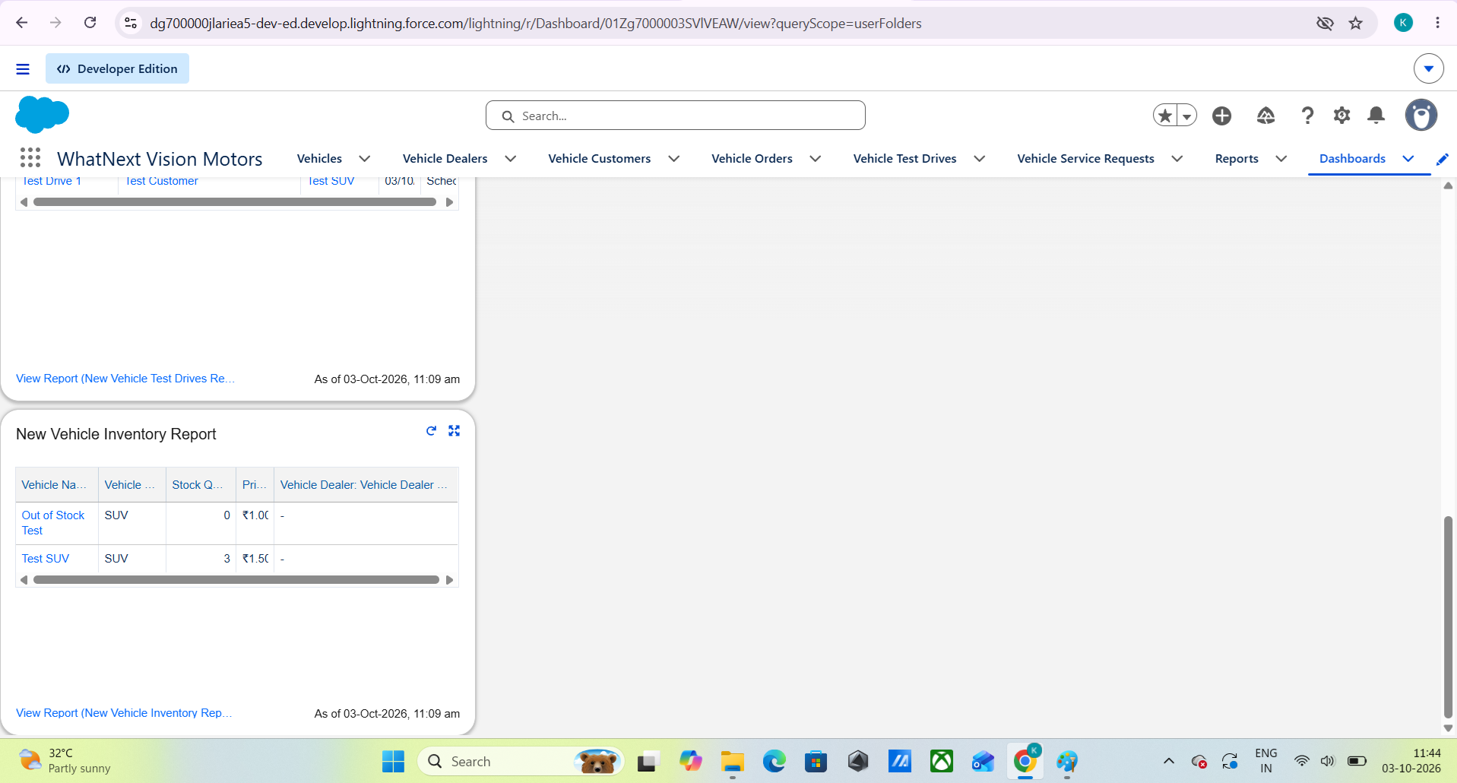

7. FUNCTIONAL & PERFORMANCE TESTING
Testing was performed on the implemented Salesforce configuration and automation. The following test cases were verified during development.
Test Case | Expected Result | Observed Result
Dealer assignment for Pending order | Dealer field should be populated from the matching customer/dealer location | Flow executed successfully and assigned the matching dealer during testing
Out-of-stock order | Order save should be blocked | Salesforce displayed: “This vehicle is out of stock. Order cannot be placed.”
Confirmed order stock reduction | Vehicle stock should reduce by 1 | Test SUV stock changed from 5 to 4
Batch processing | Pending order with available stock should become Confirmed | Batch Test Order changed from Pending to Confirmed
Test-drive reminder flow | Scheduled path should execute one day before test drive | Debug completed with 0 errors; Send Email action executed in rollback test
Service request report | Created service request should appear in report | Report displayed 1 test service request after filter adjustment
Dashboard | Operational reports should be available as dashboard components | Four dashboard components were added
Performance consideration: Apex logic uses sets, maps and bulk-oriented processing, and pending-order processing is implemented with Batch Apex. Actual production-scale performance benchmarking was not performed in the college development org.

8. ADVANTAGES & DISADVANTAGES

Advantages
- Centralized vehicle, dealer, customer and service data.
- Automated stock validation reduces invalid orders.
- Dealer assignment reduces manual processing.
- Scheduled test-drive reminders support customer communication.
- Batch Apex supports processing of multiple pending orders.
- Reports and dashboards improve operational visibility.

Disadvantages
- The solution depends on Salesforce platform configuration and availability.
- Initial configuration and Apex development require Salesforce knowledge.
- The current dealer assignment implementation uses location text matching rather than GPS distance calculation.
- Email delivery depends on Salesforce email configuration and recipient data.

9. CONCLUSION
The WhatNext Vision Motors Salesforce CRM project provides a centralized solution for vehicle sales and customer service operations. The implemented custom objects, Lightning application, Flows, Apex Trigger and Trigger Handler, Batch Apex, Scheduled Apex, reports and dashboard demonstrate how Salesforce can automate important business processes. Functional tests confirmed stock validation, stock reduction, batch status processing and automation execution in the development environment.

10. FUTURE SCOPE
- GPS-based nearest-dealer calculation using actual geographic distance.
- Customer-facing mobile or web ordering interface.
- SMS and WhatsApp notifications in addition to email.
- AI-based demand forecasting for vehicle inventory planning.
- Advanced analytics for sales trends and dealer performance.
- Integration with payment, delivery and external dealership systems.

11. APPENDIX

11.1 Source Code
Salesforce source metadata is maintained in the Salesforce DX project structure, including Apex Classes, Apex Trigger, Flows, Custom Objects, Custom Tabs and the WhatNext Vision Motors Lightning Application.

11.2 Dataset / Test Data
Development test records were created for vehicles, dealers, customers, orders, test drives and service requests to validate the implemented automation.

11.3 Documentation and Evidence
- Salesforce configuration screenshots
- Flow and Apex implementation evidence
- Out-of-stock validation result
- Stock reduction result
- Batch processing result
- Reports list
- Dashboard view
- GitHub repository containing project source and documentation

References
- Salesforce Developer Documentation – Lightning Platform, Apex, Flow and Reports.
- Project guide: WhatNext Vision Motors – Salesforce CRM implementation.
- Salesforce Developer Edition environment used for project development.

