Experiment Number: 1

Simulation and Comparative Analysis of FDMA, TDMA and CDMA: Resource Allocation, User Capacity and Mobile-Generation Context Program 1 — Capacity estimate for FDMA, TDMA and CDMA Objective 1: To estimate and compare the illustrative number of users supported by FDMA,
TDMA and CDMA using the specified system parameters. CODE:
clear; clc; close all;
% Illustrative system parameters
totalBandwidthHz = 1e6; % Total bandwidth: 1 MHz fdmaChannelHz = 200e3; % FDMA channel width: 200 kHz tdmaSlots = 8; % Number of TDMA slots per frame processingGain = 64; % CDMA processing gain targetSIRdB = 7; % Minimum acceptable CDMA SIR
% Capacity estimates under the stated assumptions fdmaUsers = floor(totalBandwidthHz / fdmaChannelHz); tdmaUsers = tdmaSlots;
targetSIR = 10^(targetSIRdB / 10);
cdmaUsers = floor(1 + processingGain / targetSIR); fprintf('Illustrative maximum supported users\n'); fprintf('FDMA: %d users\n', fdmaUsers); fprintf('TDMA: %d users\n', tdmaUsers);
fprintf('CDMA: %d users at a target SIR of %.1f dB\n\n', ... cdmaUsers, targetSIRdB);
% CDMA SIR as the number of simultaneous users increases K = 2:30;
sirLinear = processingGain ./ (K - 1); sirDb = 10 * log10(sirLinear);
% Display a comparison table
method = ["FDMA"; "TDMA"; "CDMA"];
supportedUsers = [fdmaUsers; tdmaUsers; cdmaUsers];

results = table(method, supportedUsers); disp(results);
% Plot estimated user capacity figure;
bar(categorical(method), supportedUsers);

ylabel('Illustrative maximum supported simultaneous users'); title('FDMA, TDMA and CDMA: Capacity Estimate');
grid on;
% Plot estimated CDMA SIR as users are added figure;
plot(K, sirDb, 'o-', 'LineWidth', 1.5); hold on;
yline(targetSIRdB, '--r', 'Target SIR'); xlabel('Number of simultaneous CDMA users (K)'); ylabel('Estimated SIR (dB)');
title('Estimated CDMA SIR versus Number of Users'); grid on;
hold off;

OUTPUT:
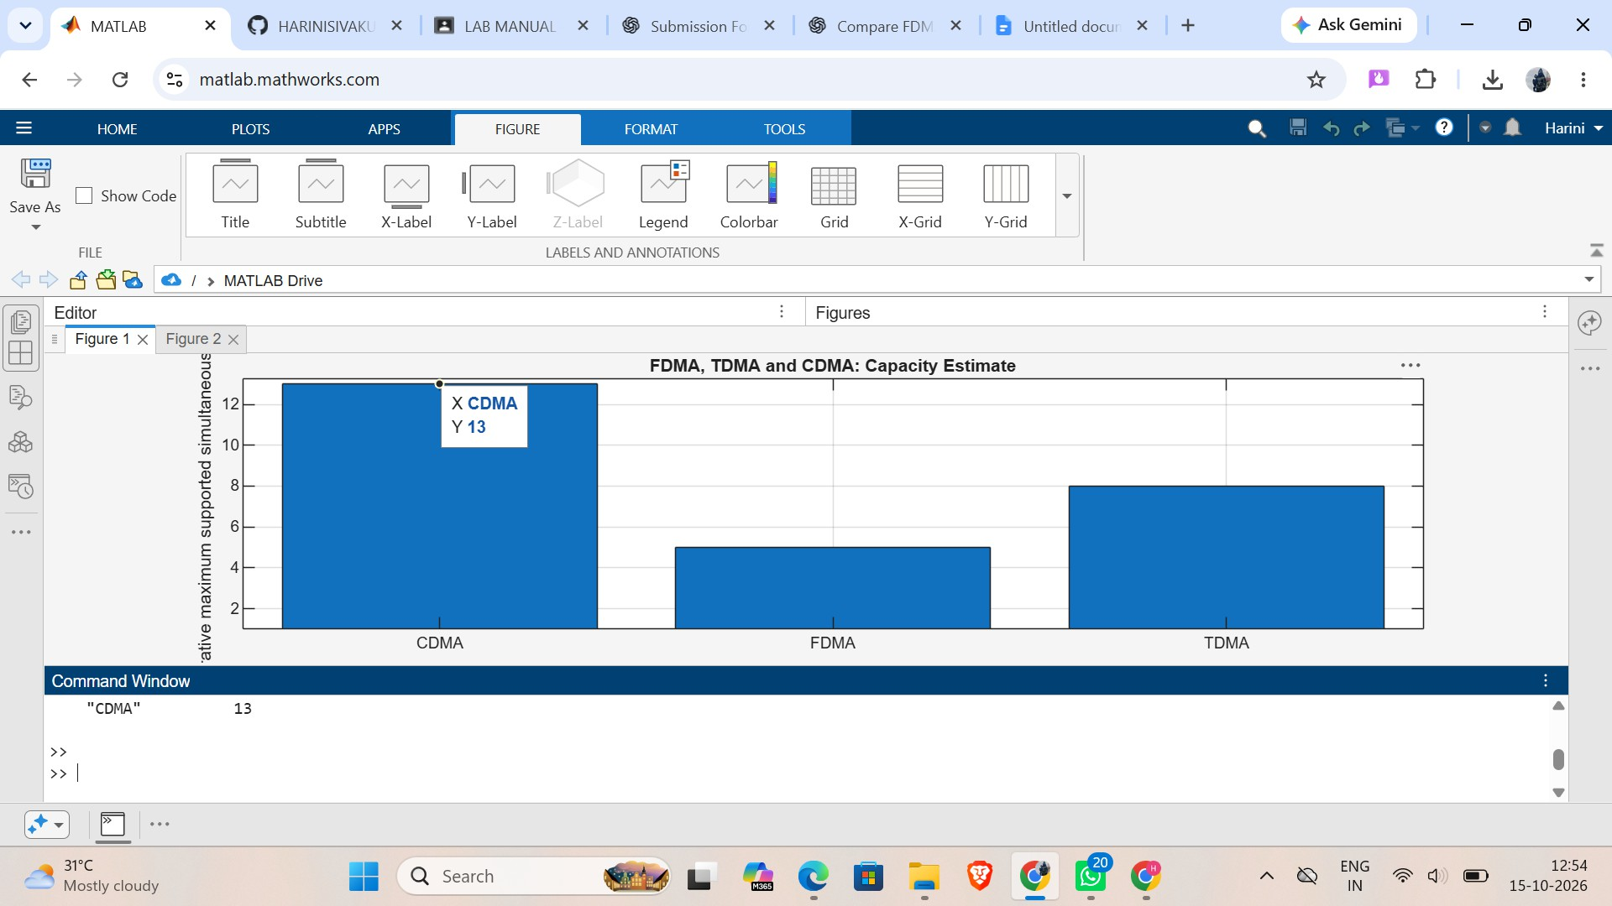
Objective 2: CDMA SIR analysis:
To analyze how the estimated CDMA signal-to-interference ratio changes as the number of simultaneous users increases.

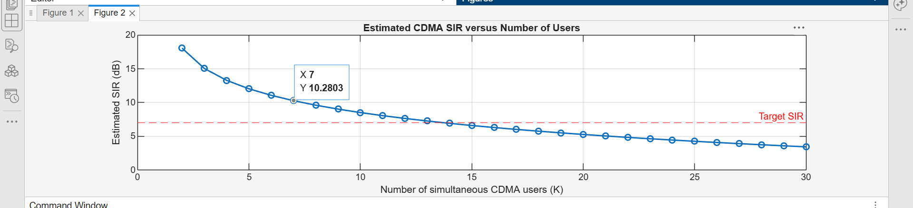
Objective 3: Mobile-generation comparison:
To relate representative multiple-access techniques to the evolution of mobile communication
systems from 1G to 5G. CODE:
generation = ["1G"; "2G"; "2G"; "3G"; "4G"; "5G"];
system = ["AMPS"; "GSM"; "IS-95"; "UMTS"; "LTE"; "5G NR"];
accessMethod = ["FDMA"; "TDMA"; "CDMA"; "WCDMA"; "OFDMA"; "OFDMA-based"];
keyIdea = ["Separate frequency channels"; ... "Separate time slots"; ...
"Code-based user separation"; ... "Wideband code-based access"; ... "Orthogonal frequency resources"; ... "Flexible OFDM-based radio access"];

evolutionTable = table(generation, system, accessMethod, keyIdea); disp(evolutionTable);

OUTPUT:
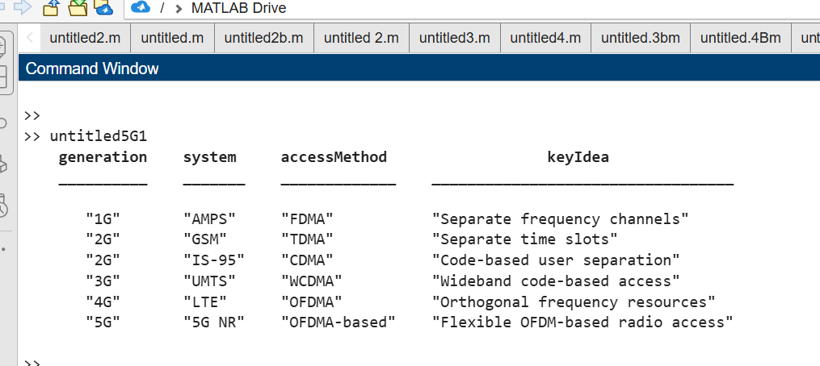
Objective 4: Resource-allocation diagrams:

To visualize how FDMA, TDMA and CDMA assign frequency, time and code resources to
multiple users. CODE:
figure; tiledlayout(1,3);
% FDMA: users occupy different frequency channels nexttile;
hold on;
colors = lines(4); for u = 1:4
rectangle('Position',[0, u-1, 1, 0.8], ...
'FaceColor',colors(u,:), 'EdgeColor','k');
text(0.5, u-0.6, sprintf('User %d',u), ... 'HorizontalAlignment','center');
end
xlim([0 1]); ylim([0 4]); xlabel('Time'); ylabel('Frequency channel'); title('FDMA');

set(gca,'YTick',[]); hold off;
% TDMA: users occupy different time slots on one frequency channel nexttile;
hold on; for u = 1:4
rectangle('Position',[u-1, 0, 0.8, 1], ...
'FaceColor',colors(u,:), 'EdgeColor','k');
text(u-0.6, 0.5, sprintf('User %d',u), ... 'HorizontalAlignment','center');
end
xlim([0 4]); ylim([0 1]); xlabel('Time slot'); ylabel('Frequency channel'); title('TDMA'); set(gca,'YTick',[]);
hold off;
% CDMA: users share the same time and frequency band using different codes nexttile;

hold on; for u = 1:4
rectangle('Position',[0, 0, 1, 1], ...
'FaceColor',colors(u,:), 'FaceAlpha',0.22, ...
'EdgeColor',colors(u,:), 'LineWidth',1.5); end
text(0.5, 0.62, 'Users 1-4 share', 'HorizontalAlignment','center'); text(0.5, 0.40, 'band; different codes', 'HorizontalAlignment','center'); xlim([0 1]); ylim([0 1]);
xlabel('Time'); ylabel('Frequency band'); title('CDMA'); set(gca,'YTick',[]);
hold off;
sgtitle('Conceptual Time-Frequency Resource Allocation');

OUTPUT:
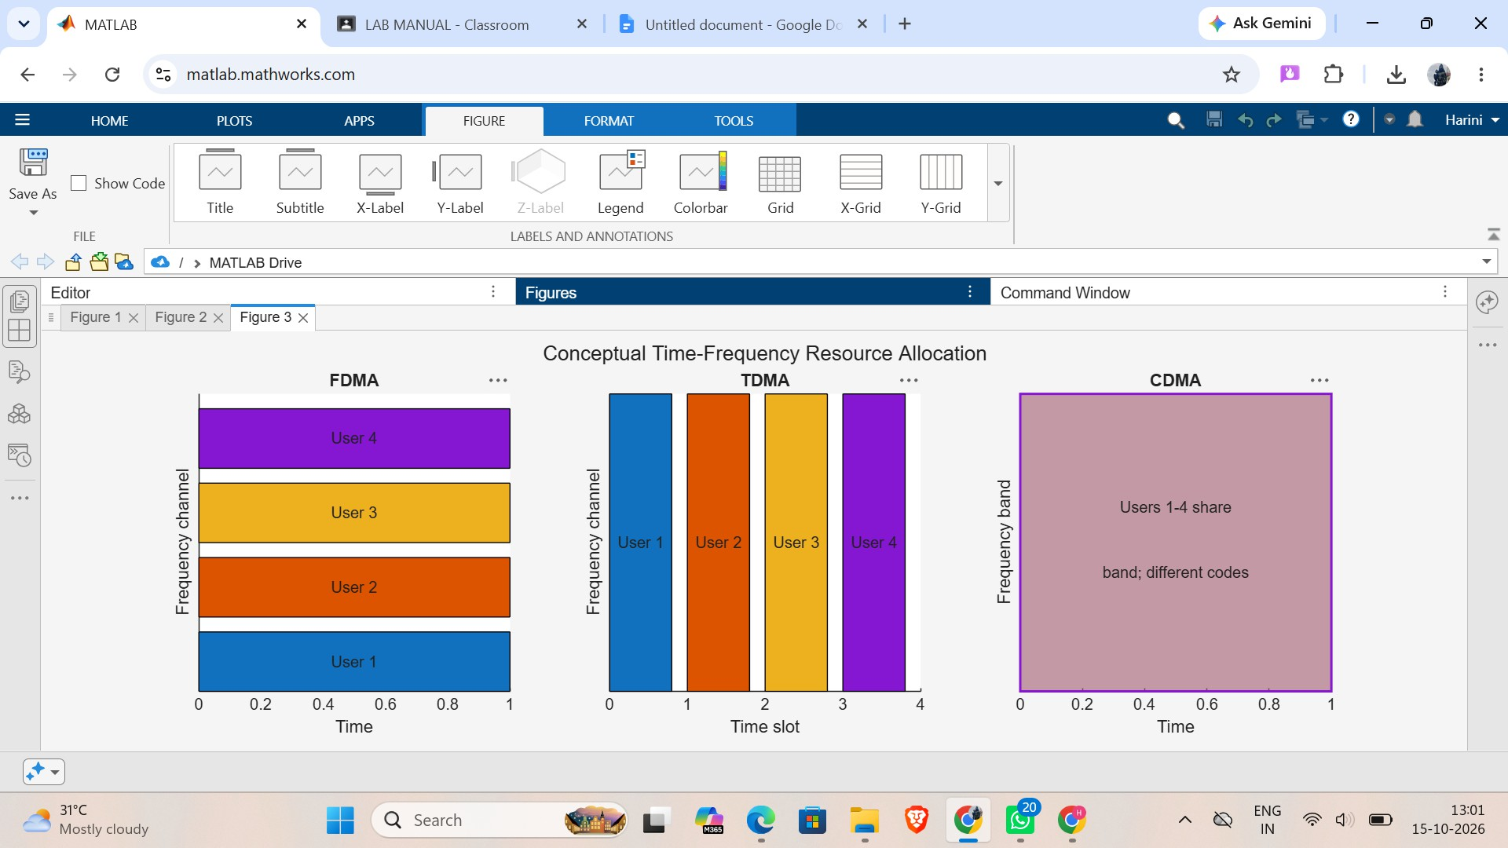
Experiment Number: 2

MATLAB Simulation of Cellular Coverage, Cell Splitting and Handoff in a Multi-Cell

Network CODE:
% Experiment 2: simplified hexagonal coverage and handoff clear; clc; close all;
% Baseline assumptions serviceAreaKm2 = 5;
radiiKm = [1.0 0.5];
usersPerCell = 30;
hexArea = @(R) (3*sqrt(3)/2) .* R.^2; cellAreaKm2 = hexArea(radiiKm);
cellCount = ceil(serviceAreaKm2 ./ cellAreaKm2); estimatedUsers = cellCount .* usersPerCell;
capacityTable = table(radiiKm(:), cellAreaKm2(:), cellCount(:), ... repmat(usersPerCell,numel(radiiKm),1), estimatedUsers(:), ... 'VariableNames', {'Radius_km','CellArea_km2','EstimatedCells', ... 'UsersPerCell','IllustrativeUsers'});
disp(capacityTable);
% Plot a 7-cell cluster: central cell plus six neighbors R = radiiKm(1);
centers = [0 0; 1.5*R sqrt(3)*R/2; 1.5*R -sqrt(3)*R/2; ... 0 sqrt(3)*R; 0 -sqrt(3)*R; -1.5*R sqrt(3)*R/2; ...
-1.5*R -sqrt(3)*R/2];
theta = (0:6)*pi/3; % flat-top hexagon vertices figure; hold on; axis equal; grid on;
for k = 1:size(centers,1)
plot(centers(k,1)+R*cos(theta), centers(k,2)+R*sin(theta), 'k-'); text(centers(k,1),centers(k,2),sprintf('Cell %d',k), ... 'HorizontalAlignment','center');
end
xlabel('x (km)'); ylabel('y (km)'); title('Idealized Seven-Cell Hexagonal Cluster');

hold off;
% Mobile moves across the boundary between centers at x=0 and x=1.5R mobileX = linspace(-0.2*R,1.7*R,300);
mobileY = zeros(size(mobileX)); d1 = hypot(mobileX, mobileY);
d2 = hypot(mobileX-1.5*R, mobileY); servingCell = ones(size(mobileX)); servingCell(d2 < d1) = 2;

handoffIndex = find(diff(servingCell) ~= 0,1,'first') + 1; figure; hold on; grid on; plot(mobileX,d1,'LineWidth',1.5); plot(mobileX,d2,'LineWidth',1.5);
if ~isempty(handoffIndex) xline(mobileX(handoffIndex),'--r','Handoff decision'); end
xlabel('Mobile x-position (km)'); ylabel('Distance to cell center (km)'); legend('Cell 1','Cell 2','Location','best');
title('Nearest-Center Handoff Approximation'); hold off;
figure; stairs(mobileX,servingCell,'LineWidth',1.5); grid on; xlabel('Mobile x-position (km)'); ylabel('Serving-cell ID'); title('Serving Cell Along the Mobile Path');
if ~isempty(handoffIndex)
fprintf('Geometric handoff at x = %.3f km\n',mobileX(handoffIndex)); end

OUTPUT:
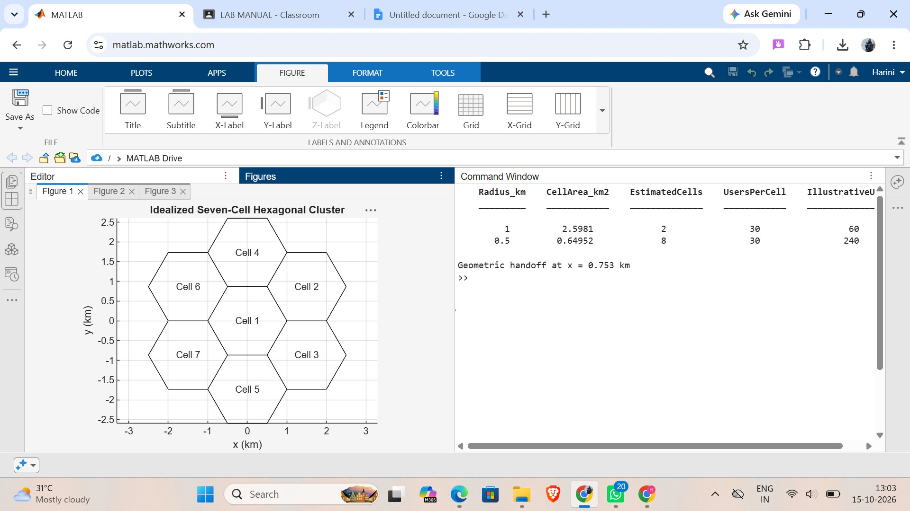

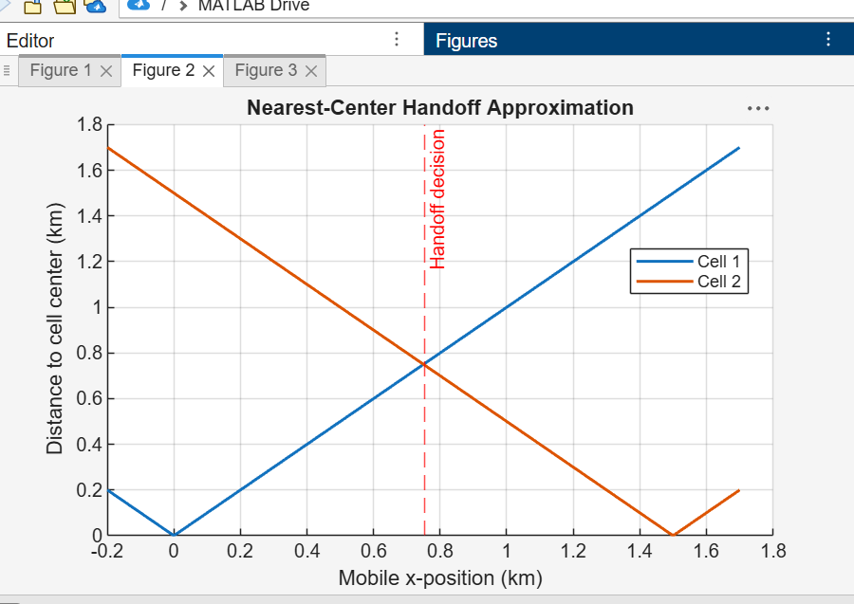

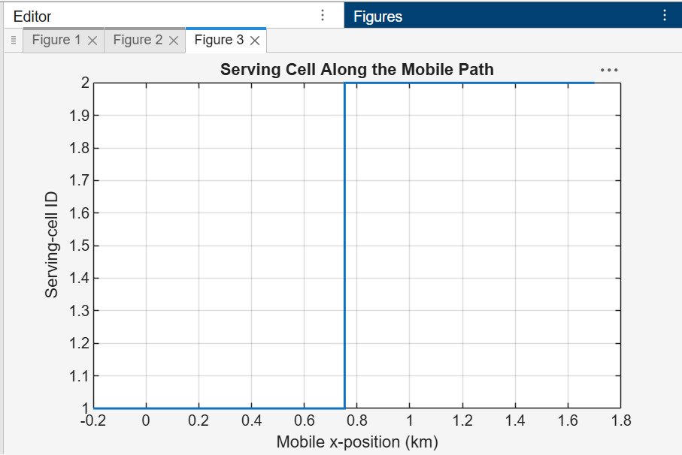
Experiment Number: 3

MATLAB Analysis of Spectrum Bands, Propagation Loss and Cellular Interference

CODE:
% Experiment 3: illustrative propagation and frequency reuse clear; clc; close all;
% Representative bands and link-budget assumptions freqGHz = [0.7 3.5 28];
freqMHz = freqGHz * 1000;
bandName = ["Sub-1 GHz"; "Mid-band"; "mmWave"]; txPowerdBm = 30;
gtDbi = 0; grDbi = 0;
distanceKm = logspace(log10(0.1),log10(2),200); distanceAtPointKm = 0.5;
% Free-space path loss (d in km, f in MHz)
fspl = @(fMHz,dKm) 32.44 + 20*log10(fMHz) + 20*log10(dKm); lossAtPoint = fspl(freqMHz,distanceAtPointKm);
rxAtPoint = txPowerdBm + gtDbi + grDbi - lossAtPoint;

linkTable = table(bandName,freqGHz(:),lossAtPoint(:),rxAtPoint(:), ... 'VariableNames',{'Band','Frequency_GHz','FSPL_dB','EstimatedRx_dBm'}); disp(linkTable);
% Path loss and received power over distance figure; tiledlayout(1,2);
nexttile; hold on; grid on; for k=1:numel(freqMHz)
plot(distanceKm,fspl(freqMHz(k),distanceKm),'LineWidth',1.5); end
set(gca,'XScale','log'); xlabel('Distance (km)'); ylabel('Path loss (dB)'); legend(bandName,'Location','northwest'); title('Free-Space Path Loss'); nexttile; hold on; grid on;
for k=1:numel(freqMHz)
rx = txPowerdBm + gtDbi + grDbi - fspl(freqMHz(k),distanceKm); plot(distanceKm,rx,'LineWidth',1.5);
end
set(gca,'XScale','log'); xlabel('Distance (km)'); ylabel('Estimated received power (dBm)');

legend(bandName,'Location','southwest'); title('Illustrative Received Power');
% Simple first-tier co-channel reuse estimate cellRadiusKm = 0.5;
reuseN = [1 3 7 12];
pathLossExponent = 3.5;
reuseDistance = sqrt(3*reuseN) * cellRadiusKm;
sirLinear = (reuseDistance/cellRadiusKm).^pathLossExponent / 6; sirDb = 10*log10(sirLinear);
reuseTable = table(reuseN(:),reuseDistance(:),sirDb(:), ... 'VariableNames',{'ReuseClusterN','ApproxInterfererDistance_km','ApproxSIR_dB'}); disp(reuseTable);
figure; plot(reuseN,sirDb,'o-','LineWidth',1.5); grid on; xlabel('Reuse cluster size N'); ylabel('Approximate SIR (dB)'); title('Simplified Co-Channel SIR versus Reuse Cluster Size');
fprintf('At %.2f km, estimated received powers are:\n',distanceAtPointKm); disp(table(bandName,rxAtPoint(:),'VariableNames',{'Band','Rx_dBm'}));

OUTPUT:

