Ex. No : 11
DEVELOP AN APPLICATION THAT CREATES AN ALARM
Date:

AIM:
To develop an android application that creates an alarm using android studio and sdk.

PROCEDURE:

Step 1 : File → NewProject
Provide the application name and Click “Next”

Step 2 : Select the target android devices
Select the minimum SDK to run the application. Click “Next”.

Step 3 : Choose the activity for the application (By default choose “Blank Activity). Click
“Next”.

Step 4 : Enter activity name and click "Finish".

Step 5 : Edit the program.

Step 6 : Run the application, 2-ways to run the application.
1. Running through emulator
2. Running through mobile device

SOURCE CODE:-

AndroidManifest.xml
<?xml version="1.0" encoding="utf-8"?>
<manifest xmlns:android="http://schemas.android.com/apk/res/android"
package="com.example.administrator.ex11" >
<application
android:allowBackup="true"
android:icon="@mipmap/ic_launcher"
android:label="@string/app_name"
android:theme="@style/AppTheme" >
<activity
android:name=".MainActivity"
android:label="@string/app_name" >
<intent-filter>
<action android:name="android.intent.action.MAIN" />
<category android:name="android.intent.category.LAUNCHER" />
</intent-filter>
</activity>
<receiver android:name="AlarmReceiver" >
</receiver>
</application>
</manifest>

activity_main.xml
<RelativeLayout xmlns:android="http://schemas.android.com/apk/res/android"
xmlns:tools="http://schemas.android.com/tools" android:layout_width="match_parent"
android:layout_height="match_parent" android:paddingLeft="@dimen/activity_horizontal_margin"
android:paddingRight="@dimen/activity_horizontal_margin"
android:paddingTop="@dimen/activity_vertical_margin"
android:paddingBottom="@dimen/activity_vertical_margin" tools:context=".MainActivity">
<TextView
android:text="Alarm.."
android:layout_width="wrap_content"
android:layout_height="wrap_content"
android:textSize="20dp"
android:id="@+id/textView" />
<Button
android:layout_width="wrap_content"
android:layout_height="wrap_content"
android:text="Set Alarm"
android:id="@+id/button2"
android:onClick="startAlarm"
android:layout_below="@+id/textView"
android:layout_alignParentLeft="true"
android:layout_alignParentStart="true"
android:layout_marginTop="66dp" />
</RelativeLayout>

MainActivity.java
package com.example.administrator.ex11;
import android.app.AlarmManager;
import android.app.PendingIntent;
import android.content.Intent;
import android.support.v7.app.ActionBarActivity;
import android.os.Bundle;
import android.view.View;
import android.widget.Toast;
import java.util.GregorianCalendar;
public class MainActivity extends ActionBarActivity {
@Override
protected void onCreate(Bundle savedInstanceState) {
super.onCreate(savedInstanceState);
setContentView(R.layout.activity_main);
}
public void startAlarm(View view)
{
Long alertTime=new GregorianCalendar().getTimeInMillis()+5*1000;
Intent alertIntent=new Intent(this,AlarmReceiver.class);
PendingIntent pendingIntent=PendingIntent.getBroadcast(
this.getApplicationContext(),234324243,alertIntent,0);
AlarmManager alarmManager=(AlarmManager)
getSystemService(ALARM_SERVICE);
alarmManager.set(AlarmManager.RTC_WAKEUP,
System.currentTimeMillis() + (5 * 1000), pendingIntent);
Toast.makeText(this, "Alarm will start in 5 seconds",
Toast.LENGTH_LONG).show();
}
}

AlarmReceiver.java
package com.example.administrator.ex11;
import android.content.BroadcastReceiver;
import android.content.Context;
import android.content.Intent;
import android.media.Ringtone;
import android.media.RingtoneManager;
import android.net.Uri;
import android.widget.Toast;
import java.util.ConcurrentModificationException;
public class AlarmReceiver extends BroadcastReceiver {
@Override
public void onReceive(Context context,Intent intent)
{
Uri notification = RingtoneManager.getDefaultUri(
RingtoneManager.TYPE_ALARM);
Ringtone r = RingtoneManager.getRingtone(
context.getApplicationContext(), notification);
r.play();
Toast.makeText(context, "Alarm Started!!!!.",
Toast.LENGTH_LONG).show();
}
}

OUTPUT:-

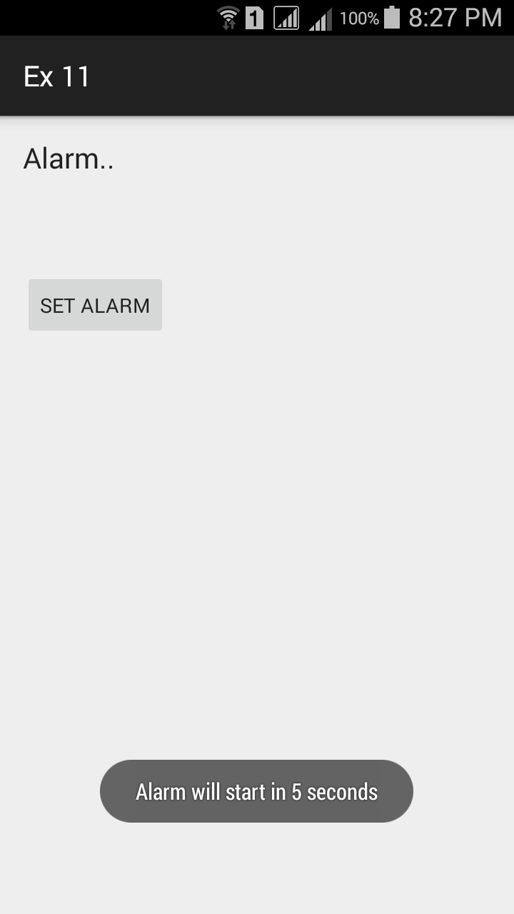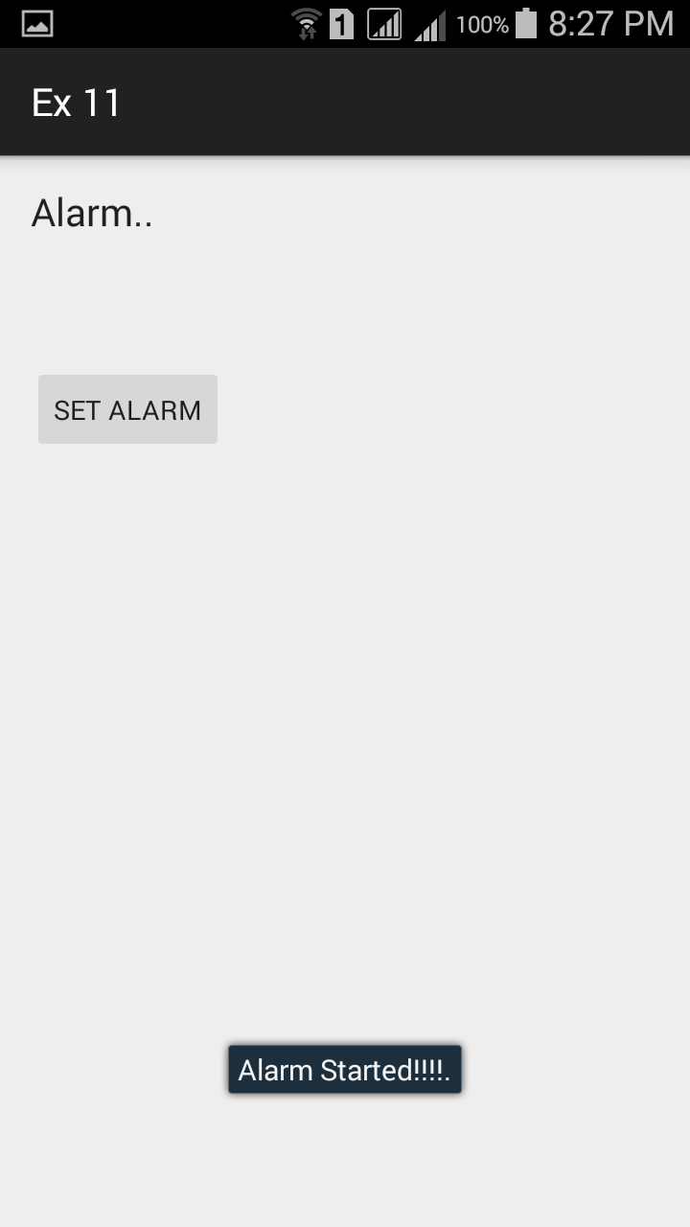

RESULT:
Thus the android application that creates an alarm using android studio and sdk was developed successfully.

