Ex. No : 6
DEVELOP AN APPLICATION THAT MAKES USE OF DATABASE
Date:

AIM:
To develop an android application that makes use of database using android studio and sdk.

PROCEDURE:

Step 1 : File → NewProject
Provide the application name and Click “Next”

Step 2 : Select the target android devices
Select the minimum SDK to run the application. Click “Next”.

Step 3 : Choose the activity for the application (By default choose “Blank Activity). Click
“Next”.

Step 4 : Enter activity name and click "Finish".

Step 5 : Edit the program.

Step 6 : Run the application, 2-ways to run the application.
1. Running through emulator
2. Running through mobile device

SOURCE CODE:-

AndroidManifest.xml
<?xml version="1.0" encoding="utf-8"?>
<manifest xmlns:android="http://schemas.android.com/apk/res/android"
package="com.example.administrator.ex6" >
<application
android:allowBackup="true"
android:icon="@mipmap/ic_launcher"
android:label="@string/app_name"
android:theme="@style/AppTheme" >
<activity
android:name=".MainActivity"
android:label="@string/app_name" >
<intent-filter>
<action android:name="android.intent.action.MAIN" />
<category android:name="android.intent.category.LAUNCHER" />
</intent-filter>
</activity>
<activity
android:name=".Home"
android:label="@string/title_activity_home" >
</activity>
<activity
android:name=".Register"
android:label="@string/title_activity_register" >
</activity>
</application>
</manifest>

activity_main.xml
<LinearLayout xmlns:android="http://schemas.android.com/apk/res/android"
xmlns:tools="http://schemas.android.com/tools" android:layout_width="match_parent"
android:layout_height="match_parent"
android:orientation="vertical"
tools:context="com.example.administrator.ex6.MainActivity">
<TextView
android:layout_width="match_parent"
android:layout_height="wrap_content"
android:text="UserName*"/>
<EditText
android:layout_width="match_parent"
android:layout_height="wrap_content"
android:id="@+id/E1"/>
<TextView
android:layout_width="match_parent"
android:layout_height="wrap_content"
android:text="Password*"/>
<EditText
android:layout_width="match_parent"
android:layout_height="wrap_content"
android:inputType="textPassword"
android:id="@+id/E2"/>
<Button
android:layout_width="match_parent"
android:layout_height="wrap_content"
android:text="Login"
android:id="@+id/B1"/>
<TextView
android:layout_width="match_parent"
android:layout_height="wrap_content" />
<TextView
android:layout_width="wrap_content"
android:layout_height="wrap_content"
android:text="New User"
android:layout_gravity="center"
android:id="@+id/L1"/>
</LinearLayout>

activity_register.xml
<LinearLayout xmlns:android="http://schemas.android.com/apk/res/android"
xmlns:tools="http://schemas.android.com/tools" android:layout_width="match_parent"
android:layout_height="match_parent"
android:orientation="vertical"
tools:context="com.example.administrator.ex6.Register">
<TextView
android:layout_width="wrap_content"
android:layout_height="wrap_content"
android:layout_gravity="center"
android:textStyle="bold"
android:textSize="30dp"
android:text="Fill Data"/>
<TextView
android:layout_width="wrap_content"
android:layout_height="wrap_content"
android:text="Name*"/>
<EditText
android:layout_width="match_parent"
android:layout_height="wrap_content"
android:id="@+id/E1"/>
<TextView
android:layout_width="wrap_content"
android:layout_height="wrap_content"
android:text="Age*"/>
<EditText
android:layout_width="match_parent"
android:layout_height="wrap_content"
android:id="@+id/E2"/>
<TextView
android:layout_width="wrap_content"
android:layout_height="wrap_content"
android:text="UserName*"/>
<EditText
android:layout_width="match_parent"
android:layout_height="wrap_content"
android:id="@+id/E3"/>
<TextView
android:layout_width="wrap_content"
android:layout_height="wrap_content"
android:text="Password*"/>
<EditText
android:layout_width="match_parent"
android:layout_height="wrap_content"
android:inputType="textPassword"
android:id="@+id/E4"/>
<Button
android:layout_width="match_parent"
android:layout_height="wrap_content"
android:text="Register"
android:id="@+id/B1"/>
</LinearLayout>

activity_home.xml
<LinearLayout xmlns:android="http://schemas.android.com/apk/res/android"
xmlns:tools="http://schemas.android.com/tools" android:layout_width="match_parent"
android:layout_height="match_parent"
android:orientation="vertical"
tools:context="com.example.administrator.ex6.Home">
<TextView
android:layout_width="wrap_content"
android:layout_height="wrap_content"
android:layout_gravity="center"
android:textSize="20dp"
android:textStyle="bold"
android:text="Welcome!.."/>
<TextView
android:layout_width="wrap_content"
android:layout_height="wrap_content"
android:id="@+id/T1"/>
<TextView
android:layout_width="wrap_content"
android:layout_height="wrap_content"
android:id="@+id/T2"/>
<TextView
android:layout_width="wrap_content"
android:layout_height="wrap_content"
android:id="@+id/T3"/>
<Button
android:layout_width="wrap_content"
android:layout_height="wrap_content"
android:text="View All"
android:id="@+id/B1"/>
</LinearLayout>

MainActivity.java

package com.example.administrator.ex6;
import android.app.Activity;
import android.app.AlertDialog;
import android.content.Context;
import android.content.Intent;
import android.content.SharedPreferences;
import android.database.Cursor;
import android.database.sqlite.SQLiteDatabase;
import android.support.v7.app.ActionBarActivity;
import android.os.Bundle;
import android.view.View;
import android.widget.Button;
import android.widget.EditText;
import android.widget.TextView;
public class MainActivity extends Activity {
EditText E1,E2;
Button B1;
TextView L1;
SQLiteDatabase db;
@Override
protected void onCreate(Bundle savedInstanceState) {
super.onCreate(savedInstanceState);
setContentView(R.layout.activity_main);
E1=(EditText)findViewById(R.id.E1);
E2=(EditText)findViewById(R.id.E2);
B1=(Button)findViewById(R.id.B1);
L1=(TextView)findViewById(R.id.L1);
db=openOrCreateDatabase("SAMPLEDB", Context.MODE_PRIVATE,null);
db.execSQL("CREATE TABLE IF NOT EXISTS LOGIN(NAME VARCHAR,AGE VARCHAR,USRNAME VARCHAR,PSWD VARCHAR);");
B1.setOnClickListener(new View.OnClickListener() {
@Override
public void onClick(View v) {
Cursor c = db.rawQuery("SELECT * FROM LOGIN WHERE USRNAME='" + E1.getText().toString() + "' AND PSWD='" + E2.getText().toString() + "'", null);
if (c.moveToFirst())
{
Intent intent=new Intent(MainActivity.this,Home.class);
intent.putExtra("USRNAME",E1.getText().toString());
startActivity(intent);
}
else
showMessage("Error", "Invalid Data!...");
}
});
L1.setOnClickListener(new View.OnClickListener() {
@Override
public void onClick(View v) {
startActivity(new Intent(MainActivity.this,Register.class));
}
});
}
public void showMessage(String title,String message)
{
AlertDialog.Builder builder=new AlertDialog.Builder(this);
builder.setTitle(title);
builder.setMessage(message);
builder.show();
}
}

Register.java
package com.example.administrator.ex6;
import android.app.AlertDialog;
import android.content.Context;
import android.database.Cursor;
import android.database.sqlite.SQLiteDatabase;
import android.support.v7.app.ActionBarActivity;
import android.os.Bundle;
import android.view.Menu;
import android.view.MenuItem;
import android.view.View;
import android.widget.Button;
import android.widget.EditText;
public class Register extends ActionBarActivity {
EditText E1,E2,E3,E4;
Button B1;
SQLiteDatabase db;
@Override
protected void onCreate(Bundle savedInstanceState) {
super.onCreate(savedInstanceState);
setContentView(R.layout.activity_register);
E1=(EditText)findViewById(R.id.E1);
E2=(EditText)findViewById(R.id.E2);
E3=(EditText)findViewById(R.id.E3);
E4=(EditText)findViewById(R.id.E4);
B1=(Button)findViewById(R.id.B1);
db=openOrCreateDatabase("SAMPLEDB", Context.MODE_PRIVATE,null);
B1.setOnClickListener(new View.OnClickListener() {
@Override
public void onClick(View v) {
String name = E1.getText().toString();
String age = E2.getText().toString();
String usrname = E3.getText().toString();
String pswd = E4.getText().toString();
Cursor c = db.rawQuery("SELECT COUNT(*) FROM LOGIN WHERE USRNAME='" + usrname + "'", null);
if(c.moveToFirst())
{
if(c.getInt(0)==0)
{
db.execSQL("INSERT INTO LOGIN VALUES('" + name + "','" + age +
"','" + usrname + "','" + pswd + "');");
showMessage("Success","Record Added");
}
else
showMessage("Error","UserName not available");
}
}
});
}
public void showMessage(String title,String message)
{
AlertDialog.Builder builder=new AlertDialog.Builder(this);
builder.setTitle(title);
builder.setMessage(message);
builder.show();
}
}

Home.java
package com.example.administrator.ex6;
import android.app.AlertDialog;
import android.content.Context;
import android.database.Cursor;
import android.database.sqlite.SQLiteDatabase;
import android.support.v7.app.ActionBarActivity;
import android.os.Bundle;
import android.view.Menu;
import android.view.MenuItem;
import android.view.View;
import android.widget.Button;
import android.widget.TextView;
public class Home extends ActionBarActivity {
TextView T1,T2,T3;
Button B1;
SQLiteDatabase db;
@Override
protected void onCreate(Bundle savedInstanceState) {
super.onCreate(savedInstanceState);
setContentView(R.layout.activity_home);
T1=(TextView)findViewById(R.id.T1);
T2=(TextView)findViewById(R.id.T2);
T3=(TextView)findViewById(R.id.T3);
B1=(Button)findViewById(R.id.B1);
db=openOrCreateDatabase("SAMPLEDB", Context.MODE_PRIVATE,null);
Cursor c = db.rawQuery("SELECT * FROM LOGIN WHERE USRNAME='" + getIntent().getStringExtra("USRNAME") + "'", null);
if(c.moveToFirst())
{
T1.setText("Name :" +c.getString(0));
T2.setText("Age :"+c.getString(1));
T3.setText("UserName:"+c.getString(2));
}
B1.setOnClickListener(new View.OnClickListener() {
@Override
public void onClick(View v) {
Cursor c = db.rawQuery("SELECT * FROM LOGIN", null);
StringBuffer buffer=new StringBuffer();
while(c.moveToNext())
{
buffer.append("Name: "+c.getString(0)+"\n");
buffer.append("Age: "+c.getString(1)+"\n");
buffer.append("UserName: "+c.getString(2)+"\n\n");
}
showMessage("Student Details", buffer.toString());
}
});
}
public void showMessage(String title,String message)
{
AlertDialog.Builder builder=new AlertDialog.Builder(this);
builder.setTitle(title);
builder.setMessage(message);
builder.show();
}
}

OUTPUT:-

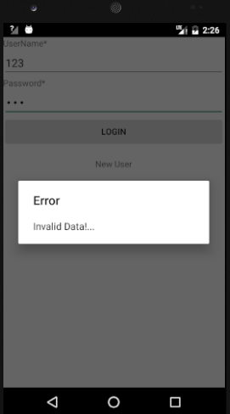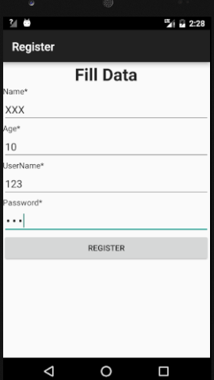

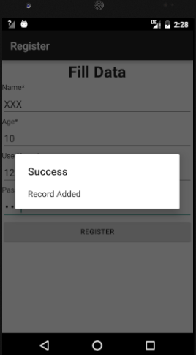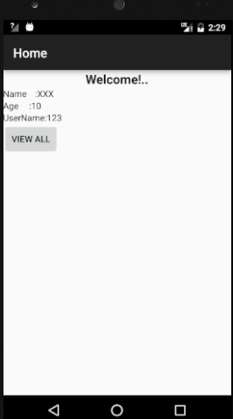

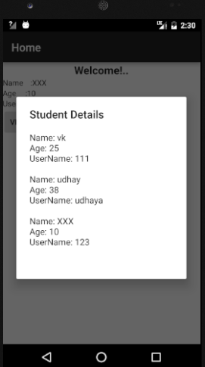
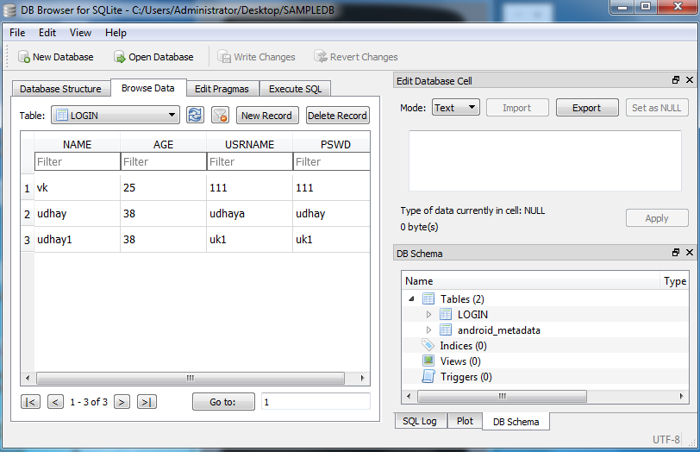

RESULT:
Thus the android application that makes use of database using android studio and sdk was developed successfully.

