Ex. No : 9
DEVELOP AN APPLICATION TO GET GPS LOCATION
Date:

AIM:
To develop an android application to get GPS Location using android studio and sdk.

PROCEDURE:

Step 1 : File → NewProject
Provide the application name and Click “Next”

Step 2 : Select the target android devices
Select the minimum SDK to run the application. Click “Next”.

Step 3 : Choose the activity for the application (By default choose “Blank Activity). Click
“Next”.

Step 4 : Enter activity name and click "Finish".

Step 5 : Edit the program.

Step 6 : Run the application, 2-ways to run the application.
1. Running through emulator
2. Running through mobile device

SOURCE CODE:-

AndroidManifest.xml
<?xml version="1.0" encoding="utf-8"?>
<manifest xmlns:android="http://schemas.android.com/apk/res/android"
package="com.example.administrator.ex9gps" >
<uses-permission android:name="android.permission.INTERNET"/>
<uses-permission android:name="android.permission.ACCESS_FINE_LOCATION"/>
<uses-permission android:name="android.permission.ACCESS_COARSE_LOCATION"/>
<application
android:allowBackup="true"
android:icon="@mipmap/ic_launcher"
android:label="@string/app_name"
android:theme="@style/AppTheme" >
<activity
android:name=".MainActivity"
android:label="@string/app_name" >
<intent-filter>
<action android:name="android.intent.action.MAIN" />
<category android:name="android.intent.category.LAUNCHER" />
</intent-filter>
</activity>
</application>
</manifest>

activity_main.xml
<RelativeLayout xmlns:android="http://schemas.android.com/apk/res/android"
xmlns:tools="http://schemas.android.com/tools" android:layout_width="match_parent"
android:layout_height="match_parent" android:paddingLeft="@dimen/activity_horizontal_margin"
android:paddingRight="@dimen/activity_horizontal_margin"
android:paddingTop="@dimen/activity_vertical_margin"
android:paddingBottom="@dimen/activity_vertical_margin" tools:context=".MainActivity">
<Button
android:layout_width="150dp"
android:layout_height="wrap_content"
android:text="Start Service"
android:id="@+id/B1"
android:layout_alignParentTop="true"
android:layout_alignParentLeft="true"/>
<Button
android:layout_width="wrap_content"
android:layout_height="wrap_content"
android:text="Stop"
android:id="@+id/B2"
android:layout_alignParentTop="true"
android:layout_alignParentRight="true"/>
<TextView
android:layout_width="wrap_content"
android:layout_height="wrap_content"
android:textSize="20dp"
android:text="Coordinates"
android:id="@+id/T1"
android:layout_below="@+id/B1"
android:layout_centerHorizontal="true" />
</RelativeLayout>

MainActivity.java
package com.example.administrator.ex9gps;
import android.content.Intent;
import android.location.Location;
import android.location.LocationListener;
import android.location.LocationManager;
import android.provider.Settings;
import android.support.v7.app.ActionBarActivity;
import android.os.Bundle;
import android.view.View;
import android.widget.Button;
import android.widget.TextView;
public class MainActivity extends ActionBarActivity {
Button B1,B2;
TextView T1;
LocationManager locationManager;
LocationListener locationListener;
@Override
protected void onCreate(Bundle savedInstanceState) {
super.onCreate(savedInstanceState);
setContentView(R.layout.activity_main);
B1 = (Button) findViewById(R.id.B1);
B2=(Button)findViewById(R.id.B2);
T1 = (TextView) findViewById(R.id.T1);
locationManager = (LocationManager)
getSystemService(LOCATION_SERVICE);
locationListener = new LocationListener() {
@Override
public void onLocationChanged(Location location) {
T1.append("\n" + location.getLatitude() + " " +
location.getLongitude());
}
@Override
public void onStatusChanged(String provider, int status,
Bundle extras) {
}
@Override
public void onProviderEnabled(String provider) {
}
@Override
public void onProviderDisabled(String provider) {
Intent intent = new Intent(
Settings.ACTION_LOCATION_SOURCE_SETTINGS);
startActivity(intent);
}
};
B1.setOnClickListener(new View.OnClickListener() {
@Override
public void onClick(View v) {
locationManager.requestLocationUpdates(
"gps",5000,0,locationListener);
}
});
B2.setOnClickListener(new View.OnClickListener() {
@Override
public void onClick(View v) {
Intent i=getIntent();
finish();
startActivity(i);
}
});
}
}

OUTPUT:-

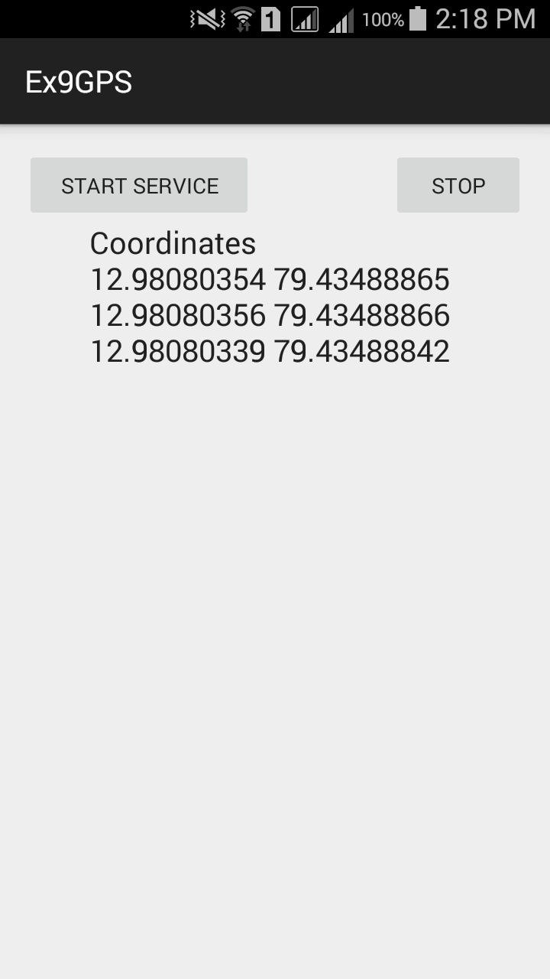

RESULT:
Thus the android application to get GPS Location using android studio and sdk was developed successfully.

