Ex. No : 8
DEVELOP AN APPLICATION THAT IMPLEMENTS MULTITHREADING
Date:

AIM:
To develop an android application that implements multithreading using android studio and sdk.

PROCEDURE:

Step 1 : File → NewProject
Provide the application name and Click “Next”

Step 2 : Select the target android devices
Select the minimum SDK to run the application. Click “Next”.

Step 3 : Choose the activity for the application (By default choose “Blank Activity). Click
“Next”.

Step 4 : Enter activity name and click "Finish".

Step 5 : Edit the program.

Step 6 : Run the application, 2-ways to run the application.
1. Running through emulator
2. Running through mobile device

SOURCE CODE:-

AndroidManifest.xml
<?xml version="1.0" encoding="utf-8"?>
<manifest xmlns:android="http://schemas.android.com/apk/res/android"
package="com.example.administrator.ex8" >
<application
android:allowBackup="true"
android:icon="@mipmap/ic_launcher"
android:label="@string/app_name"
android:theme="@style/AppTheme" >
<activity
android:name=".MainActivity"
android:label="@string/app_name" >
<intent-filter>
<action android:name="android.intent.action.MAIN" />
<category android:name="android.intent.category.LAUNCHER" />
</intent-filter>
</activity>
</application>
</manifest>

activity_main.xml
<RelativeLayout xmlns:android="http://schemas.android.com/apk/res/android"
xmlns:tools="http://schemas.android.com/tools" android:layout_width="match_parent"
android:layout_height="match_parent" android:paddingLeft="@dimen/activity_horizontal_margin"
android:paddingRight="@dimen/activity_horizontal_margin"
android:paddingTop="@dimen/activity_vertical_margin"
android:paddingBottom="@dimen/activity_vertical_margin" tools:context=".MainActivity">
<RelativeLayout
android:id="@+id/firstlayout"
android:layout_width="fill_parent"
android:layout_height="wrap_content"
android:gravity="center"
android:layout_marginTop="80dp">
<TextView
android:id="@+id/display"
android:layout_width="wrap_content"
android:layout_height="wrap_content"
android:text="Button will appear after 10 seconds" />
</RelativeLayout>
<RelativeLayout
android:id="@+id/secondlayout"
android:layout_width="fill_parent"
android:layout_height="wrap_content"
android:layout_below="@+id/firstlayout"
android:gravity="center">
<TextView
android:id="@+id/timer"
android:layout_width="wrap_content"
android:layout_height="wrap_content"
android:gravity="center_horizontal"
android:text="12"
android:layout_marginTop="80dp"
android:textSize="36dp"/>
</RelativeLayout>
<RelativeLayout
android:id="@+id/thirdlayout"
android:layout_width="fill_parent"
android:layout_height="wrap_content"
android:layout_below="@+id/secondlayout"
android:gravity="center">
<Button
android:id="@+id/clickme"
android:layout_width="wrap_content"
android:layout_height="wrap_content"
android:text="Click_me"
android:visibility="invisible"
android:layout_marginTop="100dp"/>
</RelativeLayout>
</RelativeLayout>

MainActivity.java
package com.example.administrator.ex8;
import android.support.v7.app.ActionBarActivity;
import android.os.Bundle;
import android.view.View;
import android.widget.Button;
import android.widget.TextView;
import android.os.Handler;
public class MainActivity extends ActionBarActivity {
Handler hand=new Handler();
Button clickme;
TextView timer;
@Override
protected void onCreate(Bundle savedInstanceState) {
super.onCreate(savedInstanceState);
setContentView(R.layout.activity_main);
timer=(TextView)findViewById(R.id.timer);
clickme=(Button)findViewById(R.id.clickme);
hand.postDelayed(run, 1000);
}
Runnable run=new Runnable() {
@Override
public void run() {
updateTime();
}
};
public void updateTime() {
timer.setText("" +(Integer.parseInt(timer.getText().toString())-1));
if (Integer.parseInt(timer.getText().toString()) == 0) {
clickme.setVisibility(View.VISIBLE);
} else {
hand.postDelayed(run, 1000);
}
}
}

OUTPUT:-

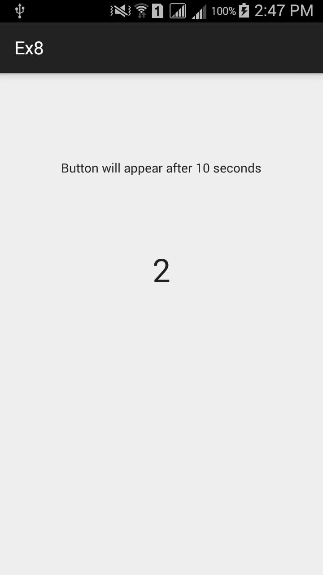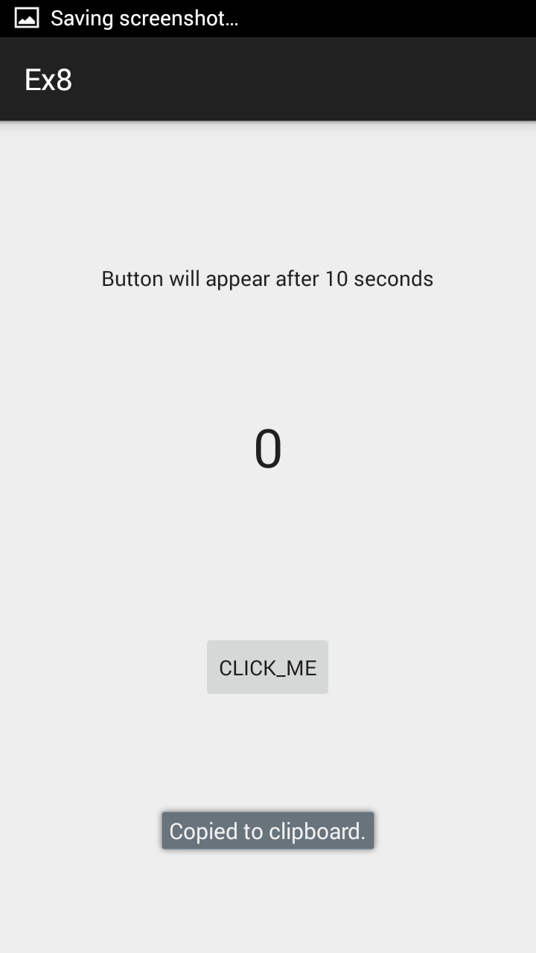

RESULT:
Thus the android application that implements multithreading using android studio and sdk was developed successfully.

