

NAME: S. JAYAPRIYA

DEPARTMENT: B.COM (ACCOUNTING & FINANCE)

REGISTER NO: 31221858

EMAIL-ID : jayapriyadhamotharan12@gmail.com

**TABLE OF CONTENTS**

* Introduction
* Create a folder and rename a folder
* Font size
* Font style
* Font color
* Table
* Picture insert
* Shapes
* Bold, italic
* Page number
* Alignment
* Line spacing
* Border add and remove
* Equation and symbols

**INTRODUCTION**

Word Processor is a software package that enables us to create, edit, print and save our documents for future retrieval and reference. With the help of Word we can create various types of documents such as letters, papers, brochures, faxes and more. In this module, you will learn about a most commonly used word processing software, Microsoft Word (often called MS Word or Word) which works in Windows operating system. Microsoft Word was designed by the Microsoft company. Microsoft introduced MS Word in Microsoft Office suite along with other application programs. Although, there are different versions of Word like Word 2000, Word 2003 etc., here we will discuss Word 2010. Word 2010 is a bit different from the earlier versions, so even if you have used Word before, you should take some time to familiarize yourself with the interface.

**CREATE A FOLDER AND RENAME A FOLDER**

Create a folder

* Click new
* Select create
* Select the type of document you want to create.

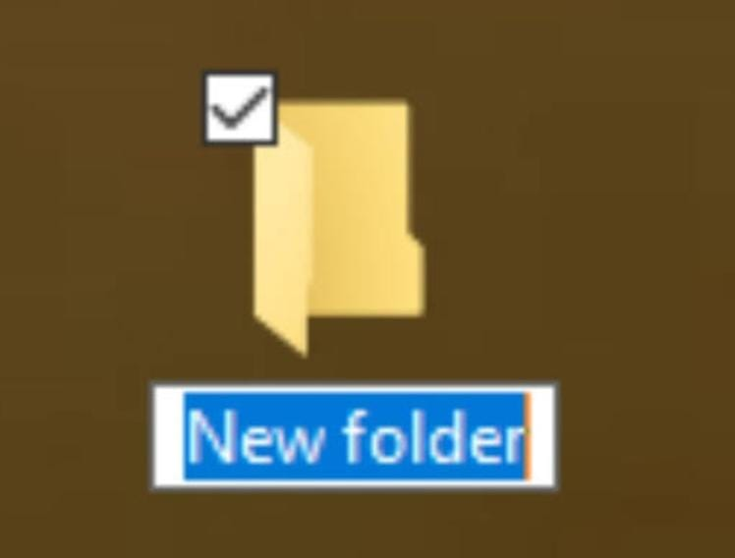 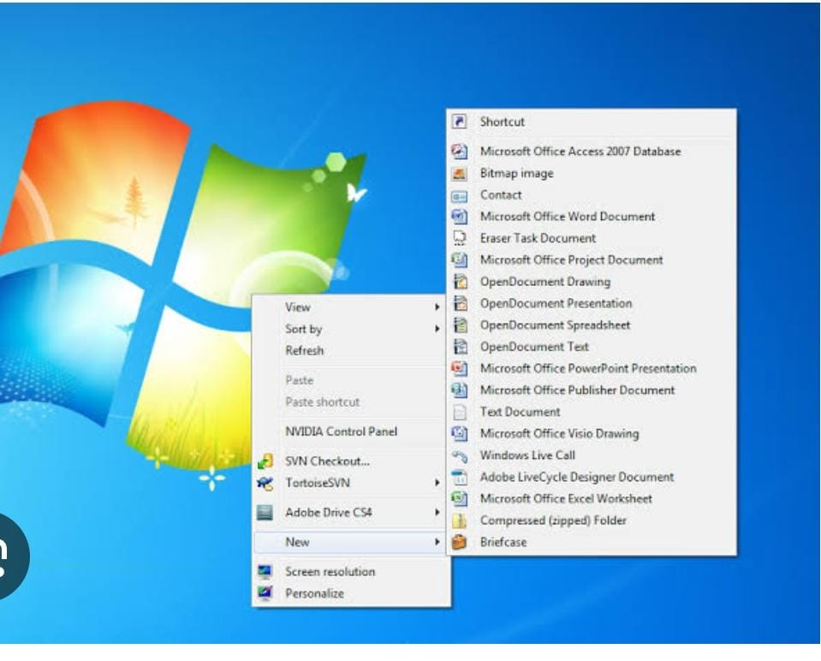

**RENAME A FOLDER**

* Select the folder and then select the ellipses
* Select rename
* Type the new name in the name field
* Select save.

**FONT SIZE**

Font size refers to the height of typeface and is commonly used to describe the size of the texton a digital device like computer and websites. It is usually measured in a points, where one points is equal to 1/72 of an inch. For example, 72-point type is an inch tall, while 12-point type is 1/6 of an inch.

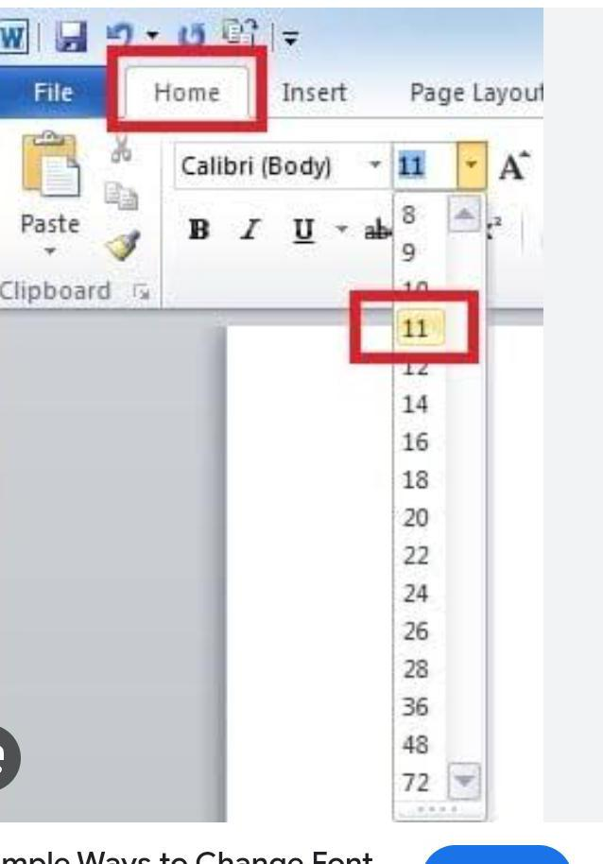

**FONT STYLE**

Font style are used to change the look ability of the text or give more emphasis on some texts in the word document. There are three types of font styles in Ms word: bold ,italics ,and underline

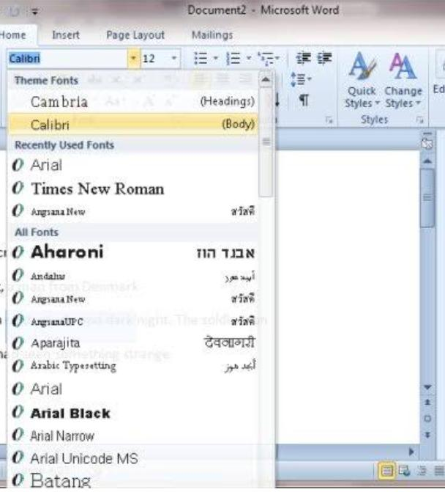

**FONT COLOR**

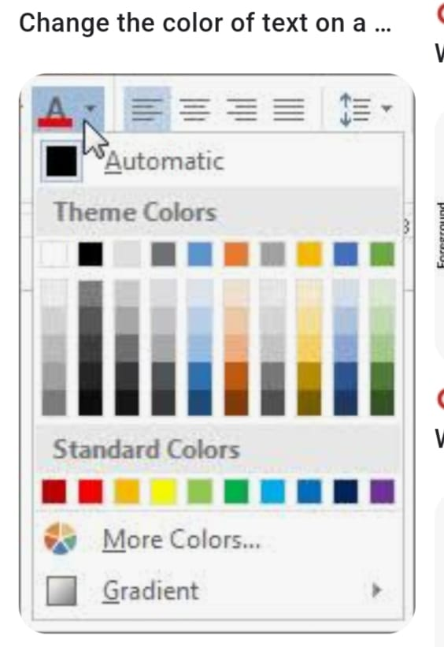

Font color refers to the color of the characters or text in a designs, determined by the choice of digital color applied to the type face. Font colors plays a crucial role in a visual communication.

**TABLE**

CREATING TABLES Tables in MS Word allow us to organize data in a tabular manner arranged in rows and columns. When there is numerical or statistical data in our document, organizing them into rows and columns allows us to view, compare and define their inter-relationship more clearly. We select Tables from the Tables group under the Insert tabs. This expands the Insert Table drop-down menu giving us a number of options.

• We may hover the mouse over the small squares representing the cells of a table. As we hover, the table is displayed in the background and gets created once we click.

• Clicking the Insert Table option, the dialog box of Figure 3.30 will appear, which allows us to select the table properties. Or,

• The Draw Table option allows us to draw a table using the mouse.

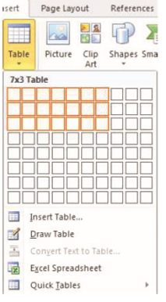 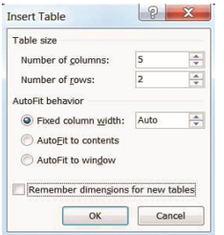

**TABLES**

|  |  |  |
| --- | --- | --- |
| S.NO | NAME | MARKS |
| 1 | JAI | 504 |
| 2 | AATHI | 475 |
| 3 | PAVI | 450 |
| 4 | SRI | 375 |
| 5 | MAYLINI | 500 |
| 6 | PRIYA | 450 |

**INSERTING PICTURE**

We sometimes need to add pictures to our MS Word document to add more descriptive details to the textual representation. Hence, we need to know how to insert a picture in any MS Word document.Following are the steps to insert a picture into a document:

• Under the Insert tab, in the Illustrations group as in Figure.25 we click the Picture icon. 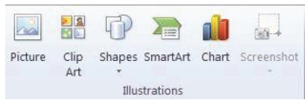

• This opens the Insert Picture dialogue box of Figure 3.26 below.

• We browse through to the picture we want to insert, then select it and click Insert.

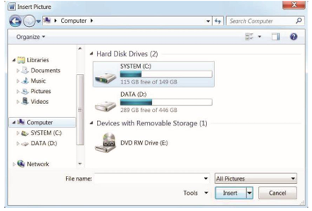

**SHAPES**

We can add shape to our document or combine multiple shapes to drawing. For this we can do the following:

• On the Insert tab, in the Illustrations group, we click Shapes (Figure 3.25).

• A drop down menu will appear (Figure 3.27), we click the shape that we want.

• Then we click anywhere in the document, and then drag to place the shape.

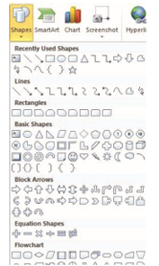

**HEADER AND FOOTER**

Headers and Footers can be used to give a uniform look to the pages of our document. The steps for adding header, footer and page number are given below. Adding Header and Footer :

• On the Insert tab, in the Header & Footer group, we click Header or Footer.

• Then we click the header or footer that we want to add to our document and header or footer area will open.

• We type text in the header or footer area.

• To return to the body of our document, we click Close Header and Footer on the Design tab (under Header & Footer Tools).

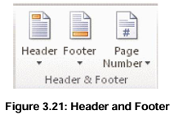

**ADDING PAGE NUMBER**

We can add page number on each page of our document with the following steps:

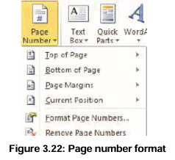

On the Insert tab, in the Header & Footer group, we click Page Number.

• Then we click the page number location that we want.

• In the gallery, we scroll through the options, and then click the page number format that we want.

• To return to the body of your document, click Close Header and Design tab (under Header & Footer Tools).

**ALIGNMENT**

Alignment is a way of organizing the text. It refers to the position of the text relative to margins. The Alignment option allows us to choose how we want our paragraph to look (i.e., justified, right, center, or left). The default alignment in MS Word is left alignment. The following screenshot(Figure 3.17) shows all the alignement options

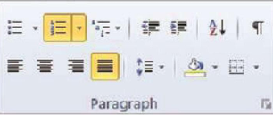

# **LEFT ALIGNED**

A computer is made up of multiple physical components of computer hardware, upon, which can be installed a system software called an operating system and a multitude of software application to perform the operators desired function

## **RIGHT ALIGNED**

Computer software, or just software ,is a collection of computer programs and related data that provide the instruction for telling a computer what to do and how to do it in other words , software is a conceptual entity which is a set of computer programs , procedures, and associated documentation concerned with the operation of a data processing system.

**CENTER ALIGNED**

We can also say software refers to one or more computer programs and data held in the storage of the computer for the same purposes. In others words software is a set of programs ,procedures, algorithms and its documentation

**JUSTIFIED**

Program software performs the function of the program it implemends , either by directly providing instruction to the computer hardware or by serving as input to another piece of software . A computer is made up of multiple physical components of computer hardware upon which can be installed a system.

**ADDING ROWS AND COLUMNS’**

Adding rows in a table: We click in a cell that is located just below or above where we want to add a row. Under Table Tools, on the Layout tab ,we can do one of the following:

• To add a row just above the cell that we clicked in, in the Rows and Columns group, we click Insert Above.

• To add a row just below the cell that we clicked in, in the Rows and Columns group, we click Insert Below.

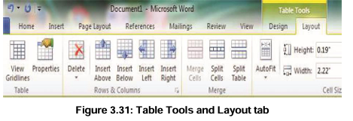

**BULLETED AND NUMBER LISTS**

Bullets and numbers highlight the portion of a text we want to highlight. We can use bullets and numbers to highlight the important contents of our document and to make it easy to read. Steps to insert Bulleted or Numbered List :

• We click on the area where we would like our list to appear or highlight the text we would like to be in a list.

• Then we go to the Home tab, in the Paragraph group and click Bullets or Numbering (Figure 3.19) • A bullet(s) or number(s) will be inserted.

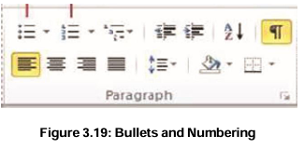

**STEPS FOR SELECTING BULLETS OR NUMBERING STYLE**

• We select the items that we want to add bullets or numbering to.

• On the Home tab, in the Paragraph group, we click the arrow next to the Bullets or Numbering command .

• We select the bullet or number format we would like to insert.

**PAGE NUMBER**

For Windows:

1. Open your Word document.

2. Click on the "Insert" tab in the ribbon.

3. Click on "Page Number" in the "Header & Footer" group.

4. Choose the desired page number location (e.g., top or bottom of the page).

5. Select a page number style or format.

6. Click "OK".

**For Mac:**

1. Open your Word document.

2. Click on "Insert" in the menu bar.

3. Select "Page Numbers".

4. Choose the page number location and style.

5. Click "OK".

To customize or remove page numbers:

**For Windows and Mac:**

1. Double-click on the header or footer containing the page number.

2. Modify or delete the page number as needed.

**Equations:**

1. Click the "Insert" tab.

2. Click "Equation" in the "Symbols" group.

3. Choose from pre-built equations or select "Insert New Equation".

4. Use the Equation Editor to create your equation.

**Symbols:**

1. Click the "Insert" tab.

2. Click "Symbol" in the "Symbols" group.

3. Select from various symbol categories or search by character.

**Math AutoCorrect:**

1. Type the equation using plain text (e.g., "x^2 + 3x - 4").

2. Word will automatically convert it to a formatted equation.

Shortcut keys:

- Equation: Alt+=

- Symbol: Alt+Shift+:=

**Additional tips:**

- Use the "Professional" format for complex equations.

- Right-click on an equation to access formatting options.

- Save frequently used equations to the "Equation Gallery".

**Specific symbols:**

- Greek letters: Ctrl+Shift+G (e.g., α, β, γ)

- Mathematical operators: Ctrl+Shift++ (e.g., ±, ×, ÷)

- Currency symbols: Ctrl+Shift+$ (e.g., $, €, ¥)

1. Select the text.

2. Press Ctrl+B (Windows) or Command+B (Mac).

3. Or, click the "Bold" button in the "Font" group on the "Home" tab.

**Italic:**

1. Select the text.

2. Press Ctrl+I (Windows) or Command+I (Mac).

3. Or, click the "Italic" button in the "Font" group on the "Home" tab.

**Alternative methods:**

1. Right-click on the selected text and choose "Bold" or "Italic".

2. Use the "Font" dialog box: Select text, click "Home" tab, then "Font" group, and select "Bold" or "Italic".

**Shortcuts:**

- Bold: Ctrl+B

- Italic: Ctrl+I

- Underline: Ctrl+U

- Strikethrough: Ctrl+Shift+5

THANK YOU !