

Applied Data Science-phase 3

Topic: Future sales prediction

Team members:

* 1. K.Jayapriya - (51132110436) - [jayapriyakumaresan02@gmail.com](mailto:jayapriyakumaresan02@gmail.com)
  2. P.Lahari - (511321104045) - [laharipasala8@gmail.com](mailto:laharipasala8@gmail.com)
  3. S.Anu - (511321104005) - [s.anupriyanka1225@gmail.com](mailto:s.anupriyanka1225@gmail.com)
  4. M.Charishma - (511321104014) - [Charishmamasarapu@gmail.com](mailto:Charishmamasarapu@gmail.com)

CONTENT:

1.Importing the required Libraries(data.csv)  
2.Importing the data set(read data set; create matrix )  
3.Handling the Missing Data.(sklearn.preprocessing library contains class called imputer, helps in missing data)  
4.Encoding Categorical Data.(one-hot encoding)  
5.Splitting the data set into test set and training set.( import train train_test_split)(X_train,X_test, Y_train,Y_test)  
6.Feature Scaling.(import StandardScaler)

SALES PREDICTION:

It is determining present-day or future sales using data like past sales, seasonality, festivities, economic conditions, etc.

So, this model will predict sales on a certain day after being provided with a certain set of inputs.

Required packages and installation:

1. Numpy
2. pandas
3. keras
4. tensorflow
5. csv
6. matplotlib.pyplot

Source code:

def forecast_testing(date):

maxj = max(traffic) # determines the maximum sales value in order to normalize or return the data to its original form

out=[]

count=-1

ind=0

for i in list_row:

count =count+1

if i[0]==date: #identify the index of the data in list

ind = count

t7=[]

t_prev=[]

t_prev.append(list_row[ind-365][1]) #previous year data

# for the first input, sales data of last seven days will be taken from training data

for j in range(0,7):

t7.append(list_row[ind-j-365][1])

result=[] # list to store the output and values

count=0

for i in list_date[ind-364:ind+2]:

d1,d2,d3,week2,h,sess = input(i) # using input function to process input values into numpy arrays

t_7 = np.array([t7]) # converting the data into a numpy array

t_7 = t_7.reshape(1,7,1)

# extracting and processing the previous year sales value

t_prev=[]

t_prev.append(list_row[ind-730+count][1])

t_prev = np.array([t_prev])

#predicting value for output

y_out = model.predict([d1,d2,d3,week2,h,t_7,t_prev,sess])

#output and multiply the max value to the output value to increase its range from 0-1

print(y_out[0][0]*maxj)

t7.pop(0) #delete the first value from the last seven days value

t7.append(y_out[0][0]) # append the output as input for the seven days data

result.append(y_out[0][0]*maxj) # append the output value to the result list

count=count+1

return

output:

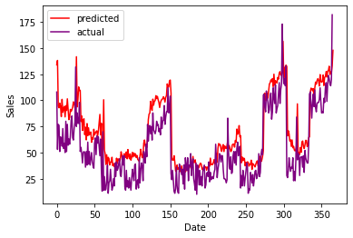

Sales forecasting prediction is the process of using historical sales data and various statistical or machine learning methods to estimate future sales for a business or product. It is a critical aspect of business planning, as it helps organizations make informed decisions regarding inventory management, production, marketing strategies, and financial planning. Here are some key steps and considerations for sales forecasting prediction:

1.Data Collection:

Gather historical sales data, which may include information on product sales, revenue, customer demographics, seasonality, and other relevant factors. This data can come from various sources, including point-of-sale systems, online transactions, and customer databases.

2.Data Preprocessing:

cleaning and preprocess the data to remove any outliers, missing values, or inconsistencies. This step ensures that the data used for forecasting is accurate and reliable.

3.Selecting a Forecasting Model:

Choose an appropriate forecasting model based on the nature of your business and the data available. Common models include time series analysis (e.g., ARIMA, Exponential Smoothing), regression analysis, machine learning algorithms (e.g., random forests, neural networks), and more.

4.Feauture engineering:

Identify and create relevant features that can influence sales. These may include factors like pricing, promotions, advertising expenditures, economic indicators, and seasonality patterns.

5.Model Training:

Use the historical data to train your chosen forecasting model. This involves fitting the model to the data and adjusting its parameters to make accurate predictions.

6.Validation and Testing:

Evaluate the model's performance by using a portion of the historical data not used for training. Common metrics for model evaluation include Mean Absolute Error (MAE), Mean Squared Error (MSE), and Root Mean Squared Error (RMSE).

7.Tuning and Optimization:

Fine-tune the model by adjusting hyperparameters, feature selection, and model architecture to improve accuracy.

8.Deployment:

Once the model performs well on the validation data, deploy it to make real-time sales predictions. This can involve integrating the model into your business systems, such as an inventory management system or e-commerce platform.

9.Continuous Monitoring:

Sales forecasting is an ongoing process. Regularly monitor the model's performance and update it as necessary, especially if external factors affecting sales change, like market trends or consumer preferences.

10.Scenario Analysis:

Consider various scenarios and what-if analyses to account for different market conditions and uncertainties. This can help in risk assessment and better decision-making.

11.Collaboration:

Collaborate with different departments within your organization, such as marketing, finance, and operations, to ensure that the forecasts align with business goals and strategies.

Sales prediction:

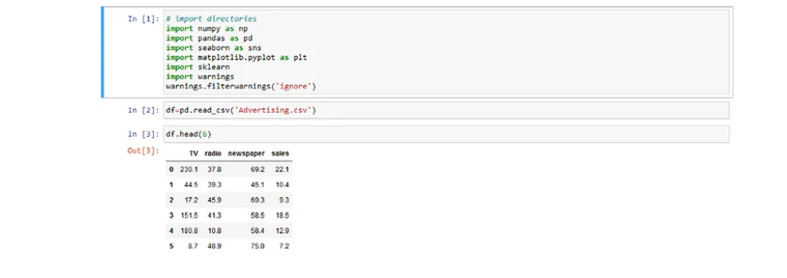

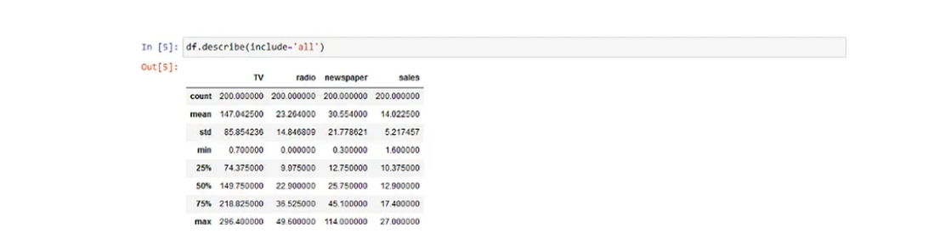

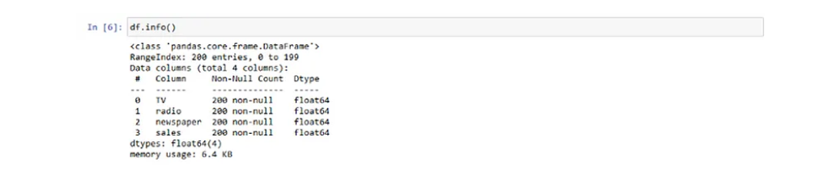

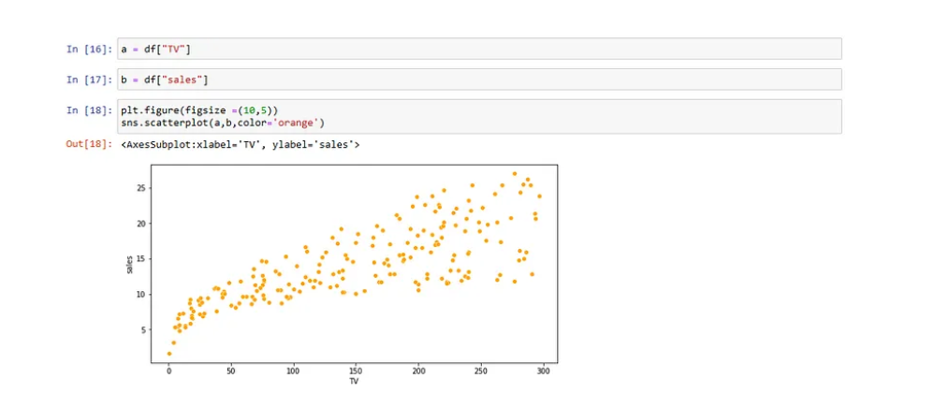

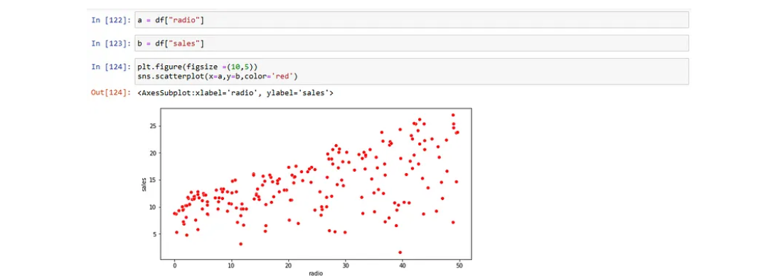

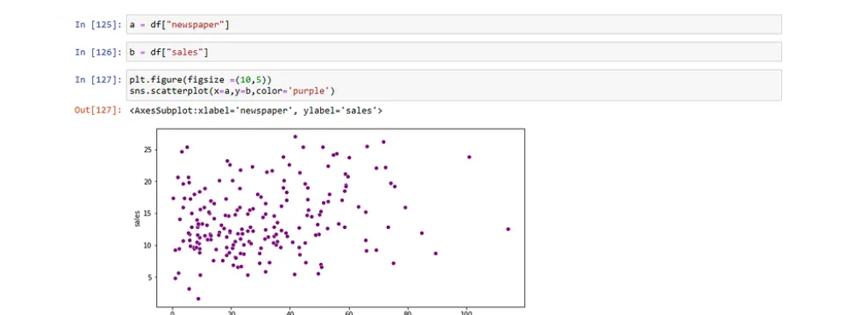

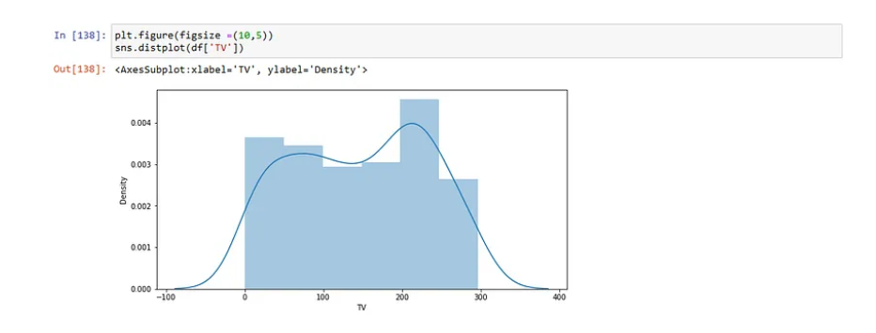

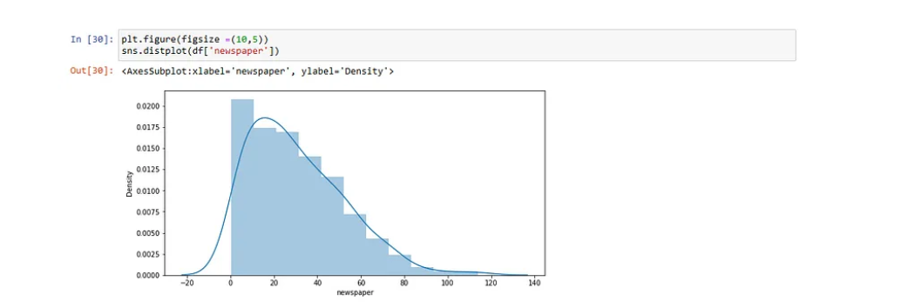

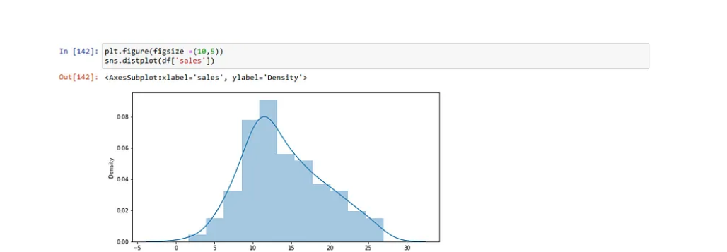

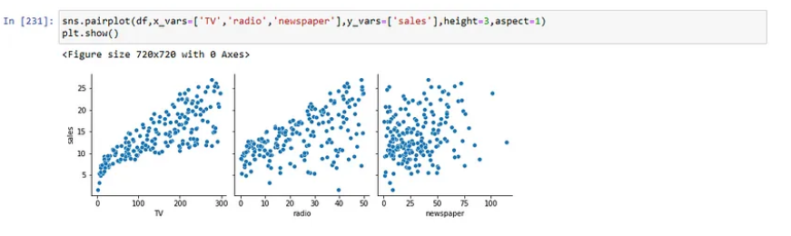

Pair plot between Tv ,Radio and Newspaper With respect to sales

Conclusion:

Sales forecasting prediction is not a one-size-fits-all process. The choice of model and approach can vary significantly depending on the industry, product, and available data. It's essential to use the most appropriate methods and regularly update your forecasting models to adapt to changing market conditions.