TASK 1

Task 1.1 Creating reposerver using ISO file
Objective: The goal is to set up Repo server in a network so we can use

prerequisites
- VMware
- VMware Vnet
- Rhel VM
- Rhel iso file

- Configure server to use repos from ISO files
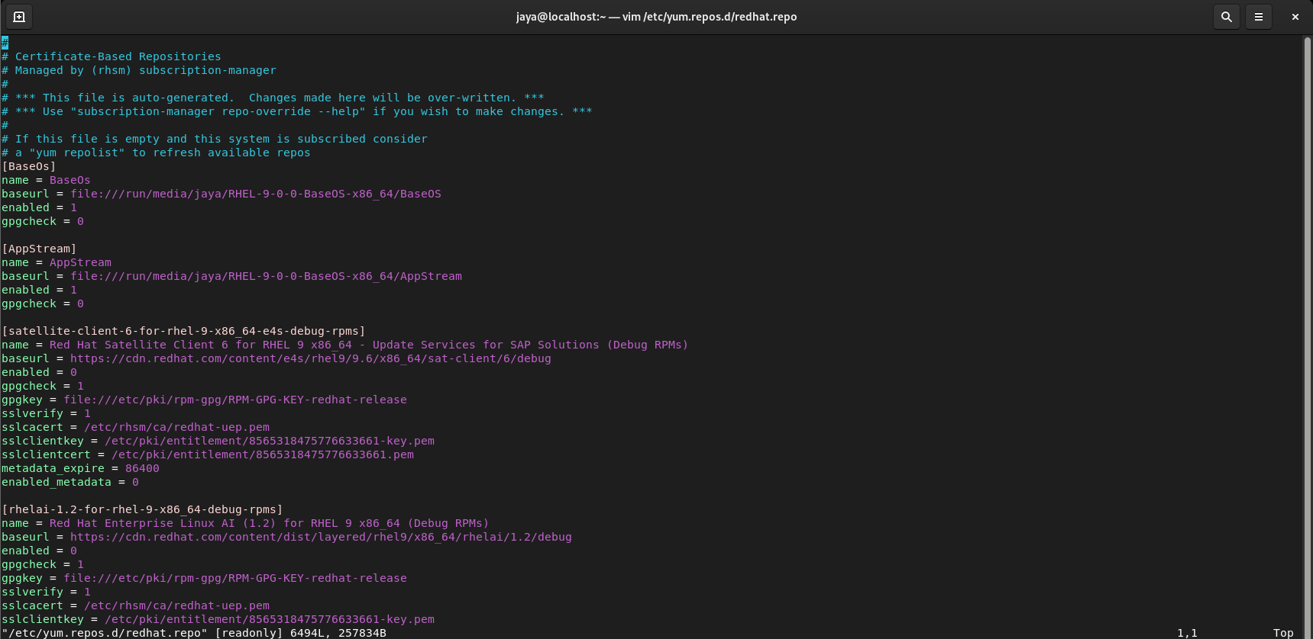
- Copy the repos which you want to host in network to /var/www/html/server
2.1 mkdir /var/www/html/server
2.2 lsblk
2.3 copy mount location of sr0
2.4 cd /run/media/jaya and ls REDHAT
2.5 cp BaseOS and AppStream to /var/www/html/server
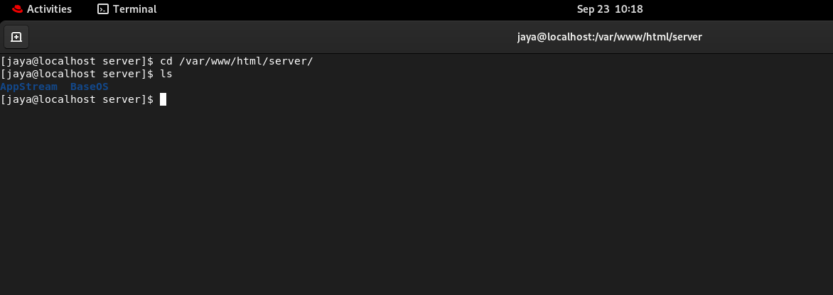
- On Clint side configure
In /etc/yum.repos
Create repo
[BaseOs]
name= BaseOs
Baseurl = http://192.168.233.130/server/BaseOS
Enabled = 1
Gpgcheck = 0

[AppStream]
name= AppStream
Baseurl = http://192.168.233.130/server/AppStream
Enabled = 1
Gpgcheck = 0

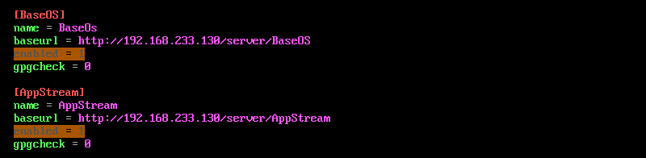

(Disable enabled repos before adding new repos)
Restart Httpd and try installing something using dnf
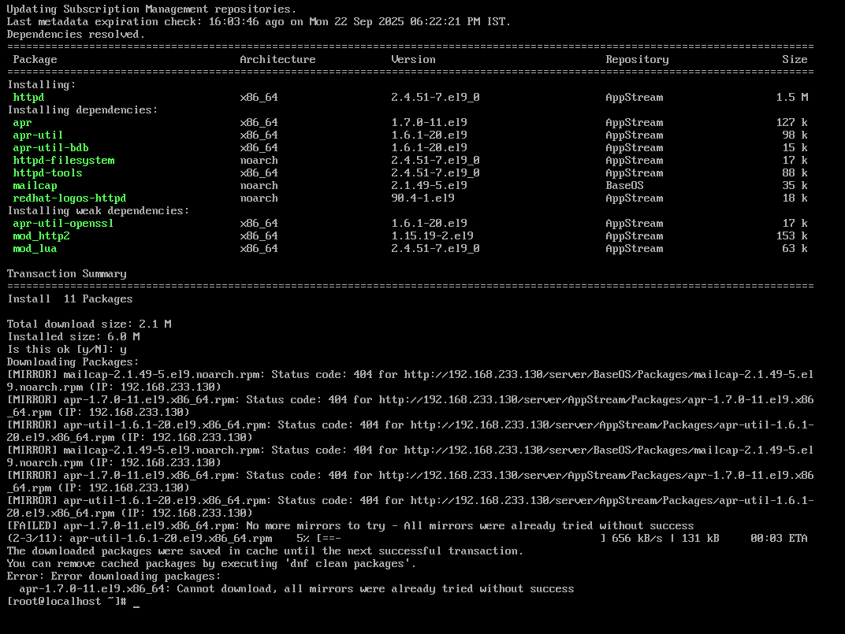

Task 1.2 Creating Reposerver using redhat CDN
prerequisites
- VMware
- VMware Vnet
- Rhel VM
- Redhat subscription on repos-server
- Download the required repo by using reposync and you can get repo id from /yum.repo.d/redhat.repo
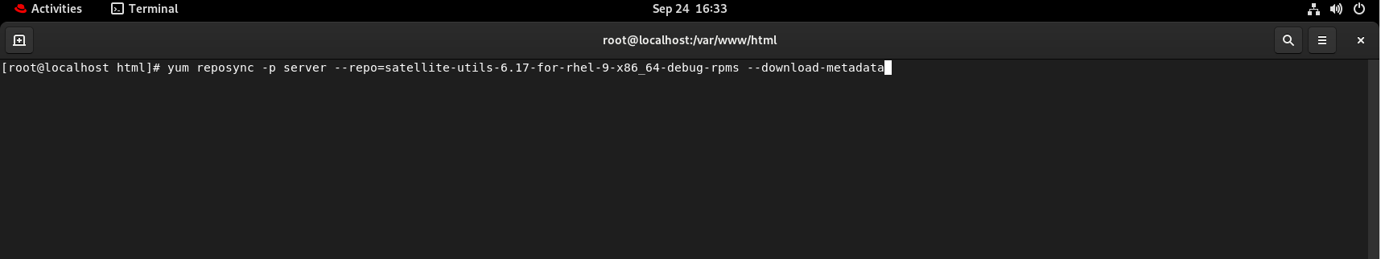

- Once downloaded it in server folder client can access the repo after the configuration is completed in client machin
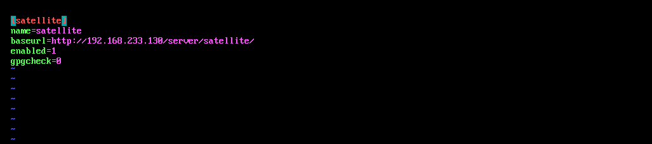

Task 2 (Additional) Automating client configuration
The script below retrieves the list of repos inside reposerver (/server) and creates repo_name.repo folder inside /etc/yum.repos.d/
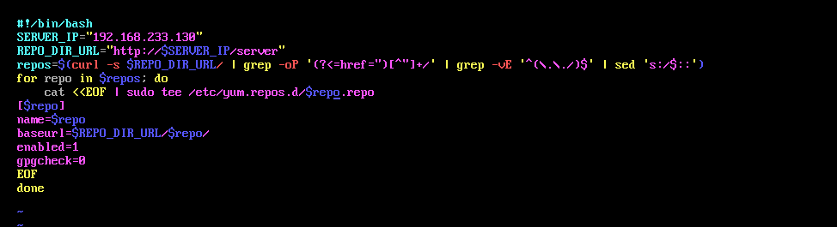
This script will be present in server and client will download it and run and automatically all the repos inside server will be configured in client machine and same script can be used to update packages

