**HOSTEL MANAGEMENT PORTAL**

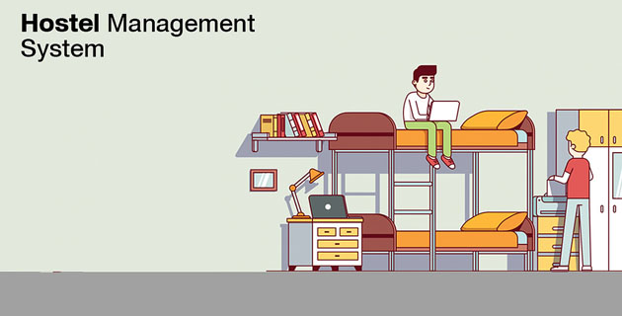

**TEAM MEMBERS**

Hemanent S (195001038)

Jayakrishnan S V (195001040)

Jayaraja S K (195001041)

Karthik A (195001046)

**PROBLEM STATEMENT**

In today’s modern world, although a lot of things have been modernized/digitalised, still most of the activities carried out by the students at hostel and mess involves either a lot of paperwork (or) have to spend a lot of waiting in a long queue

**SOLUTION**

To overcome this situation, a Web application has been developed to benefit the students, wardens and mess in-charges to ease their work by going paper less and save time

**MAIN FUNCTIONALITIES**

1. Add student details
2. Online Leave form request
3. Complaint Registration
4. Mess bill cancellations

**TECHNOLOGIES USED**

1. Node.js
2. React.js
3. MySQL

**USER’S FUNCTIONALITIES**

1. **LOGIN**

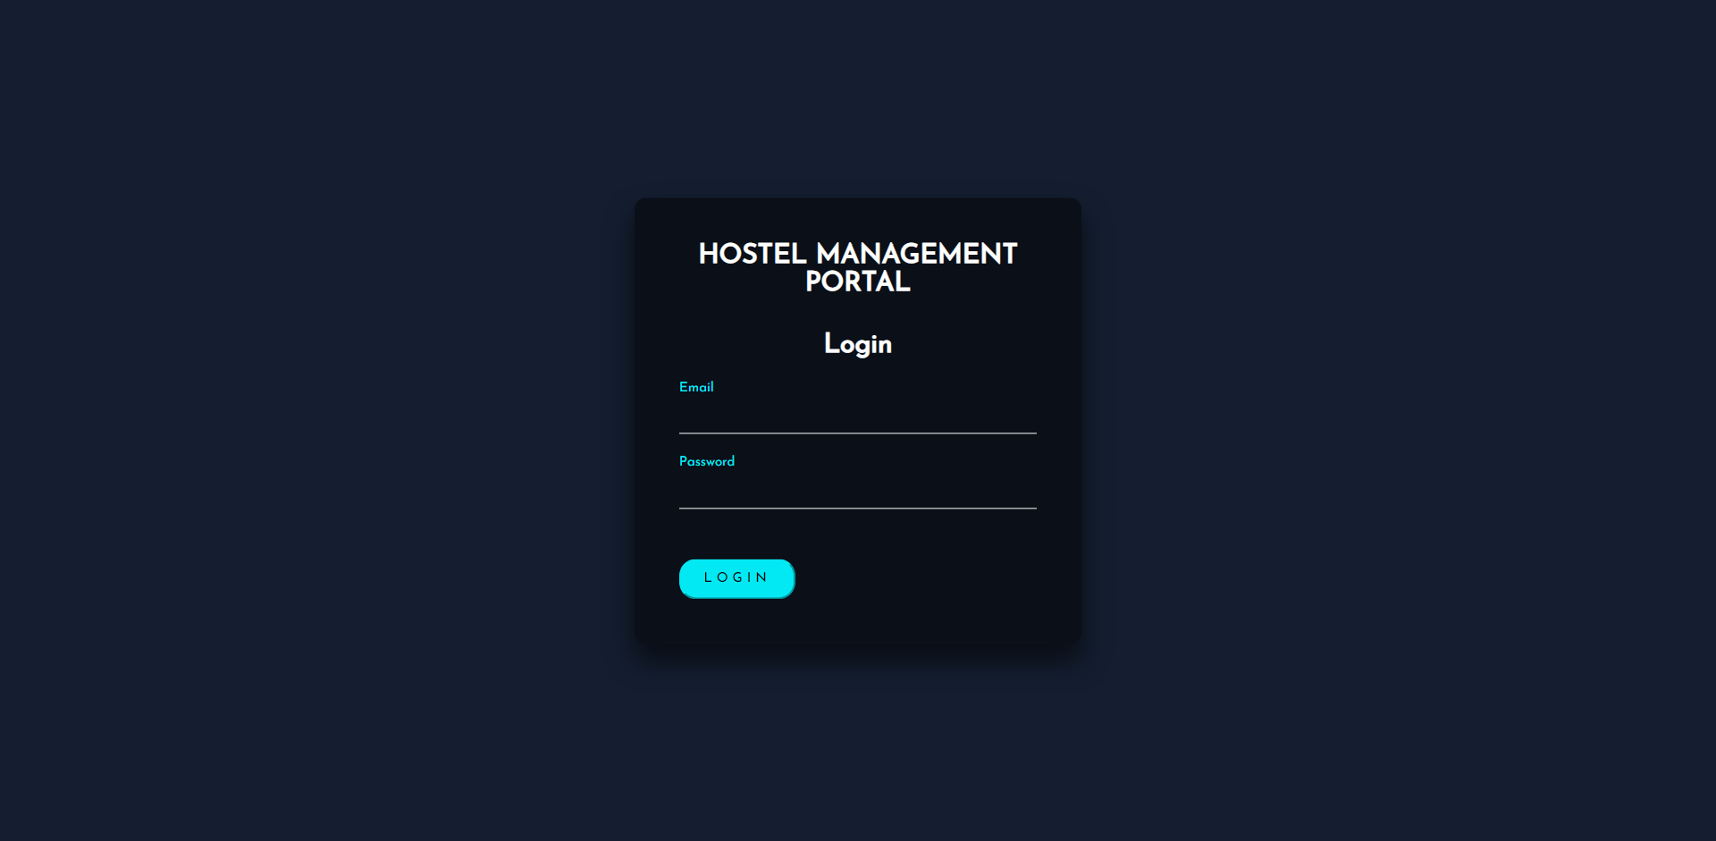

1. **SUPER WARDEN**
2. **ADD CAMPUS AND COURSES**

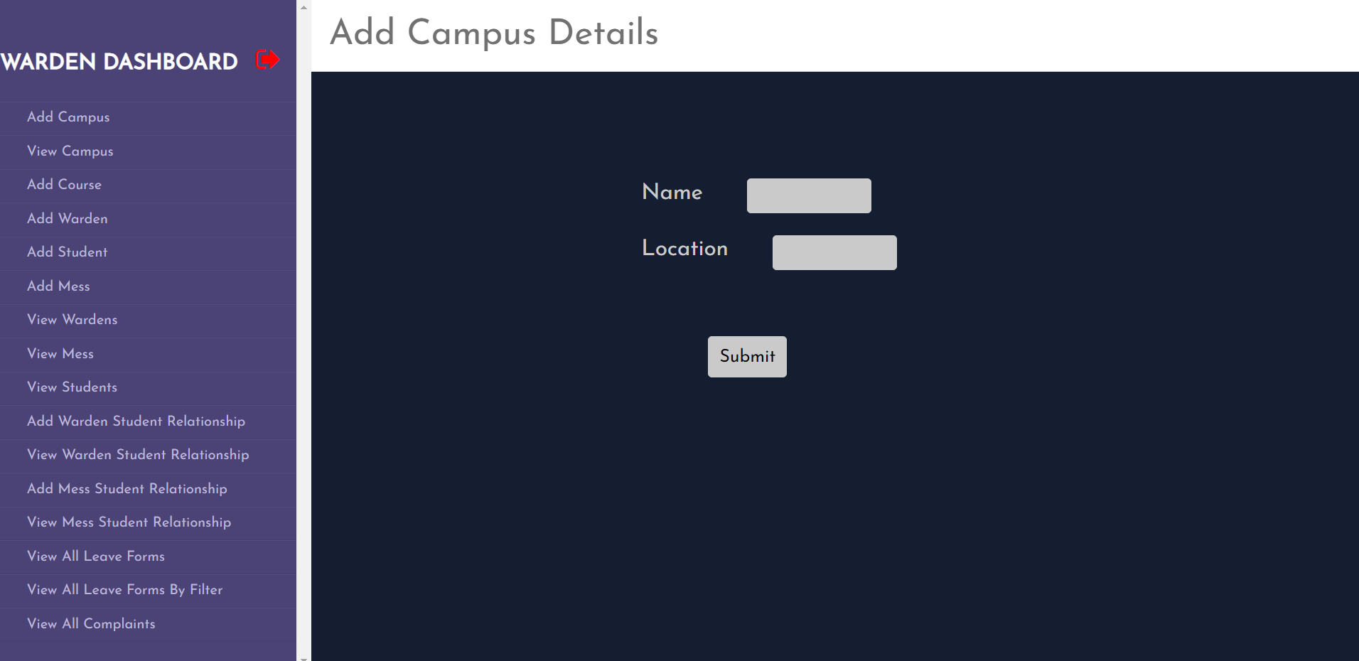

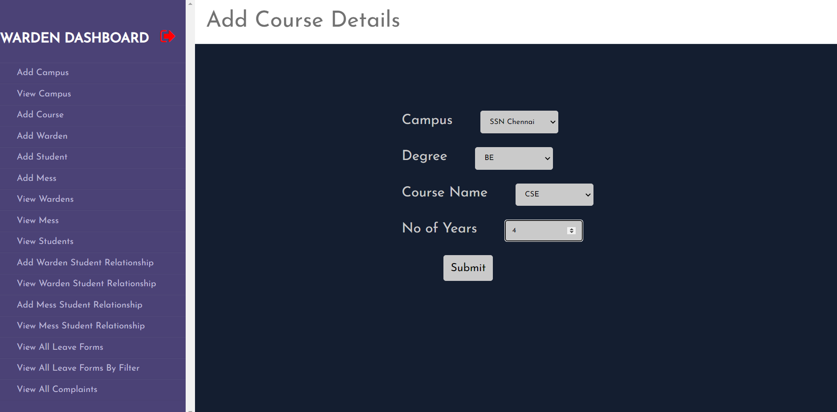

1. **VIEW, EDIT AND DELETE CAMPUS AND COURSE DETAILS**

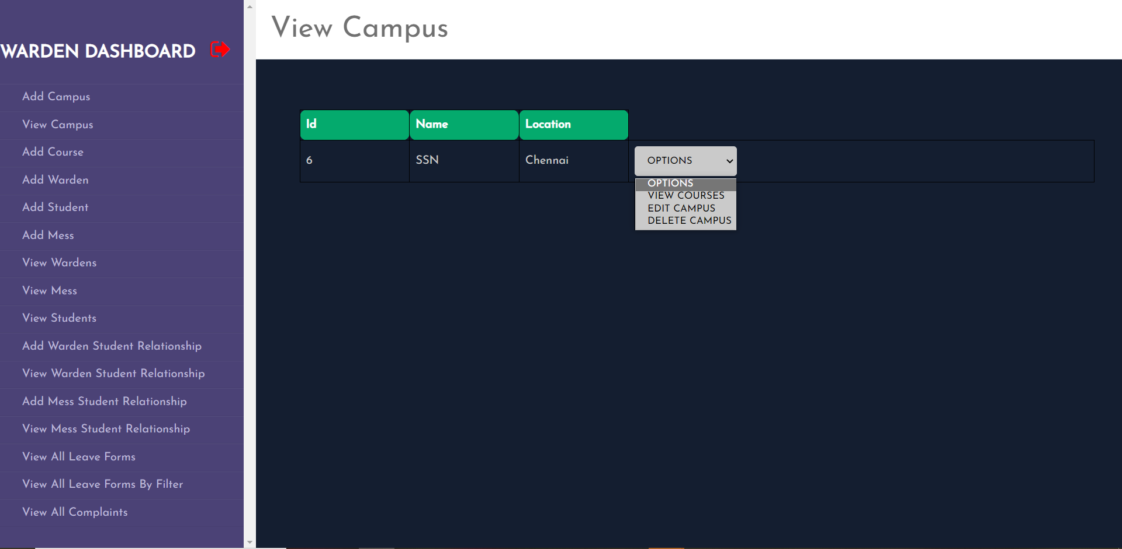

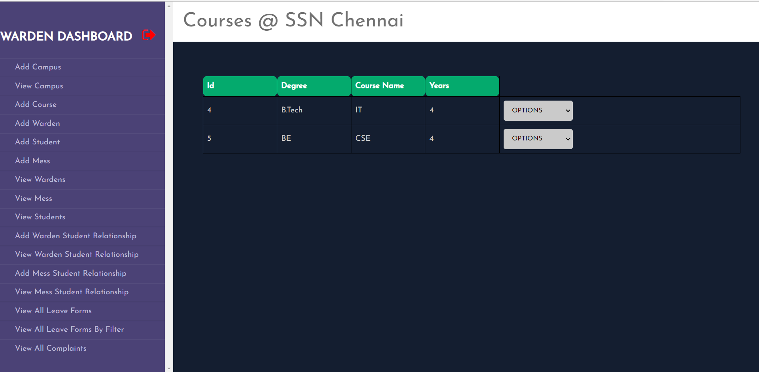

1. **ADD USERS**

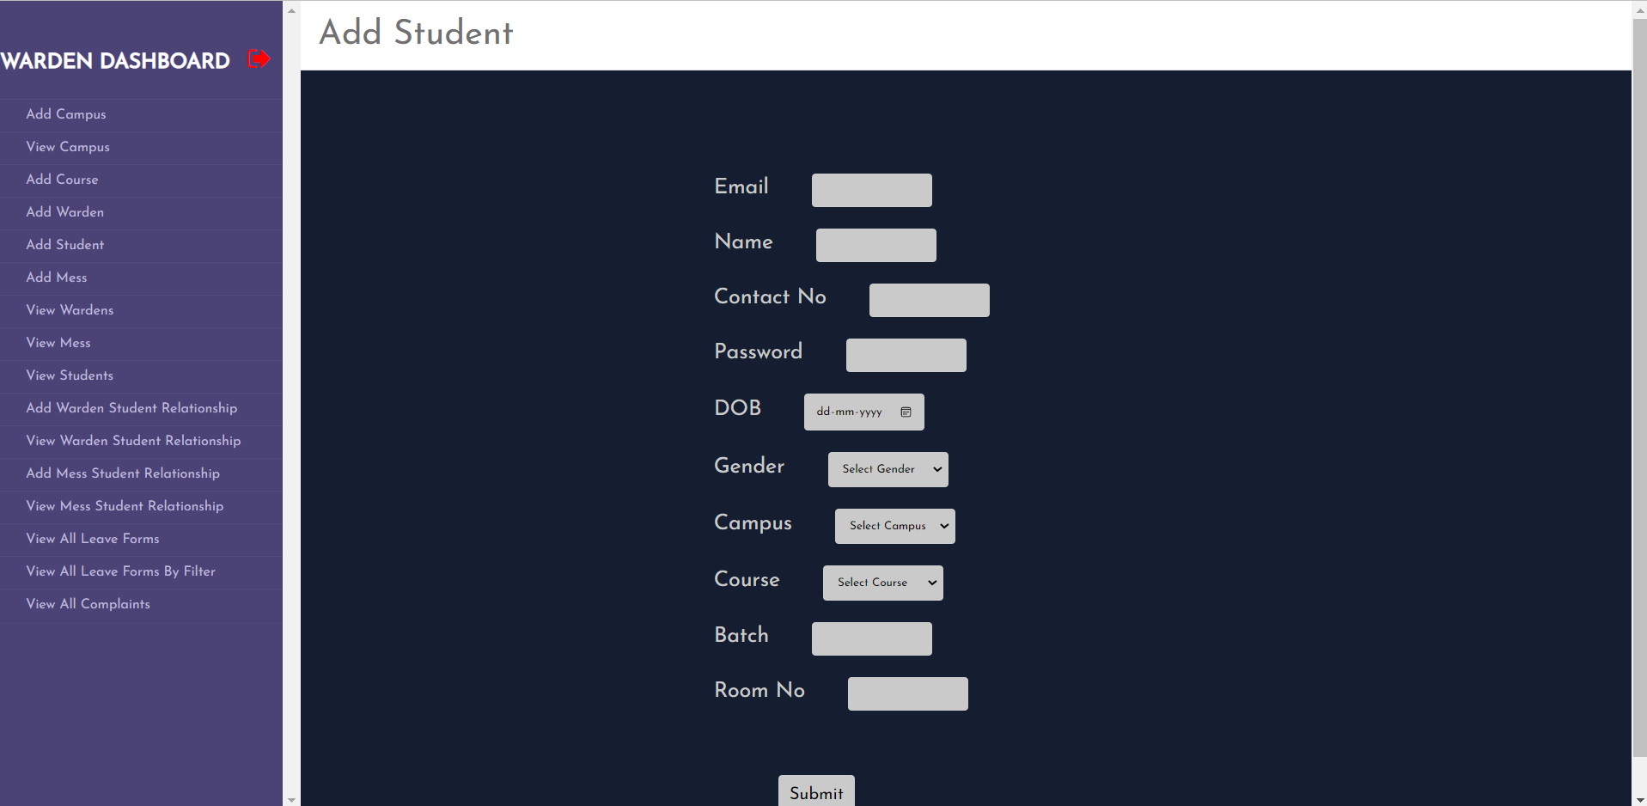

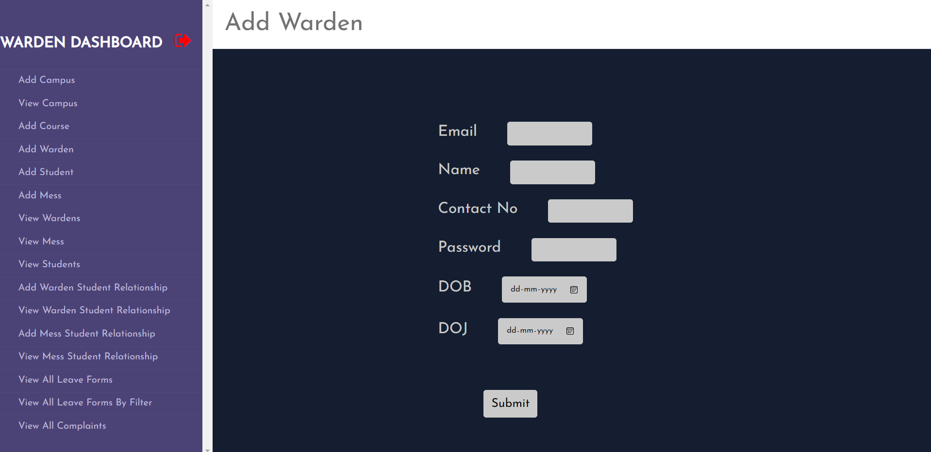

1. **VIEW, EDIT AND DELETE USERS**

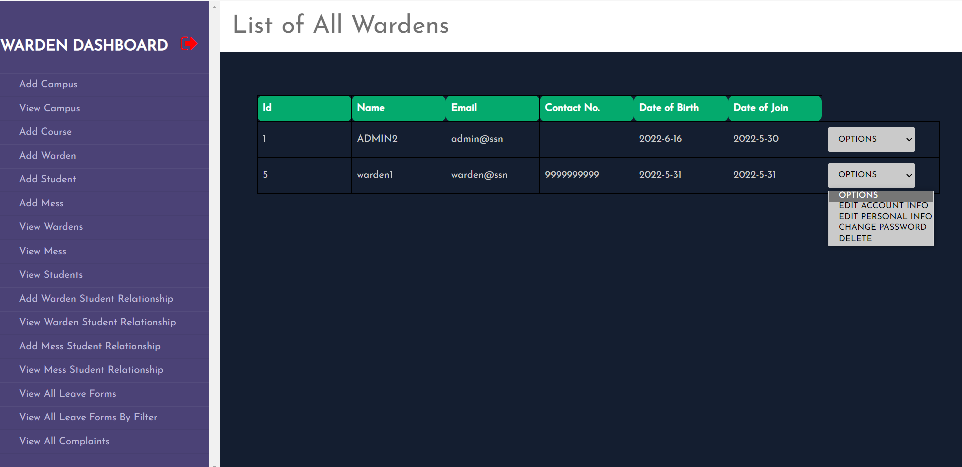

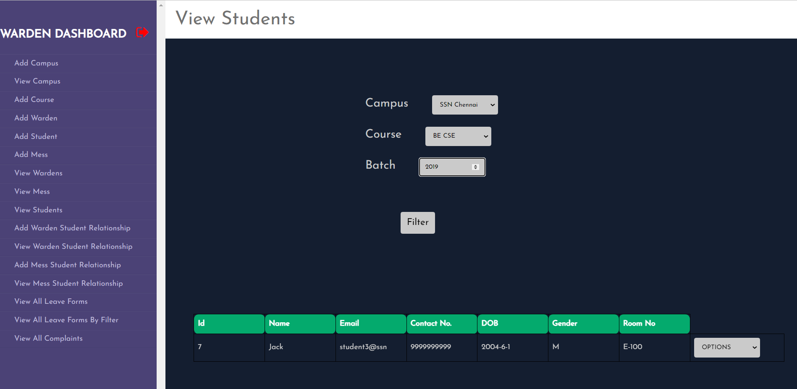

1. **MAP A SPECIFIC WARDEN TO SPECIFIC SET OF STUDENTS (LEAVE REQUEST AND COMPLAINTS ARE SENT ONLY TO THEM)**

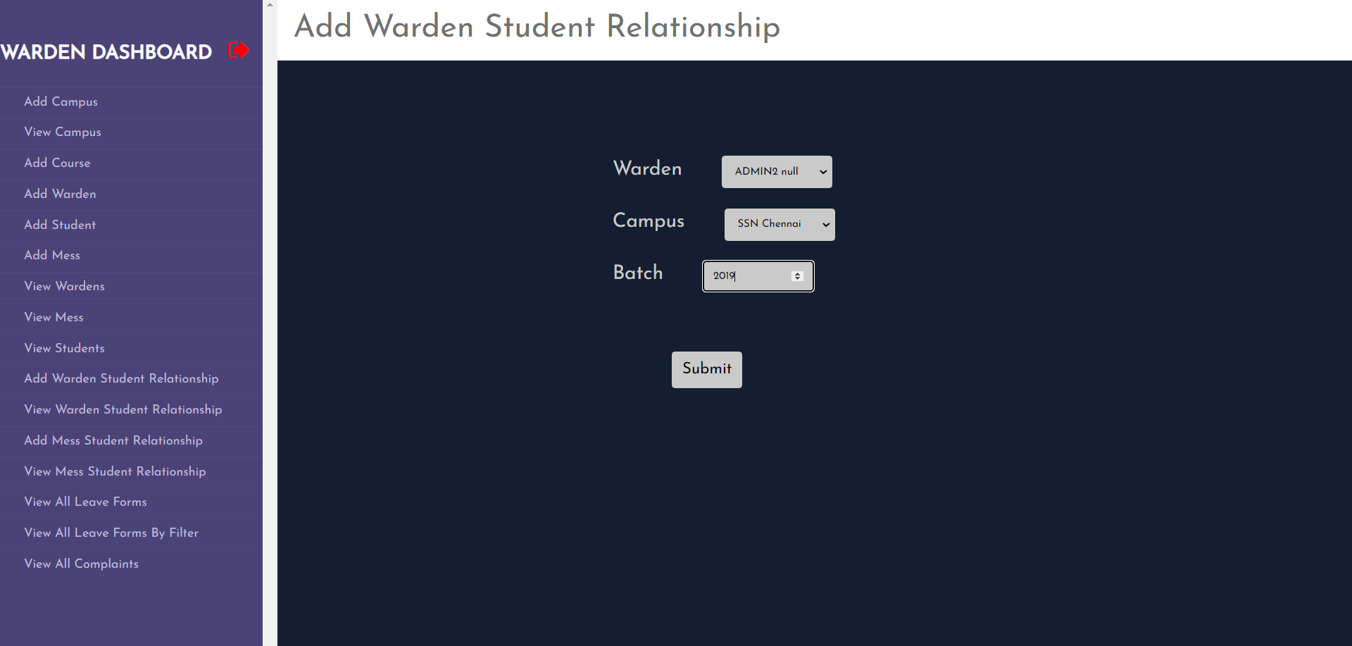

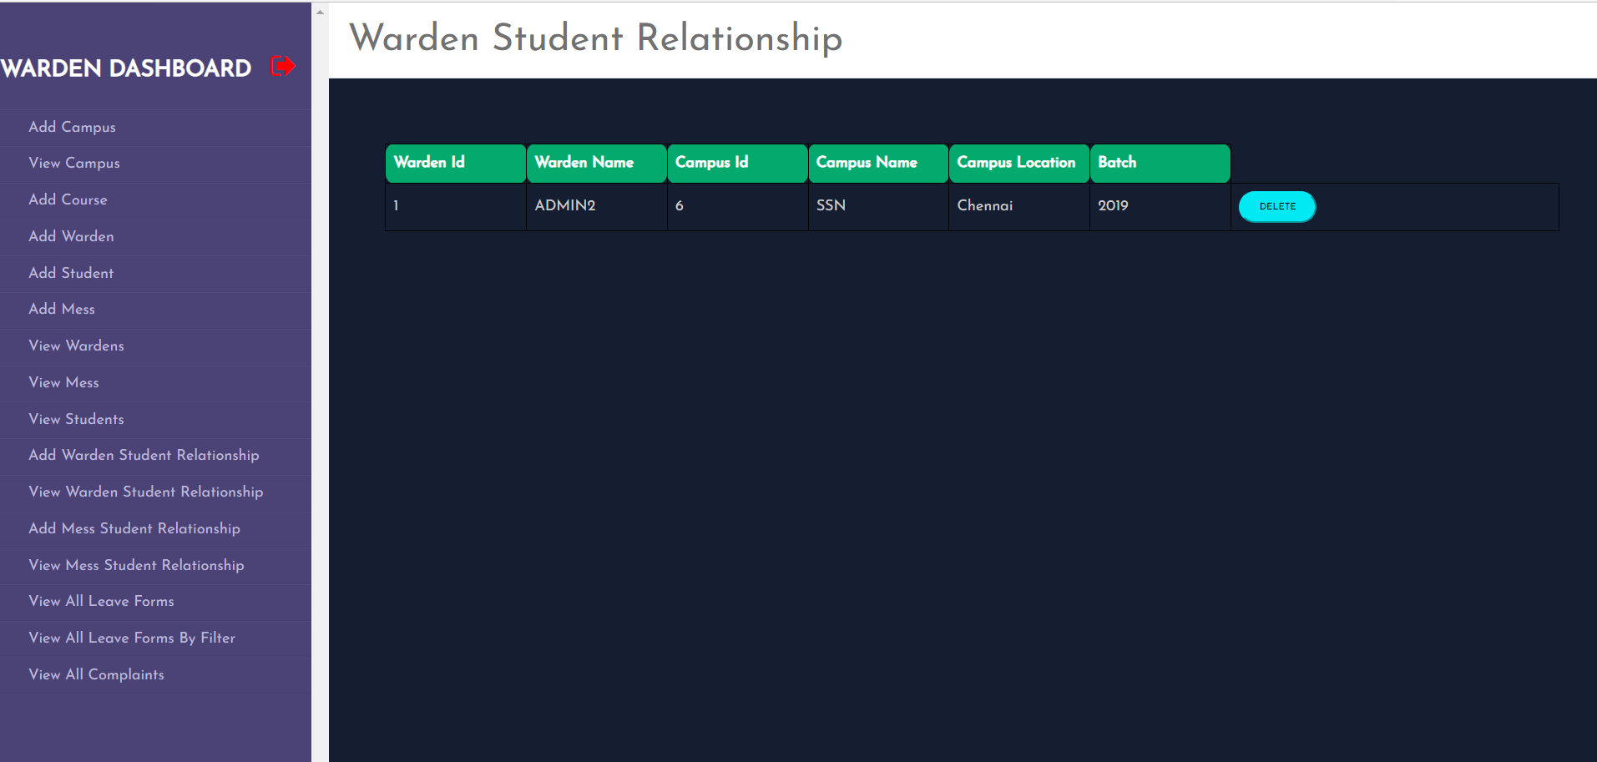

1. **VIEW AND PROCESS LEAVE FORM REQUESTS**

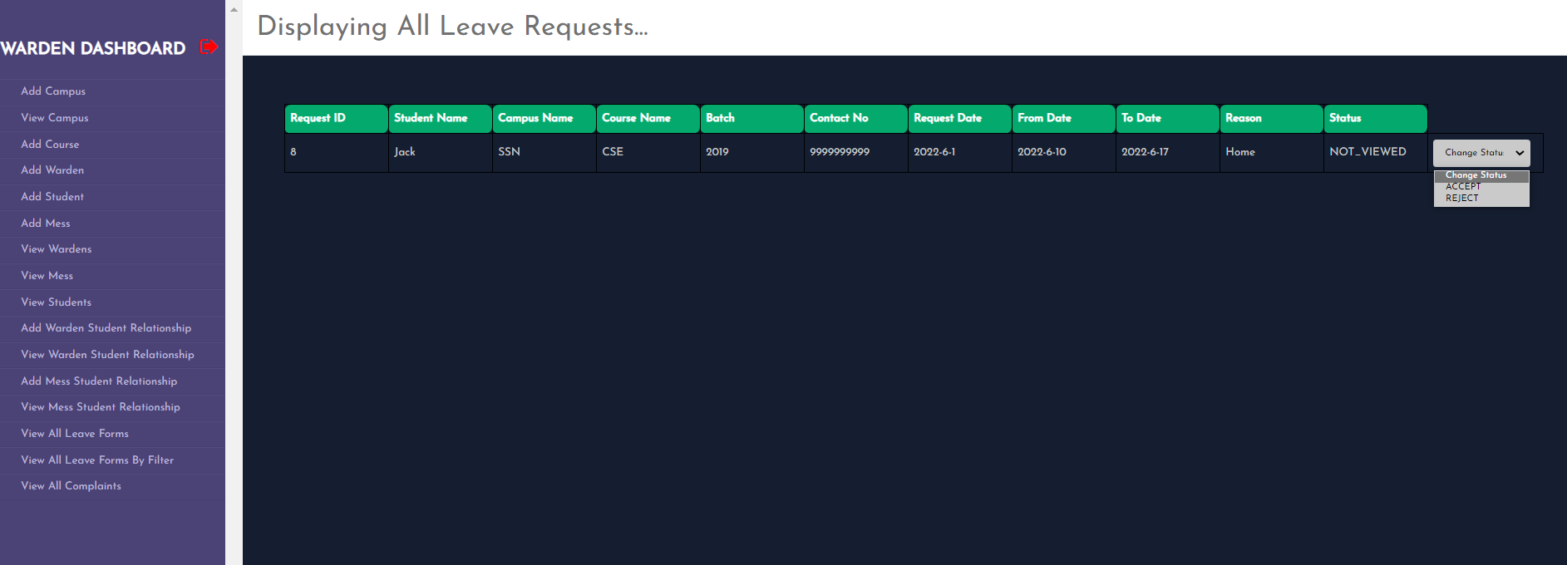

1. **VIEW COMPLAINTS**

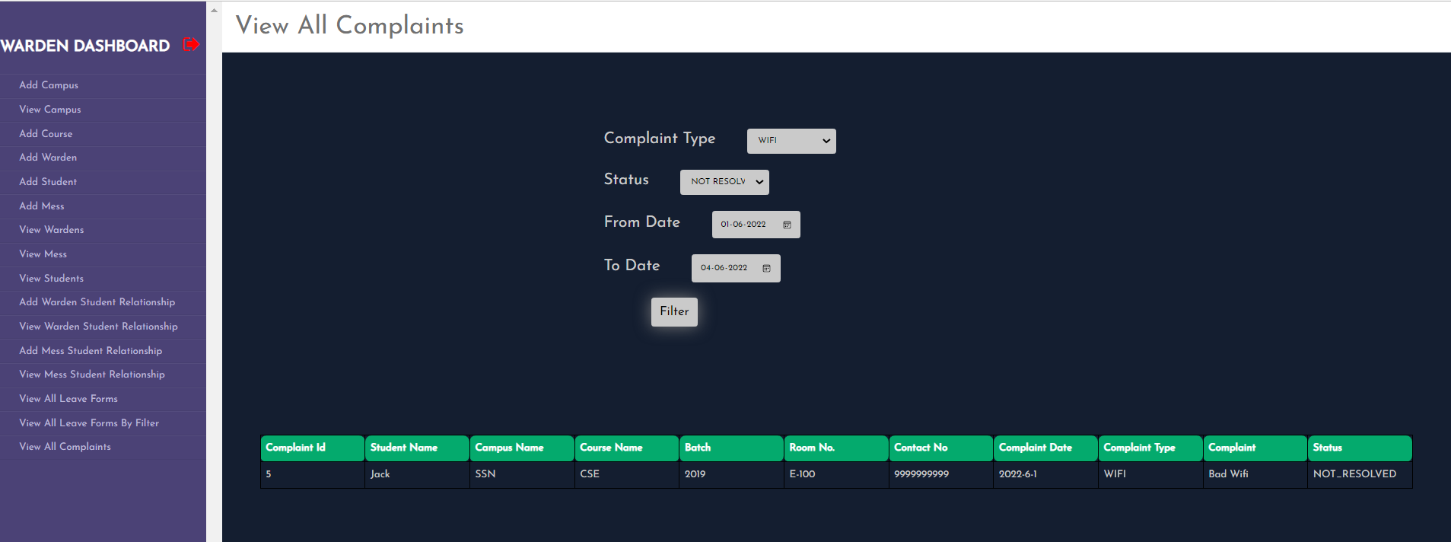

1. **WARDEN**

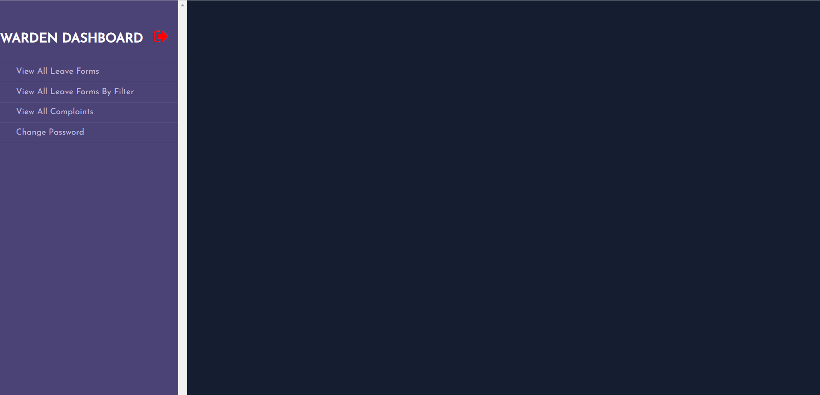

1. **STUDENT**
2. **SEND LEAVE FORM REQUEST**

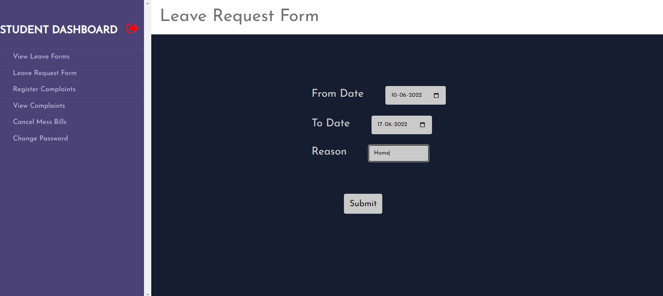

1. **VIEW LEAVE FORM REQUESTS**

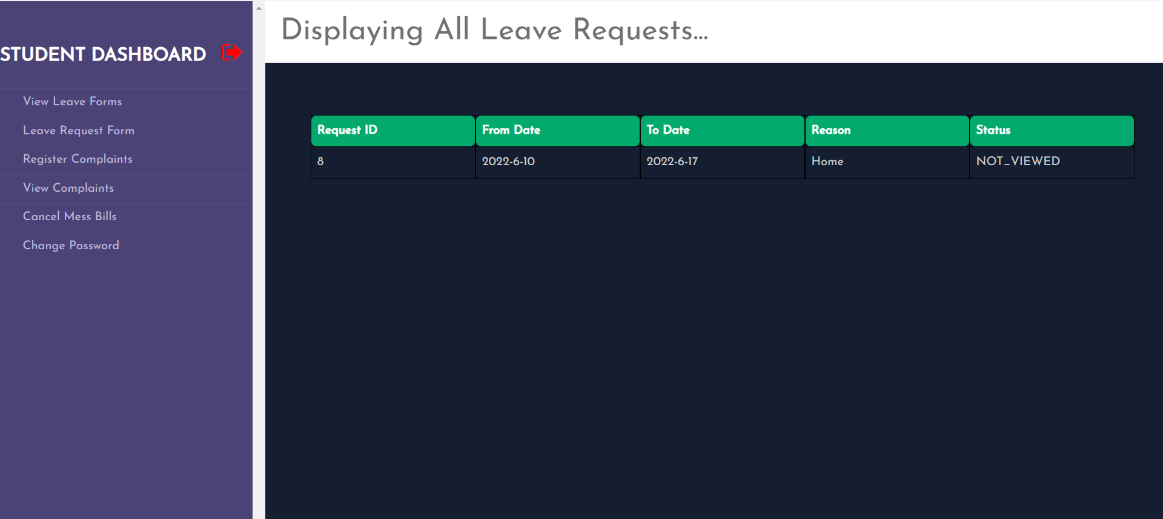

1. **REGISTER AND VIEW COMPLAINTS**

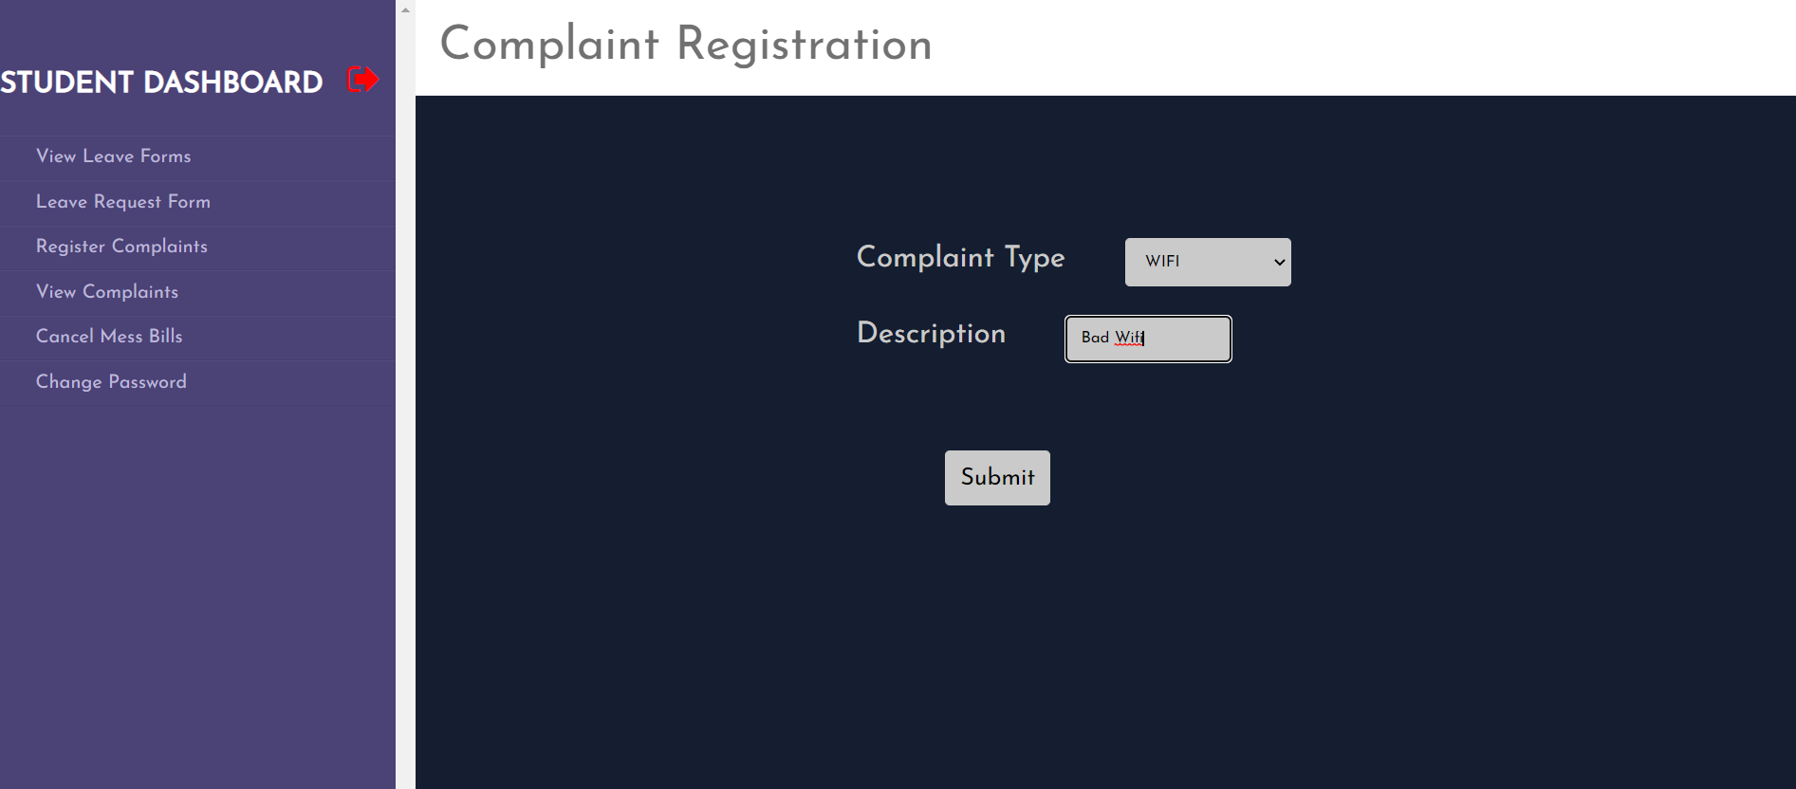

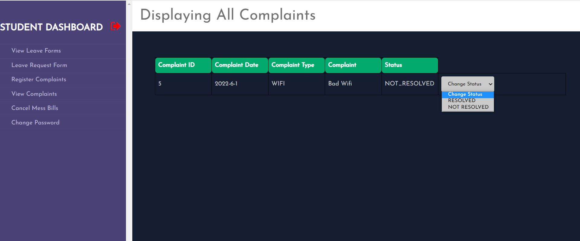

1. **CANCEL MESS BILL**

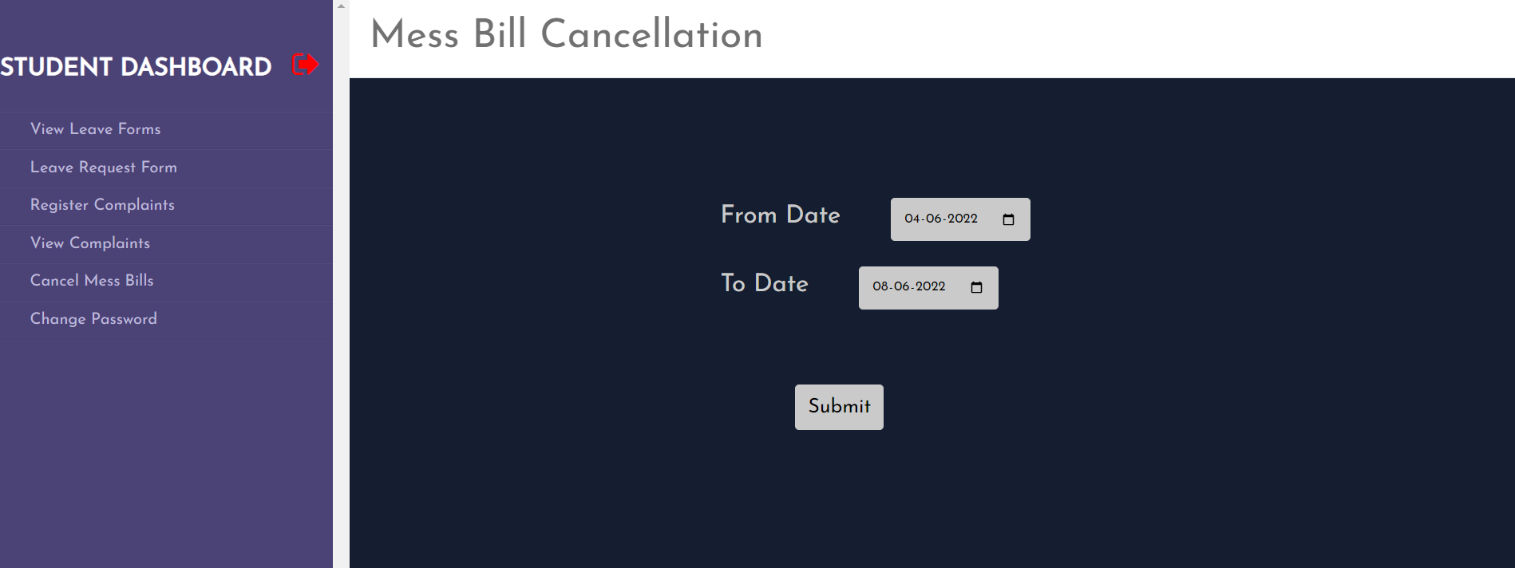

1. **MESS**
2. **VIEW BILL CANCELLATIONS**

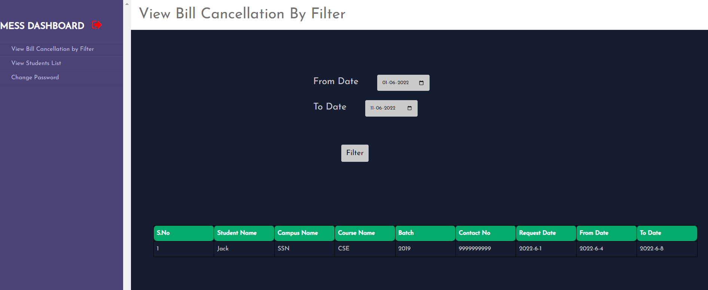

1. **VIEW STUDENTS LIST AND THEIR BILL CANCELLATIONS**

