Jquery

Introduction

The dollar($) sign is the shorthand sign for calling the jquery library. It can be also replace by typing “jquery”.

Example:

$("document").ready(function(){
$("body").append("<h3><center>Hi! welcome all to the jquery beginner tutorial</center></h3>");
});

and

jQuery("document").ready(function(){
jQuery("body").append("<h3><center>Hi! welcome all to the jquery beginner tutorial</center></h3>");
});

both will give the same output.

Selectors and Filters

The Selectors is used to select the elements from the HTML web page. The filters is used to filter out elements from the selected elements.

Selectors:

- To select all the elements in the HTML web page. - $(“*”)
- To select all the elements of the particular tag use - $(“p”) (In this case all the elements with p tag are selected).
- To select the current HTML element - $(“this”)
- To select the all the element with particular class - $(“.class_name”)
- To select the all the element with particular class and particular tag - $(“h3.modern”)
- To select all the element with particular(href) attribute. $(“[href]”)
- To select all the tr odd elements. $(“tr:odd”)
- To select all the tr even elements. $(“tr:even”)
More information will be available in the www.w3schools.com/jquery/trysel.asp

Creating and Changing page content

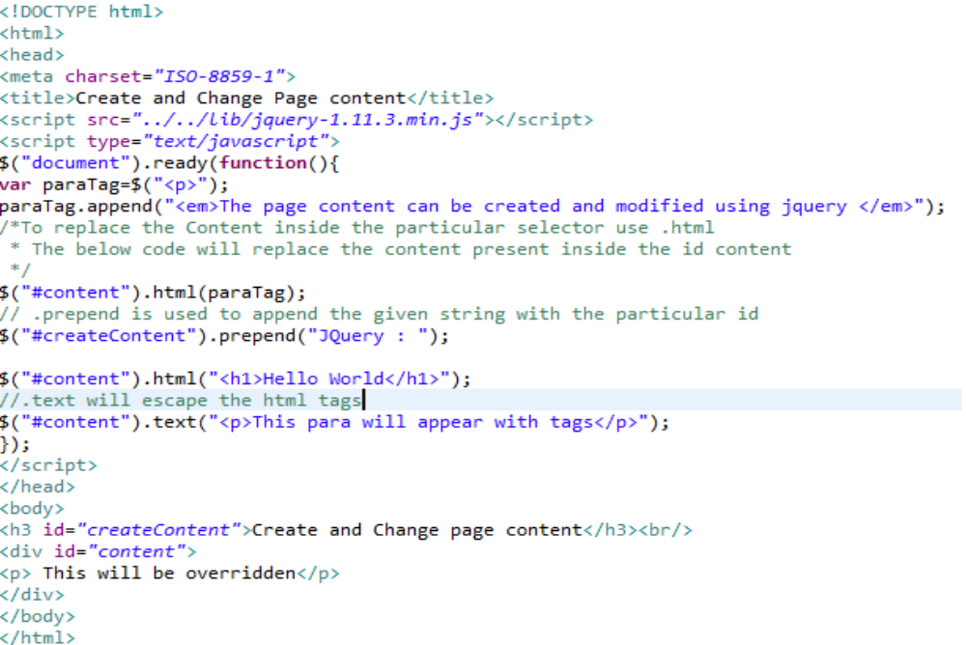

Handling Events in JQUERY:

There are three main events that are handled in Jquery are as follows

- mousemove
- click
- mouseleave

1. mousemove:
When we hover over the selected item this event is triggered.
The keyword for mousemove is mousemove.

SYNTAX:
$(“#selector”).on(“mousemove”,onMouseMove);

function onMouseMove(evt){

}

2. click:
When we left click on the selected item this event is triggered.
The keyword for click is click.

SYNTAX:
$(“selector”).on(“click”,onMouseClick);
function onMouseClick(evt){

}

3. mouseleave:

When we move the cursor out of the selected element the mouseleave is triggered

The keyword for mouseleave is mouseleave

SYNTAX:
$(“selector”).on(“mouseleave”,onMouseLeave);
function onMouseLeave(evt){

}

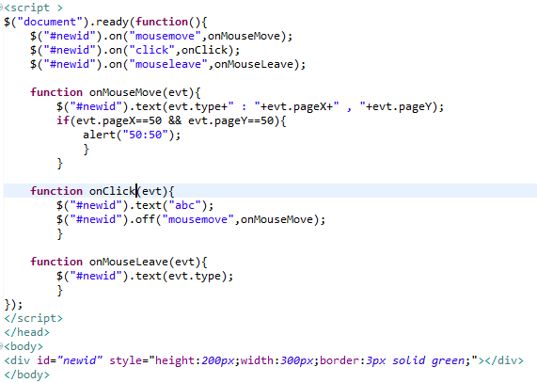

When we want to off the certain mouse event use off instead of on

$(“selector”).off(“mousemove”,onMouseMove);

Jquery Animations:

Selecting and fetching the page content

Selectors:

There are three major selectors they are.
1. To select a particular html tag
$(“tag”)

Example:
$(“a”)
This will select all the “a” tags in the entire html

2. To select identifier
$(“#Identifier”)

Example:
$(“first”)
This will select the particular id first.

3. To select class
$(“#class”)

Example:
$(“intro”)
This will select all the intro classes

<!DOCTYPE html>
<html>
<head>
<meta charset="ISO-8859-1">
<title>Basic selectors</title>
<script type="text/javascript" src="../../lib/jquery-1.11.3.min.js"></script>
<style type="text/css">

</style>
<script type="text/javascript">
$("document").ready(function(){
$("a").css("color","green");
$("p#first").css("color","red");
$("p.abc").css("color","blue");
});
</script>
</head>
<body>
<a href="#"> This is "a" tag</a>
<p class="abc"> This is "p" tag with class "abc"</p>
<p id="first"> This is "p" tag with id "first"</p>
<article class="abc">This is "article"" tag</article>
</body>
</html>

Output:
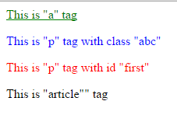

Filters

- :first → To select the first element of the given selector type
- :last → To select the last element of the given selector type.
- :even → To select only the even element of the given selector type.
- :odd → To select only the odd element of the given selector type.
- :gt() → To select the items greater than the index
- :lt() → To select the item lesser than the index
- :eq() → To select the item equal to an index
- :animated → To select the items that are in the process of being animated.
- :focus → To select the element that currently has the focus.
- :not(expr) → To select the element that does not match the given expression.

