Vetsource System Setup

Summary of Ubuntu installation & Vetsource setup:

1. Booting Ubuntu 16.0.4 with the Provided DVDs
2. Log into Developer account with common password
3. Run the installation setup script with the relevant lines.

Ubuntu setup:

1. Connect the external DVD driver to the USB port in the CPU.

2. Once the Driver is power on, load the first disk (CD1). Press F12 to go to the boot menu screen .

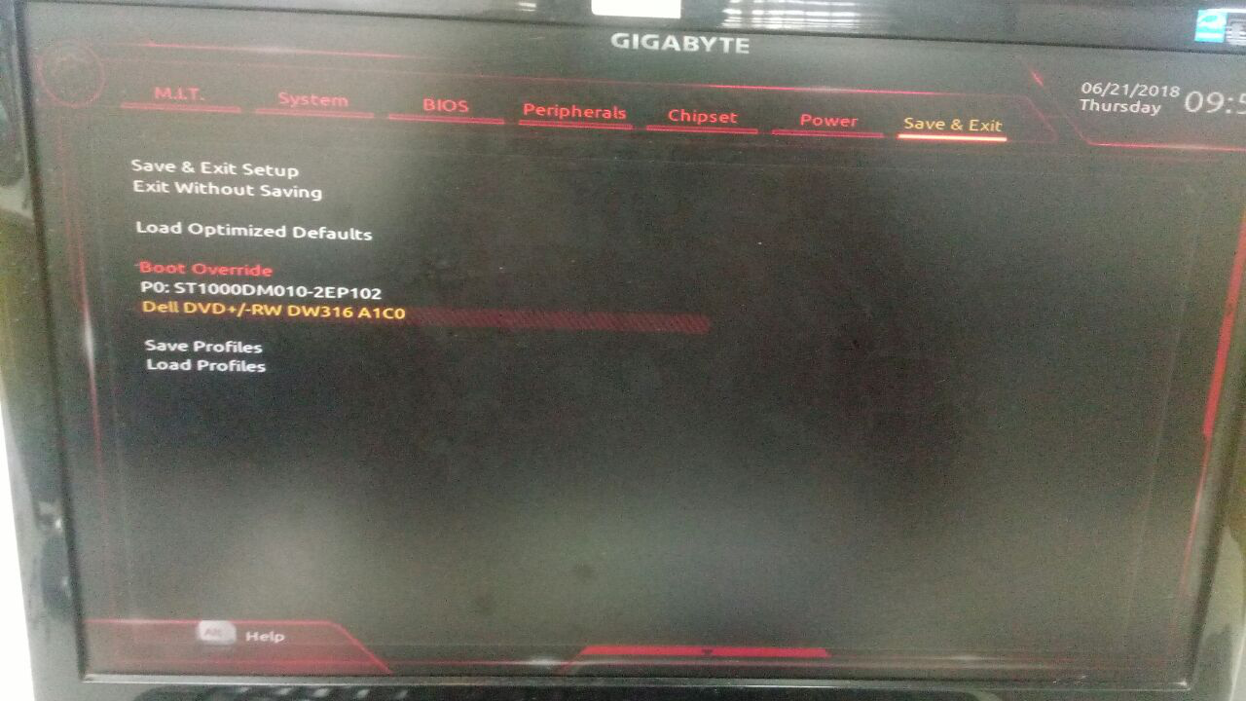
3. At Boot menu screen, in Save & exit tab, choose the option ‘Load from Dell DVD’ to pick up the disk as boot load option.

4. Now the system navigates to the Boot Loading screen. Type ‘nuke’ to continue.

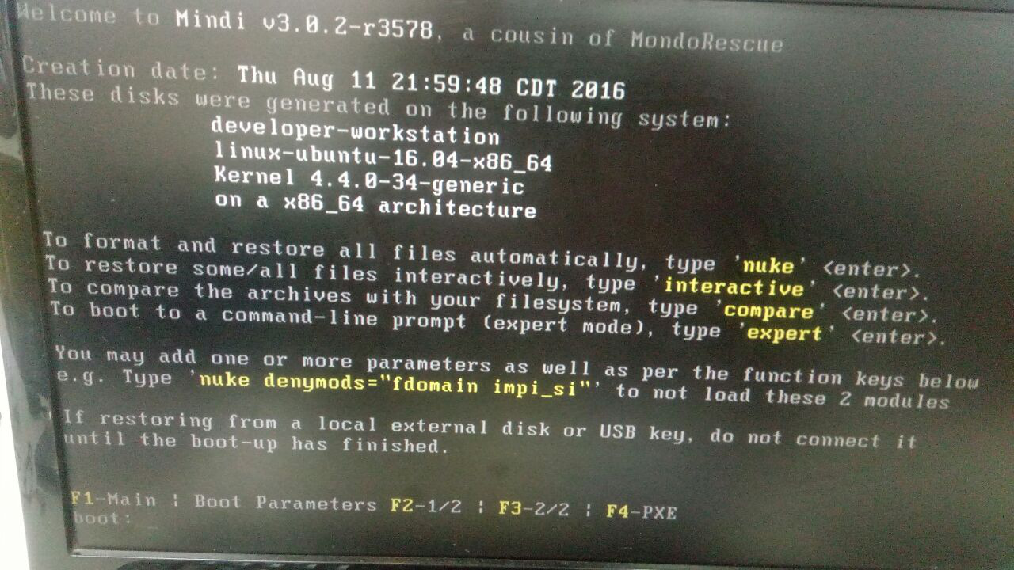

5. Wait for the First disk to get complete. Once a disk completes loading it prompts us to insert next Disk. Insert next disk and press enter.

Note : While loading the next Disk into the driver, wait for 10 to 15 sec before pressing Enter.

6. Follow the above steps for all disk. Once you are done with loading all the Six CDs, it will alert you asking ‘’. Now press the option ‘No’.

7. enter the command ‘reboot’ to finish and reboot the system.

Developer Machine Setup:

1. Login to developer account using the common developer password.

2. Execute the development setup script using the command
$ sudo bash developer_system_install-postVPN.sh

3. The Script will prompt for email Id and user name. Enter the details

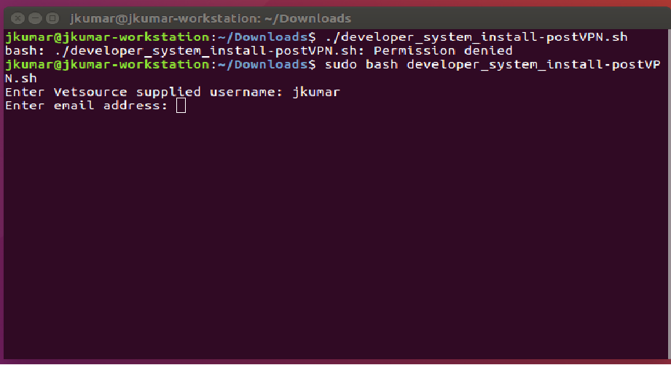

4. Once the script finish running the system account will be rename to the given username.

