https://factordaily.com/how-mechanics-bigo-live-works/

BLive

**Objective**

BLive is a **live streaming app** that allows users to vlog about their lives, stream video game play, host their own shows and interact with other users on the platform. **Rated for teens seventeen year of age and older**, BLive is **free to download and use**, but does contain**in-app purchases** for platform currency. It is available for both **iOS and Android devices**.

While BLive can be used for free, dedicated users, and those looking to travel up the ranks of the platform, will want to take advantage of in-app currency, or beans.

Users purchase bean packages, ranging in price from $0.99 to $89.99, to ‘gift’ or tip their favourite vloggers. Vloggers are then able to cash out their in-app currency for real world cash thus successfully monetizing their channels.

BLive users can watch or stream themselves with live feedback and commentary from the BLive community. Users can opt to share their video posts via social media, on both Facebook and Twitter.

The BLive platform is established similar to that of a gaming app, with levels and ranks assigned to users. Users receive bonus experience, or XP, points for daily sign-ins and watching other user videos, as well as sending and receiving gifts in the form of the platform currency.

Make new friends globally

Live streaming

Endless Live Videos

Group Video chat

Live PK – Funny, Entertaining, Addictive

Video Calling

Voice Chat

Funny Stickers and Filters

What BLive app.?

It is a live video streaming social media network based in India

Users can go live with video streaming, vide chart with others, or watch live stream videos from other broadcasters

Video calls can be one-on-one or group chats with up to 9 users

It encourage users to randomly chat with strangers via the video calls feature

Similar to Snapchat and Instagram Stories, There are several filters should available that can change the user’s appearance

The Voice Chat rooms are designed for users to live voice chart with strangers

During a live stream, viewers can comment on the video for everyone to see

The App is free but users can purchase “beans” which they give to their favourite broadcasters as a gift or tip.

Broadcasters can then exchange their “beans” for real money.

Similar to video games, users can level up their rank on the app by logging in daily, watching other live stream videos, and sending/receiving “beans”

The higher a broadcasters climbs the ranks the more their live streams will be shown to viewers

Disadvantage:

The emphasis of connecting with strangers on app is a major red flag that this app is NOT safe for students.

Content on the app can be mature, violent and inappropriate for teens

The app relies on AI to verify a user’s age and there are several reports of younger students bypassing the AI

Commentary on live videos can often lead to bullying behaviour

Broadcasters are rewarded for growing their following which can lead to them doing extreme or dangerous activities

**FIRST SCREEN**

For a registered and logged-in user, their app opens up into this screen. Here the user can check out the most popular ongoing broadcasts. This has a bunch of faces, which are essentially the profile pics of the broadcasters. This allows them to, for instance, put a highly click worthy pic.

**BROADCAST SCREEN**

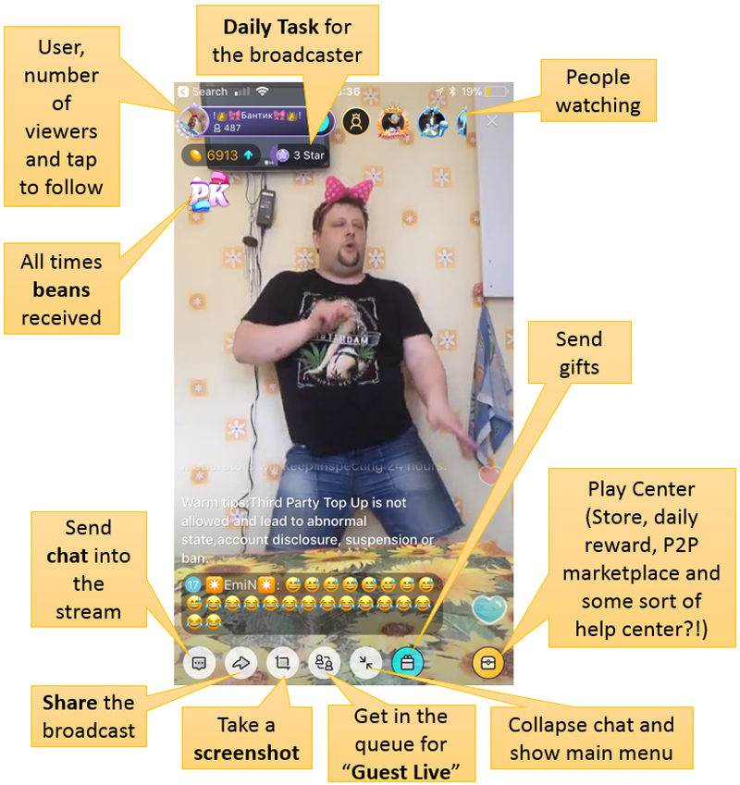Once you tap into a broadcast, you’ll see this screen. And maybe even this amazing man. This screen can get really busy (I’ll give an example later on in this post).

This is where the action happens. Viewers and broadcasters interact here over chat / video / gifts and a bunch of other things!

**THE CORE LOOP**

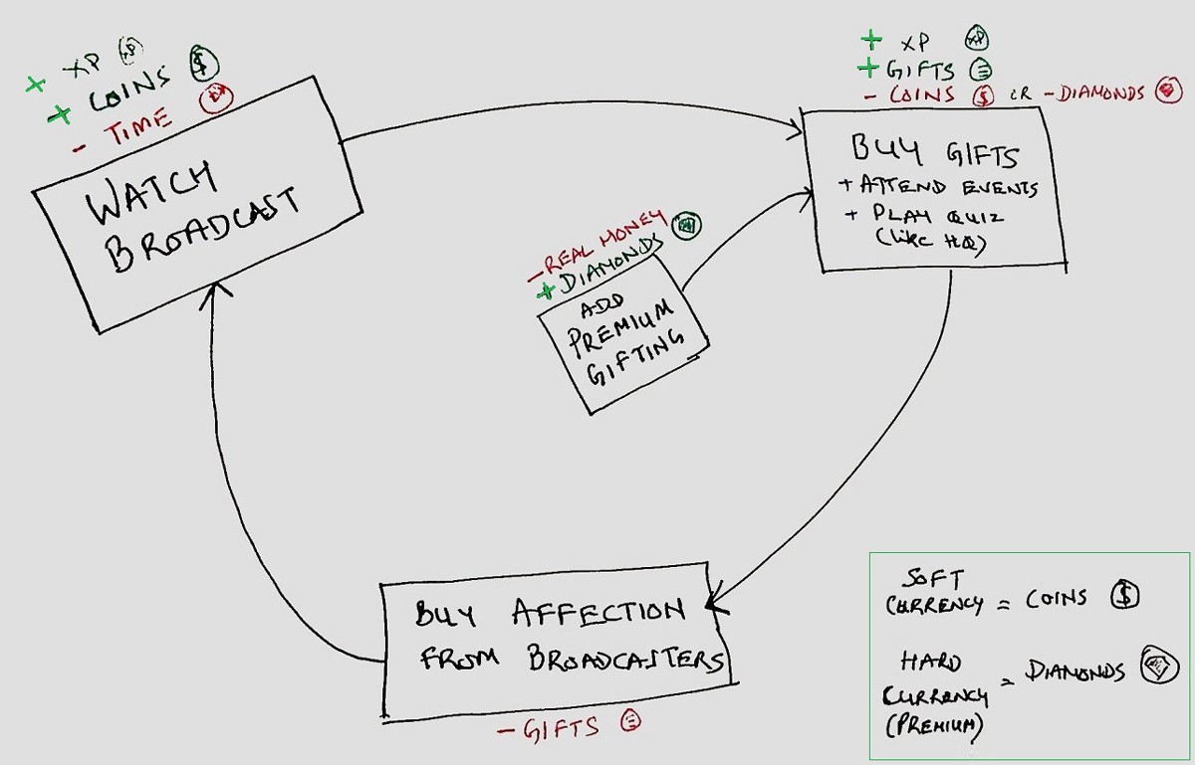

The core loop of Bigo is dead simple. Spend time in the app to get the soft currency. In gaming parlance, soft currency is the currency earned by users through gameplay and hard currency has to be bought. Use these coins to get (gifts). Use the gifts to get noticed in a broadcast.

It isn’t too hard to earn soft currency – but it can get grindy. There are two ways, which give a pretty solid clue about how game inspired this app is: