# EX NO:

# DATE:

**AIM:**

# SALESFORCE CRM

To login to salesforce and create an account in the salesforces to assign some of the task and event in salesforce calendar.

# ALGORITHM:

**STEP 1:-** Create a salesforce account and login into the salesforce.

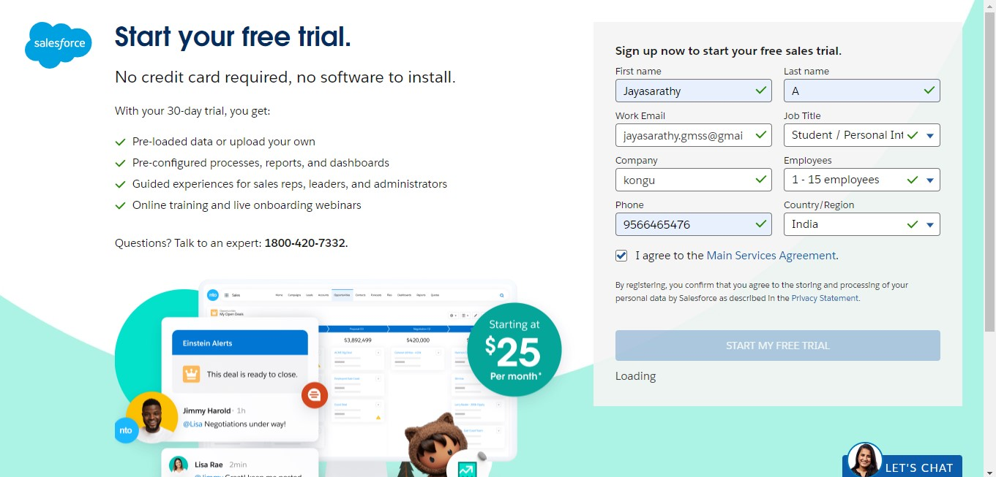

**STEP 2:-** After creating and verifying the salesforce account login to the salesforce account.

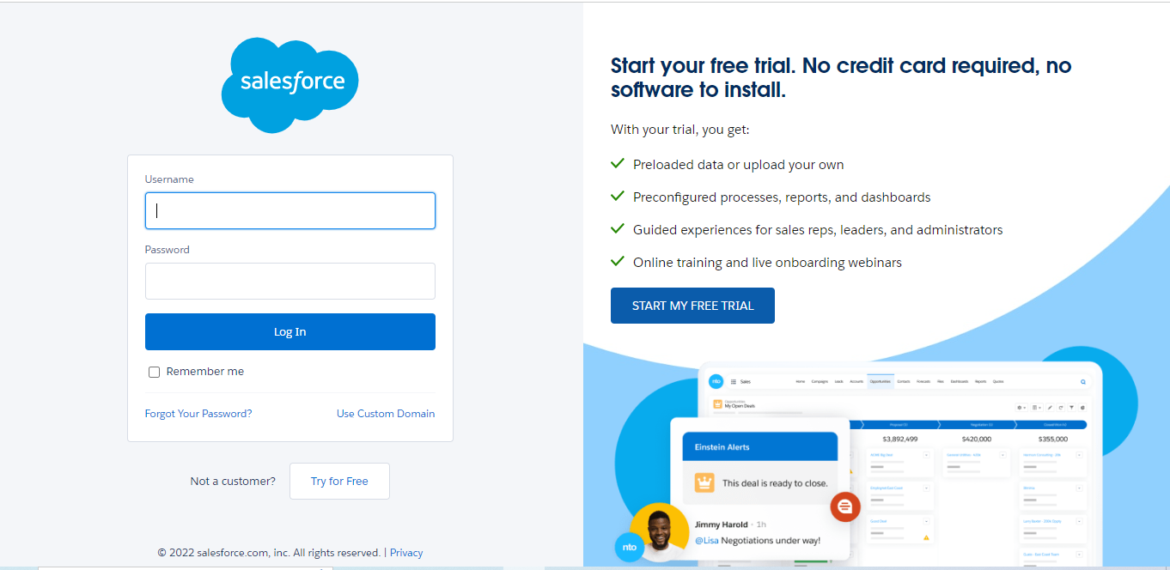

**STEP 3:-** After login into the account create a new account.

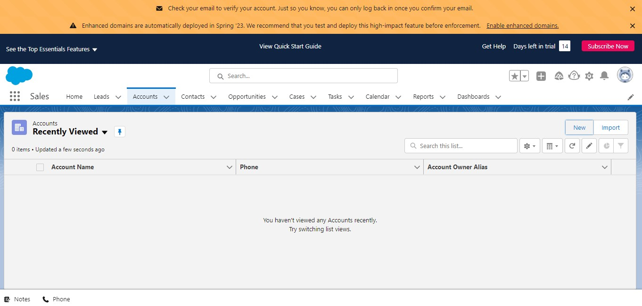

**STEP 4:-** Click on new to create a new account.

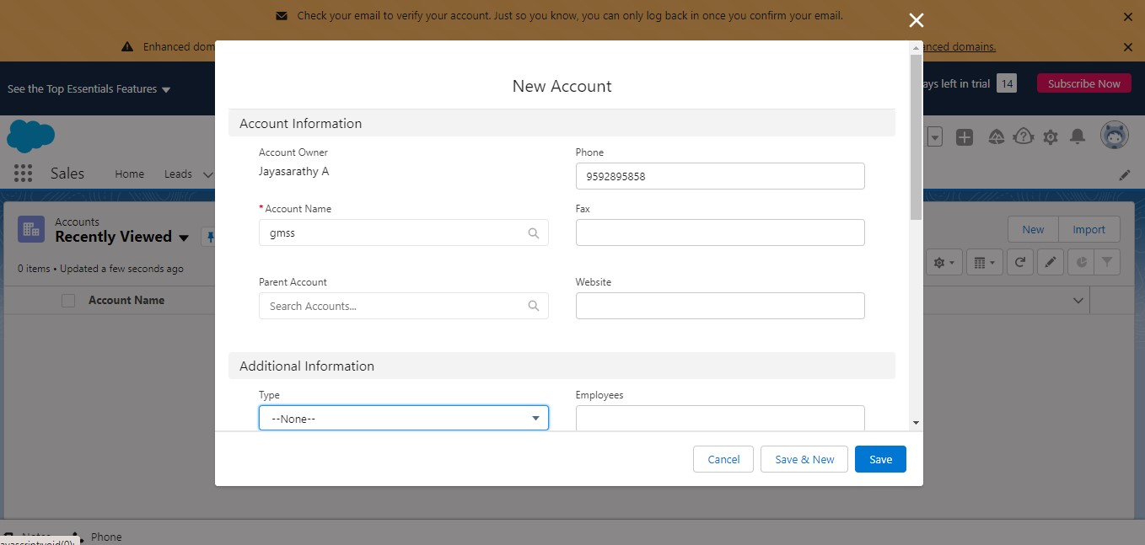

**STEP 5:-** Click on save a new account has been created and saved.

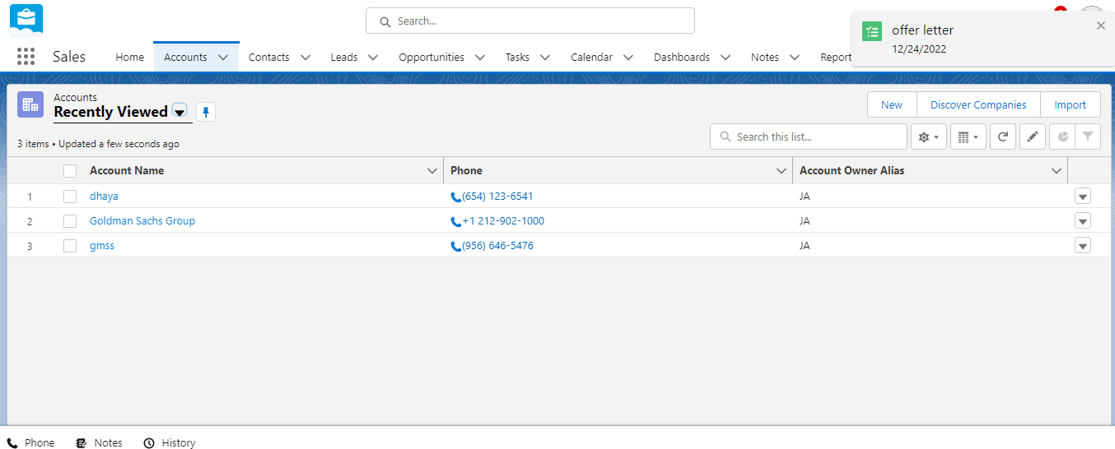

**STEP 6:-** After creating an account create a new contact.

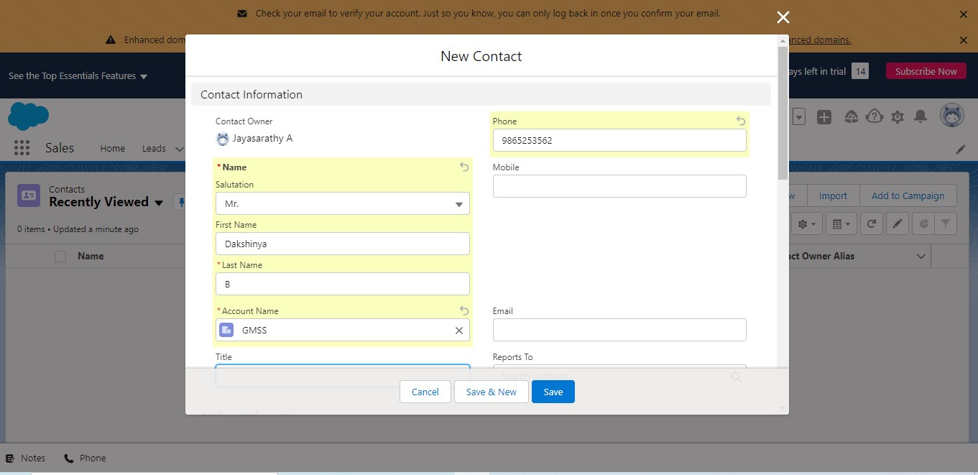

**STEP 7:-** Enter the valid account name, email id, phone number and click on save. A new contact has been created.

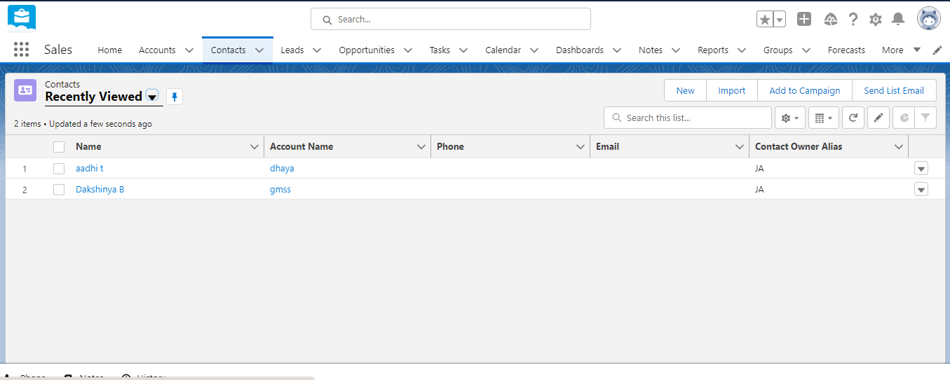

**STEP 8:-** After creating the contact create a new task.

**STEP 9:-** Click on + button to create a new task.

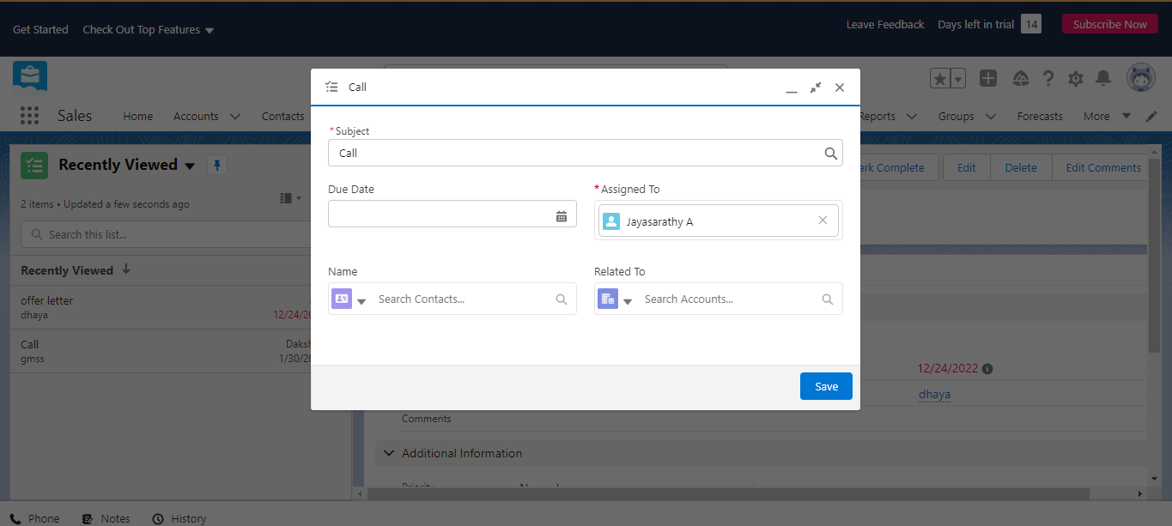

**STEP 10:-** Enter the valid details to create a task by giving subject to the task and save the task. We can also view the task.

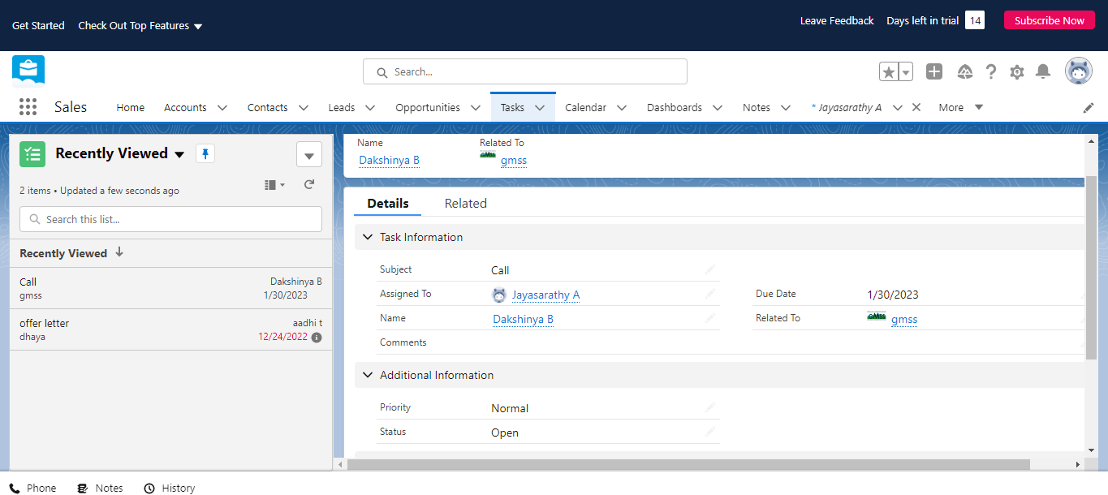

**STEP 11:-** Now make a schedule a new event in the calendar.

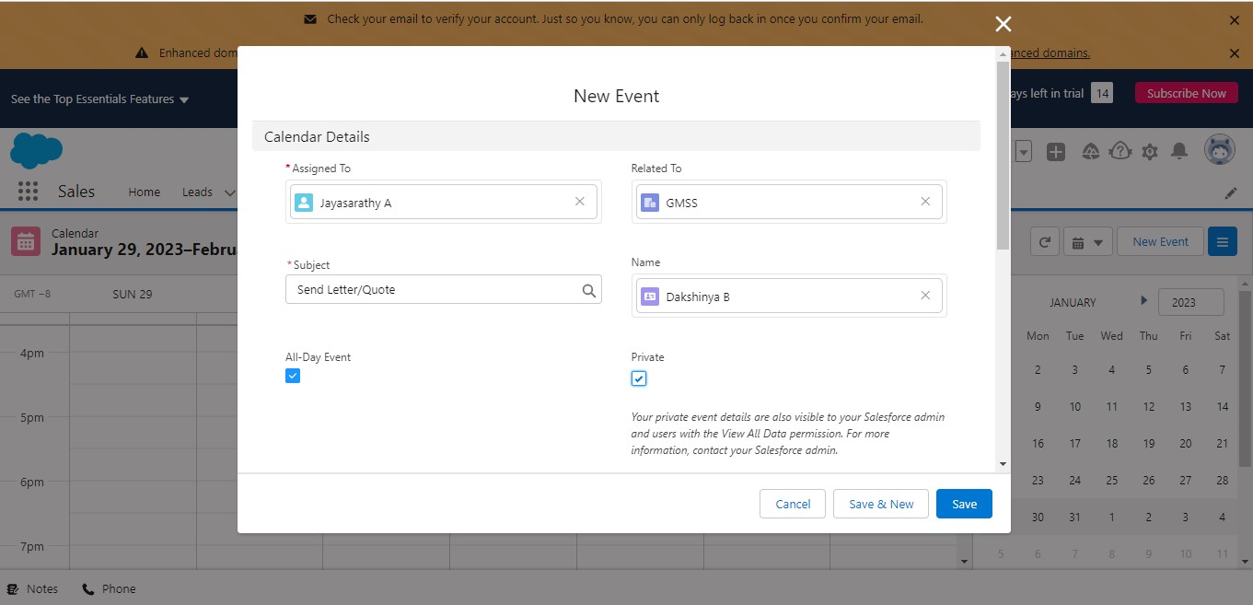

**STEP 12:-** We can also preview the event assigned in the calendar.

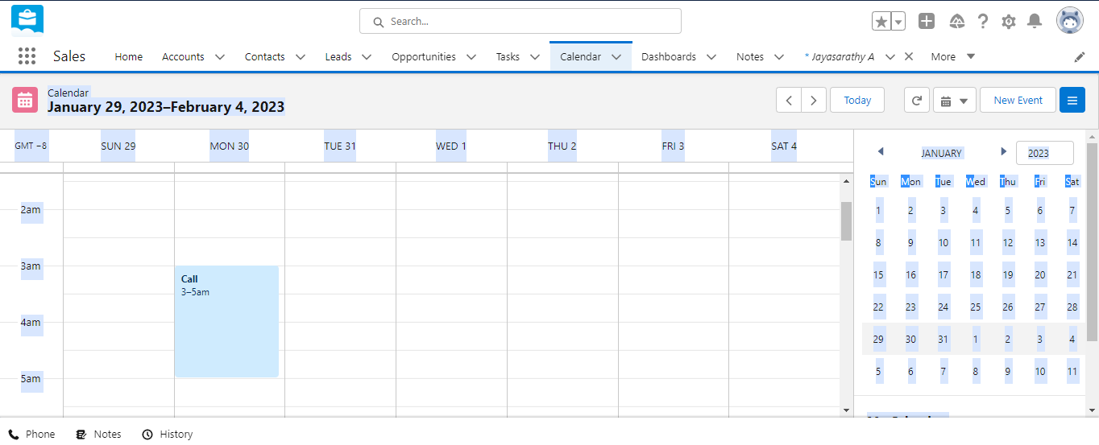

# RESULT:

Thus the implementation of assign a task and add event in the calendar in the salesforce CRM has been executed successfully.