 

1.

: InsightStream

  **:**Jayaseelan R [email id; rjayaseelan950@gmail.com]

Team member : Umasankar K [email id; [madesh887@gmail.com](mailto:madesh887@gmail.com)]

 : Monish G [email [id; monish721834@gmail.com](mailto:id;%20%20monish721834@gmail.com)]

 : Ganesh E [email id; [eganesh481@gmail.com](mailto:eganesh481@gmail.com)]

 Mukesh C [email id; mukesh.a1605[@gmail.com](mailto:mohamedabb342@gmail.com)]



InsightStream is a modern news application designed to deliver categorized news to users in an intuitive and engaging manner. The primary goal is to keep users informed with the latest news across multiple categories while providing a seamless user experience.

* Categorized news display (e.g., Technology, Sports, Business, Entertainment, etc.)
* Responsive and user-friendly UI
* Home page displaying trending and latest news
* About page with details about InsightStream
* Subscribe page for users to sign up for personalized news updates



* - Root component managing routes and layout
* 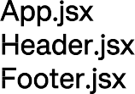- Contains navigation and branding
* - Displays copyright and links
* 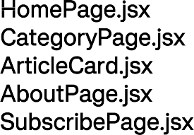- Displays top and trending news
* - Shows news based on user-selected category
* - Reusable component to display individual news articles
* - Information about InsightStream
* - Allows users to subscribe for updates



*  is used for global state management, storing news data, user preferences, and subscriptions.
* Local state management within individual components for UI interactions.
*  is used to handle navigation between pages:
  + / - Home Page
  + /about - About Page
  + /subscribe - Subscription Page
  + /category/:categoryName - Dynamic route for news categories



Ensure you have the following installed:

* Node.js (latest LTS version recommended)
* Git download
* npm or yarn
* Clone the repository:
* Git clone https://github.com/Ashu1090/insightstream.git
* Navigate into the project directory:
* Cd insightstream
* Install dependencies:
* npm install
* Start the development server:
* npm run dev



insightstream/

│── src/

│ │── components/ # Reusable components (Header.jsx, Footer.jsx, ArticleCard.jsx)

│ │── pages/ # Page components (HomePage.jsx, AboutPage.jsx, SubscribePage.jsx)

│ │── assets/ # Images, icons, and styles

│ │── utils/ # Utility functions and custom hooks

│ │── context/ # Context API files for global state

│── public/ # Static files

│── package.json # Project dependencies and scripts

│── README.md # Project documentation



To start the frontend server locally, run:

npm run dev

This will launch the application at [http://localhost:5173/.](http://localhost:5173/)



* : Displays a single news article with title, image, and description.
* : Renders a list of available news categories.
* : Handles user subscription input and submission.



:



* Styled button used across the app.
* : Displays a loading spinner while fetching data.



* Managed via  to store and share news data and user preferences.



* Used within components to handle UI interactions such as toggles and input fields.



Screenshots or GIFs showcasing:

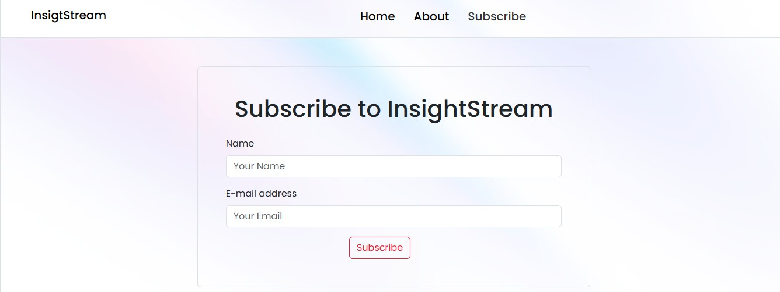



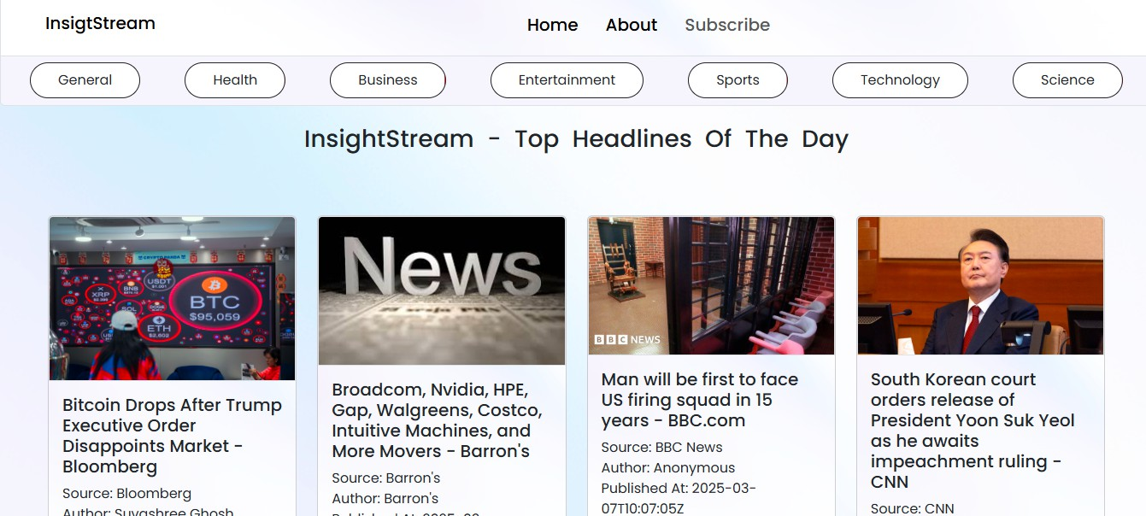

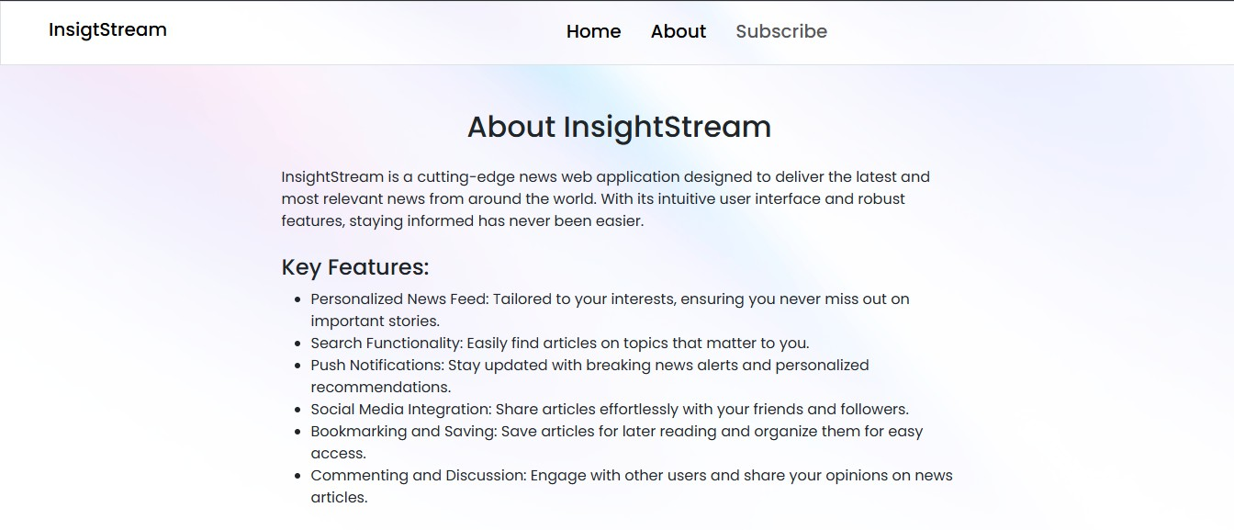







* for modular and dynamic styling.
* for scoped styles in individual components.
* Dark mode support (if implemented in future versions)



*  for unit and integration tests.
* (future enhancement) for end-to-end testing.





* Code coverage reports generated using Jest.

https://drive.google.com/file/d/10OS4kzjyS_AhjEIdOidkYeNH93mUICtQ/view?usp=drive sdk



* Performance optimizations needed for large news datasets.
* Improve mobile responsiveness for small-screen devices.



* Implement dark mode for better accessibility.
* Add a search functionality for articles.
* Improve animation and transitions for a smoother user experience.