**JAVA**

**Installation**

* Use wget command and java Debian package download link to Download jdk-17

# wget <https://download.oracle.com/java/17/latest/jdk-17_linux-x64_bin.deb>

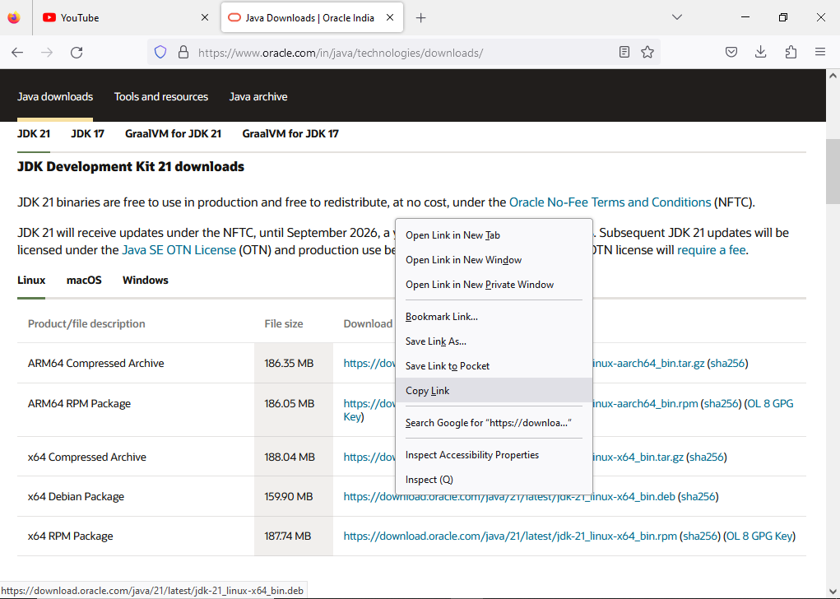

* Then install jkd-17 by using following command

# sudo dpkg -i jdk-17_linux-x64_bin.deb

* check the version of the JAVA

# java –version

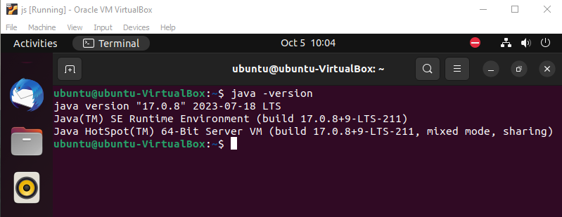

**APACHE TOMCAT 10**

**Installation**

* Go to Apache Tomcat 10 download page in Brower and copy the tomcat-10 link

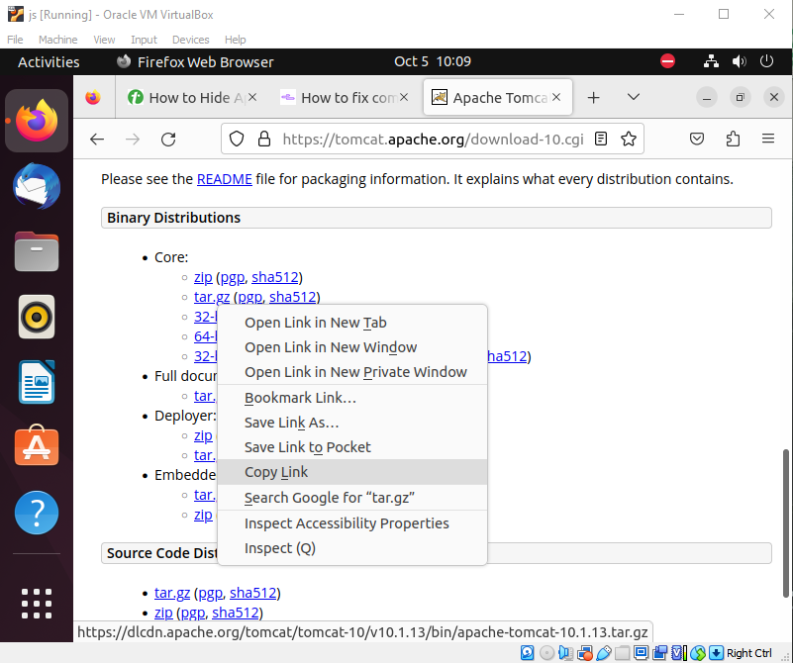

* Use wget command and Apache tomcat tar package download link to past it on

# wget <https://dlcdn.apache.org/tomcat/tomcat-10/v10.1.13/bin/apache-tomcat-10.1.13.tar.gz>

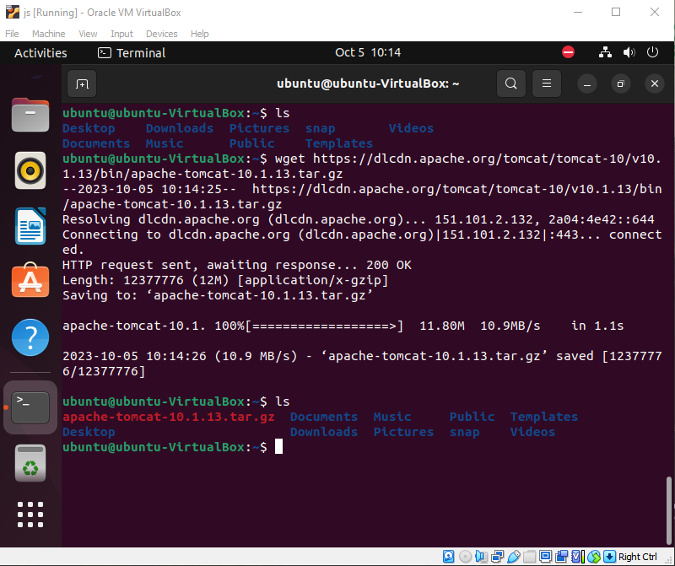

* Then extract tomcat-10 by using following command

# tar -zxf apache-tomcat-10.1.13.tar.gz

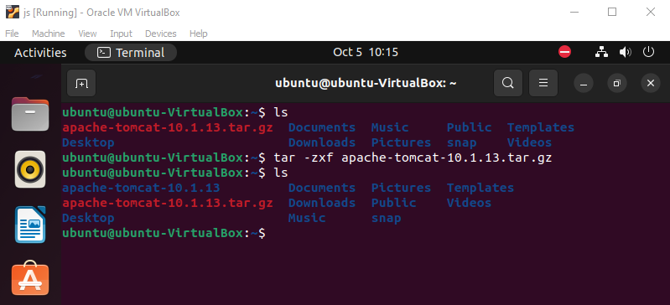

* Then ensure java install



**Configuration**

* Go to java installation path and then copy this path of jvm

# cd /usr/lib/jvm/jdk-17-oracle-x64

# pwd

* Copy the result

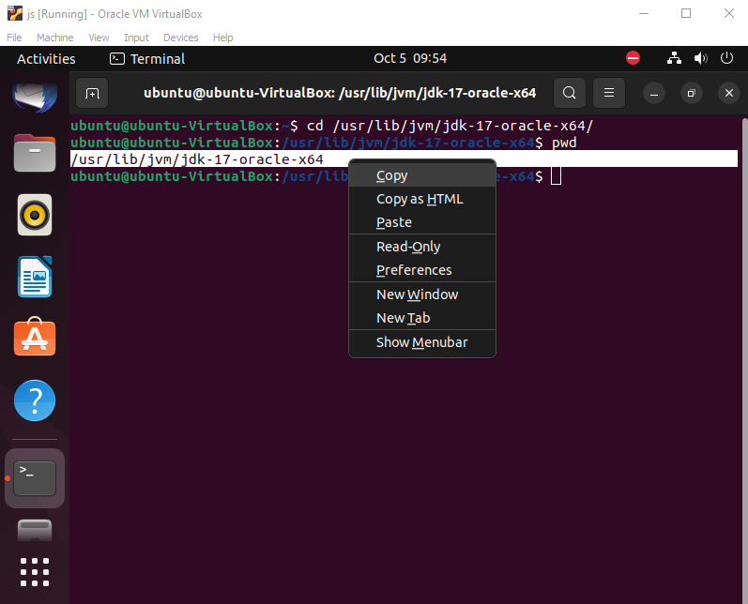

* Then move to bin directory in apache-tomcat-10 and open catalina.sh file

# cd /home/user/apach-tomcat-10/bin

# nano catalina.sh

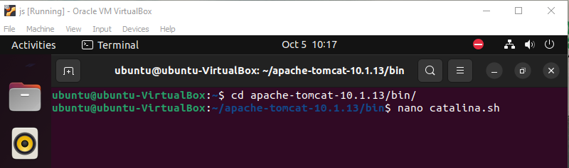

* Past the jvm path in catalina.sh and following format

JAVA_HOME=/usr/lib/jvm/jdk-17-oracle-x64

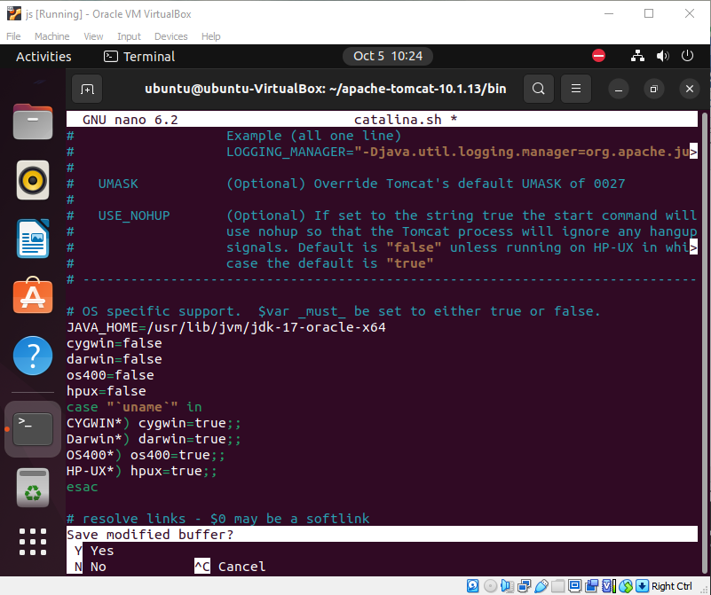

* Save the file and then restate apache-tomcat

# ./startup.sh (or)

# /home/user/apache-tomcat-10/bin/startup.sh

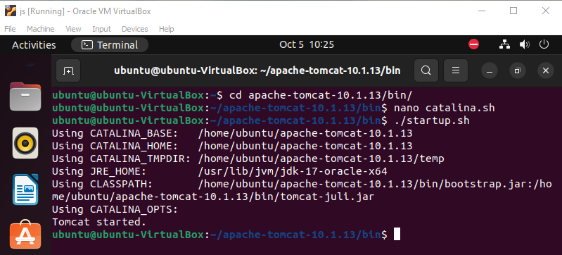

* Go to Brower, search localhost:8080 and open shown this

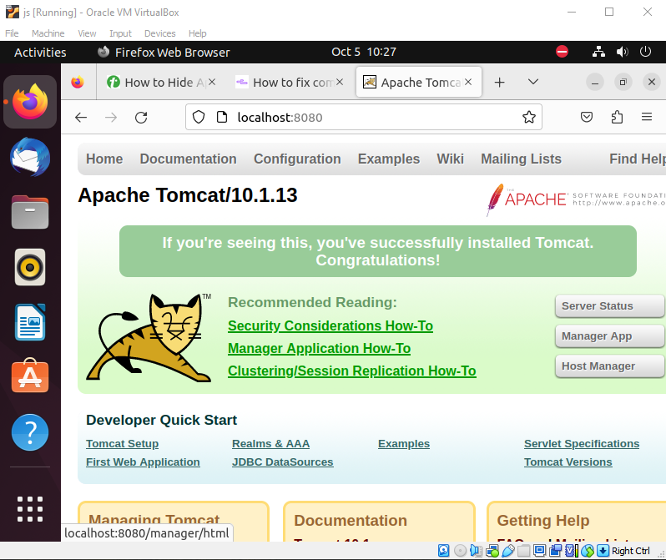

* Then click on Manager App and double click sign-in

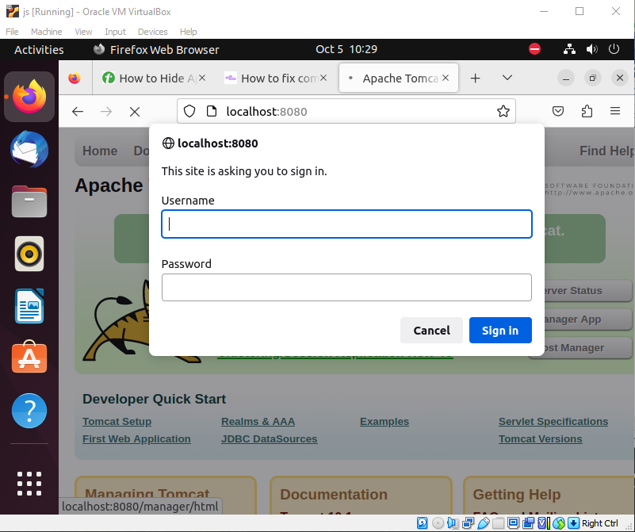

* Then copy the rolename and username lines (2 lines) and go back to terminal

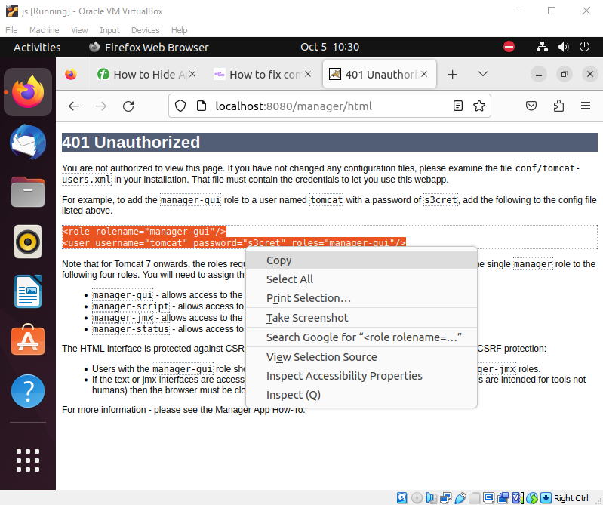

* Then change directory bin to conf in apache-tomcat-10 and open the file (tomcat-users.xml)

# cd ../conf

# nano tomcat-user.xml

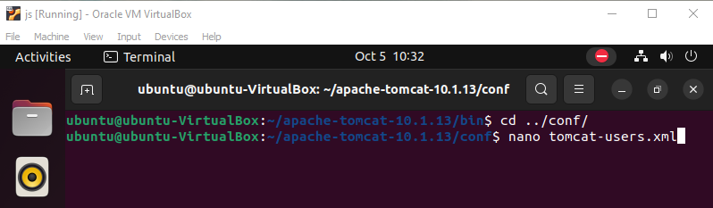

* To past the rolename and username lines in this file (tomcat-users.xml) and change user & password

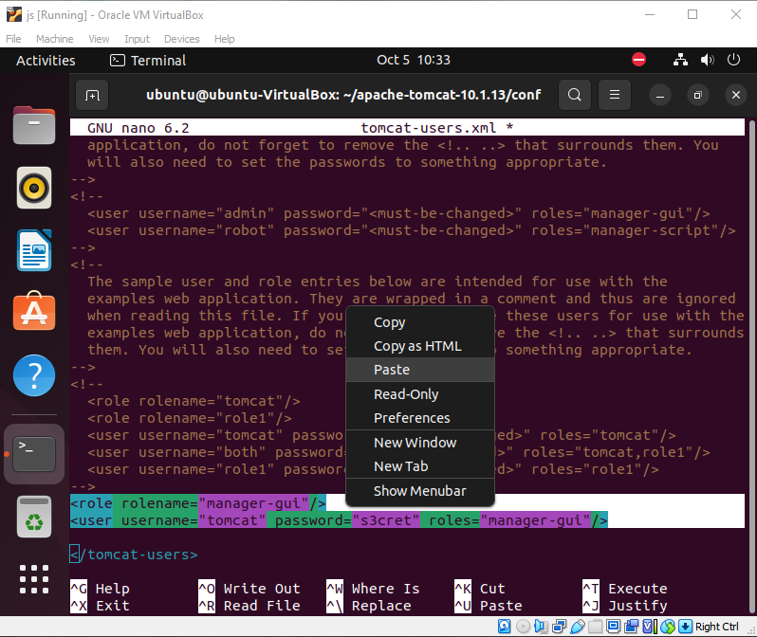

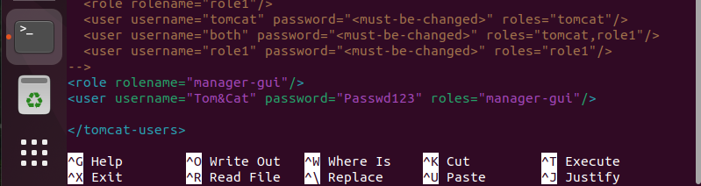

* Change directory to bin and start the apache-tomcat-10

# ./shutdown.sh

# ./startup.sh

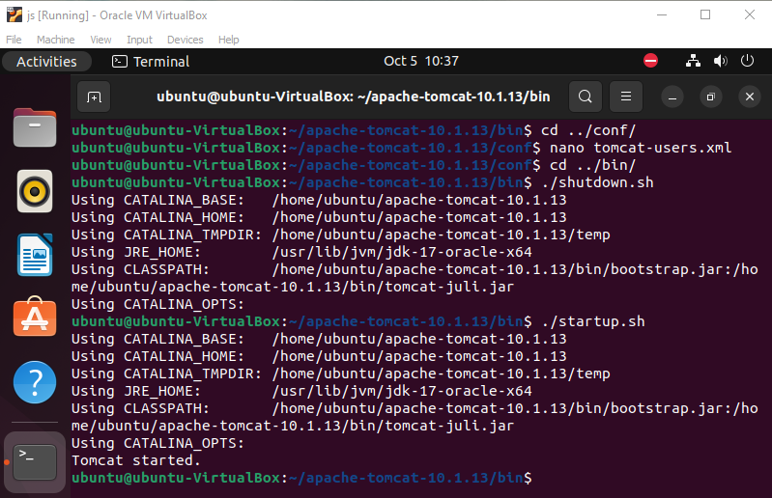

* Go to Brower and then sign in apache-tomcat-10

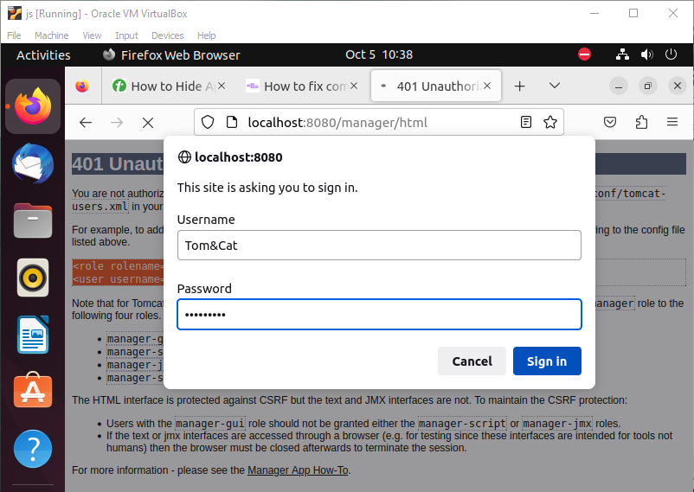

* Finally show this page

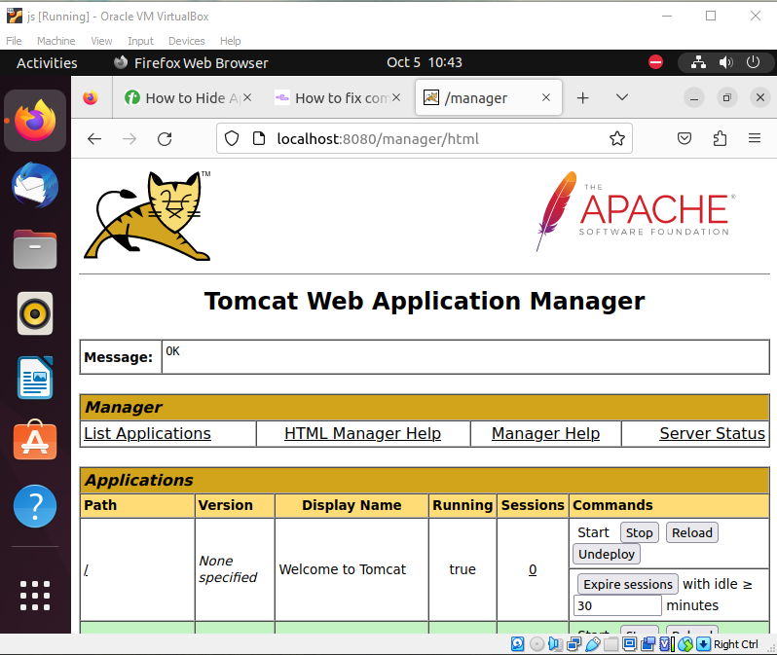

**Deploy war file**

Tomcat-10

**Redirection URL**

Tomcat-10

* Go to ROOT directory in apache-tomcat/WebApps and first take backup index.jsp

# cd /home/user/Downloads/apache-tomcat-10.1.13/webapps/ROOT

# cp index.jsp backup_index.jsp

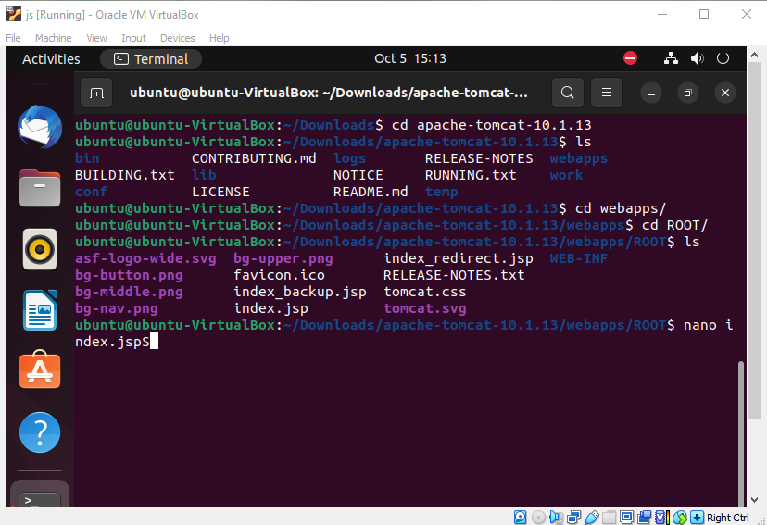

Then open index.jsp file and delete all text in this file and also type following lines

# nano index.jsp

<% response.sendRedirect("http://otherserver.example.com/some/where"); %>

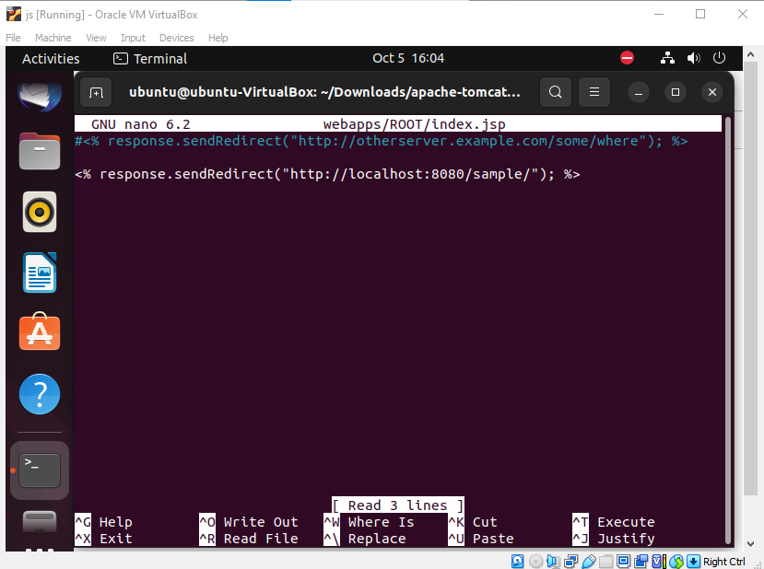

* Change directory to bin and start the apache-tomcat-10

# ./shutdown.sh

# ./startup.sh

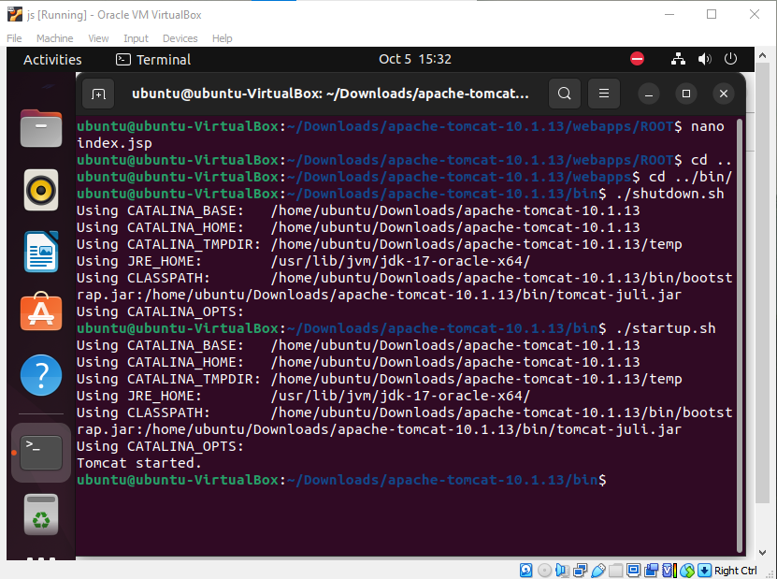

* Go to Brower and type URL “localhost:8080”

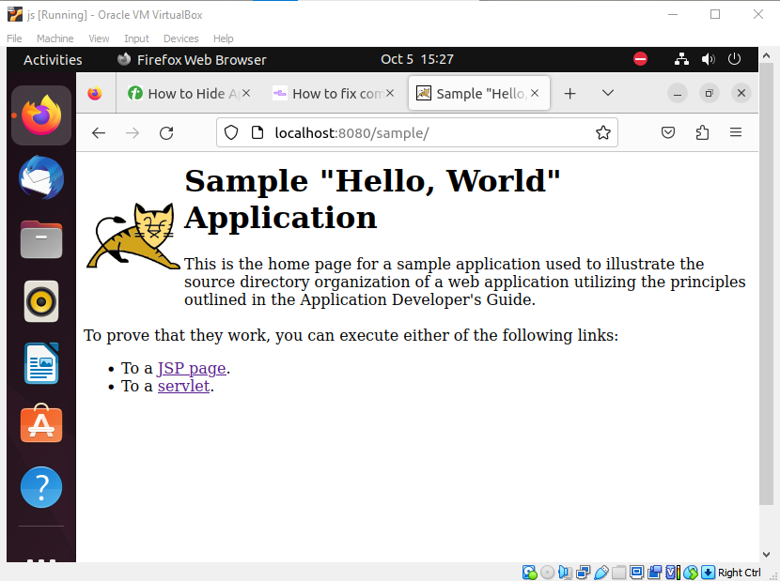

How to fix common problems with Apache2

<https://upcloud.com/resources/tutorials/fix-common-problems-apache2>