Enable WLAN AutoConfig on your Computer
- Click the Start button and type services.msc into the search box and press <Enter>. Image 1
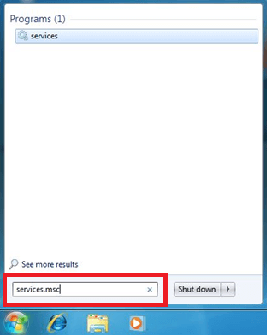

2) In the services window locate the service named WLAN AutoConfig. Image 2
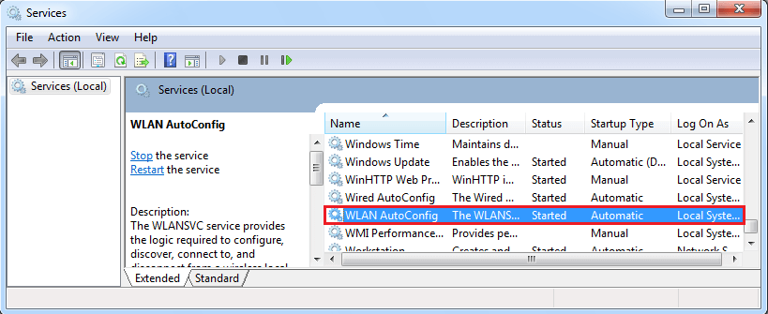
3) Right click on this service and click on Properties. Set the Startup Type Automatic. Image 3
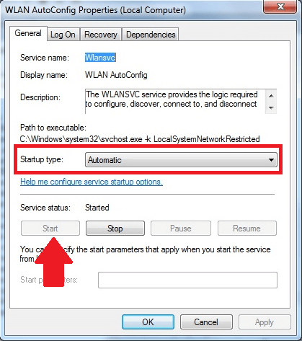
5) If the service status is Stopped then click the Start button. Press OK and close the services window.

