Enable WLAN AutoConfig on your Computer
1) Click the Start button and type services.msc into the search box and press <Enter>.
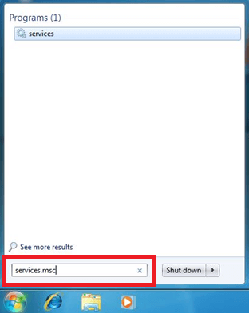
2) In the services window locate the service named WLAN AutoConfig.
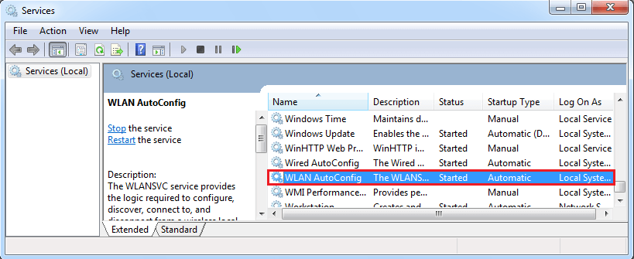
3) Right click on this service and click on Properties.
4) Set the Startup Type Automatic.
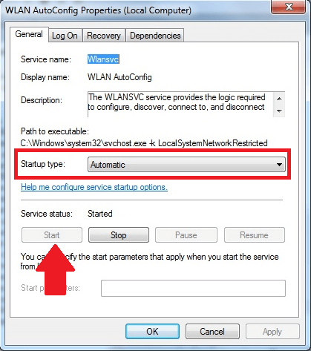
5) If the service status is Stopped then click the Start button.
6) Press OK and close the services window.

