How to Create an EC2 Instance in AWS (Step by Step)
Prerequisites: AWS account with required permissions.
1. Overview
Amazon Elastic Compute Cloud (EC2) is a web service that provides secure, resizable compute capacity in the cloud. This KB explains how to launch an EC2 instance using the AWS Management Console.

2. Prerequisites
Before creating an EC2 instance, ensure:
- Active AWS account
- IAM user/role with permissions:
  - AmazonEC2FullAccess (or equivalent)
- Basic understanding of:
  - AMI
  - Instance types
  - Key pairs
  - Security groups
- Internet browser access to AWS Console

3. Step-by-Step Procedure
Step 1: Log in to AWS Management Console
- Login to the AWS management console. This link is given. https://aws.amazon.com/console/ , either you can use the IAM user access or you can use the root user email and password. Authenticate it if you have enabled any MFA. refer Image1
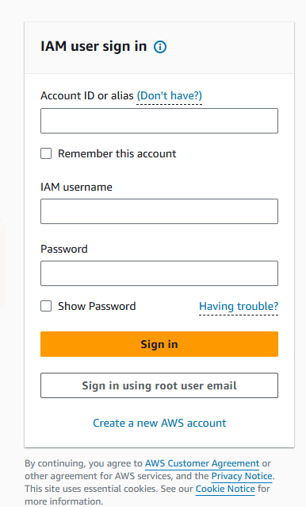
Image1
Tip: Always choose the region closest to your users for lower latency.

Step 2: Navigate to EC2 Dashboard
- In the search bar, type EC2. It will populate list of EC2 related options. Refer Image2
- Click on EC2 under Services
- You will land on the EC2 Dashboard. Refer Image3

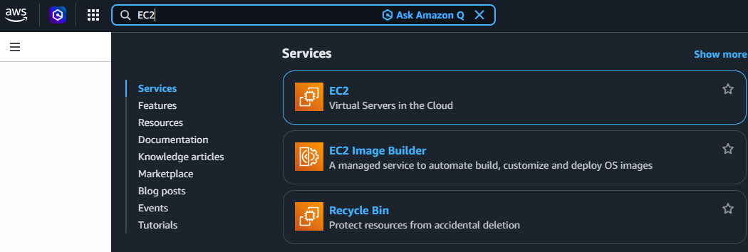
Image2
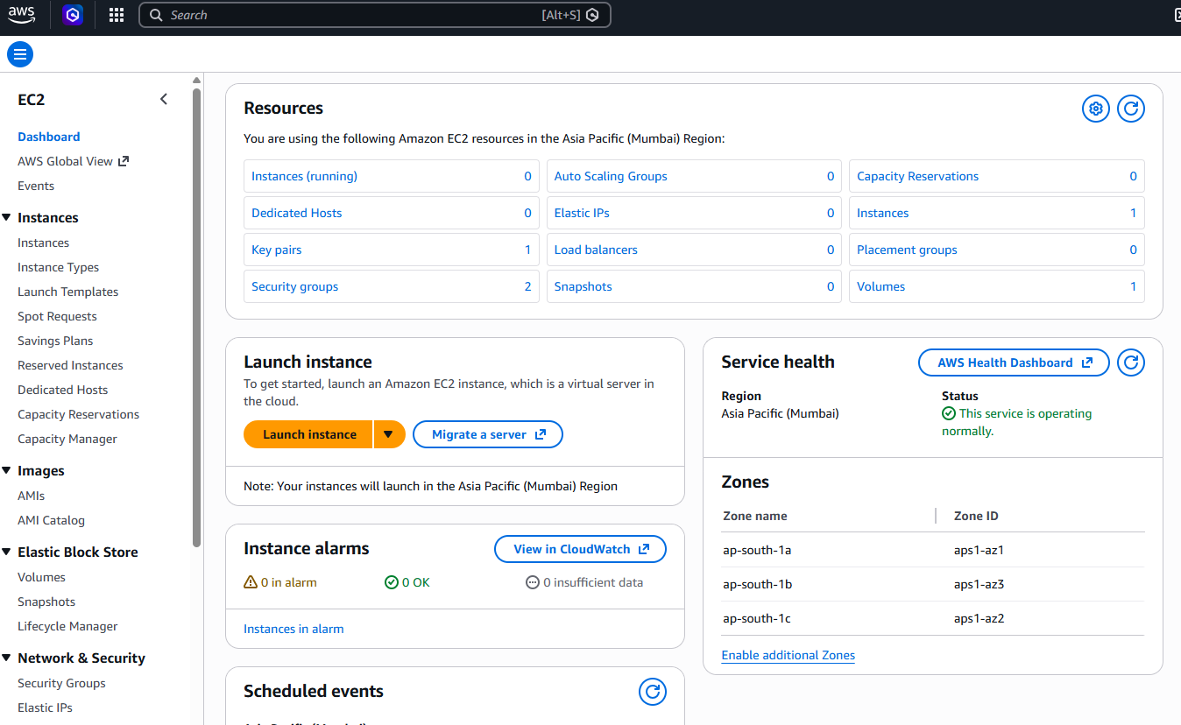
Image3

Step 3: Launch Instance
- Click Launch Instance. Once clicked on launch instance the new instance creation screen opens. Refer Image4
- Provide an Instance Name.
Example: My-First-EC2-Server
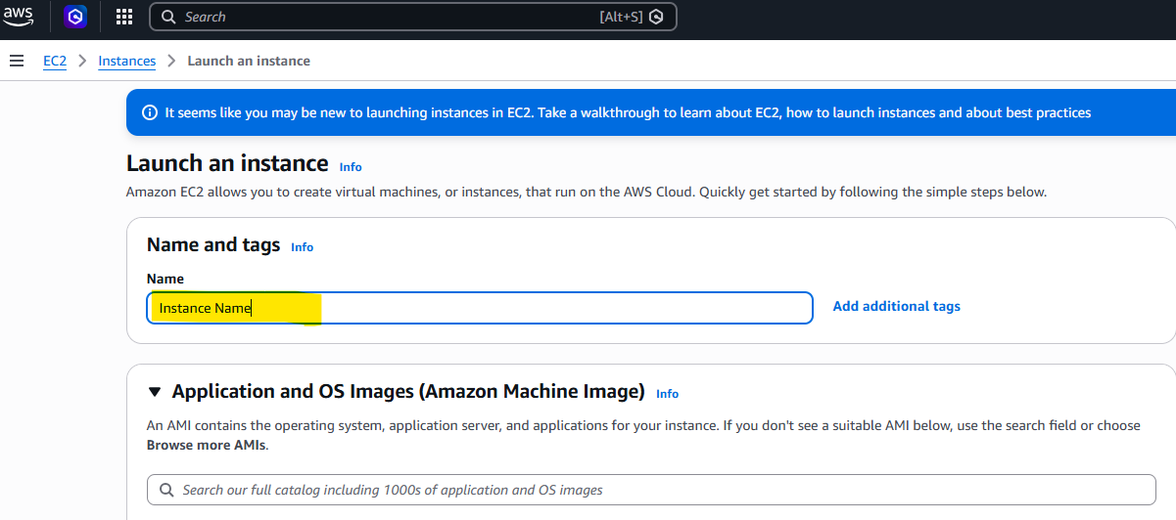
Image4

Step 4: Choose an Amazon Machine Image (AMI)
Select an operating system image for the list of options. Refer Image 5
Common options:
- Amazon Linux 2023
- Ubuntu Server 22.04 LTS
- Red Hat Enterprise Linux
- Windows Server
Recommendation:
Use Amazon Linux or Ubuntu for cost-effective and widely supported setups.

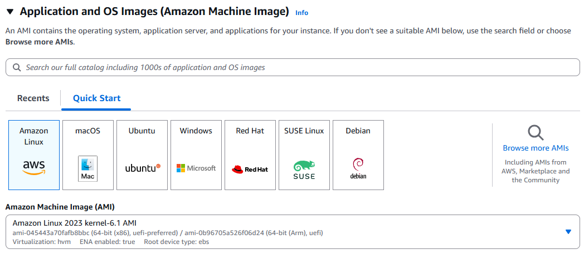
Image5
Step 5: Choose an Instance Type
Select the instance size based on workload. Refer Image 6
Free Tier:
t2.micro or t3.micro

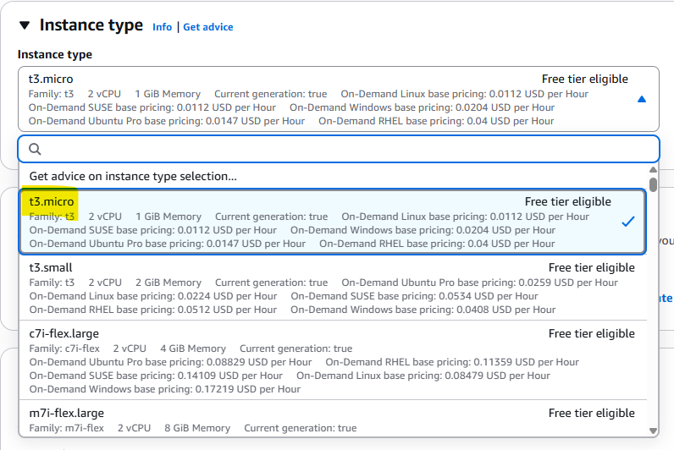
Image6

Click Next or continue scrolling.

Step 6: Configure Key Pair (Login)
- Choose:
  - Create new key pair OR
  - Select an existing key pair
- Key pair type: RSA
- Download the .pem file and store it securely
⚠️ Important:
Without the key pair, you cannot SSH into the instance. Refer Image 7
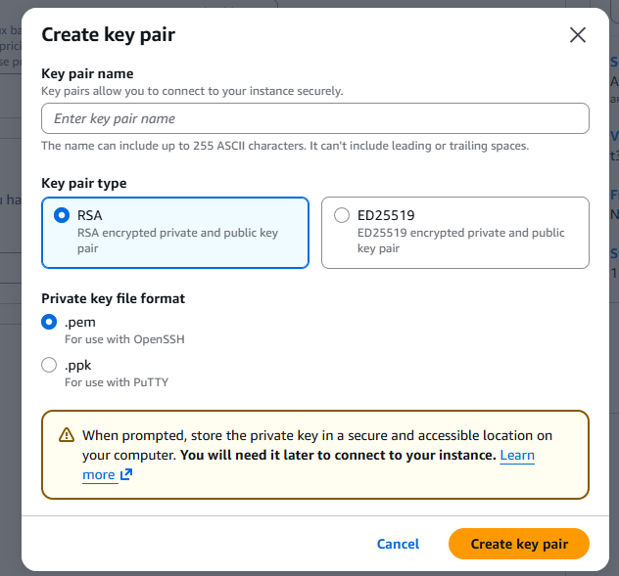
Image6

Step 7: Configure Network Settings
- VPC: Default VPC (recommended for beginners)
- Subnet: Auto-assign
- Auto-assign Public IP: Enable (for internet access)
Firewall (Security Group)
Create or select a Security Group:
✅ Best Practice: Restrict SSH access to your IP only. Refer Image 7
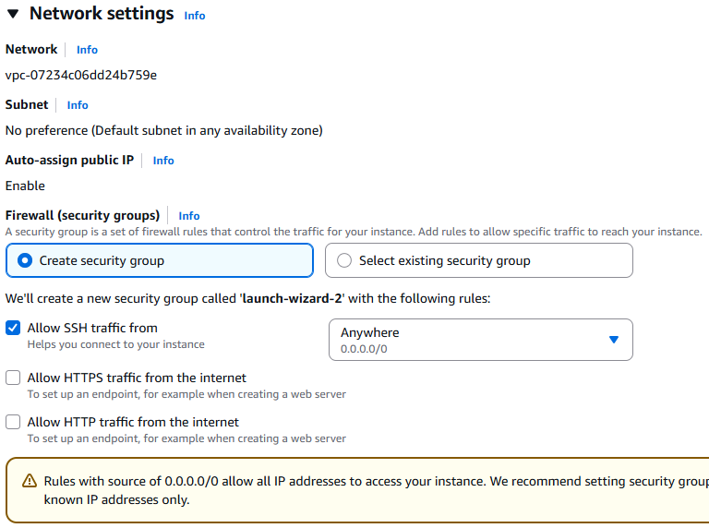
Image7

Step 9: Review and Launch
- Review all configurations:
  - AMI
  - Instance type
  - Key pair
  - Security group
- Click Launch Instance
✅ You will see a success message.

4. Verify EC2 Instance Status
- Go to EC2 → Instances
- Check:
  - Instance state: Running
  - Status checks: 2/2 passed

