STANDARD OPERATING PROCEDURE
External Network Connection (ENC) Process

Document ID | Version | Effective Date | Classification
ENC-SOP-001 | 1.0 | June 2025 | Confidential

1. Purpose
This Standard Operating Procedure (SOP) defines the process for requesting, reviewing, and managing External Network Connections (ENC) within the Sanofi IT environment. It ensures that all changes to perimeter security equipment are properly validated, documented, and compliant with Sanofi's Information Security policies.

2. Scope
This SOP applies to:
- All Sanofi employees, contractors, and third parties who require changes to perimeter security equipment configurations.
- All projects involving the opening of sensitive applications to external partners.
- All firewall rule changes and external network connection requests across the Sanofi global network.

3. Background
The External Network Connection (ENC) process has been in use within the Sanofi IT environment since 2006. It was established to provide a controlled and auditable framework for managing changes to network perimeter security devices.

4. Objectives
The ENC process achieves the following key objectives:
- Validate every change made to perimeter security equipment configurations, ensuring that new configurations do not introduce unacceptable risk to the Sanofi network, or that identified risks are mitigated by appropriate security measures.
- Document all changes to support firewall configuration audits and the decommissioning of firewall rules when an associated application is retired.
- Ensure that projects requiring external partner access to sensitive applications have adequately integrated Information Security requirements.
- Ensure compliance with the SCADALAN security model.

5. Access & Prerequisites

5.1 Training Requirement
Before raising an ENC request, all users must complete the mandatory ENC process training. Access to the ENC portal will only be granted upon successful completion of this training.

Training Portal: https://encv3.sanofi.com/encv3-doc/etraining/

5.2 Registration
To activate your account after completing the training:
- Navigate to the training portal using the link above.
- At the end of the training, you will be prompted to enter your User ID. Image1

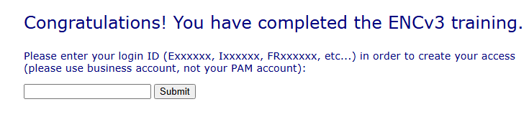

- Enter your Sanofi Employee ID (EID) in the designated field.
- Click Submit. Your account will be enabled to create ENC requests. Image2
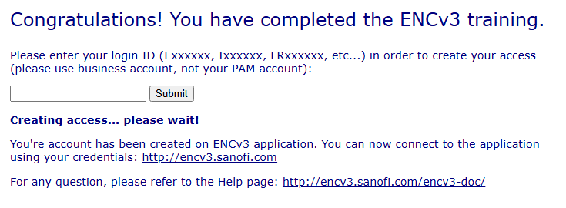

6. Raising an ENC Request

6.1 ENC Portal
All ENC requests must be submitted through the Algosec portal using the link below:

ENC / Algosec Portal: https://encv3.sanofi.com/FireFlow/SelfService/

6.2 Submission Steps
- Log in to the Algosec portal using your Sanofi credentials.
- Select the appropriate request type for your ENC.
- Complete all required fields, including application details, business justification, and requested firewall rules.
- Attach any relevant supporting documentation (e.g., architecture diagrams, security risk assessment).
- Submit the request for review and approval.

7. Review & Approval
All ENC requests are subject to review by the IS Security team. The review process evaluates the following:
- Potential security risks introduced by the requested configuration change.
- Adequacy of compensating security controls where risk cannot be eliminated.
- Compliance with Sanofi IS Security policies and the SCADALAN model.
- Completeness of documentation for audit purposes.
Requests that do not meet security standards will be returned to the requestor with documented reasons and recommended remediation steps.

8. Documentation & Audit
All approved ENC requests and their associated firewall rules are retained in the Algosec system for audit and lifecycle management purposes. This documentation supports:
- Periodic firewall configuration audits by the IS Security team.
- Decommissioning of obsolete firewall rules when an application is retired or a project concludes.
- Compliance reporting and regulatory reviews.

9. Roles & Responsibilities

Role | Responsibility
ENC Requestor | Completes mandatory training; submits complete and accurate ENC requests via the Algosec portal.
IS Security Team | Reviews and approves/rejects ENC requests; ensures policy and SCADALAN model compliance.
Application Owner | Ensures business justification is provided; responsible for requesting decommissioning of rules when the application is retired.
Network / Firewall Team | Implements approved firewall rule changes; coordinates with IS Security for complex requests.

10. References & Related Resources

ENC Training | https://encv3.sanofi.com/encv3-doc/etraining/
Algosec ENC Portal | https://encv3.sanofi.com/FireFlow/SelfService/
Document Owner | Sanofi IS Security
Review Cycle | Annual or upon significant process change

Document Approval

Prepared By | Reviewed By | Approved By
Name:  Signature: ________________  Date: ____________________ | Name:  Signature: ________________  Date: ____________________ | Name:  Signature: ________________  Date: ____________________

