**Business Problem/Problem Statement:**

In recent years, both City and Resort hotels have experienced high cancellation rates. Each hotel is dealing with several issues because of the high cancellation rates, such as less revenue and less than-ideal hotel room use. Consequently, our primary goal is to lower the cancellation rate for both hotels to increase their efficiency in increasing revenue. Our goal is to offer thorough business advice to address this problem.

The main topics of this report are to analyze hotel booking cancellations as well as other factors that have no bearing on the business and yearly revenue generation.

**Assumptions for the Data:**

1. No unusual occurrences between 2015 and 2017 will substantially impact the data being used.

2. The information is still current and can be used to analyze a hotel’s possible plans efficiently.

3. There are no unanticipated negatives to the hotel for employing any techniques advised by us.

4. The hotels are currently not using any of the suggested solutions.

5. The biggest factor affecting the effectiveness of earring income is booking cancellation.

6. Cancellations result in vacant rooms for the booked length of time (hotels will not generate revenue for )

7. Cancellations are in the same year as the reservations.

**Research Question:**

1. What are the variables or factors that affect the hotel cancellation?
2. How can we decrease hotel reservation cancellations?
3. How can we assist hotels in making better pricing and promotional decisions?

**Hypothesis:**

1. More cancellations will occur when the price is higher
2. When there is a longer waiting list, the customer tends to cancel more frequently.
3. The majority of clients are coming from offline travel agencies to make their reservations.

**Analysis and Finding:**

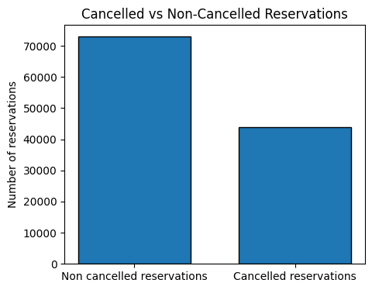

The bar graph above shows us that a significant number, 37% of the reservations are being cancelled. Out of a total of 116958 reservations, 73009 were not cancelled but 43949 were. The significant number of cancellations affects the total earnings of the hotels.

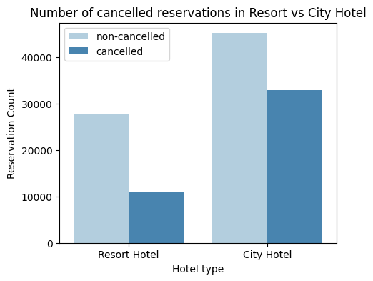

City hotels are more popular than Resort Hotels according to the count plot above. Resort Hotels may have a higher adr than City Hotels, we will look at this further in our analysis.

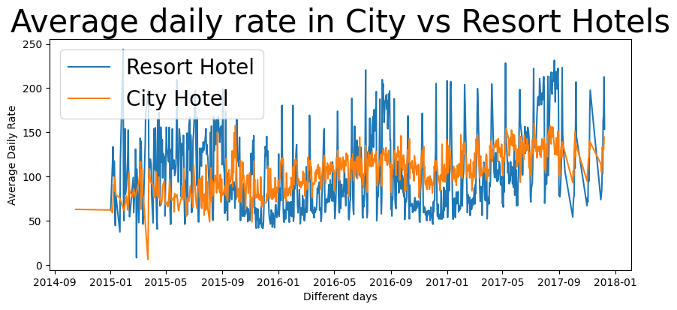

We can see from the line graph above that the adr of the City Hotel is lower than the adr of the Resort Hotel. The spikes occur on weekends, holidays, and at the end of the month, here, the Resort Hotel is still more expensive.

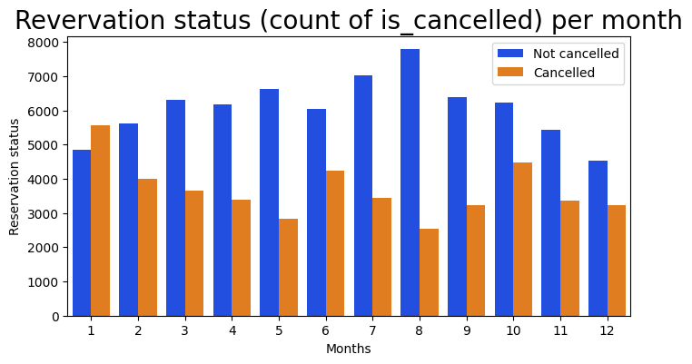

The bar graph above helps us in analyzing the reservation status depending on each month. Both, the highest number of reservations and lowest number of cancellations occur in August. Whereas, the most cancelled reservations occur in January.

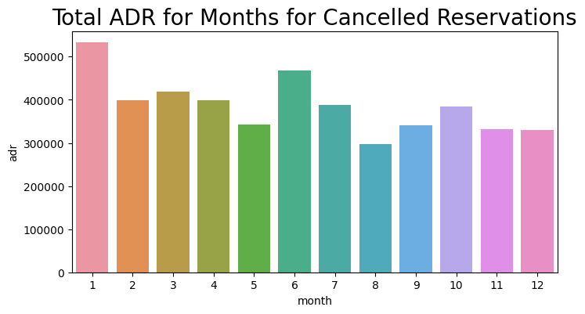

The barplot above shows us that when the adr is the lowest (August), reservations are the least cancelled. It also shows us that when the adr is the highest (January), reservations are the most cancelled. The cost of the hotel is directly responsible for the number of cancellations.

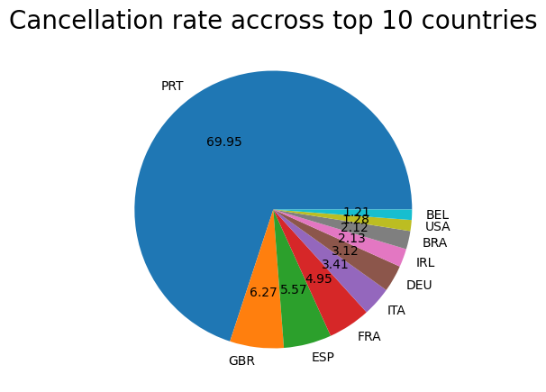

According to the pie chart above, Portugal has significantly more cancellations than any other country, this needs to be looked into further.

Next, we will be analyzing the booking methods of the reservations. Are they coming from Direct, Group or Online or Offline Travel Agents? 47% of the reservations are made through Online Travel Agents, 27% are made through Groups, 18% of reservations are made using Offline Travel Agents, and only 4% of the reservations are made Directly.

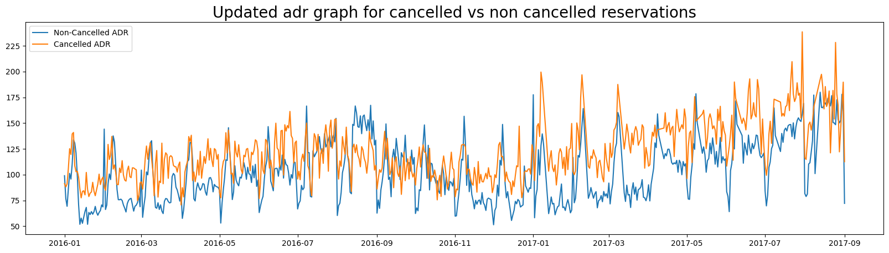

The above line graph compares the status of reservations depending on the adr. It is evident that the cancellation of reservations occurs when the adr is higher. This proves our hypothesis that a higher price leads to greater cancellations.

**Suggestions:**

1. The price of the hotel directly affects the cancellation rate. To prevent cancellation rates, hotels should work on their pricing strategy and lower rates on specific days/locations. They can also try to implement special discounts.
2. The hotels should provide reasonable discounts on weekends on holidays since it is evident that Resort Hotels have a higher cancellation ratio than City Hotels.
3. In January when the cancellation is the highest, hotels can implement campaigns or marketing strategies to increase revenue.
4. Hotels can increase the quality and services they offer to attract more customers. Especially in Portugal, where the most cancellations occur.

qqqqqaz