TITLE:HR ANALYTICS DASHBOARD
Name:Jayshree Manohar Shinde
SYNTEXHUB INTERN
Employee Attrition Analysis using Power BI
1. Introduction
Human Resource Analytics helps organizations understand employee behavior, workforce trends, and attrition patterns. This project focuses on analyzing employee data using Power BI to identify key factors affecting employee attrition and organizational performance.
The dashboard was developed using Power BI and DAX to provide interactive visual insights for decision-making.
2. Objectives
The main objectives of this project are:
To analyze employee attrition patterns
To identify factors influencing employee turnover
To compare employee performance across departments
To perform correlation analysis between important variables
To create an interactive HR Analytics Dashboard
To provide business insights for improving employee retention
3. Tools & Technologies Used
Tool Purpose
Power bi Dashboard Development
DAX KPI Measures & Calculation
Excel/CSV Dataset HR Data Source
4. Dataset Description
The dataset contains employee-related information such as:
Employee ID
Age
Gender
Department
Job Role
Monthly Income
Years at Company
Attrition
Job Satisfaction
Education Field
Overtime
Performance Rating
The dataset was cleaned and transformed before visualization.
5. Data Cleaning & Preparation
The following preprocessing steps were performed:
Removed duplicate records
Checked missing values
Corrected data types
Converted categorical values into numeric format
Created calculated columns and DAX measures
Example:
Attrition converted:
Yes → 1
No → 0
6. KPI Measures Created
The following KPIs were developed:
Total Employees
Attrition Count
Attrition Rate
Retention Rate
7. Dashboard Visualizations
The dashboard includes the following visuals:
KPI Cards
Total Employees
Attrition Rate
CHARTS
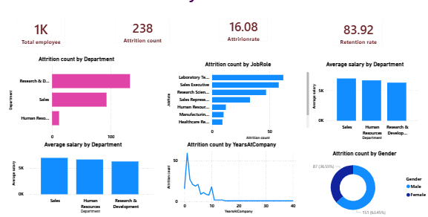
1. Attrition Count by Department
Insight
The Research & Development department shows the highest employee attrition.
The Sales department also experiences considerable attrition.
The Human Resources department has the lowest attrition count.
Business Interpretation
High attrition in R&D and Sales may affect productivity and organizational performance.
HR management should focus on employee retention strategies in these departments.
2. Attrition Count by Job Role
Insight
Laboratory Technicians show the highest attrition among job roles.
Sales Executives and Research Scientists also experience higher turnover.
Manufacturing and Healthcare Representative roles have comparatively lower attrition.
Business Interpretation
Technical and sales-related roles may face higher workload or pressure.
Organizations may need better engagement and career development programs for these employees.
3. Average Salary by Department
Insight
The Sales department has the highest average salary.
Human Resources and Research & Development departments have slightly lower average salaries.
Business Interpretation
Salary differences across departments may influence employee satisfaction and retention.
Compensation policies should be reviewed to ensure fairness and motivation.
4. Attrition Count by Years at Company
Insight
Attrition is highest during the early years of employment.
Employee exits decrease significantly as years at company increase.
Business Interpretation
New employees are more likely to leave the organization.
The company should improve onboarding, training, and employee engagement for newly hired staff.
5. Attrition Count by Gender
Insight
Male employees show slightly higher attrition compared to female employees.
Attrition exists across both genders but is more concentrated among male employees.
Business Interpretation
HR teams may analyze workload, work-life balance, and departmental distribution to understand gender-based attrition differences.

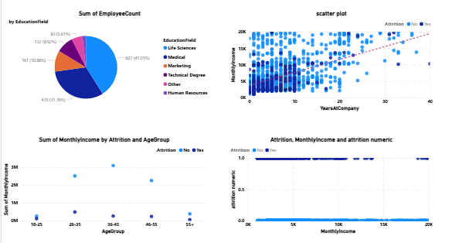
1. Sum of EmployeeCount by EducationField (Pie Chart)
The largest segment is light blue (Life Sciences), followed by dark blue (likely Engineering or Technical fields), with smaller portions in orange (Marketing), purple/magenta (possibly Technical Degree), and other categories. Life Sciences dominates the employee headcount.
2. Scatter Plot (Top Right)
Shows the relationship between Years at Company (x-axis) and what appears to be Monthly Income (y-axis). The dense clustering of blue dots suggests:
Most employees cluster in the lower-to-middle income range
Income generally increases with tenure, though there's significant variation
Some outliers earn substantially more despite similar tenure
The trend line shows a positive correlation between time at company and compensation
3. Sum of MonthlyIncome by Attrition and AgeGroup (Bottom Left)
Compares income levels across age groups (18-25, 26-35, 45-55, 55+), split by attrition status (Yes/No):
Income increases with age (older employees earn more)
The 55+ age group shows notably higher income
Attrition appears relatively consistent across age groups
4. Attrition, MonthlyIncome and Attrition Numeric (Bottom Right)
A trend analysis showing:
Attrition status (Yes/No) compared against monthly income
Both groups show similar income distributions with minimal difference
Suggests attrition is not strongly driven by salary alone
Key Insight: Employee retention may need attention beyond compensation, as attrition occurs across all income levels.
8.Key Insights
Total Employees: Approximately 1,000
Attrition Rate: 16.08%
Retention Rate: 83.92%
Research & Development department shows the highest attrition.
Laboratory Technicians and Sales Executives experience maximum employee turnover.
Employees with lower years at the company are more likely to leave.
Male employees show slightly higher attrition compared to female employees.
Salary increases with employee experience.
Early-stage employees require better engagement and retention strategies.
9.Business Recommendation
The organization should focus on:
Improving employee engagement programs
Strengthening onboarding processes
Providing career growth opportunities
Enhancing work-life balance
Monitoring high-attrition departments regularly
These strategies can help reduce employee turnover and improve long-term workforce stability.
10.Conclusion
The HR Analytics Dashboard provides valuable insights into employee attrition, workforce distribution, salary trends, and employee behavior within the organization. The analysis reveals that employee attrition is mainly concentrated in the Research & Development and Sales departments, particularly among Laboratory Technicians and Sales Executives.
The dashboard also indicates that employees with fewer years at the company are more likely to leave, highlighting the importance of effective onboarding, employee engagement, and retention strategies for newly hired employees. Salary and experience show a positive relationship, while lower satisfaction and workload-related factors may contribute to higher attrition.
Overall, the dashboard helps HR teams identify critical workforce challenges and supports data-driven decision-making to improve employee retention, employee satisfaction, and organizational performance.

