Title:Bank Loan Analysis Dashboard using Power BI
Name:Jayshree Manohar Shinde
SYNTEXHUB INTERN
1. Introduction
The banking sector handles large amounts of loan-related data every day. Analyzing this data helps financial institutions understand customer behavior, loan risks, repayment patterns, and approval factors. This project focuses on analyzing bank loan data using Power BI to generate meaningful insights and interactive visualizations.
The dashboard helps identify:
Good and bad loans
Customer financial behavior
Factors affecting repayment
Loan distribution patterns
Credit risk indicators
The project demonstrates the use of:
Data cleaning
Data visualization
KPI analysis
Trend analysis
Business intelligence techniques
2. Objectives of the Project
The main objectives of this project are:
To analyze bank loan data effectively.
To classify good and bad loans.
To identify factors affecting loan approval and repayment.
To perform trend analysis using customer and financial data.
To create an interactive Power BI dashboard.
To generate business insights for decision-making.
3. Tools and Technologies Used
Tool Purpose
Power BI Dashboard creation and visualization
Excel/CSV Dataset Data source
DAX KPI calculations
Power Query Data cleaning and preprocessing
4. Dataset Description
The dataset contains customer and loan-related information used for loan analysis.
Important Columns Used
Column Name
Description
credit_score
Customer credit score
loan_amnt
Loan amount
loan_int_rate
Loan interest rate
loan_status
Good or bad loan
loan_intent
Purpose of loan
person_income
Customer income
person_age
Customer age
person_gender
Gender
person_education
Educational qualification
person_emp_exp
Employment experience
person_home_ownership
Home ownership status
5. Dashboard Visualizations
The dashboard includes multiple interactive visualizations.
5. 1KPI Cards
The following KPI cards were created:
Total Applications
Total Loan Amount
Average Loan Amount
Average Interest Rate
Good Loans
Bad Loans
These KPIs provide a quick overview of loan performance.
5.2 GRAPHS
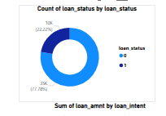

Good vs Bad Loans (Donut Chart)
Insight
1.The majority of loans are classified as bad loans.
2.Only a smaller percentage represents good repayment behavior.
3.Loan default risk is relatively high in the dataset.
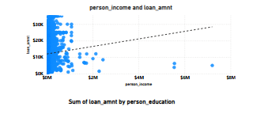

Income vs Loan Amount (Scatter Plot)
Insight
1.Customers with higher income generally receive larger loan amounts.
2.Most customers are concentrated in lower-to-medium income ranges.
3.The trend line shows a positive relationship between income and loan amount.
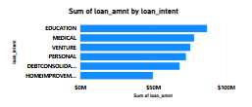
Loan Amount by Loan Intent (Bar Chart)
Insight
Education loans have the highest loan amount.
Medical and venture-related loans also contribute significantly.
Personal and home improvement loans are comparatively lower.
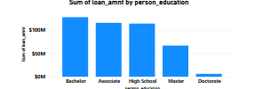

Loan Amount by Education (Column Chart)
Insight
Customers with Bachelor’s and Associate education levels receive the highest loan amounts.
Doctorate holders represent the lowest loan distribution.
Educational background influences loan demand and approval.
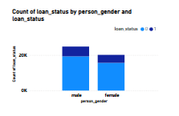

. Loan Status by Gender
Insight
Male customers contribute more loan applications than female customers.
Both genders contain good and bad loans, but bad loans dominate overall.
Gender-based repayment patterns can be analyzed further for risk assessment.
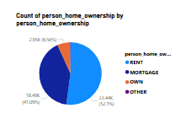

Home Ownership Analysis (Pie Chart)
Insight
Most customers belong to rented or mortgage housing categories.
Customers with owned homes are fewer but may indicate stronger financial security.
Home ownership status can influence loan repayment capability.

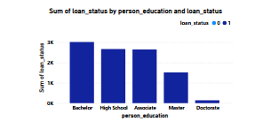

Education vs Loan Status
Insight
Bachelor and High School education groups contain the largest number of loans.
Higher education groups appear to have comparatively fewer defaults.
Educational qualification impacts financial stability and repayment behavior.
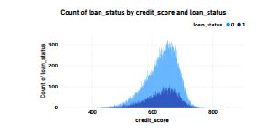
Credit Score vs Loan Status
Insight
Customers with higher credit scores show better loan quality.
Lower credit score ranges are associated with increased bad loans.
Credit score is one of the strongest indicators of repayment behavior and approval risk.
Key Insights
Most loans are classified as good loans.
Customers with high income tend to receive larger loan amounts.
Credit score strongly affects loan quality and repayment behavior.
Educational background influences financial stability.
Home ownership positively impacts repayment capability.
Higher interest rates are associated with higher loan risk.
Loan intent categories such as education and medical purposes have high loan demand.
6.Conclusion
The Bank Loan Analysis Dashboard provides valuable insights into customer financial behavior, loan distribution, repayment trends, and risk factors. The dashboard helps identify important factors affecting loan approval and repayment performance.
Using Power BI visualizations and DAX measures, the project successfully transformed raw loan data into meaningful business intelligence. The analysis can support financial institutions in improving loan decision-making, risk assessment, and customer evaluation processes.
This project demonstrates practical skills in:
Data analysis
Dashboard development
Business intelligence
Data visualization
Financial analytics
7.Future Improvements
Future enhancements may include:
Real-time loan monitoring
Predictive loan default analysis
Machine learning integration
Regional and time-based analysis
Advanced customer segmentation

