FireMeX System Design
Planning week 13 to 19 July 2026
This planning-stage design explains how the proposed FireMeX web application would connect its frontend, Go backend and PostgreSQL database. The frontend would use a REST API to send requests and receive JSON. The Go backend would apply the system rules and read or write database records. The camera and fire detection workflow is shown as a planned extension. These are design proposals, not completed features.

System goal and component roles
FireMeX was planned as a console where an operator could view cameras, review possible fire or smoke incidents and respond to alerts. The proposed design puts all application data behind one Go API so that browser screens would not connect directly to the database.
Component | Planned responsibility | Communication
Frontend | Show screens, collect user input and display returned data. | HTTPS requests to the Go REST API; JSON responses.
Go backend | Authenticate users, validate requests, enforce organization access and manage records. | REST with the frontend; SQL connection to PostgreSQL.
PostgreSQL | Store persistent users, cameras, incidents and alerts. | Private SQL connection from the Go backend only.
Detection service | Analyse a camera image and return a fire or smoke result when added. | Private REST request from Go to a Python service.

Proposed communication map
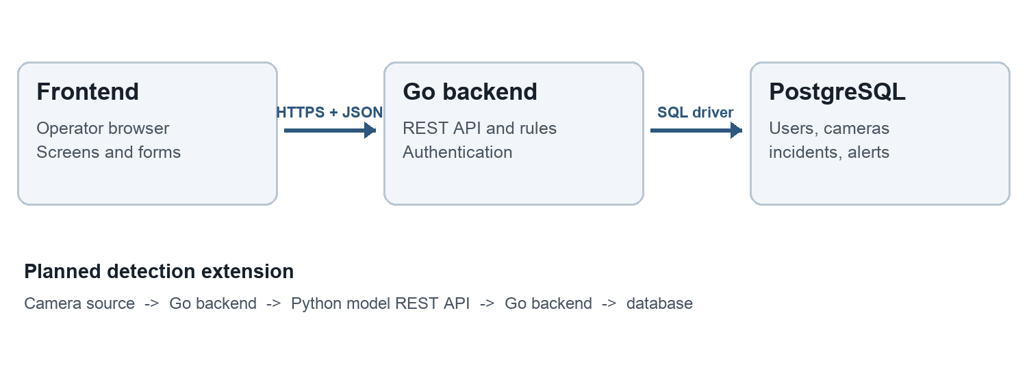
Figure 1 Proposed data paths

How a screen would get data
- The operator opens the Incidents screen. The frontend sends GET /api/incidents with the user token and any filter values.
- The Go API checks the token and organization, validates the filters, then uses parameterized SQL to read matching rows from PostgreSQL.
- The API returns a JSON list and an HTTP status. The frontend turns that data into incident cards or a table, or shows a useful error message.

Planned REST API contract
The following routes are a proposed starting contract. Names and fields could change during implementation, but each route would have a clear request, response and error behavior.
Method and route | Purpose | Expected result
POST /api/auth/login | Check credentials and start an authenticated session. | Token or session details; 401 for invalid credentials.
GET /api/cameras | List cameras available to the organization. | JSON camera list; 401 if not signed in.
POST /api/cameras | Add a camera after validating its details. | Created camera record; 400 for invalid input.
GET /api/incidents | List incidents, with optional camera and status filters. | JSON incident list; 400 for invalid filters.
PATCH /api/incidents/{id}/status | Record an authorized response or status change. | Updated incident; 403 if the user lacks permission.

Example of one request
A planned incident list request could be GET /api/incidents?status=open with Authorization: Bearer <token>. The API would respond with application/json and an object such as {"incidents":[{"id":42,"camera_id":7,"type":"smoke","status":"open"}]}. The exact field names were to be finalized when the frontend and backend were built.

Database connection and draft records
The Go backend would hold the database connection details in environment variables and use a PostgreSQL driver to run SQL. The browser would never receive database credentials. Records would be related by IDs so the API could load an incident together with its camera and organization.
Draft record | Key data to store | Relationship
Organization | Name and identifier. | Owns users, cameras and incidents.
User | Organization, role, password hash. | Belongs to one organization.
Camera | Organization, name, source reference, location. | Belongs to one organization.
Incident | Organization, camera, hazard type, time, status, evidence reference. | Belongs to a camera and organization.
Alert | Incident, state and created time. | Refers to one incident.

Planned detection extension
For an AI detection feature, the backend would obtain a camera image through the chosen camera integration and send that image to a private Python model endpoint, such as POST /detect. Python would return a small JSON result containing the detected hazard and confidence. Go would decide whether the result met the alert rule, save the incident and evidence reference, and make the new incident available through the normal API. The image capture interval, confidence threshold and evidence storage location remained design choices to confirm during implementation.

Security and failure handling
- Use HTTPS for browser requests and keep database and model endpoints on a private network. Store passwords as hashes and secrets outside the source code.
- Check the user role and organization on every protected API request. The backend must filter records by organization, not trust an organization ID sent by the browser.
- Return standard HTTP status codes: 400 for invalid input, 401 for missing authentication, 403 for insufficient access, 404 for a missing record and 500 for an unexpected server error.
- If the database or model service is unavailable, log the failure, return a clear error and avoid showing an incident as saved unless the database write succeeds.

Checks planned before implementation
The design would be validated with a small end to end path: sign in, add a camera, read the camera list, create a test incident through the backend, and load it in the frontend. API tests would check both successful responses and invalid or unauthorized requests. Database checks would confirm that one organization cannot read another organization’s records. The camera and Python model link would be tested separately once the basic REST and database path worked.

