Assignment - 2
Create a Cloud SQL database (PostgreSql) from the GCP Console
Step 1:Click on SQL option.
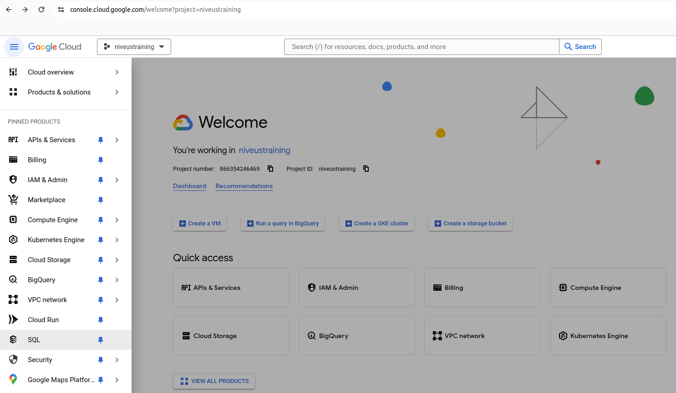
Step 2: Click on create instance and then select PostgreSQL
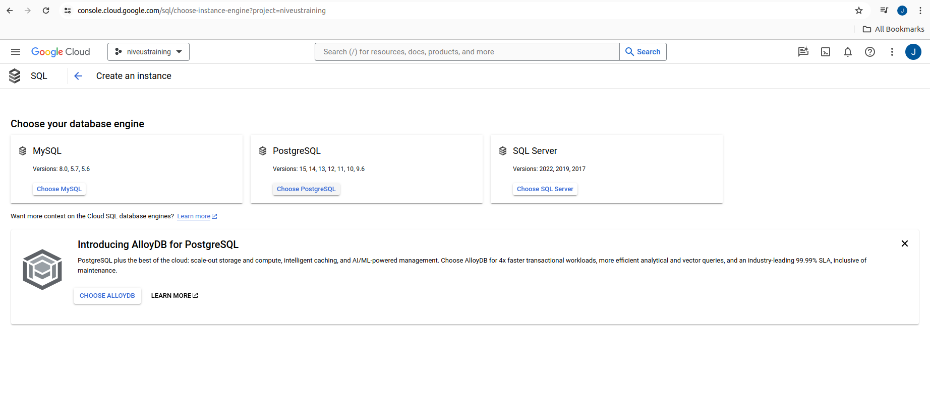
Step 3: provide required information and create
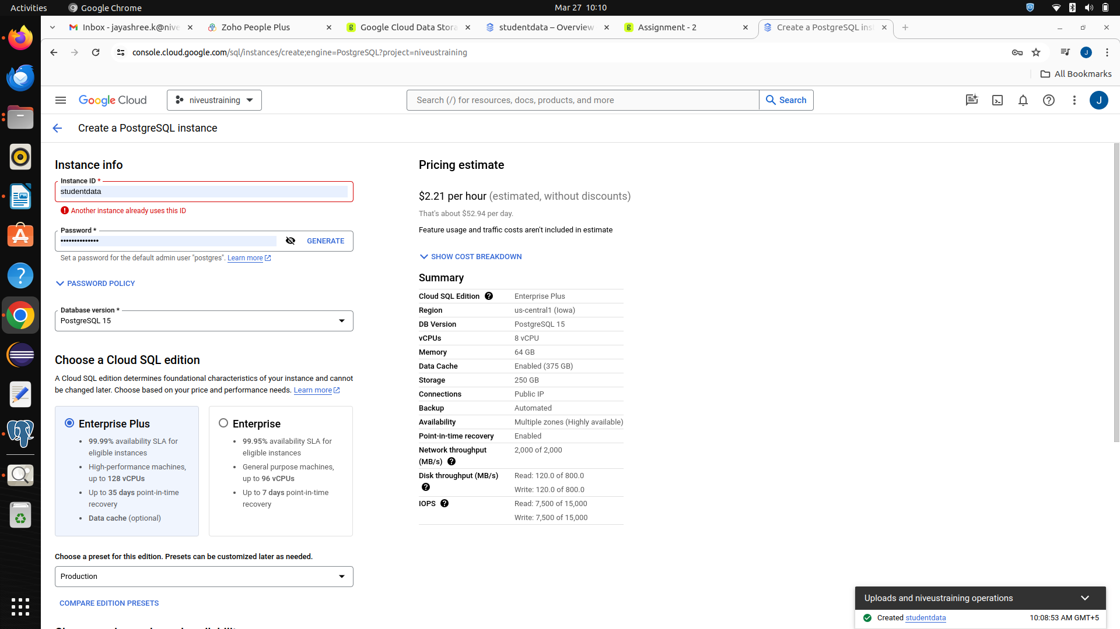
Step 4: Add a connection with your ip address , click on done and then save.
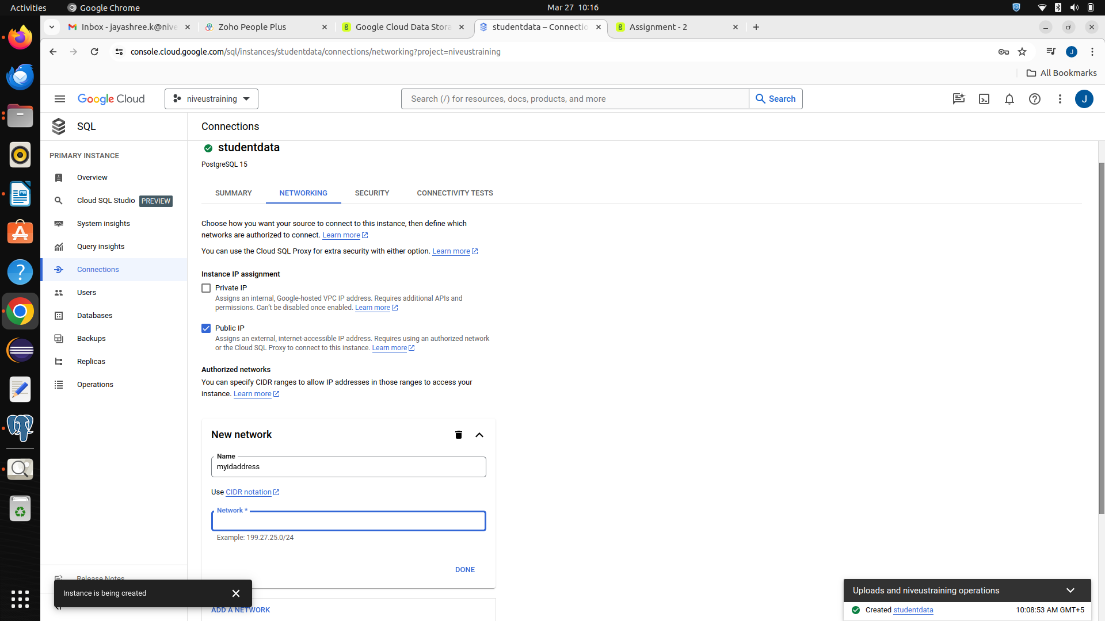

Step 5: Open pgAdmin and register the server with ip of your created instance from GCP
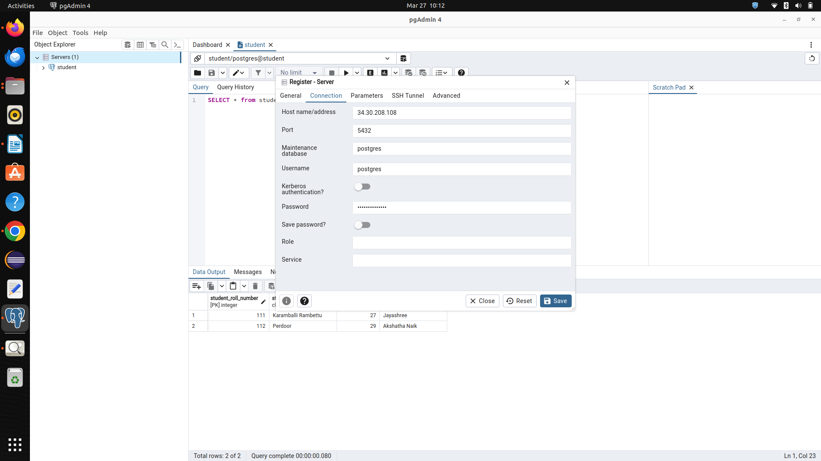
Step 6: Create the Database and add table and create table by using Query Tool.
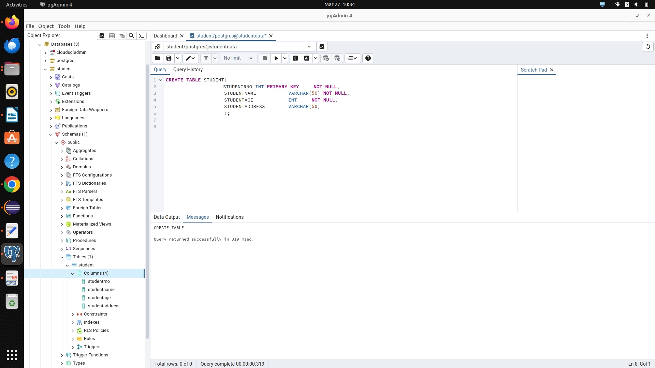
Step 7: Insert data into the table by writing an insert statement.
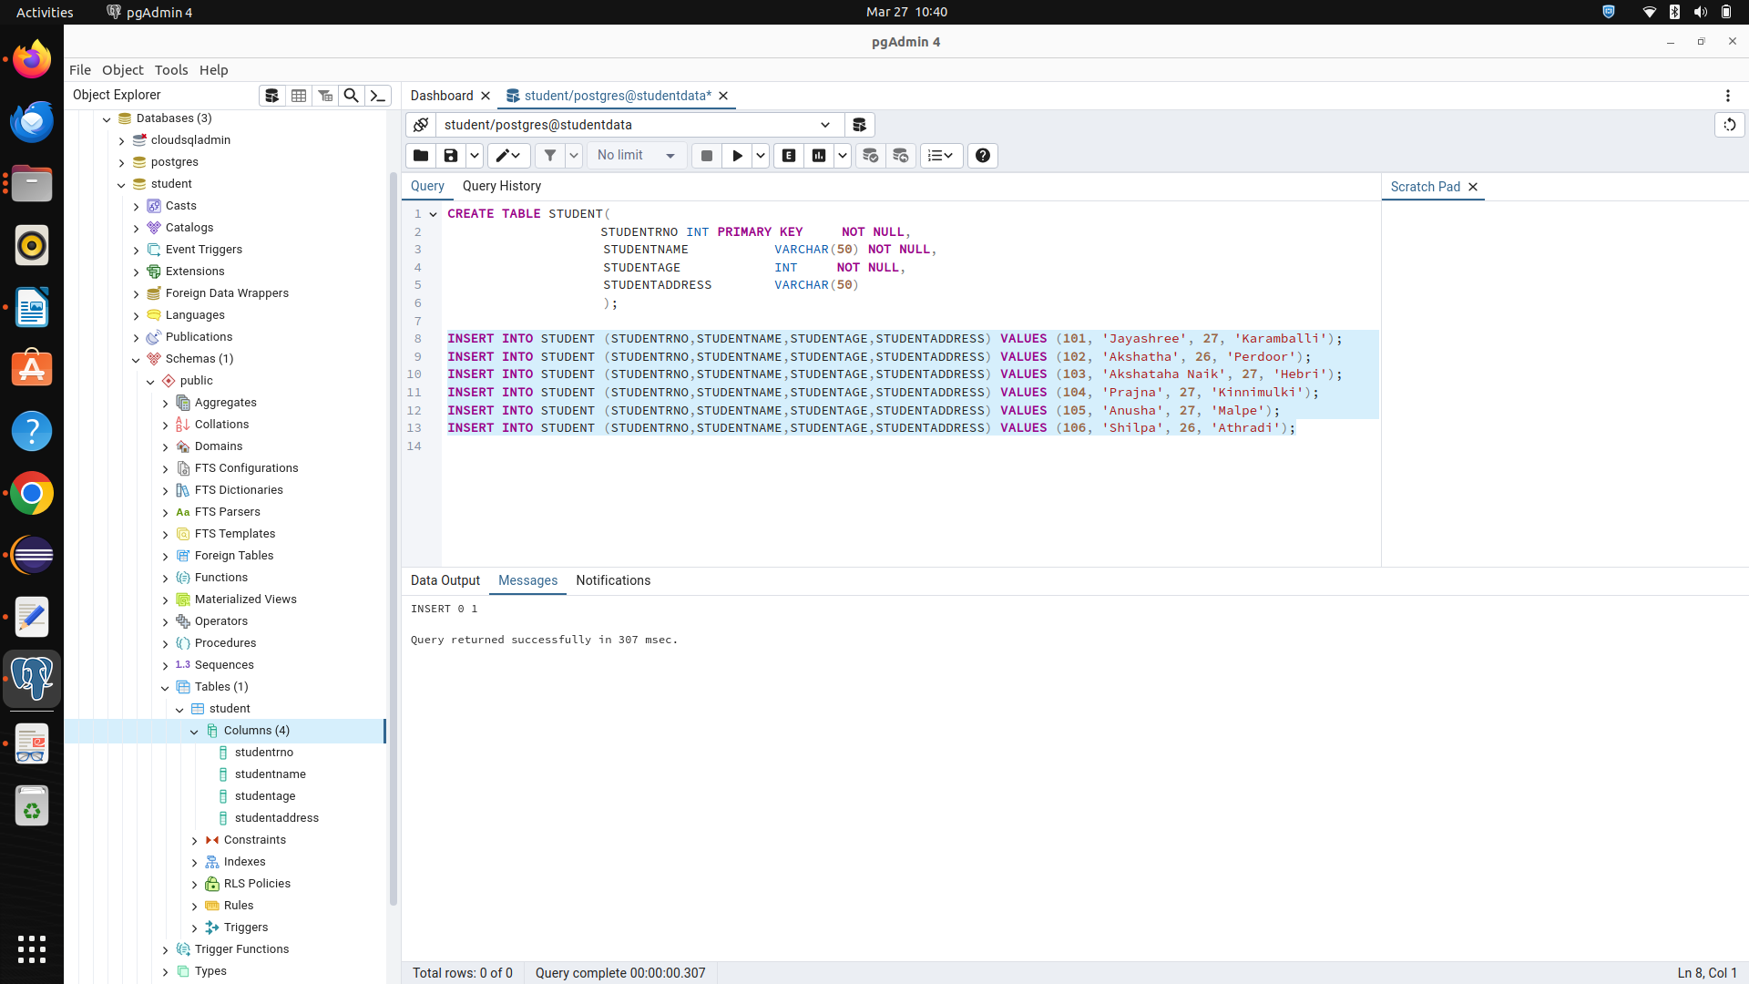

Step 8: Execute INSERT, UPDATE, SELECT and DELETE commands.
