Placement Skewness and

Kurtosis Report

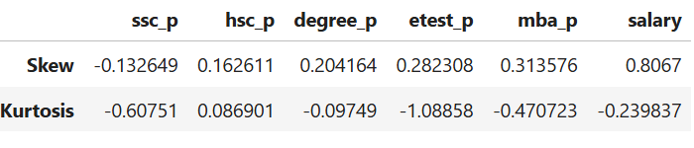
Skewness
S.No | Variable | Skewness | Type
1 | ssc_p | -0.132649 | Approximately symmetric with slight negative skew
2 | hsc_p | 0.162611 | Approximately symmetric with slight positive skew
3 | degree_p | 0.204164 | Approximately symmetric
4 | etest_p | 0.282308 | Mild positive skewness
5 | mba_p | 0.313576 | Mild positive skewness
6 | salary | 0.8067 | Moderately positive skewness

Kurtosis
S.No | Variable | Kurtosis | Type
1 | ssc_p | -0.60751 | Platykurtic
2 | hsc_p | 0.086901 | Mesokurtic
3 | degree_p | -0.09749 | Mesokurtic
4 | etest_p | -1.08858 | Platykurtic
5 | mba_p | -0.470723 | Platykurtic
6 | salary | -0.239837 | Platykurtic

