Tera term to Tera term iam using windows non internet pc

Got it — you want Tera Term to Tera Term communication between two Windows PCs without internet, using UART. I’ll give you a clear, practical setup from scratch so you can actually make it work.

🔌 1. What you need
- 2 Windows PCs (no internet needed ✅)
- 2 USB-to-Serial adapters (or built-in COM ports)
- Null modem cable (very important ❗ — normal cable won’t work)
- Tera Term installed on both PCs

🔗 2. Physical Connection
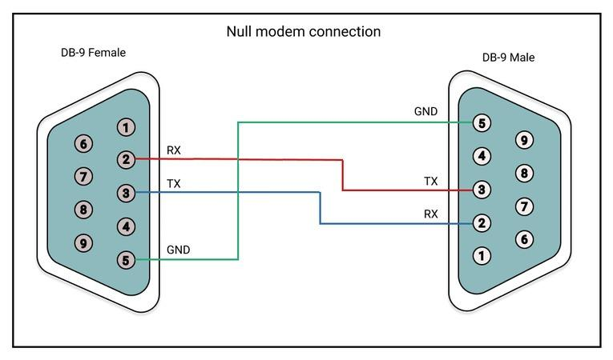
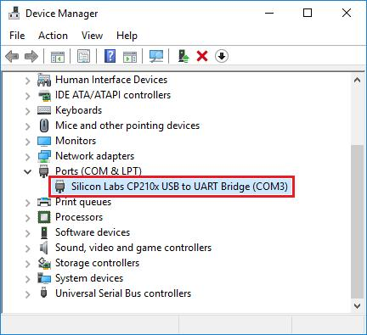
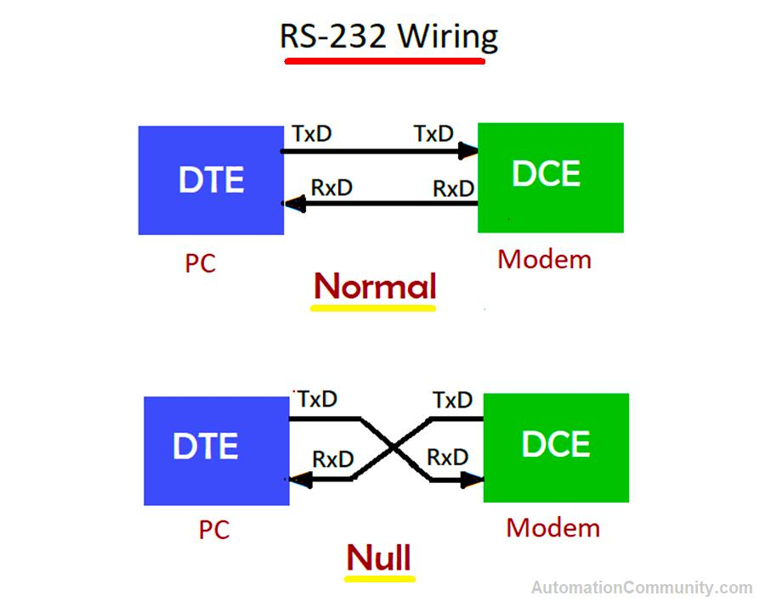
6
- Connect like this:
  - PC1 → USB-to-Serial → Null Modem Cable → USB-to-Serial → PC2
- Why null modem?
  - It cross connects TX ↔ RX, enabling communication

⚙️ 3. Find COM Ports (Both PCs)
- Open Device Manager
- Expand Ports (COM & LPT)
- Note COM numbers
  - Example:
    - PC1 → COM3
    - PC2 → COM4

🖥️ 4. Open Tera Term on both PCs
- Launch Tera Term
- Select:
  - Serial
  - Choose correct COM port

⚙️ 5. Configure Serial Settings (IMPORTANT)
Set same values on both PCs:
- Baud rate: 115200
- Data bits: 8
- Parity: None
- Stop bits: 1
- Flow control: None
👉 Path in Tera Term:
Setup → Serial Port

🔁 6. Enable Local Echo (Optional)
- Go to:
Setup → Terminal → Local echo ON
- This helps you see what you type

💬 7. Test Communication
👉 Now type on PC1
👉 You should see it on PC2 instantly
And vice versa 🎉

⚠️ Common Problems (Most people get stuck here)
1. Nothing is showing
- Wrong cable (must be null modem ❗)
- COM port mismatch
- Baud rate mismatch
2. Garbage characters
- Different baud rates
- Wrong parity or stop bits
3. Port not opening
- Another app using COM port (close PuTTY, Arduino IDE, etc.)

🔥 Pro Tip (for your UART voice project)
Once this works, you can:
- Replace manual typing with your C++ program output
- Use same COM port settings in code
- Send encoded audio data through UART

🎯 If you want next step
I can give you:
- Full C++ UART send/receive code (Windows COM port)
- Or your voice over UART (mic + headphones setup)
- Or even a diagram + viva explanation
Just tell me 👍

How to send and receive any files using tera term

You can send files between two PCs using Tera Term over your UART connection — but here’s the reality first:
👉 It’s not like Bluetooth or USB file copy
👉 You must use file transfer protocols (XMODEM / YMODEM / ZMODEM)
👉 Both sides must coordinate (one sends, one receives)

📁 Method 1: Using XMODEM (Simple & Works Offline)
🔄 Steps (PC → PC transfer)
🟢 On RECEIVER PC (very important: start here)
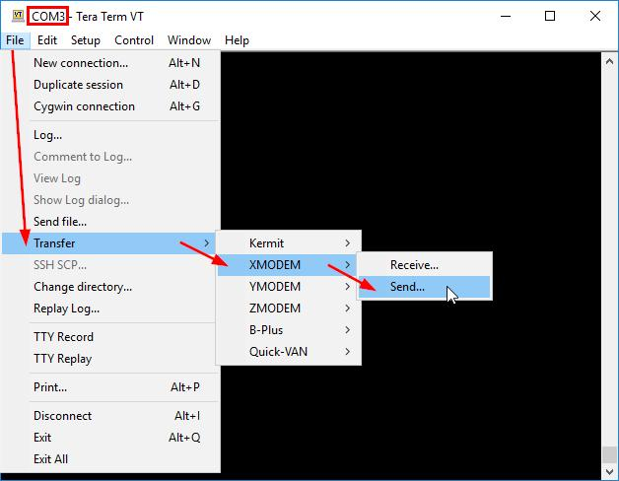
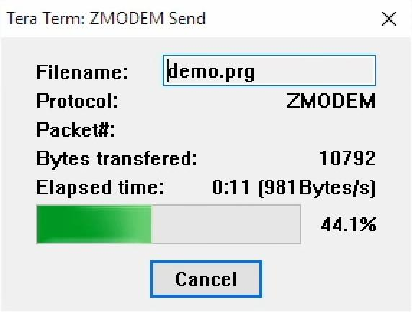
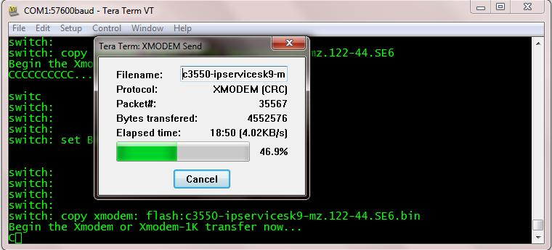
5
- Open Tera Term
- Go to:
File → Transfer → XMODEM → Receive
- Choose:
  - File name (where to save)
  - Click Open
- Now it is waiting for sender

🔵 On SENDER PC


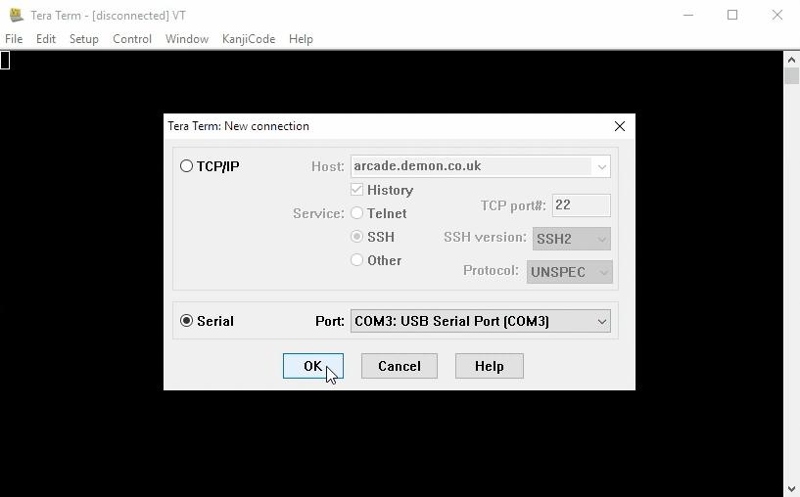
5
- Go to:
File → Transfer → XMODEM → Send
- Select your file
- Click Open / Send

🎉 Done!
- File will transfer over UART
- You’ll see progress bar

⚡ Method 2: YMODEM (Better for bigger files)
Same steps, just choose:
File → Transfer → YMODEM → Send/Receive
👉 Advantages:
- Faster than XMODEM
- Supports batch files

🚀 Method 3: ZMODEM (Best, but limited support)
File → Transfer → ZMODEM
👉 Faster + auto resume
👉 But sometimes not enabled depending on setup

⚙️ IMPORTANT SETTINGS (Must match both PCs)
- Baud rate: 115200 (or higher if stable)
- Data: 8N1
- Flow control: None

⚠️ Common Issues (and fixes)
❌ Transfer not starting
- Receiver didn’t start first
✔ Always start Receive first

❌ Transfer very slow
- XMODEM is slow by nature
✔ Use YMODEM

❌ File corrupted
- Baud mismatch
- Noise in cable
✔ Reduce speed (9600 / 57600)

❌ Nothing happens
- Wrong cable (must be null modem)
- COM port wrong

🔥 Pro Insight (for your project)
Since you're doing UART + voice/data project, this teaches you:
- How raw data packets move
- How error checking works
- Base for your own protocol in C++

If you want next level:
- I can show how to send files using your own C++ code (no XMODEM)
- Or build a mini file transfer app over UART like WhatsApp but serial 😄
Just tell me 👍

After this without using tera term i need to send and receive using simple socket python program using uart

You can’t use a socket program directly over UART the way you do with TCP/IP. Sockets belong to networking (IP stack), while UART is just a raw byte stream.
👉 So the correct approach is:
- Use pyserial for UART
- Then build your own “socket-like” send/receive protocol on top of it
Think of it like:
UART = pipe → you design rules → behaves like sockets

🧠 How your setup will work
PC1 (Python Sender) ←UART→ PC2 (Python Receiver)
- No internet needed ✅
- Works exactly like Tera Term file transfer, but controlled by Python

⚙️ 1. Install library (both PCs)
(If no internet → copy wheel file manually)
pip install pyserial

📤 2. Sender Code (Python – send file via UART)
import serial import time import os ser = serial.Serial('COM3', 115200, timeout=1) filename = "test.txt" # Send file name first ser.write((filename + "\n").encode()) time.sleep(1) # Send file size filesize = os.path.getsize(filename) ser.write((str(filesize) + "\n").encode()) time.sleep(1) # Send file data with open(filename, "rb") as f: while True: data = f.read(1024) if not data: break ser.write(data) print("File sent successfully") ser.close()

📥 3. Receiver Code (Python – receive file)
import serial ser = serial.Serial('COM4', 115200, timeout=1) # Receive filename filename = ser.readline().decode().strip() # Receive filesize filesize = int(ser.readline().decode().strip()) with open("received_" + filename, "wb") as f: received = 0 while received < filesize: data = ser.read(1024) if data: f.write(data) received += len(data) print("File received successfully") ser.close()

🔁 4. How to run
- Connect PCs via null modem cable
- Match settings:
  - Baud: 115200
  - Same COM ports as before
- Run:
  - First → Receiver script
  - Then → Sender script

⚠️ Important limitations (don’t ignore)
❌ Not a real socket
- No built-in:
  - Retransmission
  - Error correction
  - Packet ordering
❌ Risk of corruption
UART is not reliable like TCP

🔥 Upgrade it (make it “socket-like”)
If you want next-level (good for interview 🔥):
Add:
- ACK/NACK system
- Packet numbering
- Checksum (CRC)
Then it becomes:
👉 “Custom transport protocol over UART”

🎯 Interview explanation (use this line)
“Sockets require an IP stack, so over UART I used PySerial and implemented a custom file transfer protocol with framing, metadata, and streaming to simulate socket-like communication.”

🚀 If you want next step
I can help you build:
- ✅ Full reliable UART protocol (like TCP mini version)
- ✅ Voice + file transfer combo system
- ✅ Diagram + viva explanation (very useful for interviews)
Just tell me 👍

1st and 2nd point

Got it — you want both upgrades:
1️⃣ ACK/NACK system
2️⃣ Packet numbering (sequence control)
This is exactly how you turn your UART program into a mini TCP-like reliable system 🔥

🧠 Concept (Simple Understanding)
Instead of sending raw data, we send:
[SEQ][DATA][CHECKSUM]
- SEQ → packet number
- DATA → actual bytes
- CHECKSUM → detect errors
Receiver will:
- Verify checksum
- Send back:
  - ACK ✅ (correct)
  - NACK ❌ (wrong → resend)

📤 Sender Code (with ACK + Sequence)
import serial import time ser = serial.Serial('COM3', 115200, timeout=1) filename = "test.txt" # Send filename ser.write((filename + "\n").encode()) time.sleep(1) seq = 0 with open(filename, "rb") as f: while True: data = f.read(64) if not data: break checksum = sum(data) % 256 packet = bytes([seq]) + data + bytes([checksum]) while True: ser.write(packet) ack = ser.read(3) if ack == b'ACK': print(f"Packet {seq} ACK") seq = (seq + 1) % 256 break else: print(f"Resending packet {seq}") ser.write(b'EOF') print("File sent successfully") ser.close()

📥 Receiver Code (with ACK + Validation)
import serial ser = serial.Serial('COM4', 115200, timeout=1) filename = ser.readline().decode().strip() with open("received_" + filename, "wb") as f: expected_seq = 0 while True: packet = ser.read(66) # 1(seq)+64(data)+1(checksum) if packet == b'EOF': break if len(packet) < 2: continue seq = packet[0] data = packet[1:-1] checksum = packet[-1] calc_checksum = sum(data) % 256 if seq == expected_seq and checksum == calc_checksum: f.write(data) ser.write(b'ACK') print(f"Received packet {seq}") expected_seq = (expected_seq + 1) % 256 else: ser.write(b'NACK') print(f"Error in packet {seq}") print("File received successfully") ser.close()

🔁 How it works (flow)
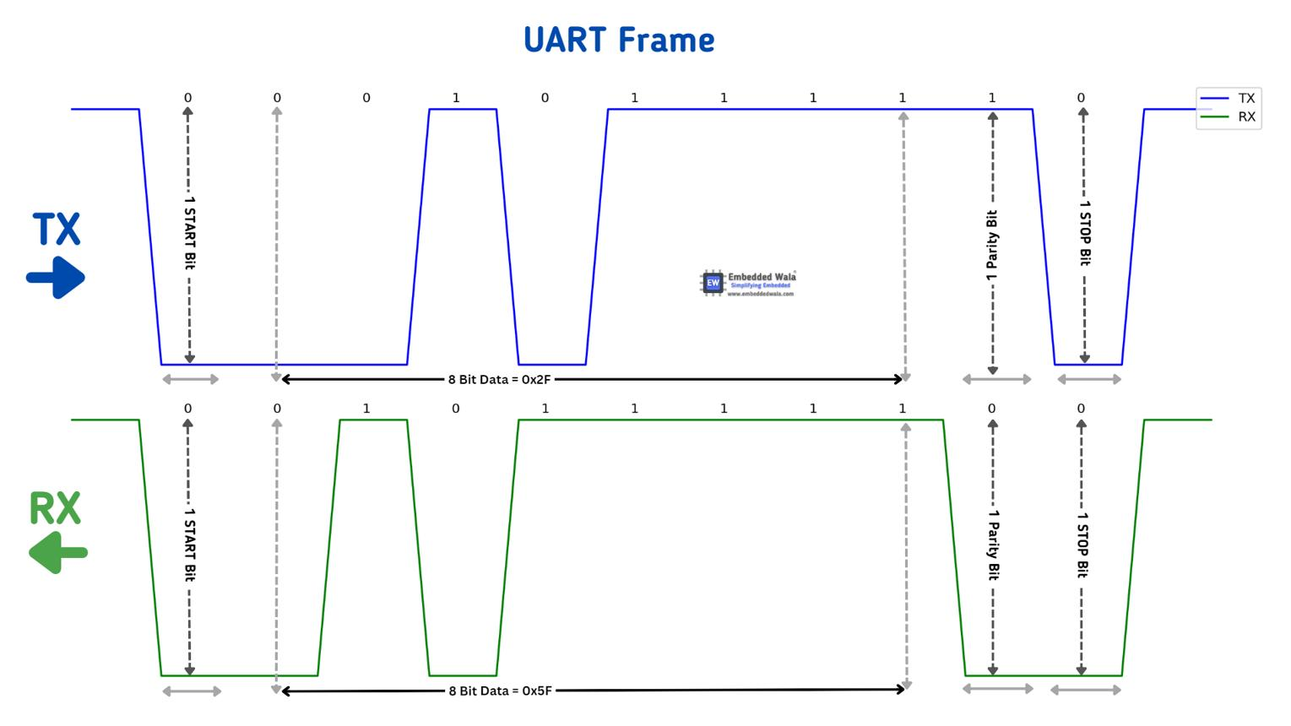
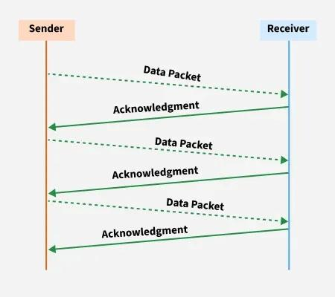
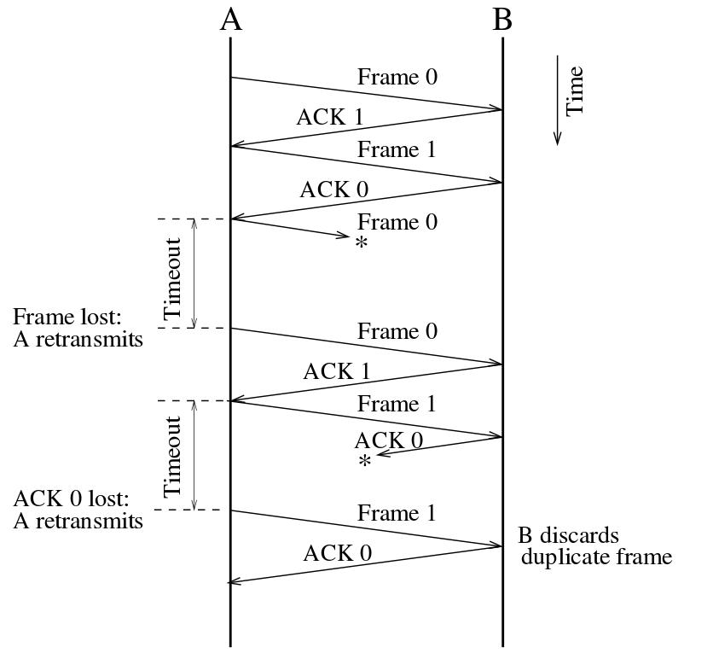
6
- Sender sends packet (SEQ 0)
- Receiver checks:
  - If correct → sends ACK
  - If wrong → sends NACK
- Sender:
  - ACK → next packet
  - NACK → resend same packet
👉 This is called Stop-and-Wait Protocol

⚠️ Important Improvements (optional but powerful)
🔹 Add timeout handling
If no ACK:
ser.timeout = 2

🔹 Add packet size control
- Use smaller chunks (32–128 bytes) for stability

🔹 Add start/end markers
Instead of raw packet:
[START][SEQ][DATA][CHECKSUM][END]

🎯 Interview Gold Line
“I implemented a reliable UART protocol using Stop-and-Wait with sequence numbers, checksum validation, and ACK/NACK retransmission to ensure data integrity without TCP.”

🚀 If you want next level
I can extend this into:
- Sliding window protocol (faster than stop-and-wait)
- Full voice + file hybrid system
- GUI file transfer app (like mini AirDrop over UART 😄)
Just tell me 👍

Where can I find pyserial for uart and how can I build my own socket -like send/receive protocol

You’re on the right track — this is exactly how people move from “using tools” to building their own communication system.
Let’s split it cleanly:

📦 1️⃣ Where to get PySerial (offline + online)
🔹 What it is
pyserial is the standard Python library to access UART/COM ports.

✅ Option A — If you have internet (quick)
pip install pyserial

✅ Option B — No internet (your case)
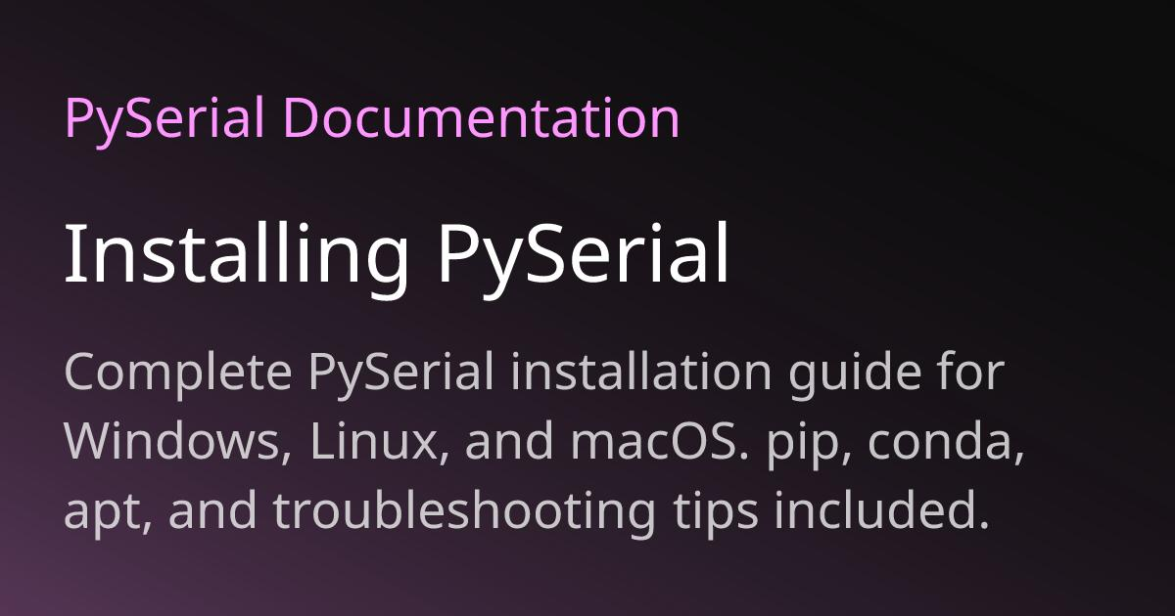
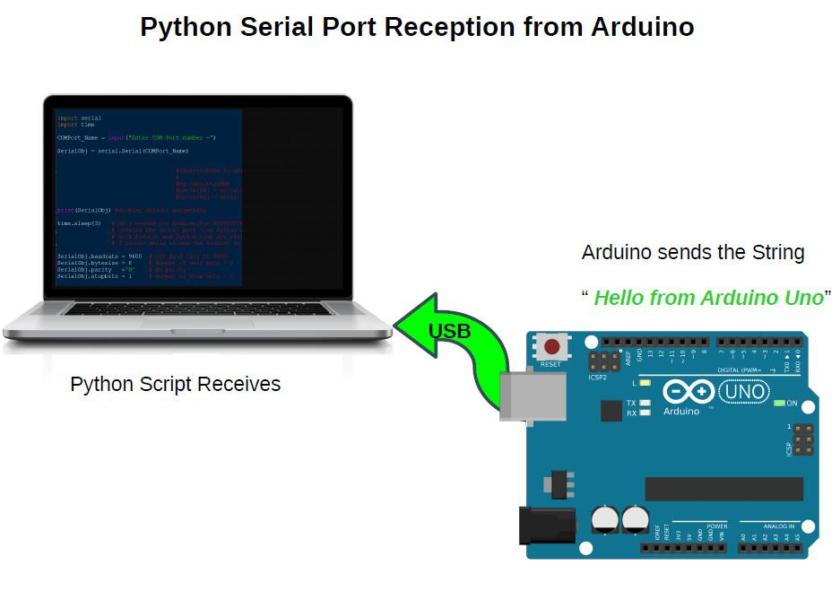
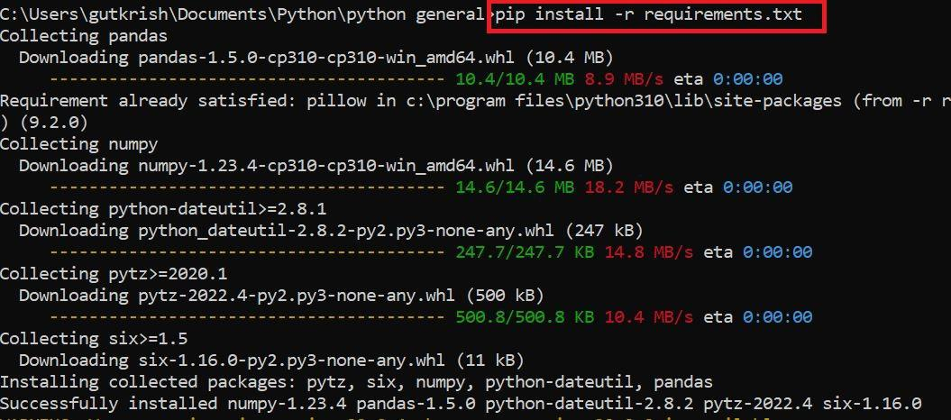
6
Steps:
- On another PC (with internet):
  - Go to:
👉 https://pypi.org/project/pyserial/#files
  - Download .whl file (example):
  - pyserial-3.5-py2.py3-none-any.whl
- Copy it using USB → to your offline PC
- Install:
pip install pyserial-3.5-py2.py3-none-any.whl

🔍 Verify installation
python -c "import serial; print('OK')"

🧠 2️⃣ How to build your own “socket-like” protocol
Let’s be honest:
👉 UART ≠ sockets
👉 You are basically creating your own TCP

🧱 Step-by-step architecture
🔹 Layer idea (like real networking)
Application Layer → Your File/Voice App Transport Layer → Your Protocol (ACK, SEQ, etc.) Physical Layer → UART (PySerial)

🔹 Core features you MUST build
1. Framing (start/end of packet)
<START> | SEQ | LENGTH | DATA | CHECKSUM | <END>
Example:
b'\x02' + seq + length + data + checksum + b'\x03'

2. Packet Numbering (SEQ)
- Prevent duplicate packets
- Maintain order

3. ACK / NACK system
- Receiver → sends ACK or NACK
- Sender → resend if needed

4. Checksum (error detection)
checksum = sum(data) % 256

5. Timeout + Retransmission
- If no ACK → resend

🔄 3️⃣ Full Communication Flow
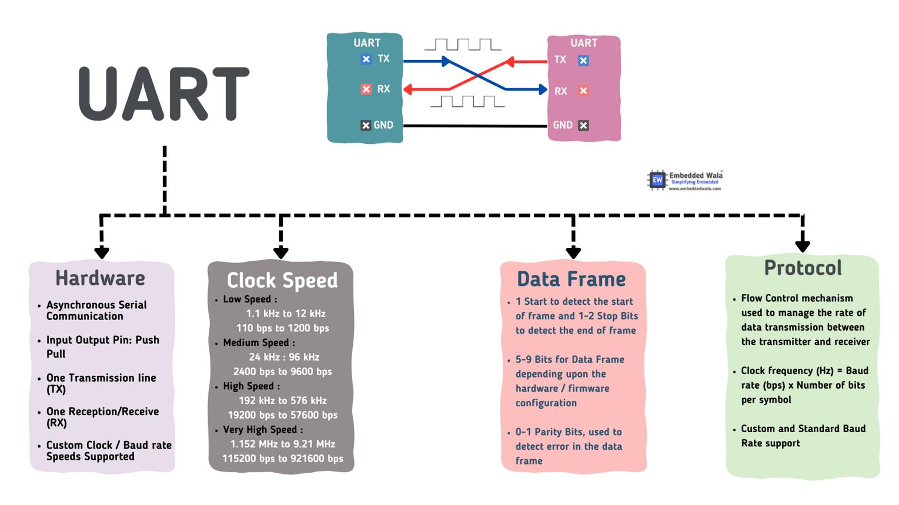
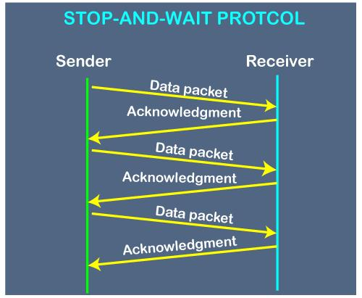
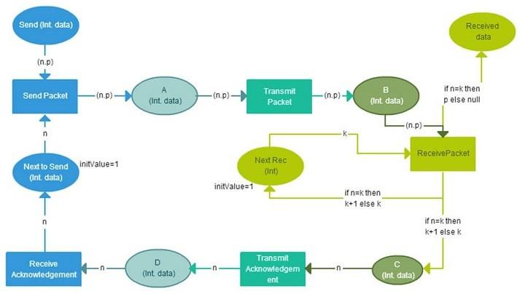
6
Sender:
- Break file → chunks
- Add header (SEQ, checksum)
- Send packet
- Wait for ACK
- Retry if needed

Receiver:
- Detect START/END
- Extract packet
- Validate checksum
- Send ACK/NACK
- Store data

🧪 4️⃣ Minimal “Socket-like” Example Design
Instead of:
socket.send(data)
You build:
send_packet(data) wait_for_ack()

🔥 5️⃣ Real-world naming (for interviews)
What you’re building is:
- Stop-and-Wait ARQ Protocol
- Custom Transport Layer over UART

🎯 Strong interview line
“Since UART doesn’t support sockets, I implemented a custom transport protocol using PySerial with framing, sequencing, checksum validation, and ACK/NACK retransmission to ensure reliable communication.”

⚠️ Common mistakes (avoid these)
- ❌ No framing → data mixing
- ❌ Large packets → data loss
- ❌ No timeout → program hangs
- ❌ No checksum → corrupted files

🚀 If you want next level (recommended)
I can give you:
- ✅ Full modular protocol code (clean + professional)
- ✅ Sliding window (faster than stop-and-wait)
- ✅ Voice + file transfer combined system
- ✅ Block diagram + viva explanation (super helpful)
Just tell me 👍

Any videos regarding this

Here are some good, relevant YouTube videos that will help you understand exactly what you’re doing (PySerial + UART + building your own protocol).

🎥 1️⃣ Beginner – PySerial Basics (MUST WATCH FIRST)
👉 What you’ll learn:
- How to open COM port in Python
- Send & receive data using UART
- Basic setup (exactly like your project)
This is your foundation video.

🎥 2️⃣ PySerial Setup + Working Example
👉 Why this is useful:
- Quick understanding of functions
- read(), write(), timeouts
- Clean explanation (no confusion)

🎥 3️⃣ Practical Serial Communication (Real Hardware)
👉 Even though it uses Arduino:
- Concept is SAME as PC ↔ PC UART
- Shows real data flow
- Helps you visualize communication

🎥 4️⃣ Another Simple COM Port Example
👉 Focus:
- COM port configuration
- Serial parameters (baud, parity, etc.)

🧠 How to connect these videos to YOUR goal
After watching:
Step 1 (from videos)
- Learn:
  - serial.Serial()
  - .write()
  - .read()
👉 This is your UART layer

Step 2 (your upgrade)
Add:
- Packet format
- ACK/NACK
- Sequence number
👉 This becomes your socket-like protocol

🔥 Important (don’t skip this insight)
These videos teach:
“How to send data”
But YOU are building:
“How to send data reliably like TCP”
That’s the difference 🔥

🎯 Suggested learning order (perfect flow)
- Video 1 → basics
- Video 2 → functions
- Video 3 → real communication
- Then → implement your protocol (the code I gave earlier)

🚀 If you want next step
I can give you:
- 🎯 Full project-level code (clean + modular like real software)
- 🎯 GUI file transfer app (resume, progress bar)
- 🎯 Viva explanation + diagrams (for interview)
Just tell me 👍

