You can send files between two PCs using Tera Term over your UART connection — but here’s the reality first:
👉 It’s not like Bluetooth or USB file copy
👉 You must use file transfer protocols (XMODEM / YMODEM / ZMODEM)
👉 Both sides must coordinate (one sends, one receives)

📁 Method 1: Using XMODEM (Simple & Works Offline)

🔄 Steps (PC → PC transfer)

🟢 On RECEIVER PC (very important: start here)
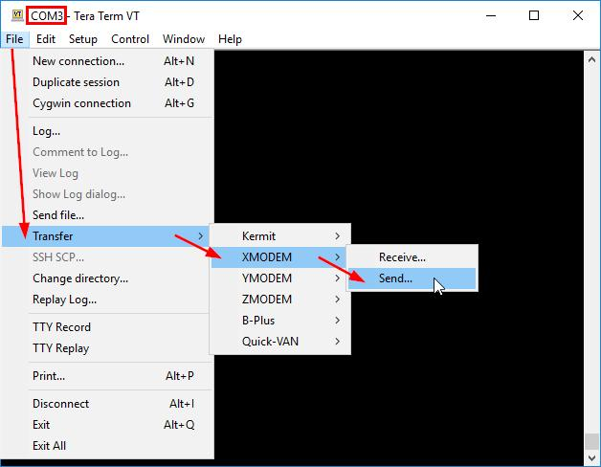
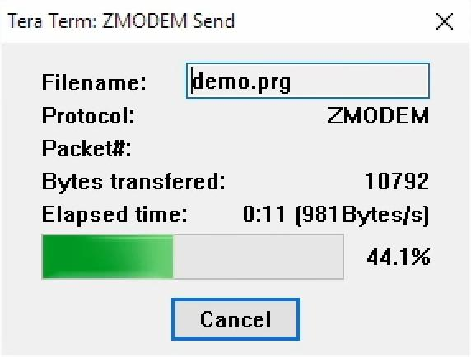
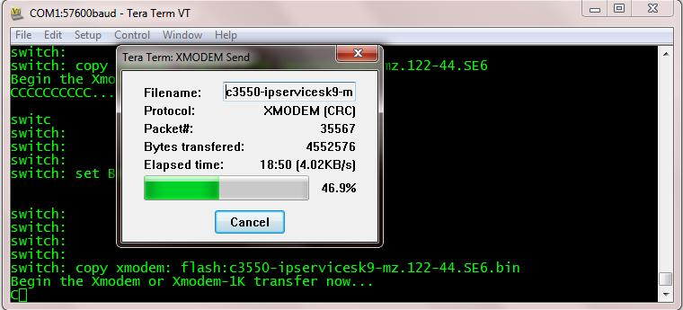
5
- Open Tera Term
- Go to:
File → Transfer → XMODEM → Receive
- Choose: You can send files between two PCs using Tera Term over your UART connection — but here’s the reality first:
- 👉 It’s not like Bluetooth or USB file copy
- 👉 You must use file transfer protocols (XMODEM / YMODEM / ZMODEM)
- 👉 Both sides must coordinate (one sends, one receives)
- ________________________________________
- 📁 Method 1: Using XMODEM (Simple & Works Offline)
- 🔄 Steps (PC → PC transfer)
- 🟢 On RECEIVER PC (very important: start here)

- 5
- Open Tera Term
- Go to:
- File → Transfer → XMODEM → Receive
- Choose:
- File name (where to save)
- Click Open
- Now it is waiting for sender
- ________________________________________
- 🔵 On SENDER PC

- 5
- Go to:
- File → Transfer → XMODEM → Send
- Select your file
- Click Open / Send
- ________________________________________
- 🎉 Done!
- File will transfer over UART
- You’ll see progress bar
- ________________________________________
- ⚡ Method 2: YMODEM (Better for bigger files)
- Same steps, just choose:
- File → Transfer → YMODEM → Send/Receive
- 👉 Advantages:
- Faster than XMODEM
- Supports batch files
- ________________________________________
- 🚀 Method 3: ZMODEM (Best, but limited support)
- File → Transfer → ZMODEM
- 👉 Faster + auto resume
- 👉 But sometimes not enabled depending on setup
- ________________________________________
- ⚙️ IMPORTANT SETTINGS (Must match both PCs)
- Baud rate: 115200 (or higher if stable)
- Data: 8N1
- Flow control: None
- ________________________________________
- ⚠️ Common Issues (and fixes)
- ❌ Transfer not starting
- Receiver didn’t start first
- ✔ Always start Receive first
- ________________________________________
- ❌ Transfer very slow
- XMODEM is slow by nature
- ✔ Use YMODEM
- ________________________________________
- ❌ File corrupted
- Baud mismatch
- Noise in cable
- ✔ Reduce speed (9600 / 57600)
- ________________________________________
- ❌ Nothing happens
- Wrong cable (must be null modem)
- COM port wrong
- ________________________________________
- 🔥 Pro Insight (for your project)
- Since you're doing UART + voice/data project, this teaches you:
- How raw data packets move
- How error checking works
- Base for your own protocol in C++
- ________________________________________
- If you want next level:
- I can show how to send files using your own C++ code (no XMODEM)
- Or build a mini file transfer app over UART like WhatsApp but serial 😄
- Just tell me 👍

  - File name (where to save)
  - Click Open
- Now it is waiting for sender

🔵 On SENDER PC


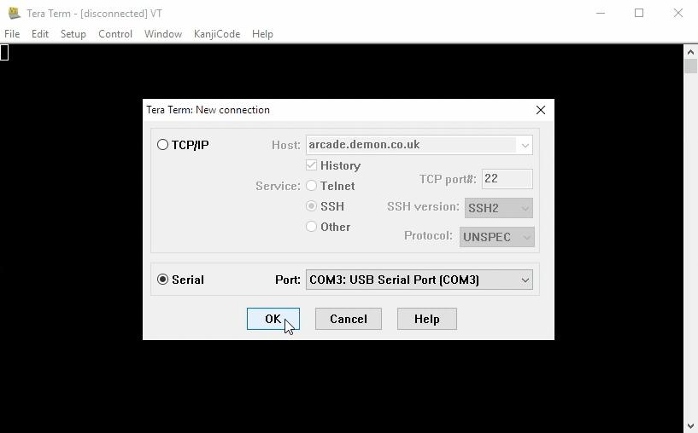
5
- Go to:
File → Transfer → XMODEM → Send
- Select your file
- Click Open / Send

🎉 Done!
- File will transfer over UART
- You’ll see progress bar

⚡ Method 2: YMODEM (Better for bigger files)
Same steps, just choose:
File → Transfer → YMODEM → Send/Receive
👉 Advantages:
- Faster than XMODEM
- Supports batch files

🚀 Method 3: ZMODEM (Best, but limited support)
File → Transfer → ZMODEM
👉 Faster + auto resume
👉 But sometimes not enabled depending on setup

⚙️ IMPORTANT SETTINGS (Must match both PCs)
- Baud rate: 115200 (or higher if stable)
- Data: 8N1
- Flow control: None

⚠️ Common Issues (and fixes)

❌ Transfer not starting
- Receiver didn’t start first
✔ Always start Receive first

❌ Transfer very slow
- XMODEM is slow by nature
✔ Use YMODEM

❌ File corrupted
- Baud mismatch
- Noise in cable
✔ Reduce speed (9600 / 57600)

❌ Nothing happens
- Wrong cable (must be null modem)
- COM port wrong

🔥 Pro Insight (for your project)
Since you're doing UART + voice/data project, this teaches you:
- How raw data packets move
- How error checking works
- Base for your own protocol in C++

If you want next level:
- I can show how to send files using your own C++ code (no XMODEM)
- Or build a mini file transfer app over UART like WhatsApp but serial 😄
Just tell me 👍

