Tera term to Tera term

If you want Tera Term → Tera Term communication (PC to PC via UART), here’s a clean, practical guide from scratch.

🖥️ What is Tera Term?
A free terminal emulator used to send/receive data over Serial (COM ports) or network. Perfect for UART communication between two systems.

🔌 Setup Overview
You’ll connect 2 PCs using a UART interface and use Tera Term on both sides.

🧰 Requirements
- 2 PCs/Laptops
- USB-to-Serial adapters (FTDI / CH340)
- UART connection (TX, RX, GND wires OR null modem cable)
- Tera Term installed on both PCs

🔗 Hardware Connection
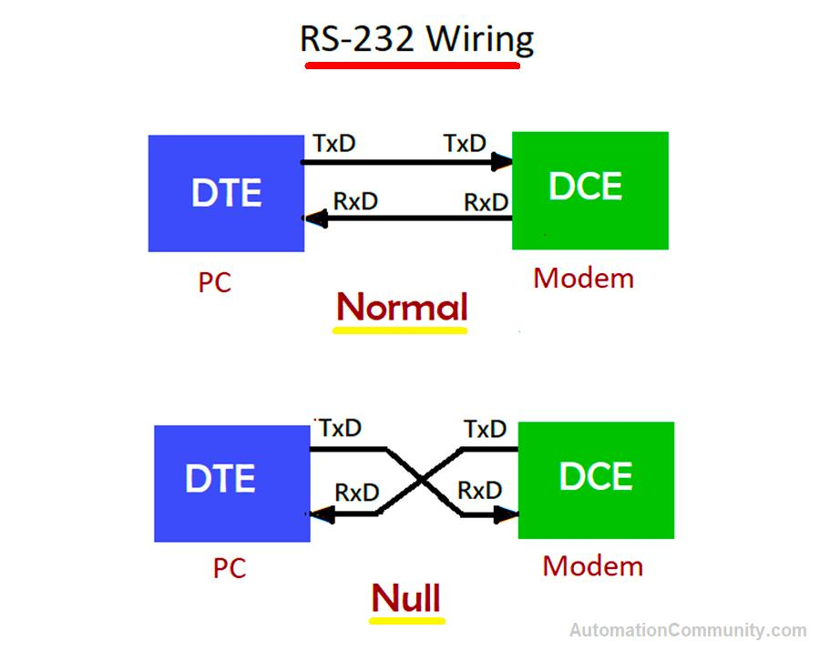
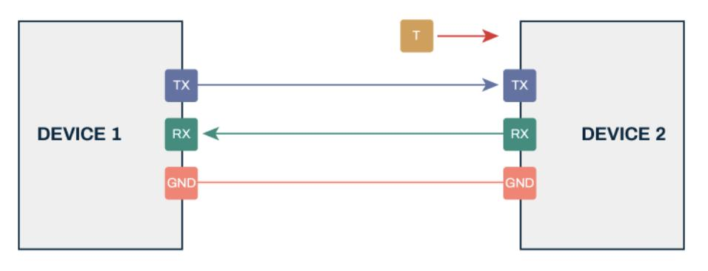
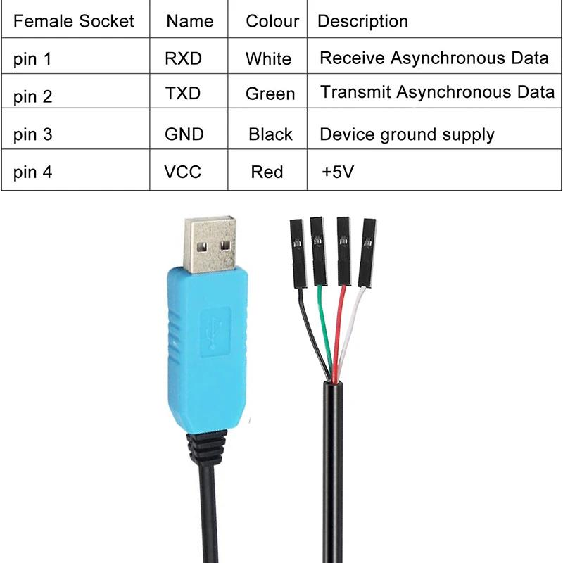
5
Connect like this:
- TX (PC1) → RX (PC2)
- RX (PC1) → TX (PC2)
- GND → GND
👉 If using RS232 cable → use a null modem cable (cross connection already inside)

⚙️ Step-by-Step Setup
1. Install Tera Term
- Download & install on both PCs

2. Find COM Ports
- Open Device Manager → Ports (COM & LPT)
- Note COM numbers (e.g., COM3, COM5)

3. Open Tera Term on BOTH PCs
- Select Serial
- Choose correct COM port

4. Configure Serial Settings (IMPORTANT)
On both PCs:
- Baud rate: 115200
- Data: 8 bit
- Parity: None
- Stop bit: 1
- Flow control: None
👉 Path:
Setup → Serial Port

5. Start Communication
Now type on one PC → it should appear on the other 🎯

🔁 Example
PC1 types:
Hello from PC1
PC2 receives instantly:
Hello from PC1

⚠️ Common Issues (Fix Fast)
- ❌ No output
→ Check TX/RX swapped correctly
- ❌ Garbage text
→ Baud rate mismatch
- ❌ COM port not showing
→ Driver not installed
- ❌ Nothing works
→ Try loopback test (connect TX to RX on same device)

🎧 If You Want Voice (Advanced)
Tera Term only sends text, not audio.
For voice:
- Use C++ + PortAudio + UART encoding
- Or tools like:
  - Docklight
  - PuTTY (still text only)

🧠 Simple Block Flow
PC1 (Tera Term) → UART → PC2 (Tera Term)

🚀 Want Next Level?
I can help you with:
- ✅ Full C++ UART chat program
- ✅ Voice over UART (with compression)
- ✅ Mini project report + viva explanation
Just tell me 👍

