**INTERNET CONNECTIVITY MUST TO START OUR MAVEN PROJECT**

MAVEN – BUILD MANAGEMENT TOOL

* We can maintain proper structure
* We can manage the dependencies
* It will build the code for us.

***************************************************************

Local Repository 🡪 m2 folder

Remote Repository 🡪 Maven Repository

Pom.xml 🡪 Project Object Model.

src.test.java 🡪 Only runnable class

src.main.java 🡪 Reusable methods. We cannot run it.

*****************************************************************

Terminologies:

Group ID: Company Name 🡪 com.google.gmail

Artificat ID: Project Name 🡪 gmail

Version: Version number

ArcheType : Inbuild Template 🡺 Quickstart 1.1

Dependencies: External Jar and Libraries

*****************************************************************

Maven Creating Procedure

File🡪Project🡪Maven Project🡪 Click Next

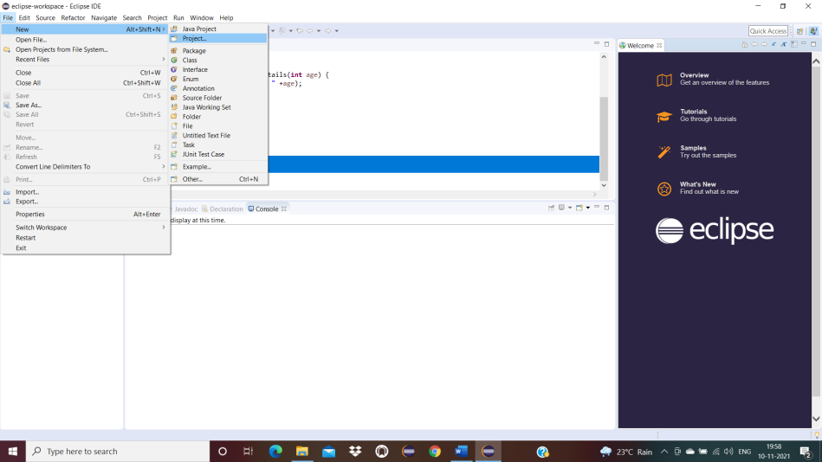

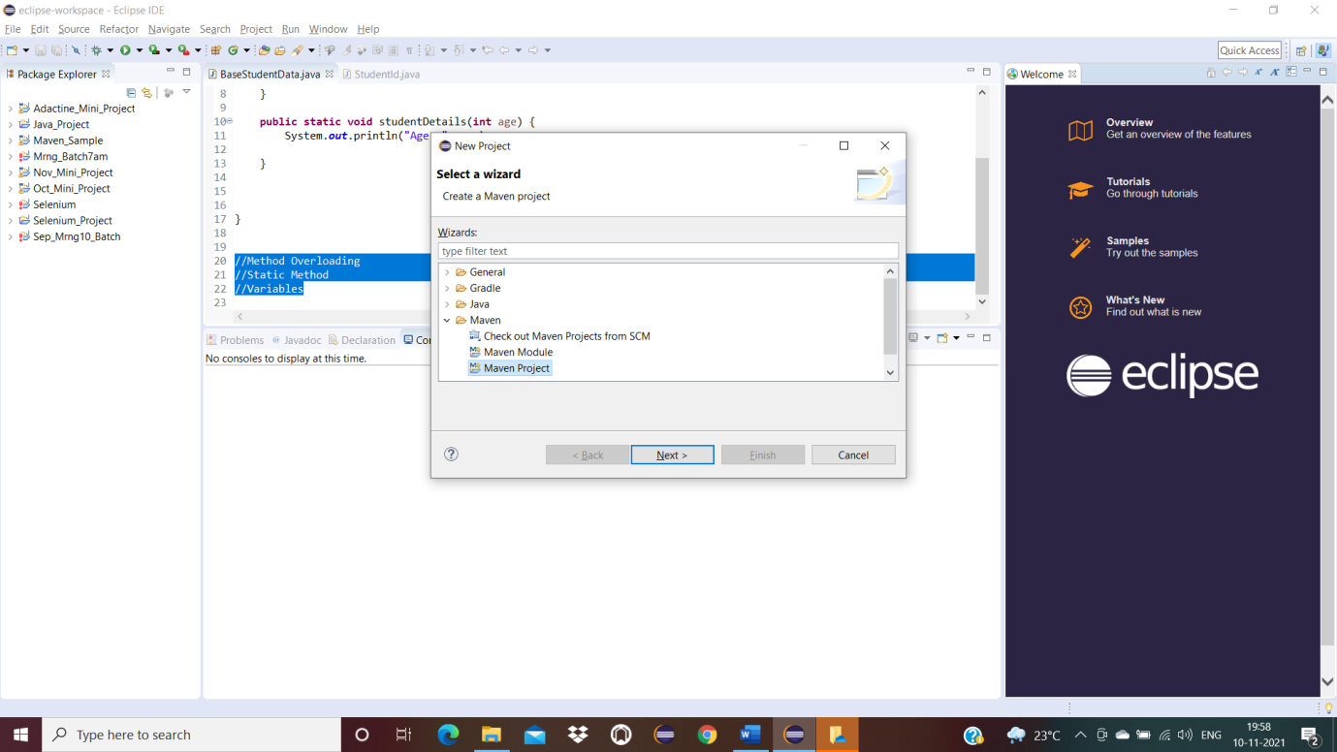

Click Next Again

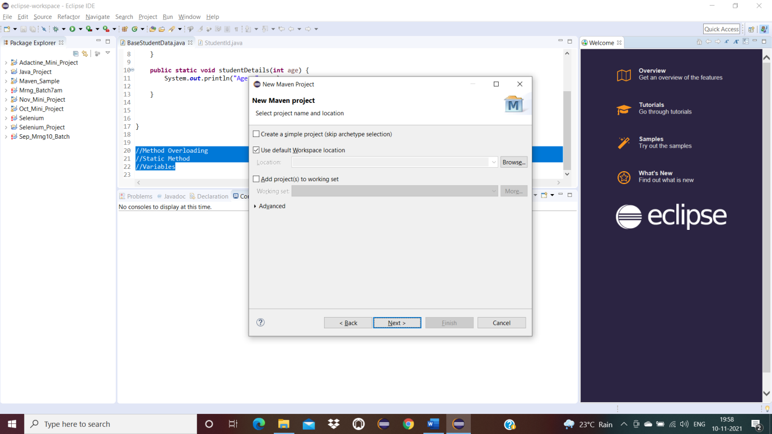

Select maven-archetype-Quickstart – 1.1 then click Next

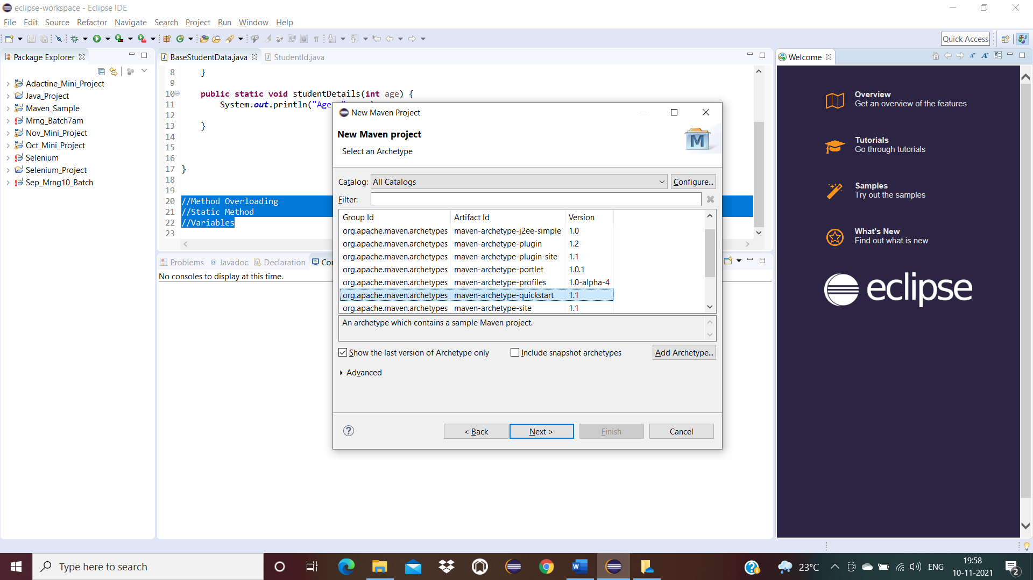

Provide valid name Group Id and Artifact Id – Click Finish

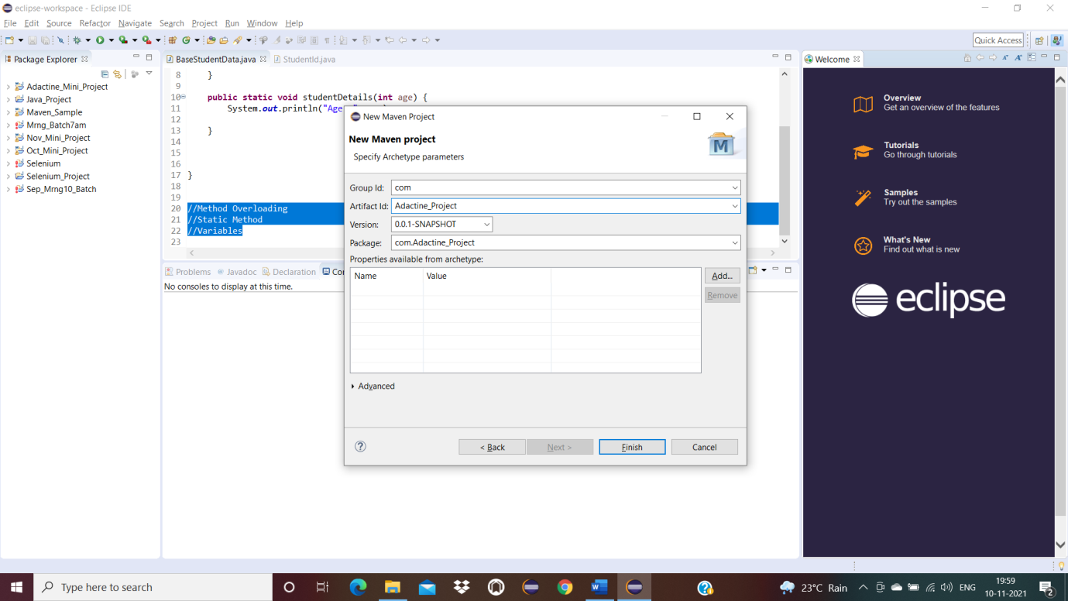

Open Pom.xml and add required dependencies

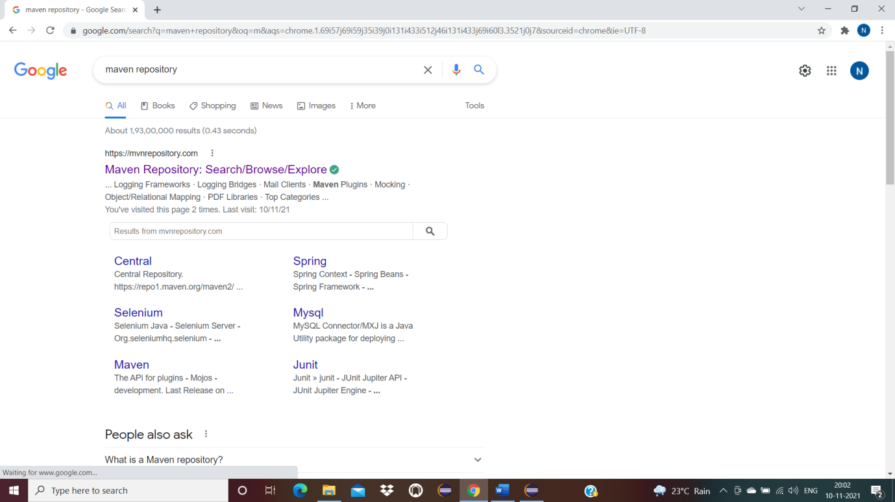

Example Selenium Java and Search

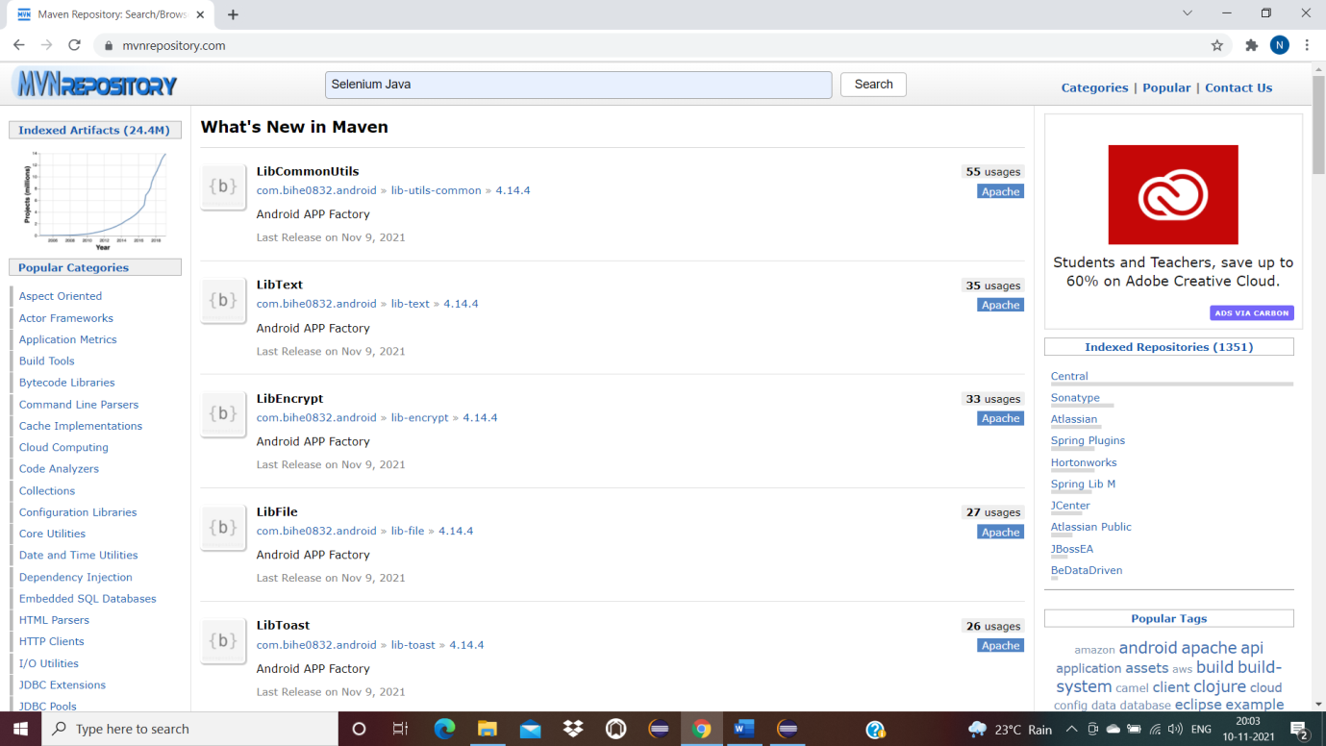

Select Selenium Java

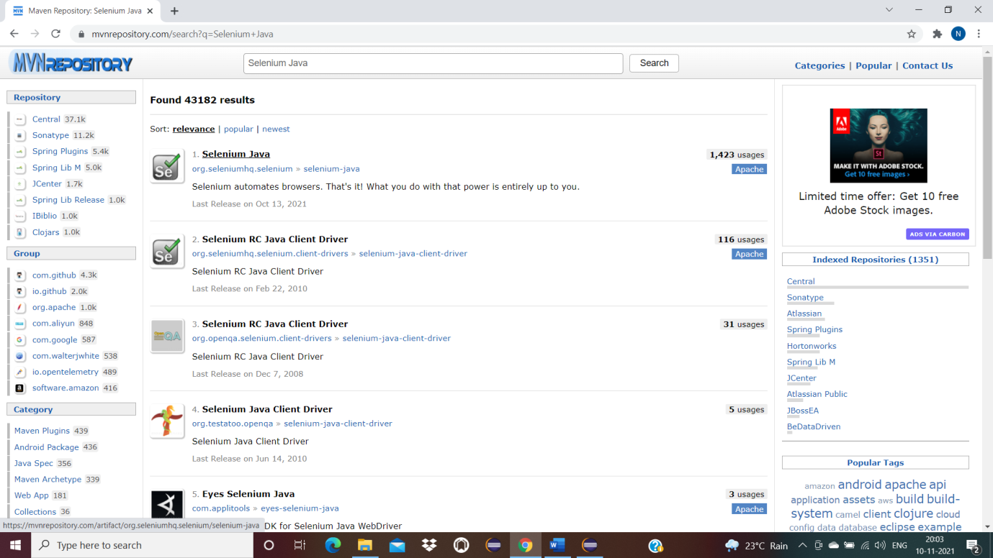

Select 3.141.59 version copy and paste the text in pom.xml

