CSS Selector:

* It is easier to learn/understand
* Typically, faster than Xpath.
* It is used a lot on the development side to style web pages.
* we can find / select HTML elements on the basis of their id /class / attributes

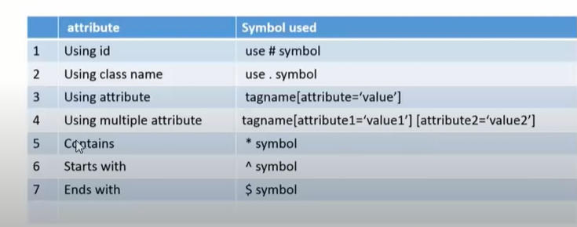

Locate by ID

***************

syntax:

tag#id(or)#id

Ex: input#lst-ib

Locate by class:

******************

syntax:

tag.className

Ex: input.gsfi

Locate by Name or any attribute:

**************************************

syntax:

tagName[att.name='att.value']

or

[att.name='att.value']

EX: [name='q']

Match with Prefix:

********************

syntax:

[Att.name^='prefix_of_att.value']

Ex: [id^='lst']

Match with Suffix:

*********************

syntax

[Att.name$='Suffix_of_att.value']

Ex: [class$='fi']

Match with SubString or Contains:

***************************************

Syntax:

[Att.Name*='Substring_Value']

Ex: [value*='Google'] or input[id*='user'] or input[id*='name']

Css With Two Attribute

**********************

input[id='username'][type='email']

xpath with 2 attribute

**********************

//input[@id='username' and @type='email']