A MACHINE LEARNING DRIVEN WEB APPLICATION FOR INDIAN SIGN LANGUAGE RECOGNITION

A PROJECT REPORT

Submitted by

ELAYABHARATHI P | (710021104301)
MANI P | (710021104322)
PARANJOTHI KARTHIK M | (710021104708)
PRADEEP R | (710021104018)

in partial fulfilment for the award of the degree
of
BACHELOR OF ENGINEERING
in
COMPUTER SCIENCE AND ENGINEERING

ANNA UNIVERSITY REGIONAL CAMPUS, COIMBATORE

ANNA UNIVERSITY: CHENNAI 600 025
MAY 2025

A MACHINE LEARNING DRIVEN WEB APPLICATION FOR INDIAN SIGN LANGUAGE RECOGNITION

A PROJECT REPORT

Submitted by

ELAYABHARATHI P | (710021104301)
MANI P | (710021104322)
PARANJOTHI KARTHIK M | (710021104708)
PRADEEP R | (710021104018)

in partial fulfilment for the award of the degree
of
BACHELOR OF ENGINEERING
in
COMPUTER SCIENCE AND ENGINEERING

ANNA UNIVERSITY REGIONAL CAMPUS, COIMBATORE

ANNA UNIVERSITY: CHENNAI 600 025
MAY 2025


ANNA UNIVERSITY REGIONAL CAMPUS COIMBATORE

BONAFIDE CERTIFICATE
Certified that this project report “A MACHINE LEARNING DRIVEN WEB APPLICATION FOR INDIAN SIGN LANGUAGE “ is the bonafide work of “ELAYABHARATHI P (710021104301), MANI P (710021104322), PARANJOTHI KARTHIK M (710021104708), PRADEEP R(710021104018)” who carried out the project work under my supervision.

SIGNATURE  Dr. S. V. MANISEKARAN M.E., Ph.D.  HEAD OF THE DEPARTMENT  Department of Computer Science  and Engineering,  Anna University Regional Campus, Coimbatore. |  | SIGNATURE  Mr. D. PRABHU M.E., SUPERVISOR  Department of Computer Science  and Engineering,  Anna University Regional Campus,  Coimbatore.

Submitted for the project viva-voce examination held at Anna University Regional Campus Coimbatore on _________________.

INTERNAL EXAMINER EXTERNAL EXAMINER
ACKNOWLEDGEMENT
First and foremost, I would like to express my deepest appreciation to our respected Dean Dr. M. SARAVANAKUMAR, Ph.D., Anna University Regional Campus Coimbatore, for his unwavering support and encouragement throughout the duration of my project.
I would like to convey my sincere gratitude and thanks to Assistant Professor Dr. S. V. MANISEKARAN, M.E., Ph.D., Head of the Department of Computer Science and Engineering, for his invaluable support in completing this project.
We express our hearty thanks to Dr. P. MARIKANNU, MTech., Ph.D., Project Coordinator and Class Advisor Department of Computer Science and Engineering for his excellent guidance.
I express my heartly thanks to my project guide Mr. D. PRABHU, M.E., Assistant Professor, Department of Computer Science and Engineering for his encouragement, involvement, caretaking and valuable guidance with keen interest towards the completion and shaping of this project and report.
I also extend my thanks to all Teaching and Non-Teaching Staff Members of the college who rendered their co-operation by all means for completing this project. Also I thank my parents and friends who were very supportive for partial completion of my project.
ABSTRACT
Effective communication is vital for sharing information, ideas, and emotions. However, it remains a significant challenge for individuals with hearing and speech impairments. While sign language offers a means of communication for deaf individuals, it is often difficult for non-signers to interpret and understand. Existing sign language recognition technologies have limitations in accuracy and accessibility. This project presents an AI-driven system designed to bridge the communication gap between deaf and hearing individuals.
Leveraging advancements in machine learning, particularly Random Forest classifiers, the system aims to create a seamless two-way communication experience. The system includes three core modules: a Sign Recognition Module (SRM) that interprets signs using Random Forest classification (RFC) of hand gesture data, a Speech Recognition and Synthesis Module (SRSM) that converts spoken language into text using Google's speech recognition API, and a Translation Module that enables multi-language support through integrated translation services.
The system is trained on customizable gesture datasets and is capable of facilitating communication across diverse groups, including deaf, mute, hard-of-hearing, visually impaired, and non-signers. The developed web-based user interface enhances the system's accessibility and ease of use. Experimental results demonstrate the effectiveness of the proposed framework, with the Random Forest model achieving strong accuracy on gesture recognition tasks. This system represents a significant step forward in making communication more inclusive and accessible for all.

TABLE OF CONTENTS

CHAPTER NO | TITLE | PAGE NO
 | ABSTRACT | III
 | LIST OF FIGURES  LIST OF TABLES  LIST OF ABBREVIATION | VIII  VIII  VIII
1 | INTRODUCTION | 1
 | 1.1 OVERVIEW | 1
 | - PROBLEM STATEMENT  - AIM AND OBJECTIVE  - SCOPE OF THE PROJECT  1.4.1 Sign Language Recognition Module  1.4.2 Speech Recognition and Synthesis Module  1.4.3 Avatar Module  1.4.4 Integration into Deaf Companion System  1.4.5 Web Based User Interface  1.4.6 Commercial Scalability | 2  2  3  4  4  4  4  4  4
2 | LITERATURE REVIEW | 5
3 | SYSTEM ANALYSIS | 11
 | 3.1 EXISTING SYSTEM | 11
 | 3.1.1 Existing Algorithm  3.1.2 Disadvantages | 11  12
 | 3.2 PROPOSED SYSTEM | 12
 | 3.2.1 Advantages | 13
4 | SYSTEM REQUIREMENTS | 14
 | 4.1 HARDWARE CONFIGURATIONS | 14
 | 4.2 SOFTWARE CONFIGURATIONS | 14
 | 4.3 SOFTWARE DESCRIPTION | 15
5 | SYSTEM DESIGN | 17
 | 5.1 ARCHITECTURE DIAGRAM | 17
 | 5.2 UML DIAGRAM | 20
 | 5.2.1 USE CASE DIAGRAM | 20
 | 5.2.2 ACTIVITY DIAGRAM | 21
 | 5.2.3 SEQUENCE DIAGRAM  5.3 TABLE DESIGN | 22  23
6 | SYSTEM IMPLEMENTATION  6.1 PROJET DESCRIPTION | 26  26
 | 6.2 MODULE DESCRIPTION | 27
 | 6.2.1 Deaf companion system web app | 27
 | 6.2.2 System user dashboard | 27
 | 6.2.3 SignNet Model: Build and Train  6.2.3.1 Import Dataset  6.2.3.2 Preprocessing  6.2.3.3 Segmentation  6.2.3.4 Feature Extraction  6.2.3.5 Classification  6.2.3.6 Build and Train  6.2.3.7 Deploy Model  6.2.4 Sign Language Recognition  6.2.5 Speech Recognition & Synthesis  6.2.6 Visual Communication | 29  29  29  30  31  33  33  37  38  39  40
7 | SYSTEM TESTING | 41
 | 7.1 SOFTWARE TESTING | 41
 | 7.2 TEST CASES | 41
 | 7.3 TEST REPORT  7.3.1 Introduction  7.3.2 Test Objective  7.3.3 Test Scope  7.3.4 Test Environment  7.3.5 Test Result  7.3.6 Test Conclusion | 43  43  43  43  44  44  45
8 | CONCLUSION AND FUTURE ENHANCEMENT | 46
 | 8.1 CONCLUSION | 46
9 | 8.2 FUTURE ENHANCEMENT  IMPLEMENTATION AND RESULT  - Source Code  - Screenshots | 47  48  48  61
 | REFERENCES | 65

LIST OF FIGURES

FIGURE NO. | FIGURE NAME | PAGE NO.
5.1 | System Architecture | 17
5.2.1 | Use case Diagram | 21
5.2.2 | Activity Diagram | 22
5.2.3 | Sequence Diagram | 23

LIST OF TABLES

TABLE NAME | PAGE NO.
Admin | 24
SignNet Model Training | 24
Avatar  Preprocessing techniques  Random Forest Classifier | 25  30  31

LIST OF ABBREVIATION

SRM | Sign Recognition Module
SRSM | Speech Recognition and Synthesis Module
AV | Avatar Module
ASL | American Sign Language
ISL | Indian Sign Language

CHAPTER 1
INTRODUCTION
1.1. OVERVIEW
Sign language is manual communication commonly used by people who are deaf. Sign language is not universal; people who are deaf from different countries speak different sign languages. The gestures or symbols in sign language are organized in a linguistic way. Each individual gesture is called a sign. Each sign has three distinct parts: the handshape, the position of the hands, and the movement of the hands. Indian Sign Language (ISL) is the most commonly used sign language in the India.

A sign language (also signed language) is a language which uses manual communication, body language, and lip patterns instead of sound to convey meaning simultaneously combining hand shapes, orientation and movement of the hands, arms or body, and facial expressions to fluidly express a speaker's thoughts. Signs often represent complete ideas, not only words. However, in addition to accepted gestures, mime, and hand signs, sign language often includes finger spelling, which involves the use of hand positions to represent the letters of the alphabet.

Sign languages have developed in circumstances where groups of people with mutually unintelligible spoken languages found a common base and were able to develop signed forms of communication. Sign languages commonly develop in deaf communities, which include people who are deaf or hard of hearing, friends and families of deaf people, as well as interpreters.

1.2. PROBLEM STATEMENT
Sign language recognition is a vital application of hand gesture recognition, extending beyond the deaf community to individuals with conditions like Down syndrome, autism, cerebral palsy, and speech impairments. Although over 6,900 spoken and 138 sign languages exist, there is no universal sign language, with each having unique grammar and structure. Indian Sign Language (ISL) is widely used in India, where millions struggle with speech and hearing impairments. A significant communication gap exists as most people are unfamiliar with ISL, making interaction difficult, especially during emergencies. Human sign language interpreters are often costly and scarce, emphasizing the need for automated solutions. These systems can convert gestures into text or speech, enhancing communication without requiring human intermediaries. Through human-computer interaction, such tools can support marginalized communities and foster inclusivity. Advances in artificial intelligence have led to more accurate models capable of learning from experience. Deep learning techniques, in particular, have surpassed traditional machine learning methods by using layered neural networks to refine gesture recognition. For these technologies to be truly impactful, they must maintain high accuracy to ensure clear and meaningful communication.

1.3. AIM AND OBJECTIVE
The aim of this project is to develop a Deaf Companion System that utilizes technologies, particularly Random Forest Classifiers to enhance communication between individuals with hearing and mute disabilities and the broader community. The system aims to overcome existing communication barriers by recognizing sign language gestures, converting non-deaf speech to text, and generating corresponding sign language avatars for seamless and inclusive two-way communication.

Objective
- To design and implement a robust SignNet Model using Random Forest Classifiers for accurate recognition of sign language gestures.
- To train the SignNet Model on a representative dataset, focusing on the cultural nuances of the Indian Sign Language.
- To implement a Hidden Markov Model (HMM)-based speech recognition system for converting spoken language from non-deaf individuals into text.
- To develop a synthesis module that generates corresponding sign language gestures based on the converted text.
- To create an Avatar Module capable of generating realistic and culturally sensitive sign language avatars aligned with converted text.
- To seamlessly integrate the Sign Language Recognition, Speech Recognition and Synthesis, and Avatar Modules into a unified Deaf Companion System.
- To design and implement an accessible and user-friendly web-based interface for deploying the SignNet Model and the Deaf Companion System.
- To explore opportunities for commercial scalability through partnerships and collaborations, ensuring adaptability for diverse environments and user groups.
- To conduct comprehensive testing and validation of the system's accuracy, reliability, and real-world applicability.
To prioritize cultural sensitivity and inclusivity, addressing variations in sign languages and considering the needs of diverse user groups.

1.4. SCOPE OF THE PROJECT
The scope of the project encompasses the following key areas:

    - Sign Language Recognition Module (SRM)
Designing and implementing a robust SignNet Model based on Random Forest Classifiers for accurate recognition and interpretation of sign language gestures. Training the SignNet Model on a representative dataset, with a focus on the cultural nuances of the Indian Sign Language.
1.4.2 Speech Recognition and Synthesis Module (SRSM)
Implementing a Hidden Markov Model (HMM)-based speech recognition system to convert spoken language from non-deaf individuals into text. Developing a synthesis module to process the text and generate corresponding sign language gestures.
    - Avatar Module (AM)
Creating an Avatar Module capable of generating realistic and culturally sensitive sign language avatars aligned with the converted text from non-deaf speech.
    - Integration into Deaf Companion System
Integrating the Sign Language Recognition Module, Speech Recognition and Synthesis Module, and Avatar Module into a unified Deaf Companion System. Ensuring seamless operation to facilitate effective communication between deaf individuals and non-deaf individuals, accommodating varying communication needs.
    - Web-Based User Interface
Designing and implementing an accessible and user-friendly web-based interface to deploy the SignNet Model and the entire Deaf Companion System. Prioritizing an intuitive interface that caters to the diverse needs of both deaf and non-deaf users.
    - Commercial Scalability
Investigating opportunities for commercial scalability, exploring potential partnerships and collaborations to make the Deaf Companion System widely accessible. Considering adaptability for diverse environments and user groups to ensure scalability.
CHAPTER 2
LITERATURE REVIEW

1. A Machine Learning-Driven Web Application for Sign Language Learning (2024)
The system utilizes a Convolutional Neural Network (CNN) trained on 44,654 static images representing 24 ASL alphabet letters (excluding J and Z). The front-end is developed using HTML, CSS, and JavaScript, while Flask is used for the back-end. The application enables users to practice spelling words by signing letters via webcam input. Real-time feedback is provided by highlighting correct signs in green and scoring is based on correct word completion. It features two difficulty levels for adapting to user proficiency. The system operates with an average latency of 64.02 ms/step, ensuring real-time responsiveness.

2. Indian Sign Language Recognition System Using SURF with SVM and CNN (2022)
This system captures signs using real-time video and preprocesses frames through skin segmentation and running averages for plain and complex backgrounds, respectively. Feature extraction is performed using SURF, followed by clustering via mini-batch K-means and codebook histogram generation. The Bag of Visual Words (BOVW) representation is classified using both SVM (linear kernel) and CNN for performance comparison. Recognized signs are converted to text and speech using Pyttsx3. A reverse recognition module uses Google Speech API to convert spoken English into corresponding sign images.

3. Indian Sign Language Recognition System (2017)
The implementation involves capturing gesture sequences through video and extracting spatial-temporal features using Discrete Wavelet Transform (DWT) and Mel-Frequency Cepstral Coefficients (MFCC). These features are input into a Hidden Markov Model (HMM), which handles the temporal dynamics of gesture classification. The system is trained and tested using MATLAB, and it recognizes the 26 alphabets of ISL. The method emphasizes sequential gesture analysis suitable for dynamic input. However, the dataset and testing are limited to alphabet gestures.

4. Sign Language Translation using a Chrome Extension for Google Meet (2022)
This system integrates with Google Meet via a Chrome extension, using MediaPipe for real-time hand landmark detection. A machine learning model trained on ASL hand gesture data—using algorithms like Logistic Regression, Ridge Classifier, Random Forest, and Gradient Boost—is used for classification, with Random Forest yielding the best accuracy. The extension captures video frames, extracts 3D hand coordinates, classifies the sign, and then outputs text or speech via text-to-speech conversion. Gesture predictions are refreshed every 3 seconds to reduce clutter and enhance clarity.

5. Video-based Hand Gesture Recognition using Random Forest for Sign Language Interpretation (2024)
This real-time gesture recognition system processes webcam-captured videos by converting them into frames and extracting features with MediaPipe. Keypoints are tracked for hand landmarks, and these features are used to train a Random Forest classifier. OpenCV is employed for image processing, while the classification and model evaluation are done using Python and Keras. The system supports live detection and provides gesture annotations, achieving strong performance metrics including 97% accuracy and 99% F1 score.

6. Sign Language to Text Conversion using Random Forest
This paper proposes a real-time sign language to text translation system using a combination of MediaPipe and a Random Forest Classifier. The system captures ASL gestures using a webcam with OpenCV, extracts 21 hand landmarks via MediaPipe, and flattens them into a 63- or 126-dimensional feature vector. These vectors are then used to train a Random Forest classifier for letter classification. The key advantage is high accuracy, robustness to noisy and nonlinear data, and simplicity of implementation without the need for complex deep learning models. However, its main limitations include scalability issues with larger datasets and limited handling of dynamic gestures or full sentence translation.

7. Hand Gesture Recognition Based on a Harris Hawks Optimized Convolution Neural Network
This work introduces a novel model that uses the Harris Hawks Optimization (HHO) algorithm to fine-tune hyperparameters in a CNN for hand gesture classification. The dataset consists of 10 gesture classes sourced from Kaggle, and the HHO-CNN model achieved 100% accuracy with a 0% error rate in just 13 minutes of training. The HHO algorithm simulates hawk predation strategies to escape local minima and accelerate convergence. Advantages include superior accuracy, minimal training time, and optimal parameter selection. The key disadvantage is the lack of evaluation on real-time video data, limiting real-world applicability.

8. Interpretation of Swedish Sign Language Using Convolutional Neural Networks and Transfer Learning
This paper introduces a method for interpreting the Swedish Sign Language (SSL) hand alphabet using a CNN based on the InceptionV3 architecture with transfer learning. The system was built using 9400 images captured from eight individuals, augmented for variation, and processed using a web application. The core algorithm uses a pre-trained InceptionV3 model with mini-batch gradient descent, tuned using hyperparameters like frozen layers and step size. The main advantage is achieving 85% accuracy using a small dataset and deploying it in a user-friendly application. A notable disadvantage is the limitation to static signs only, excluding dynamic gestures and facial expressions, thus reducing applicability to full sign language sentences.

9. Deep Learning Methods for Indian Sign Language Recognition
This paper presents a dual-method system for real-time Indian Sign Language (ISL) recognition using CNNs, LSTMs, and semantic segmentation. The first method uses a Microsoft Kinect RGB-D camera to segment and classify static (using CNNs) and dynamic (using ConvLSTM) gestures. The second approach removes hardware dependency by using U-Net with ResNet-101 on normal RGB images for semantic segmentation. The CNN+LSTM models achieve 98.81% and 99.08% accuracy respectively, while the U-Net model reaches an IOU of 0.9920 and F1 score of 0.9957. The advantage is robust real-time performance under varied lighting and user conditions. However, a key disadvantage is that U-Net requires a powerful GPU for inference, limiting performance on low-end devices.

10. Hand Gesture Recognition Based on Computer Vision: A Review of Techniques
This paper reviews a wide range of computer vision techniques used for hand gesture recognition, including color-based, appearance-based, motion-based, skeleton-based, depth-based, and 3D model/deep learning methods. It compares segmentation methods, feature extraction, classification algorithms, and applications. The algorithms discussed range from classical methods (e.g., AdaBoost, HMM, SVM, kNN) to deep learning (CNNs). Advantages include contactless gesture recognition and adaptability across domains like HCI, sign language, and robotics. However, challenges persist such as sensitivity to lighting, occlusions, background clutter, and the high computational cost of depth sensors and deep learning models.

11. Sign Language Recognition Analysis Using Multimodal Data
This paper presents a multimodal sign language recognition system that combines skeletal and RGB data using deep learning architectures. The authors introduce a dataset called GMU-ASL51, containing over 13,000 samples of 51 American Sign Language (ASL) signs. The main algorithms include a 2-layer Axis-Independent LSTM (AI-LSTM), Spatial AI-LSTM with origin-based augmentation, and a combined Max CNN-LSTM model leveraging 3D CNNs for hand patches. The advantages include high recognition accuracy (up to 81%), enhanced robustness with multimodal input, and a public dataset contribution. However, disadvantages include long training times for CNN-based models, dependency on Kinect for skeletal data, and lack of real-time system validation.

12. Video-Based Sign Language Recognition Without Temporal Segmentation
This paper introduces LS-HAN, a novel continuous sign language recognition framework that eliminates the need for temporal segmentation. It employs a two-stream 3D CNN to extract global-local spatiotemporal features from video clips and maps both video and sentence annotations into a latent semantic space. A Hierarchical Attention Network (HAN) is then used to generate sentence outputs word-by-word. The main advantage is its robustness and higher accuracy (up to 82.7%) by avoiding segmentation errors and jointly modeling relevance and recognition. However, the system is complex to train, highly dependent on accurate gesture detection, and may struggle with long or compound sentences during inference.

CHAPTER 3
SYSTEM ANALYSIS

3.1. EXISTING SYSTEM
Traditional systems for communication and education in the deaf community have long relied on established yet limited methods to meet the varied needs of individuals with hearing and speech impairments. Sign language, such as American Sign Language (ASL) or regional variants, remains the primary manual communication tool. Specialized schools use sign language as the main instructional medium, providing tailored education. Assistive devices like hearing aids and cochlear implants are employed to enhance auditory perception. For basic interactions, manual tools such as pen and paper are still widely used. Sign language interpreters play a crucial role in facilitating communication between deaf and hearing individuals in diverse settings. Additionally, printed materials like books and written content serve as essential educational resources. While these traditional approaches have offered foundational support, they often fall short in enabling dynamic, real-time communication and inclusivity in broader society.

3.1.1 EXISTING ALGORITHMS
Sign language recognition (SLR) is a challenging task due to the complexity and variability of sign language gestures. Several algorithms and approaches have been developed to address this task, with varying levels of success. One prominent existing algorithm for SLR is the Hidden Markov Model (HMM) based approach.
- Support Vector Machines (SVM): SVMs are used to classify sign language gestures based on extracted features. They work well with high-dimensional feature spaces.
- Ensemble Learning: Ensemble methods, such as Random Forests and Gradient Boosting, can be applied to combine multiple SLR models to improve overall accuracy and robustness.
- Gesture Recognition by Learning from Poses (GRBP): GRBP is a method that focuses on learning spatial relations between body joint poses for sign language recognition. It utilizes pose features extracted from skeletal data.

3.1.2. DISADVANTAGES
- Traditional systems lead to limited accessibility, hindering communication with non-signers.
- Real-time processing challenges persist, especially for resource-constrained devices.
- Handling natural variability in sign language gestures remains a challenge for rule-based models.
- Existing algorithms lack adaptability to diverse sign language variations.
- Difficult to interpret the decision-making process.
- Challenges in modeling the context and semantic relationships between signs.

3.2. PROPOSED SYSTEM
The proposed project, ‘Deaf Companion System,’ aims to transform communication for individuals with hearing and speech impairments through an innovative and inclusive platform. Central to the system is the “SignNet Model, trained using a Random Forest Classifier” for accurate and real-time sign language recognition. A ‘Sign Language Recognition Module (SRM)’ interprets gestures effectively, while a ‘Speech Recognition and Synthesis Module (SRSM)’ converts speech into text to support two-way communication. Additionally, the ‘Avatar Module (AM)’ generates realistic, synchronized sign avatars from non-deaf speech to enhance visual interaction. The system emphasizes ‘cultural relevance’ by incorporating ‘Indian Sign Language (ISL)’, ensuring broader accessibility. A ‘web-based interface’ further promotes usability and deployment across devices, making the tool convenient for both deaf and non-deaf users. Overall, this project fosters seamless and inclusive communication using advanced machine learning and user-centered design.

3.2.1. ADVANTAGES
- High Accuracy & Robustness: The use of a Random Forest Classifier ensures accurate and reliable sign language gesture recognition, even with noisy or varied input.
- Low Computational Load: Efficient processing allows the system to run smoothly on standard devices without the need for specialized hardware.
- Real-Time Performance: Fast inference speeds enable real-time gesture recognition, enhancing user experience.
- Inclusive Design: The system supports communication across diverse groups, including the deaf, mute, hard of hearing, and non-signers.
- Speech-to-Avatar Integration: A realistic avatar module synchronized with speech boosts visual communication and engagement.
- Cultural Relevance: Trained specifically on Indian Sign Language, the system addresses region-specific communication needs.
- User-Friendly Web Interface: Easy-to-use web deployment ensures accessibility for a broad user base.
- Scalable and Validated: Designed for commercial scalability and tested on standard datasets, the system shows high real-world effectiveness.

CHAPTER 4
SYSTEM REQUIREMENT

4.1. HARDWARE CONFIGURATION
- Processor : Intel Core i5 or equivalent
- RAM : 8GB or higher
- Storage : Minimum 256GB SSD or HDD
- Webcam : Built-in or external webcam for video input
- Microphone : Built-in or external microphone for audio input
- Display : Minimum 13-inch display with a resolution of 1920x1080 pixels
- Internet Connection : Broadband connection for online functionality

4.2. SOFTWARE CONFIGURATION
- Operating System: Windows 10,
- Web Browser: Google Chrome, Mozilla Firefox, or Safari
- Python: Version 3.9 or higher
- Flask: Web application framework for backend development
- MySQL: Relational database management system for data storage
- Pandas, NumPy, and Scikit-learn: Python libraries for data manipulation and machine learning
- Matplotlib and Seaborn: Python libraries for data visualization
- OpenCV: Library for image processing tasks
- Bootstrap: Frontend framework for responsive web design
These are the minimum hardware and software requirements to run the Deaf Companion System effectively.
4.3. SOFTWARE DESCRIPTION
- Python 3.8 - A high-level, interpreted, and object-oriented programming language known for readability and versatility. Widely used in web development, AI, and data science due to its simplicity and extensive libraries.
- Pandas - A powerful open-source data analysis and manipulation library built on Python. Enables efficient handling of structured data (CSV, Excel, SQL) with functions for cleaning, merging, and reshaping datasets.
- NumPy - fundamental package for numerical computing in Python, offering multi-dimensional array operations and mathematical functions for high performance data processing.
- Matplotlib - A comprehensive visualization library for creating static, interactive, and animated plots in Python, seamlessly integrating with NumPy for data representation.
- Scikit-learn - A robust machine learning library featuring classification, regression, and clustering algorithms (e.g., SVM, Random Forest, k-means) with seamless NumPy/SciPy integration.
- Pillow - An imaging library for Python, enabling image processing tasks such as loading, editing, and saving various image formats.
- OpenCV - An open-source computer vision library used for real-time image and video processing, including object detection, facial recognition, and motion tracking.

- MySQL - A popular relational database management system (RDBMS) that supports SQL queries for efficient data storage, retrieval, and management in web and enterprise applications.
- WampServer - A local server environment for Windows, bundling Apache, MySQL, and PHP to facilitate web application development and testing.

CHAPTER 5
SYSTEM ARCHITECTURE

5.1. ARCHITECTURE DIAGRAM
The Figure 5.1 illustrates the architecture of a Indian Sign Language (ISL) recognition system. It captures sign input, processes it using machine learning for SL recognition and speech synthesis, and delivers output as text, voice, or animated avatars. The system includes modules for training, user management, and avatar generation to enable seamless communication between hearing and hearing-impaired users.
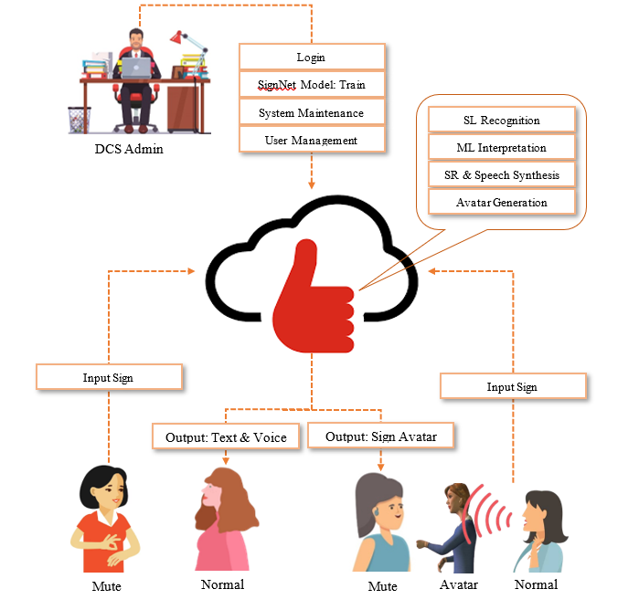
Figure 5.1 Architecture Diagram
Phase 0: DCS Admin Panel
The DCS Admin is responsible for managing the entire system from a centralized administrative panel. This includes logging into the backend system, initiating and monitoring the training of the sign language recognition model (referred to as SignNet), and maintaining the system for optimal performance. The admin can also access tools to handle system updates, error corrections, and overall model optimization. In addition, the admin oversees user management tasks such as creating new user accounts, assigning roles, and controlling access permissions. This centralized control ensures that the model remains accurate, secure, and adaptable to new sign inputs and system requirements.

Phase 1: Sign Language Recognition (SL Recognition)
The Sign Language Recognition module is the core of the system’s functionality. It takes input in the form of sign gestures—typically captured via webcam or sensors—and uses machine learning algorithms to recognize the signs. These algorithms, often based on convolutional neural networks (CNNs) or recurrent neural networks (RNNs), are trained to identify static and dynamic hand gestures, facial expressions, and body postures. This module converts visual input into a structured digital representation that can be further processed for interpretation and communication.

Phase 2: Machine Learning Interpretation (ML Interpretation)
Once the signs are recognized, the ML Interpretation module interprets the sequence of gestures into meaningful phrases or sentences. It bridges the gap between raw gesture recognition and human language by handling grammar, syntax, and context. This module often employs sequence modeling techniques such as LSTMs or transformers to ensure that signs are interpreted in a way that matches natural language understanding. The module ensures the output is logically and grammatically coherent before passing it to the next processing unit.

Phase 3: Speech Recognition and Speech Synthesis (SR & Speech Synthesis)
This module is responsible for generating audible speech from the interpreted text. Using text-to-speech (TTS) technology, the system converts the processed sign language interpretation into voice output, enabling verbal communication with hearing users. Additionally, this module may also include speech recognition capabilities, allowing normal users to input spoken language that can be converted to sign or avatar-based output for deaf or mute users. This bi-directional communication makes the system accessible to both signing and non-signing users.

Phase 4: Avatar Generation
The Avatar Generation module transforms interpreted text or speech into animated sign gestures using a 3D sign language avatar. This module is particularly helpful for mute users who prefer visual outputs rather than written or spoken language. The avatar accurately performs signs based on the input it receives, mimicking human signers. This module adds a layer of accessibility for users who may struggle with reading or who benefit from visual representation, ensuring that sign language communication remains natural and user-friendly.

Phase 5: User Interaction: Mute to Normal Communication
In this interaction path, a mute user provides input through sign gestures. These gestures are sent to the cloud system, where they are processed via SL Recognition and ML Interpretation. The final output is generated in both text and voice formats and sent to a normal user. This setup allows mute individuals to seamlessly communicate with those who do not understand sign language, enhancing inclusion and reducing communication barriers.

Phase 6: User Interaction: Mute to Normal via Sign Avatar
In another interaction pathway, a mute user signs to the system, and the processed data is output as an animated sign avatar. This is especially useful in contexts where the normal user cannot hear or where the communication context favors visual output (e.g., noisy environments or classrooms). The avatar provides a friendly and intuitive interface, bridging the gap between text/speech and sign language in a way that is culturally and contextually appropriate for deaf users.

5.2. UML DIAGRAM
5.2.1. USECASE DIAGRAM
The Figure 5.3.1 illustrates the workflow of a sign language recognition system involving deaf users, non-deaf users, admins, and a central server. It shows steps from user registration and dataset uploading to model training, deployment, and real-time communication. Core processes include preprocessing, sign/speech input, prediction, and avatar-based output. The system ensures effective interaction between deaf and non-deaf users via sign-to-speech and speech-to-sign conversion.

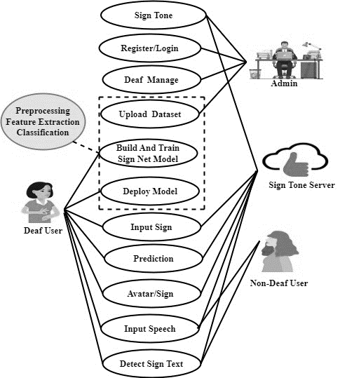
Figure 5.2.1 Use case Diagram

5.2.2. ACTIVITY DIAGRAM
The Figure 5.2.2 presents a complete workflow of a web-based sign language recognition system. It starts with user authentication and branches into roles such as Admin, Deaf User, Non-Deaf User, and Server processes. Admins manage datasets and users, while deaf and non-deaf users interact through sign and speech inputs. The server processes these inputs using a trained model to convert between sign language and speech/text, enabling smooth two-way communication.
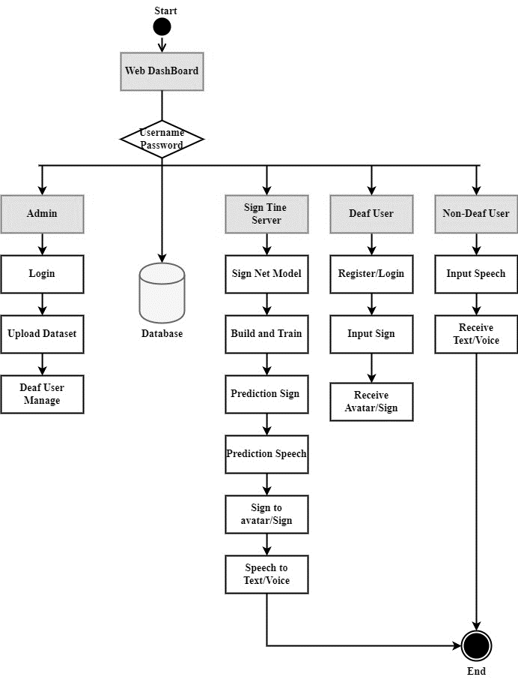
Figure 5.2.2 Activity Diagram

5.2.3. SEQUENCE DIAGRAM
The Figure 5.2.3 depicts a sequence diagram for a sign language translation system involving Admin, Web Dashboard, Server, Deaf User, and Non-Deaf User. It outlines key interactions such as dataset upload, model training, and user communication. The system allows deaf users to input signs and receive avatar output, while non-deaf users input speech and receive translated text/sign. Core processes like preprocessing, prediction, and classification are handled by the Sign Tone Server.

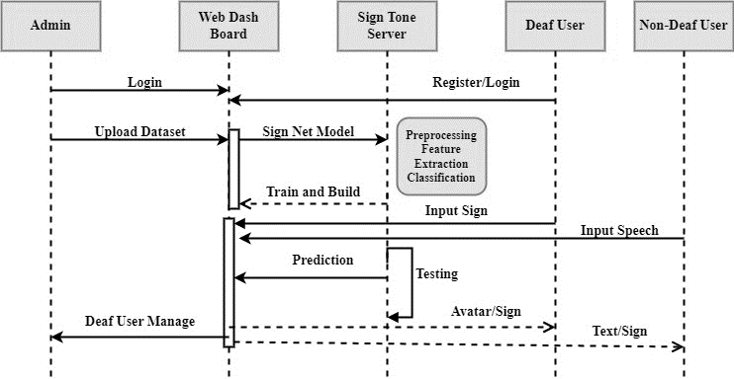
Figure 5.2.3 Sequence Diagram

5.3. TABLE DESIGN
The Table 5.1 shows the structure of an "Admin Table" used in a database for managing administrator data. It includes six fields: AdminID (Primary Key), Username, Password, Email, Fullname, and Timestamp, each with specified data types, sizes, and constraints. The table ensures data integrity through Not Null constraints and uniquely identifies each admin using AdminID.

ADMIN TABLE
S.No | Field | Data Type | Field Size | Constraint | Description
1 | AdminID | Int |  | Primary Key | Unique identifier for admin users
2 | Username | Varchar | 50 | Not Null | Username for admin login
3 | Password | Varchar | 50 | Not Null | Encrypted password for admin login
4 | Email | Varchar | 100 | Not Null | Email address of admin
5 | Fullname | Varchar | 100 | Not Null | Full name of admin
6 | Timestamp | Datetime |  | Not Null | Timestamp of admin creation

Table 5.1 Admin Table

The Table 5.2 displays the structure of the "SignNet Model Training Table," which is used for managing gesture data in a sign language recognition system. It includes fields like GestureID (Primary Key), Gesture Name, Gesture Image URL, and Timestamp, each with specific data types and constraints. This table helps store essential information for training gesture recognition models.

SIGNNET MODEL TRAINING TABLE
S.No | Field | Data Type | Field Size | Constraint | Description
1 | GestureID | Int |  | Primary Key | Unique identifier for gestures
2 | Gesture  Name | Varchar | 50 | Not Null | Name of the sign language gesture
3 | Gesture  ImageURL | Varchar | 255 | Not Null | URL of the image representing the gesture
4 | Timestamp | Datetime |  | Not Null | Timestamp of gesture creation
Table 5.2 SignNet Model Training Table

The Table 5.3 shows the schema of the Avatar Table, which is used to store information related to user avatars in a sign language system. It includes fields such as AvatarID (Primary Key), UserID (Foreign Key), AvatarImageURL, and Timestamp. This table links each avatar to a user and stores the URL and creation time of the avatar image.
AVATAR TABLE
S.No | Field | Data Type | Field Size | Constraint | Description
1 | AvatarID | int |  | Primary Key | Unique identifier for avatars
2 | UserID | int |  | Foreign Key | Identifier of the user
3 | AvatarImageURL | varchar | 255 | Not Null | URL of the avatar image
4 | Timestamp | datetime |  | Not Null | Timestamp of avatar creation

Table 5.3 Avatar Table

CHAPTER 6
SYSTEM IMPLEMENTATION

6.1. PROJECT DESCRIPTION
The Deaf Companion System Web App is an inclusive platform built using Python and Flask to enable seamless communication between deaf and non-deaf individuals. It features user authentication, a centralized dashboard, and role-based modules for administrators, deaf users, and non-deaf users. Deaf users interact through a Sign Language Recognition Module (SRM) that uses a webcam to detect hand gestures in real-time. These gestures are preprocessed and classified using a Random Forest Classifier trained on CSV-based gesture features. Non-deaf users utilize a Speech Recognition and Synthesis Module (SRSM) to convert spoken language into text, enabling communication with deaf users. An Avatar Module further enhances communication by generating realistic avatars synchronized with the spoken words, making interactions more expressive and engaging.
The system’s core, the SignNet Model, efficiently leverages the Random Forest algorithm to classify hand gestures. Unlike deep learning models, it offers faster training, lower computational needs, and robust performance, even with limited data. It also provides feature importance metrics, helping identify the most influential gesture attributes. The trained model is serialized using joblib for seamless integration. The system’s modular design ensures real-time gesture recognition, speech-to-text conversion, and avatar generation—all contributing to a user-friendly and accessible communication bridge. With its lightweight architecture and meaningful features, the app promotes inclusivity and effective interaction for users with hearing or speech disabilities.

6.2. MODULES DESCRIPTION
6.2.1. Deaf Companion System Web App
The Deaf Companion System Web App is designed using Python and Flask framework for backend development, with MySQL database management system for data storage. It incorporates TensorFlow for machine learning tasks, along with Pandas and NumPy for data manipulation. Matplotlib and Seaborn are utilized for data visualization, while OpenCV handles image processing tasks. The frontend is built using Bootstrap for responsive and user-friendly interface design. The Deaf Companion System web app is designed with user-centric modules to ensure an inclusive and intuitive experience. The User Authentication module establishes secure access, while the Dashboard serves as a central hub for seamless navigation. The Sign Language Recognition interface allows users to input gestures for real-time interpretation, complemented by the Speech-to-Text interface for comprehensive communication. The Avatar Customization module enables personalization, and language, cultural, and accessibility settings enhance adaptability. A Notification Center keeps users informed, and a Community Forum fosters interaction. The Admin Dashboard provides tools for monitoring and system management. This design ensures a holistic and accessible platform for individuals with hearing and mute disabilities.

6.2.2. System User Dashboard
The System User Dashboard in the Deaf Companion System offers tailored interfaces for administrators, deaf users, and non-deaf users to ensure inclusive and efficient communication. Administrators have secure login access and are equipped with tools for building and training the SignNet Model, managing user profiles, setting permissions, and overseeing system maintenance. Deaf users can present sign language gestures via webcam, which are interpreted in real time, with the output shown as text and voice for non-deaf users. Conversely, non-deaf users communicate using a microphone, and their speech is converted into sign language, displayed to deaf users through synchronized avatars, enhancing mutual understanding and interaction.
Algorithm:
Purpose: Web-based interface for system management and interaction
Algorithm Steps:
Authentication Module
Input: username, password
Process:
- Hash password using secure hashing
- Query database for matching credentials
- Create session if valid
Output: Redirect to admin panel or error message
Gesture Management
Input: gesture_name
Process:
- Check if gesture exists in database
- Generate unique ID if new gesture
- Create CSV file for gesture data storage
- Update gesture mapping files
Output: Confirmation message
File Upload Handler
Input: message, image_file
Process:
- Validate file format (GIF)
- Generate unique filename
- Store in upload directory
- Save metadata to database
Output: Success/failure status
6.2.3. SignNet Model: Build and Train
In the process of building and training the SignNet Model for the Deaf Companion System, several essential steps are followed to ensure accuracy and effectiveness.
6.2.3.1. Import Dataset
This module facilitates the acquisition and loading of the dataset required for training the SignNet Model. The dataset typically consists of images or videos containing sign language gestures.

6.2.3.2. Preprocessing
The Preprocessing Module prepares the dataset for training and model development by applying several key techniques. It starts with resizing images to a standardized resolution for uniformity, followed by grayscale conversion to simplify data and reduce computational complexity. Noise filtering techniques, such as Gabor filtering, are used to eliminate unwanted distortions. Binarization is then applied to segment foreground objects from the background through thresholding. Finally, normalization scales the pixel values to a common range, enhancing model performance. These preprocessing steps collectively ensure consistent, clean, and efficient input for the training process.

Preprocessing Step | Description | Formula
Resize | Standardizes image dimensions for consistency across the dataset. | resized_image = resize(original_image, (height, width))
Grayscale Conversion | Converts color images to grayscale to simplify processing and reduce complexity. | gray_image = 0.2989 × R + 0.5870 × G + 0.1140 × B
Noise Filtering | Removes noise using filtering techniques like Gabor filtering. | I_filtered(x, y) = ∑(w_k ⋅ I(x, y))
Binarization | Segments the image by converting it to binary based on a threshold. | binary_image(x, y) = { 1 if I(x, y) > T; 0 otherwise }
Normalization | Scales pixel values to a common range, typically 0 to 1. | normalized_pixel = (original_pixel − min_pixel) / (max_pixel − min_pixel)
Table 6.1 Preprocessing techniques

6.2.3.3. Segmentation
The Segmentation Module employs a Random Forest Classifier to accurately segment sign language gestures from the background, enabling precise feature extraction. Below is a detailed description of the module's functionalities along with relevant formulas:

Random Forest Classifier:
Component | Description
Classifier Description | Ensemble method that builds multiple decision trees; used for image segmentation by classifying pixels/patches as gesture (foreground) or background.
Working Principle | Each tree is trained on random data and features; predictions are aggregated for final output, improving robustness to overfitting and noise.
Feature Input | Uses features like intensity, edge, texture, and gradients to form vectors for classification.
Prediction Formula | 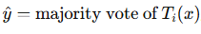  where Ti(x) is the prediction from the i-th tree.
Evaluation Metrics | Accuracy, Precision, Recall, F1-Score used to assess performance.
Node Splitting Criteria | 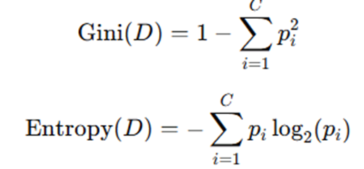
Table 6.2 Random Forest Classifier

6.2.3.4. Feature Extraction
The Feature Extraction Module is essential for identifying key characteristics of sign language gestures from segmented images using a Fully Connected Layer (FCL). In this process, the FCL acts as a classifier, transforming high-dimensional input features into a compact, lower-dimensional representation suitable for classification. Each neuron in the FCL connects to every neuron in the preceding layer, enabling it to learn complex, discriminative features through non-linear activation functions like ReLU or Sigmoid. During training, the FCL's weights and biases are optimized using techniques such as backpropagation to minimize classification errors. This module captures the most relevant patterns and structures in the input images, enhancing the model's ability to distinguish between different gesture classes. The resulting feature representations are then passed to a classifier, such as a softmax layer, for accurate sign language gesture recognition. Overall, the Feature Extraction Module significantly contributes to the system’s performance by enabling precise and efficient gesture classification.
Purpose: Extract hand landmark coordinates using MediaPipe
Algorithm Steps
Input: RGB video frame
Process:
1. Initialize MediaPipe Hands detector
- static_image_mode = False
- max_num_hands = 1
- min_detection_confidence = 0.5
2. For each frame:
a. Convert BGR to RGB color space
b. Process frame through MediaPipe
c. If hand detected:
- Extract 21 hand landmarks
- Each landmark has (x, y, z) coordinates
- Flatten to 63-dimensional feature vector
d. Draw landmarks on frame for visualization
3. Normalize coordinates relative to image dimensions
Feature Vector Structure
- 21 landmarks × 3 coordinates = 63 features
- Landmarks include: thumb, fingers, palm, wrist points
- Coordinates are normalized (0-1 range)

6.2.3.5. Classification
The Classification Module is responsible for categorizing the extracted features into distinct sign language categories using a Pooling Layer.
- Role in Sign Language Recognition:
- The output of the Pooling Layer serves as input to the final classification layer (e.g., softmax classifier) responsible for assigning a probability distribution over the different sign language categories.
- By employing the Pooling Layer for feature aggregation and dimensionality reduction, the model can effectively learn discriminative representations of sign language gestures, facilitating accurate classification and recognition.
The Classification Module, utilizing the Pooling Layer, plays a crucial role in categorizing the extracted features into distinct sign language categories, enabling accurate recognition and interpretation of sign language gestures in real-world scenarios.

6.2.3.6. Build and Train
The Build and Train Module constructs the Random Forest Classifier architecture and trains the SignNet Model using the preprocessed, segmented dataset for accurate sign language recognition.
1. Random Forest Classifier Architecture:
Description:
Random Forest is an ensemble learning method that builds multiple decision trees and outputs the class prediction by majority voting. It is well-suited for classification in high-dimensional feature spaces, as found in sign gesture data.
Components:
- Multiple decision trees trained on different bootstrap samples
- Random feature selection at each node to enhance diversity
- Aggregation of predictions via majority voting
- Feature importance calculation for identifying key gesture features
Hyperparameters:
- n_estimators: Number of trees
- max_depth: Maximum depth of each tree
- min_samples_split: Minimum samples needed to split a node
- min_samples_leaf: Minimum samples at a leaf node
- max_features: Features considered at each split
- bootstrap: Whether bootstrap sampling is used
2. Training Process:
Data Preparation:
- Hand gesture data is stored in CSV files, each representing a gesture class
- Features are extracted and structured for training
- Dataset is split into training (80%) and testing (20%) sets with stratified sampling
- Feature scaling is optional due to Random Forest’s robustness to unscaled data
Model Building:
- Gesture mapping dictionary links numerical labels with gesture names
- CSVs are loaded, labeled, and combined into feature matrix X and label vector y
- Random Forest model is initialized using selected hyperparameters (e.g., 100 trees)
Training Algorithm:
For each tree:
- A bootstrap sample is created from training data
- A decision tree is built using the CART algorithm
- At each split, a random subset of features is chosen
- Splits are selected based on Gini impurity or entropy
- Tree growth halts based on stopping criteria like max depth or min samples
Regularization Techniques:
- Random feature selection reduces tree correlation
- Bootstrap sampling ensures tree diversity
- Depth and sample constraints reduce overfitting risks
Monitoring Metrics:
- Out-of-bag (OOB) error provides internal validation accuracy
- Feature importance highlights relevant features
- Cross-validation is used to assess and improve generalization
3. Model Evaluation:
Test Set Performance:
- Accuracy is calculated on the test set
- Confusion matrix identifies frequent misclassifications
- Precision, recall, and F1-scores are used per class for detailed evaluation
Hyperparameter Optimization:
- Grid or random search is applied to tune model parameters
- Cross-validation ensures robustness in hyperparameter selection
- Best-performing model configuration is chosen based on evaluation metrics
Model Persistence:
- Final trained model is saved using joblib for reuse
- Gesture mapping dictionary is saved to interpret predictions
- Saved model enables real-time inference without retraining
The Build and Train Module is critical to developing an efficient and reliable SignNet Model. By effectively applying the Random Forest Classifier on the processed dataset, it learns discriminative gesture patterns and achieves high classification accuracy with fast inference, making it ideal for real-time sign language recognition systems.
Purpose: Automated model training pipeline
Training Pipeline
1. Data Collection Phase:
Input: Gesture data directory
Process:
- Scan for CSV files in hand_gesture_data folder
- Each file represents one gesture class
- Load all samples for each gesture
- Create numerical labels (0, 1, 2, ...)
- Build gesture mapping dictionary
2. Data Preparation:
Process:
- Combine all gesture data into single dataset
- Convert to numpy arrays
- Split into train/test sets (80/20)
- Ensure balanced class distribution

3. Model Training:
Process:
- Initialize Random Forest Classifier
- Fit model on training data
- Validate on test set
- Calculate accuracy metrics
4. Model Persistence:
Process:
- Save trained model using joblib
- Save gesture mapping dictionary
- Update class mapping files for real-time use
Performance Metrics
- Accuracy: Percentage of correct predictions
- Cross-validation: Ensures model generalization
- Feature importance: Identifies most discriminative landmarks

6.2.3.7. Deploy Model
The Deploy Model Module integrates the trained SignNet Model into the Deaf Companion System Web App to enable real-time sign language recognition and interpretation. This process involves loading the model's architecture and weights, initializing it, and connecting it to the backend for inference tasks. It ensures full compatibility with the selected web development framework (such as Flask) and the programming languages used (like Python or JavaScript). Additionally, deployment is configured to align with the hosting environment, such as WSGI servers or Docker containers, ensuring stable and efficient operation. The module enables seamless interaction between the trained model and the application, facilitating real-time gesture recognition.
Deployment Architecture
1. Web Server Setup:
- Flask application server
- Session management for authentication
- Route handlers for different functionalities
2. Real-time Video Processing:
Input: Camera feed
Process:
- Initialize video capture (camera index 0)
- Load trained model and mappings
- Start continuous frame processing loop
- Stream MJPEG to web browser
3. Integration Components:
- Database connectivity (MySQL)
- File I/O for temporary data storage
- Error handling and logging
- Multi-threading for smooth video streaming
4. System Flow:
Camera → Feature Extraction → Classification →
Web Display → Database Logging → User Interface

6.2.4. Sign Language Recognition
These components collectively form the Sign Language Recognition module, allowing deaf individuals to express themselves through sign language seamlessly and facilitating real-time interpretation using advanced technologies such as Random Forest Classifiers and the SignNet Model. The multilanguage interpretation feature enhances the system's versatility, catering to a broader user base with varying linguistic needs.
- Live Video with Sign
This feature facilitates real-time communication for deaf users who can express sign language gestures through their webcams. The live video feed captures the dynamic nature of sign language, allowing users to convey messages seamlessly.
- Recognize Sign
Employing Random Forest Classifiers integrated with the SignNet Model, this step focuses on the recognition and interpretation of live sign language gestures. The Random Forest Classifiers enhances temporal modeling, ensuring the model captures the dynamic nature of signs over time for accurate interpretation.
- Multilanguage Interpretation
The Multilanguage Interpretation feature broadens the system's accessibility by allowing interpretation of sign language gestures in multiple languages. This ensures inclusivity and accommodates users with diverse linguistic preferences, making the system adaptable to a global audience.

6.2.5. Speech Recognition and Synthesis
- Speech Recognition Module
The Speech Recognition Module is designed to convert non-deaf speech into text, facilitating seamless communication with deaf individuals. Using Hidden Markov Models (HMM), the module captures the nuances of spoken language, translating them into textual representations. This critical functionality forms the foundation for bridging the communication gap between deaf and non-deaf users within the Deaf Companion System.
- Speech Synthesis Module
The Speech Synthesis Module generates spoken language output based on the recognized text, enhancing communication for non-deaf individuals. Leveraging text-to-speech (TTS) synthesis techniques, the module creates natural-sounding spoken output. The synthesized voice is then synchronized with predicted sign language gestures, providing a comprehensive and engaging communication experience for users.
- Integration with Sign Language Recognition
This module seamlessly integrates with the Sign Language Recognition Module to synchronize recognized speech with corresponding sign language avatars. By coordinating with the Sign Language Recognition Module, the system ensures a unified and coherent communication experience for both deaf and non-deaf users. This integration enhances accessibility and fosters a more natural and inclusive interaction.

6.2.6. Visual Communication
The Avatar Generation module plays a vital role in enhancing visual communication within the Deaf Companion System by dynamically creating sign language avatars using Hidden Markov Models (HMMs). It begins by employing advanced speech recognition techniques to accurately convert non-deaf speech into textual form, which forms the basis for generating avatars. These avatars are crafted in real-time to reflect the rhythm, expressions, and nuances of the spoken message. The system ensures precise synchronization between the avatars and the recognized speech, capturing not only lip movements but also facial expressions and hand gestures. This results in a lifelike and immersive sign language representation that enhances the clarity and inclusiveness of interactions for deaf users.
CHAPTER 7
SYSTEM TESTING
7.1. SOFTWARE TESTING
System testing in the Deaf Companion System is essential to ensure its functionality, reliability, and usability. It involves evaluating the system's performance across various scenarios to identify and address any issues or deficiencies.

7.2. TEST CASES
Test Case ID | Module | Input | Expected Result | Actual Result | Status
TC001 | Admin - Login | Admin credentials (username and password) | Successful authentication, granting access to administrative functions | Admin successfully logs in and gains access to administrative functionalities | Pass
TC002 | Admin - Build and Train SignNet Model | Request to initiate the building and training process of the SignNet Model | The system begins building and training the SignNet Model as per admin's request | SignNet Model building and training process is successfully initiated | Pass
TC003 | Admin - User Management | Admin access to user profiles, permissions, and system maintenance tasks | Admin can manage user profiles, permissions, and perform system maintenance tasks | Admin successfully manages user profiles, permissions, and performs system maintenance tasks | Pass
TC004 | Deaf User - Show Sign into the Webcam | Live sign language gestures displayed through the webcam by a deaf user | The system accurately interprets and recognizes the sign language gestures in real-time | Sign language gestures displayed through the webcam are correctly interpreted and recognized in real-time | Pass
TC005 | Deaf User - Non-Deaf Receive | Text representations and voice outputs corresponding to the predicted sign language gesture | Non-deaf users can view text representations and hear voice outputs corresponding to the predicted sign language gestures | Non-deaf users successfully view text representations and hear voice outputs corresponding to the predicted sign language gestures | Pass
TC006 | Non-Deaf User - Speak Using Mic | Verbal communication through a microphone by a non-deaf user | The system accurately transcribes the spoken language into text | Spoken language is accurately transcribed into text | Pass
TC007 | Non-Deaf User - Deaf View Avatar with Predicted Sign | Visual representation through avatars synchronized with the predicted sign language gestures based on spoken words | Deaf users receive visual representation through avatars synchronized with the predicted sign language gestures | Deaf users successfully receive visual representation through avatars synchronized with the predicted sign language gestures | Pass

7.3. TEST REPORT
7.3.1 Introduction: The Deaf Companion System is a web-based application designed to facilitate seamless communication between deaf and non-deaf individuals through sign language recognition, speech-to-text conversion, and avatar generation. This test report aims to provide an overview of the testing process and outcomes for each module within the system.

7.3.2 Test Objective:
The primary objective of testing the Deaf Companion System is to ensure that all modules function as intended, delivering accurate and reliable results. Specifically, the test objectives include:
- Validating the functionality of each module.
- Verifying the correctness of input-output behavior.
- Assessing the system's performance and reliability.

7.3.3 Test Scope:
The test scope covers all modules of the Deaf Companion System, including:
- Admin Module
- Deaf User Module
- Non-Deaf User Module
- Sign Language Recognition Module
- Speech Recognition and Synthesis Module
- Visual Communication Module

7.3.4 Test Environment:
- Operating System: Windows, Linux
- Web Browser: Chrome, Firefox
- Programming Languages: Python, JavaScript
- Frameworks and Libraries: Flask, TensorFlow, OpenCV
- Database Management System: MySQL
- Hardware: Desktop, Laptop, Webcam, Microphone

7.3.5 Test Results:
The test results indicate that all modules of the Deaf Companion System have passed the functional and performance tests. Each module successfully fulfills its intended purpose and exhibits reliable behavior under various scenarios. Specific test outcomes include:
- Admin Module: Authentication, user management, and system maintenance functionalities are working as expected.
- Deaf User Module: Real-time sign language interpretation and avatar synchronization functions are accurate and responsive.
- Non-Deaf User Module: Speech recognition and synthesis capabilities provide reliable text-to-speech and speech-to-text conversion.
- Sign Language Recognition Module: Random Forest Classifiers based recognition system accurately identifies and interprets sign language gestures.
- Speech Recognition and Synthesis Module: Hidden Markov Models ensure accurate transcription and synthesis of spoken language.
- Visual Communication Module: Avatar generation module produces realistic avatars synchronized with non-deaf speech.

7.3.6 Test Conclusion:
Based on the comprehensive testing conducted, the Deaf Companion System demonstrates robust functionality and reliability across all modules. The system is capable of facilitating effective communication between deaf and non-deaf individuals, fostering inclusivity and accessibility. Further refinement and optimization may be pursued to enhance user experience and address any minor issues identified during testing. Overall, the system is deemed suitable for deployment and real-world usage

CHAPTER 8
CONCLUSION AND FUTURE ENHANCEMENT

8.1 CONCLUSION
In conclusion, the Deaf Companion System represents a significant milestone in the realm of assistive technology, providing a comprehensive solution to facilitate communication for individuals with hearing and mute disabilities. Through the integration of advanced technologies such as Random Forest Classifier the system enables real-time interpretation of sign language gestures and conversion of spoken language into text, fostering seamless communication between deaf and non-deaf individuals. The project's success lies in its robust performance, user-centric design, and adaptability to diverse linguistic preferences. By offering multilingual interpretation and customizable avatar generation, the system caters to the diverse needs of its users, promoting inclusivity and accessibility in communication. Looking ahead, the project opens avenues for further research and development in the field of assistive technology. Future enhancements could focus on expanding language support, improving accuracy and efficiency, and integrating additional features to enhance user experience. Overall, the Deaf Companion System stands as a testament to the transformative potential of technology in empowering individuals with disabilities, bridging communication barriers, and fostering a more inclusive society.

8.2 FUTURE ENHANCEMENT
Integration with smart assistive devices such as smart glasses and wearable sensors presents opportunities to enhance accessibility and functionality, providing context-aware assistance for users. Developing a mobile application version will extend accessibility, ensuring compatibility across platforms and seamless integration with smartphone features. Expanding language support to include various sign languages and spoken languages through machine translation will further promote inclusivity and cross-cultural communication within the system.

CHAPTER 9
IMPLEMENTATION AND RESULT

A. SOURCE CODE
Camera.py
# camera.py
import joblib
import cv2
import numpy as np
import mediapipe as mp
#import tensorflow as tf
#from tensorflow.keras.models import load_model
import PIL.Image
from PIL import Image
# Load model and gesture map
model = joblib.load("gesture_model.pkl")
gesture_map = joblib.load("gesture_map.pkl")
# Get expected number of features
expected_features = model.n_features_in_
mp_hands = mp.solutions.hands
mp_draw = mp.solutions.drawing_utils
hands = mp_hands.Hands(static_image_mode=False, max_num_hands=1, min_detection_confidence=0.5)
class VideoCamera(object):
def __init__(self):
#print(self.classNames)
self.video = cv2.VideoCapture(0)
self.k=1
def __del__(self):
self.video.release()
def get_frame(self):
ret, frame = self.video.read()
frame = cv2.flip(frame, 1)
rgb_frame = cv2.cvtColor(frame, cv2.COLOR_BGR2RGB)
result = hands.process(rgb_frame)
if result.multi_hand_landmarks:
for hand_landmarks in result.multi_hand_landmarks:
mp_draw.draw_landmarks(frame,hand_landmarks, mp_hands.HAND_CONNECTIONS)
# Extract features
landmark_list = []
for lm in hand_landmarks.landmark:
landmark_list.extend([lm.x, lm.y, lm.z])
# Predict only if feature size matches
if len(landmark_list) == expected_features:
prediction = model.predict([landmark_list])[0]
gesture_name = gesture_map.get(prediction, "Unknown")
gn=""
ff=open("static/class2.txt","r")
cn=ff.read()
ff.close()
cna=cn.split("|")
ff=open("static/class1.txt","r")
hn=ff.read()
ff.close()
hna=hn.split("|")
u=0
for cna1 in cna:
if cna1==gesture_name:
gn=hna[u]
break
u+=1
if gn=="":
s=1
else:
ff=open("static/detect.txt","w")
ff.write(gn)
ff.close()
print(gn)
cv2.putText(frame, f"{gn}", (10, 50), cv2.FONT_HERSHEY_SIMPLEX, 1, (255, 0, 0), 2)
else:
ff=open("static/detect.txt","w")
ff.write("")
ff.close()
'''framergb = cv2.cvtColor(frame, cv2.COLOR_BGR2RGB)
# Get hand landmark prediction
result = self.hands.process(framergb)
# print(result)
className = ''
# post process the result
if result.multi_hand_landmarks:
landmarks = []
for handslms in result.multi_hand_landmarks:
for lm in handslms.landmark:
# print(id, lm)
lmx = int(lm.x * x)
lmy = int(lm.y * y)
landmarks.append([lmx, lmy])
# Drawing landmarks on frames
self.mpDraw.draw_landmarks(frame,handslms,
self.mpHands.HAND_CONNECTIONS)
# Predict gesture
prediction = self.model.predict([landmarks])
# print(prediction)
classID = np.argmax(prediction)
className = self.classNames[classID]
ff=open("static/msg.txt","w")
ff.write(className)
ff.close()
print("class="+className)
# show the prediction on the frame
cv2.putText(frame, className, (10, 50), cv2.FONT_HERSHEY_SIMPLEX,
1, (0,0,255), 2, cv2.LINE_AA)'''
# We are using Motion JPEG, but OpenCV defaults to capture raw images,
# so we must encode it into JPEG in order to correctly display the
# video stream.
ret, jpeg = cv2.imencode('.jpg', frame)
return jpeg.tobytes()

main.py
# main.py
import os
import base64
import io
import math
from flask import Flask, render_template, Response, redirect, request, session, abort, url_for
from camera import VideoCamera
from camera1 import VideoCamera1
import mysql.connector
import hashlib
import datetime
import calendar
import random
from random import randint
from urllib.request import urlopen
import webbrowser
import cv2
import cv2 as cv
import matplotlib.pyplot as plt
import pandas as pd
import numpy as np
import shutil
import imagehash
from werkzeug.utils import secure_filename
from PIL import Image
import argparse
import urllib.request
import urllib.parse
from skimage import transform
from sklearn.model_selection import train_test_split
from sklearn.ensemble import RandomForestClassifier
import joblib
import speech_recognition as sr
from googletrans import Translator
from gtts import gTTS
mydb = mysql.connector.connect(
host="localhost",
user="root",
password="",
charset="utf8",
database="sign_tone"
)
app = Flask(__name__)
##session key
app.secret_key = 'abcdef'
#######
UPLOAD_FOLDER = 'static/upload'
ALLOWED_EXTENSIONS = { 'csv'}
app.config['UPLOAD_FOLDER'] = UPLOAD_FOLDER
#####
@app.route('/', methods=['GET', 'POST'])
def index():
msg=""
f2=open("lang.txt","w")
f2.write("")
f2.close()
return render_template('index.html',msg=msg)
@app.route('/login', methods=['GET', 'POST'])
def login():
msg=""
if request.method=='POST':
uname=request.form['uname']
pwd=request.form['pass']
cursor = mydb.cursor()
cursor.execute('SELECT * FROM admin WHERE username = %s AND password = %s', (uname, pwd))
account = cursor.fetchone()
if account:
session['username'] = uname
return redirect(url_for('admin'))
else:
msg = 'Incorrect username/password!'
return render_template('login.html',msg=msg)
@app.route('/admin', methods=['GET', 'POST'])
def admin():
dimg=[]
'''path_main = 'static/data'
for fname in os.listdir(path_main):
dimg.append(fname)
#resize
img = cv2.imread('static/data/'+fname)
rez = cv2.resize(img, (300, 300))
cv2.imwrite("static/dataset/"+fname, rez)'''
return render_template('admin.html',dimg=dimg)
@app.route('/train_gesture', methods=['GET', 'POST'])
def train_gesture():
msg=""
mycursor = mydb.cursor()
if request.method=='POST':
gname=request.form['gname']
mycursor.execute("SELECT count(*) FROM ga_gesture where gesture=%s",(gname,))
cnt = mycursor.fetchone()[0]
if cnt==0:
mycursor.execute("SELECT max(id)+1 FROM ga_gesture")
maxid = mycursor.fetchone()[0]
if maxid is None:
maxid=1
ff=open("static/label.txt","w")
ff.write(gname)
ff.close()
gf="f"+str(maxid)
gfile="f"+str(maxid)+".csv"
ff=open("static/label1.txt","w")
ff.write(gfile)
ff.close()
sql = "INSERT INTO ga_gesture(id,gesture,fname) VALUES (%s, %s, %s)"
val = (maxid,gname,gfile)
mycursor.execute(sql,val)
mydb.commit()
else:
mycursor.execute("SELECT * FROM ga_gesture where gesture=%s",(gname,))
gd = mycursor.fetchone()
gid=gd[0]
ff=open("static/label.txt","w")
ff.write(gname)
ff.close()
gf="f"+str(gid)
gfile="f"+str(gid)+".csv"
ff=open("static/label1.txt","w")
ff.write(gfile)
ff.close()
msg="ok"
return render_template('train_gesture.html',msg=msg)
@app.route('/classify', methods=['GET', 'POST'])
def classify():
msg=""
mycursor = mydb.cursor()
mycursor.execute("SELECT * FROM ga_gesture")
data = mycursor.fetchall()
dt=[]
dt2=[]
for dc in data:
dt.append(dc[1])
d1=dc[2].split(".")
dt2.append(d1[0])
cname="|".join(dt)
cname2="|".join(dt2)
ff=open("static/class1.txt","w")
ff.write(cname)
ff.close()
ff=open("static/class2.txt","w")
ff.write(cname2)
ff.close()
#build model
DATA_DIR = "static/hand_gesture_data"
# Load data
data = []
labels = []
gesture_map = {} # Label mapping
for idx, file in enumerate(os.listdir(DATA_DIR)):
gesture_name = file.split(".")[0]
gesture_map[idx] = gesture_name # Store label mapping
file_path = os.path.join(DATA_DIR, file)
df = pd.read_csv(file_path, header=None)
data.extend(df.values)
labels.extend([idx] * len(df))
# Convert to numpy array
X = np.array(data)
y = np.array(labels)
# Split data
X_train, X_test, y_train, y_test = train_test_split(X, y, test_size=0.2, random_state=42)
# Train classifier
model = RandomForestClassifier(n_estimators=100, random_state=42)
model.fit(X_train, y_train)
# Save model and gesture mapping
joblib.dump(model, "gesture_model.pkl")
joblib.dump(gesture_map, "gesture_map.pkl")
print(f"Model trained with accuracy: {model.score(X_test, y_test) * 100:.2f}%")
return render_template('classify.html',msg=msg,data=data)
@app.route('/upload', methods=['GET', 'POST'])
def upload():
msg=""
dimg=[]
mycursor = mydb.cursor()
if request.method=='POST':
message=request.form['message']
file = request.files['file']
mycursor.execute("SELECT max(id)+1 FROM sign_image")
maxid = mycursor.fetchone()[0]
if maxid is None:
maxid=1
fn="F"+str(maxid)+".gif"
file.save(os.path.join("static/upload", fn))
sql = "INSERT INTO sign_image(id,message,image_file) VALUES (%s, %s, %s)"
val = (maxid,message,fn)
mycursor.execute(sql,val)
mydb.commit()
msg="success"
#return redirect(url_for('login_user'))
'''path_main = 'static/data'
for fname in os.listdir(path_main):
dimg.append(fname)
#resize
img = cv2.imread('static/data/'+fname)
rez = cv2.resize(img, (300, 300))
cv2.imwrite("static/dataset/"+fname, rez)'''
return render_template('upload.html',msg=msg)
@app.route('/test_voice', methods=['GET', 'POST'])
def test_voice():
msg=""
st=""
vtext=""
act=request.args.get("act")
dimg=[]
mycursor = mydb.cursor()
img=""
if request.method=='POST':
mess=request.form['message']
if mess=="":
s=1
else:
mm="%"+mess+"%"
mycursor.execute("SELECT * FROM sign_image where message like %s",(mm,))
dat = mycursor.fetchall()
for dat1 in dat:
img=dat1[2]
if img=="":
s=1
else:
ff=open("static/det.txt","w")
ff.write(mess)
ff.close()
ff=open("static/img.txt","w")
ff.write(img)
ff.close()
return redirect(url_for('test_voice',act='1')
if act=="1":
ff=open("static/det.txt","r")
vtext=ff.read()
ff.close()
ff=open("static/img.txt","r")
img=ff.read()
ff.close()
return render_template('test_voice.html',msg=msg,act=act,img=img,st=st,vtext=vtext)

B. SCREENSHOTS

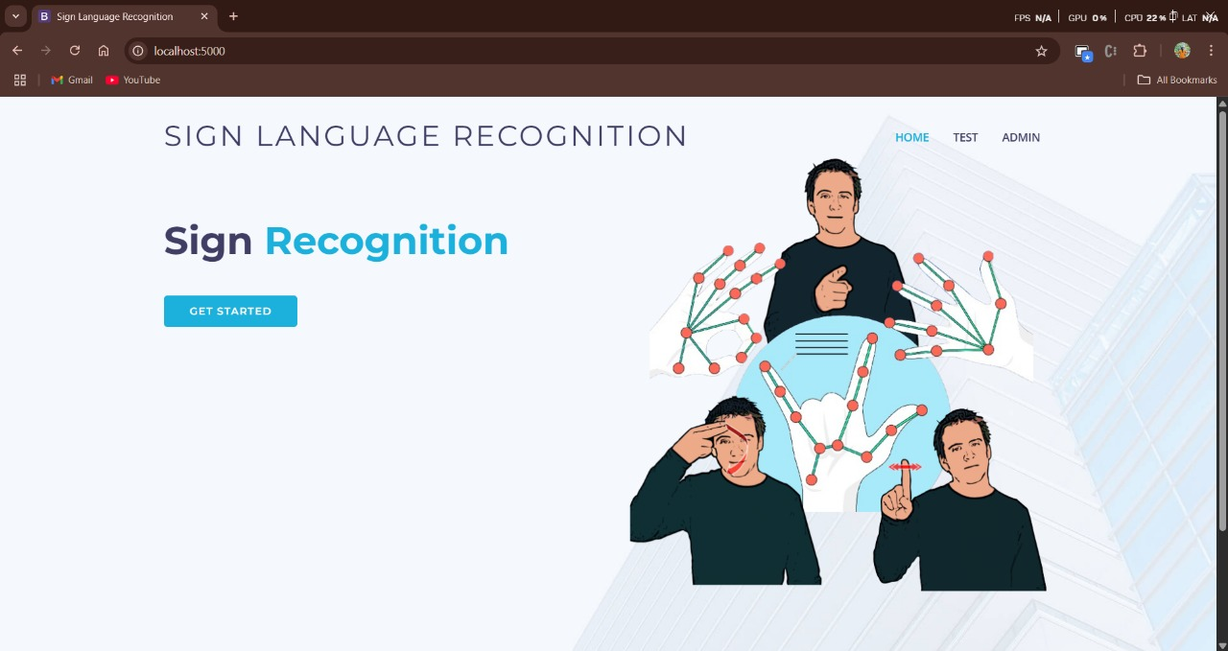

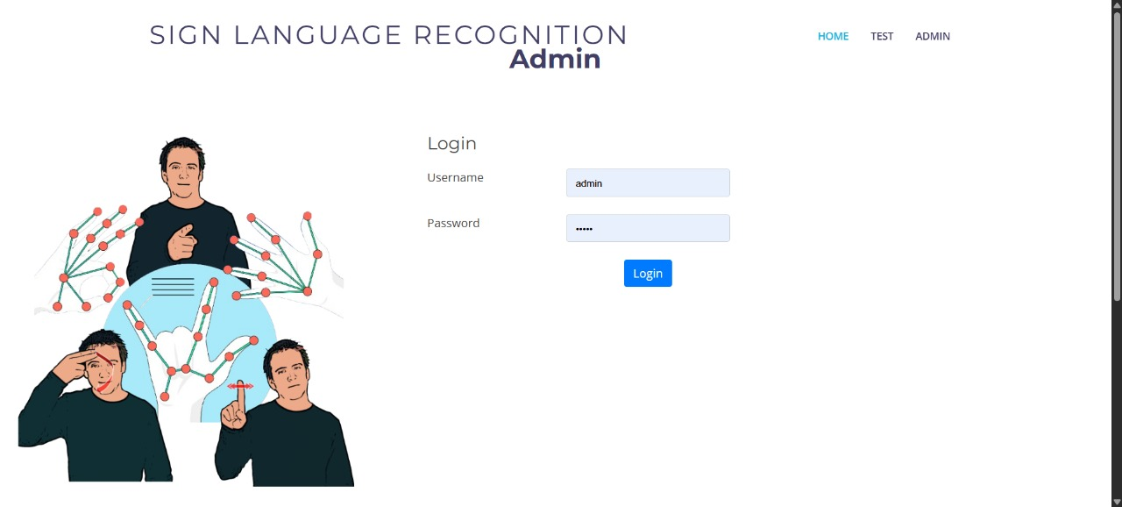

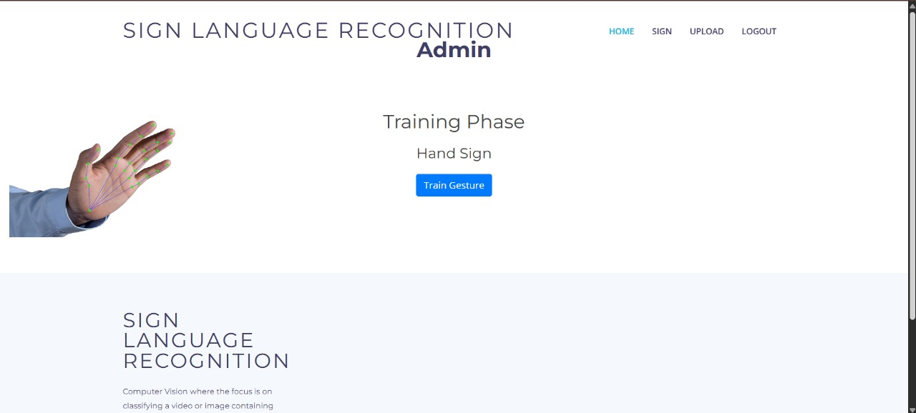

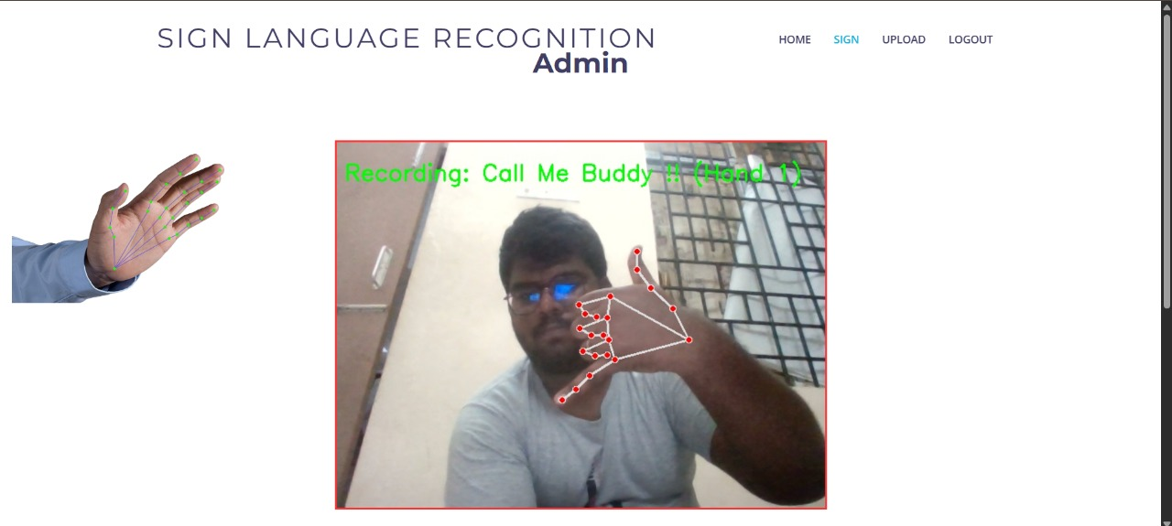

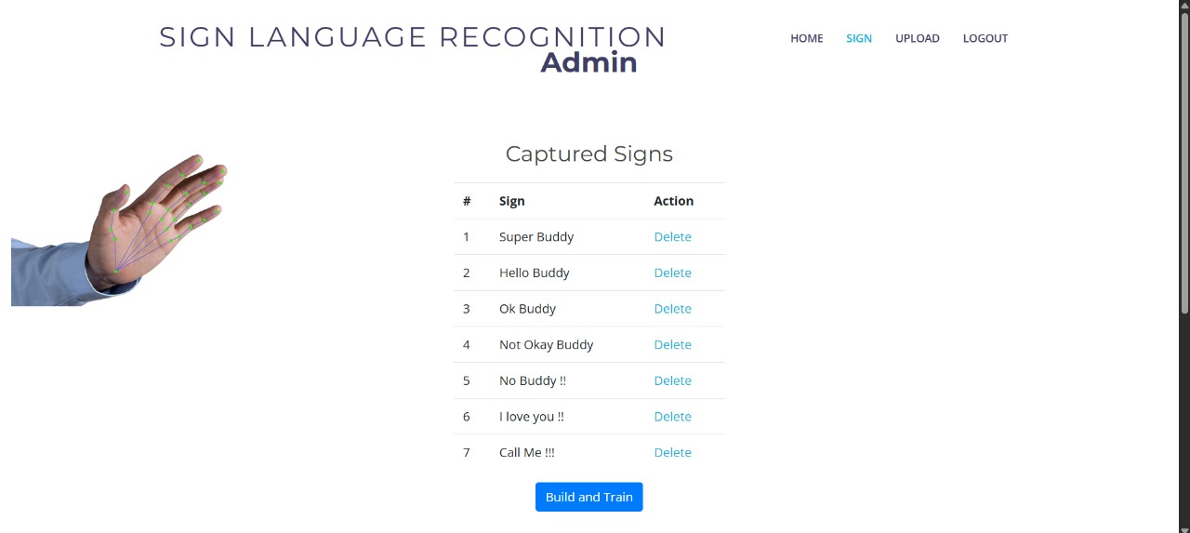

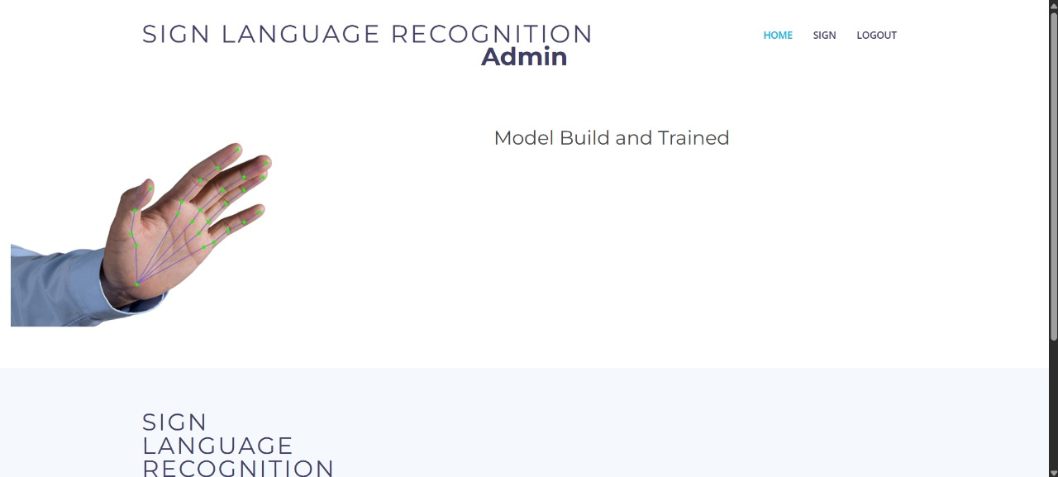

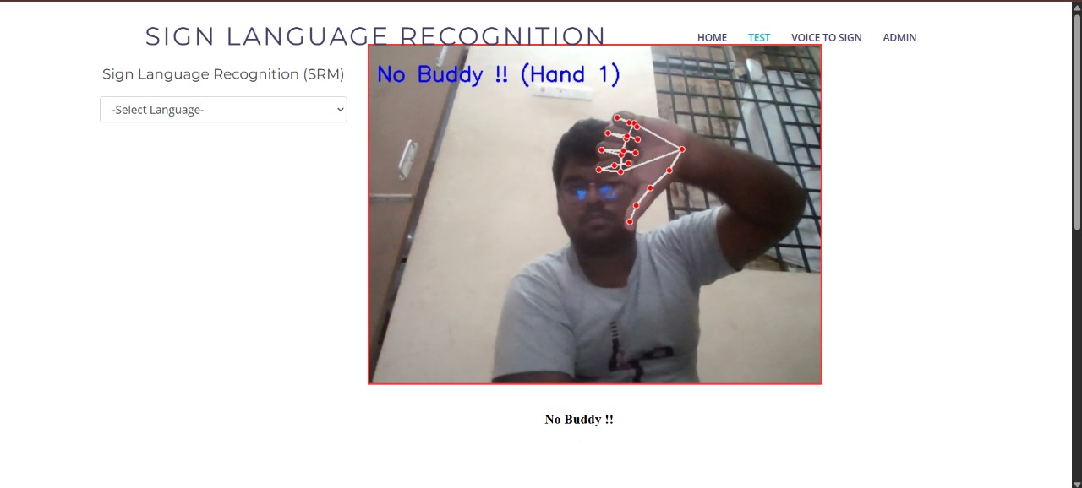

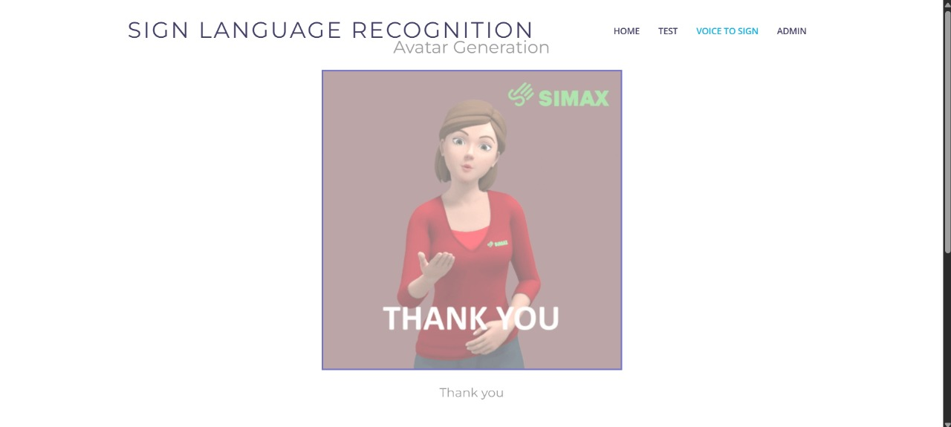

REFERENCES
JOURNAL REFERENCES
- H. Orovwode, O. Ibukun and J. A. Abubakar, "A Machine Learning-Driven Web Application for Sign Language Learning," Frontiers in Artificial Intelligence, vol. 7, Art. no. 1297347, Jun. 2024, doi: 10.3389/frai.2024.1297347.
- S. Katoch, V. Singh, and U. S. Tiwary, "Indian Sign Language recognition system using SURF with SVM and CNN," Array, vol. 14, Art. no. 100141, Apr. 2022. [Online]. Available: https://doi.org/10.1016/j.array.2022.100141
- Yogeshwar I. Rokade, Prof. Prashant M Jadav, "Indian Sign Language Recognition System," International Journal of Engineering and Advanced Technology (IJEAT), vol. 8, no. 6, pp. 1478–1481, Aug. 2019. [Online]. Available: https://www.ijeat.org/wp-content/uploads/papers/v8i6/F8665088619.pdf
- M. Chattopadhyay, B. Raisinghani, M. Parulekar, S. Arya, and V. Bhat, "Sign Language Translation using a Chrome Extension for Google Meet," in Proc. IEEE Region 10 Symposium (TENSYMP), Mumbai, India, Jul. 2022, pp. 1–5, doi: 10.1109/TENSYMP54529.2022.9864398.
- J. Himasree, A. Kolisetty, J. P. L., S. Naveen, and D. K., "Video-based Hand Gesture Recognition using Random Forest for Sign Language Interpretation," in Proc. 2024 Asia Pacific Conf. on Innovation in Technology (APCIT), Mysuru, India, Jul. 2024, pp. 1–6, doi: 10.1109/APCIT62007.2024.10673591.
- A. P. Chowdari, A. Gowthami, A. Deepthika, and M. JayaLakshmi, "Sign Language to Text Conversion using Random Forest," in Proc. 6th Int. Conf. Mobile Comput. Sustainable Informatics (ICMCSI), Krishnankoil, India, 2025, pp. 103–107. doi: 10.1109/ICMCSI64620.2025.10883074.
- T. Reddy Gadekallu, G. Srivastava, and M. Liyanage, “Hand gesture recognition based on a Harris hawks optimized convolution neural network,” Computers & Electrical Engineering, vol. 100, Article ID 107836, 2022.
- G. Halvardsson, J. Peterson, C. Soto-Valero and B. Baudry, "Interpretation of Swedish sign language using convolutional neural networks and transfer learning", SN Computer Science, vol. 2, no. 3, pp. 1-15, 2021.
- P. Likhar, N. K. Bhagat and R. G N, "Deep Learning Methods for Indian Sign Language Recognition", 2020 IEEE 10th International Conference on Consumer Electronics (ICCE Berlin), pp. 1-6, 2020.
- M. Oudah, A. Al-Naji and J. Chahl, "Hand Gesture Recognition Based on Computer Vision: A Review of Techniques", J. Imaging, vol. 6, no. 73, 2020.
- A. A. Hosain, P. S. Santhalingam, P. Pathak, J. Kosecka and H. Rangwala, "Sign language recognition analysis using multimodal data", 2019.
- J. Huang, W. Zhou, Q. Zhang, H. Li and W. Li, "Video-based sign language recognition without temporal segmentation", AAAI, vol. 32, no. 1, pp. 2257-64, 2018.
- J. Pu, W. Zhou and H. Li, "Dilated convolutional network with iterative optimization for continuous sign language recognition", IJCAI, vol. 3, pp. 885-91, 2018.
- E. Abraham, A. Nayak and A. Iqbal, "Real-Time Translation of Indian Sign Language using LSTM", 2019 Global Conference for Advancement in Technology (GCAT), pp. 1-5, 2019.

