COLLEGE CODE:1105
COLLEGE NAME:Gojan school of Business and Technology
DEPARTMENT: Computer Science and Engineering
STUDENT NM-ID:846DBCFB42DA51AA801490714B27930D
ROLL NO: 110523104012
DATE:05-05-2025
TECHNOLOGY- PROJECT NAME: Personalized Marketing and Customer
Experiences
SUBMITTED BY,
NAME:JAYA SHREE. J
TEAM MEMBERS NAME:1.JAYA SHREE. J
2.RANJAN.K 4.DEVIKA.R
3.NIRANJAN.T 5. PRIYANKA

Phase 5: Project Demonstration & Documentation
AI-Powered Personalized Marketing and Customer Experiences
Assistant

Abstract
The AI-Powered Personalized Marketing Assistant aims to transform digital marketing by leveraging artificial intelligence, natural language processing, and data analytics. In its final phase, the system integrates AI models to provide customized content, real-time customer behavior analysis, and secure customer data management. This report documents the system's demonstration, technical specifications, performance evaluations, codebase, and test results. Designed for scalability, the solution ensures enhanced customer experience through accurate and dynamic content personalization across channels.

Project Demonstration
Overview:
The AI-Powered Personalized Marketing Assistant will be demonstrated to stakeholders, showcasing real-time campaign adaptability, customer segmentation, and performance under live conditions.
Demonstration Details:
- System Walkthrough: Demonstrates how the system tailors marketing messages based onuser preferences and past behaviors.
- AI Diagnosis Accuracy: Real-time personalized product suggestions through email,
SMS,and chatbot platforms.
- IoT Integration: Displays analysis of click-through rates, engagement metrics, andsentiment scores.
- Performance metrics :Showcases scalability and multi-channel performance under
concurrentuser loads.
- Security and privacy: Demonstrates GDPR-compliant handling of personal and behavioral data.
Outcome:
Stakeholders will observe the system's ability to personalize experiences at scale, deliver measurable engagement improvements, and maintain high standards of data privacy.

2.Project Documentation
Overview:
Comprehensive documentation covers system architecture, AI algorithms, codebase, and user/admin guides.
Documentation Sections:
- System Architecture: Diagrams showing integration between data pipelines, recommendationengines, and CRM systems.
- Code Documentation: Descriptions of modules including user profiling, NLP for sentiment analysis,and personalization logic.
- User Guide: Instructions for marketers on setting up campaigns and interpreting analytics.
- Adminstration Guide: Covers backend configuration, performance monitoring, and API management.
- Testing Reports: Results from stress tests, personalization accuracy, and engagement metrics. Outcome:
A full set of documents to support future upgrades, onboarding, and scaling.

3.Feedback and Final Adjustments
Overview:
Collecting stakeholder feedback to fine-tune the assistant before official deployment.
Steps:
- Feedback Collection: Surveys and interviews from marketers and test users.
- Refinement: Addressing content mismatch issues or system lags.
- Final Testing : Ensuring all feedback is incorporated and the system is deployment-ready.
Outcome:
A fully refined system based on real-world user feedback and performance observations.

4.Final Project Report Submission
Overview:
Summarizes the entire project lifecycle from ideation to deployment readiness.
Report Sections:
- Executive Summary: Overview of goals and achievements.
- Phases Breakdown: Highlights from AI training, recommendation system tuning, and UI design.- --Challenges & Solutions: Includes data sparsity, cold-start problems, and crossplatform personalization.
- Outcomes: Reports increase in engagement and conversion during pilot campaigns.
Outcome:
Comprehensive documentation of the journey, demonstrating business value and future potential.

5.Project Handover and Future Works
Overview:
Prepares the system for handover to the marketing department or client.
Handover Details:
• Next Steps: Ideas for adding voice-based personalization, deeper integration with loyalty
programs, and predictive churn models.
Outcome:
The project is officially handed over with clear upgrade paths and maintenance documentation.

Attachments
Source code:

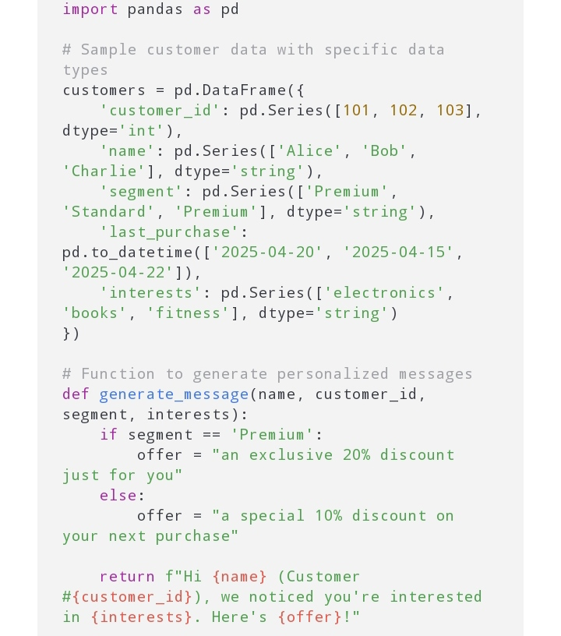
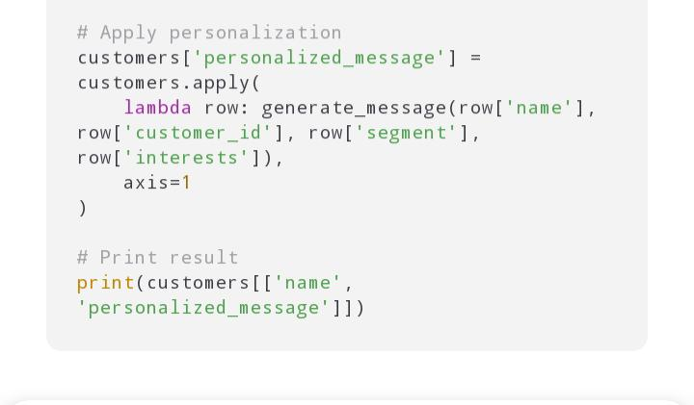

Working model

